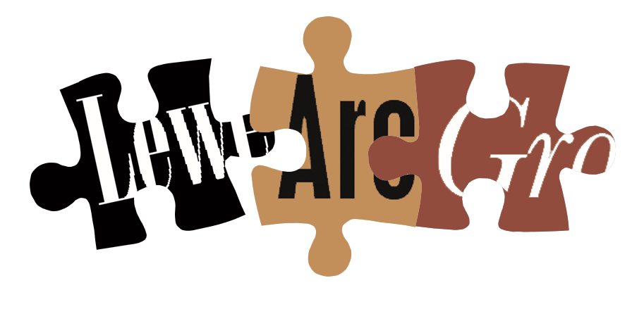
www.lewesarchaeology.org.uk

Lewes Archaeological Group
50th anniversary
Programme of Talks 2019-2020

All talks take place at 7.30pm in the Lecture Room, Lewes Town Hall
(Fisher Street entrance, lift access available).
Entrance (including tea/coffee) for members is £3/£2 concessions
Non-members are very welcome at £4/£3 concessions
FREE entry for those aged 25 years or under

2019

Fri 12 April Lewes to Wessex and Back Again – a New Archaeology of the Prehistoric Downs (and how LAG helped re-write the text books) with Dr Mike Allen MCIfA, FLS, FSA and Hon. President of LAG. Mike is also Visiting Research Fellow in Environmental Archaeology, Bournemouth University. He will launch the celebrations of LAG’s 50th anniversary with this talk looking back to LAG’s early excavations and research and how this relates to more recent developments.

Fri 4 October Henges & Hand Grenades: New Discoveries from Salisbury Plain with Martin Brown. Martin is Assistant County Archaeologist at Wiltshire Council and former Ministry of Defence Archaeologist. Martin will talk about new developments connected with the Army Basing Project which have led to discoveries that are changing thinking about the past, including the origins of the Stonehenge landscape, the conversion of Wessex and the training of WW1 soldiers.

Fri 15 November 1264: The Battle of Lewes, a military perspective with Joe Gazeley. Joe from the University of Edinburgh will present a fresh understanding of the Battle of Lewes based on the history and theory of warfare in the medieval period.

2020
Fri 17 January Romano-British Settlements in the Ouse Valley with Dr David Rudling. David is the Academic Director of the Sussex School of Archaeology and is a specialist in Romano-British settlements particularly in Sussex where he has carried out many excavations (including most recently the Roman villa site at Plumpton). He is author of Bignor Roman Villa and co-editor of the Archaeology of the Ouse Valley, Sussex, to AD 1500. David will talk about the Romano-British settlements in the Ouse Valley.
Fri 21 February The Report on the Major Excavations in Lewes at the Lewes Library, Baxter’s Printworks and Lewes House with Dan Swift. Dan is a post-excavation project manager at Archaeology South East and is the author of the monograph for the major excavations that took place on the sites of the Lewes Library, Baxter’s Printworks and Lewes House (to be published in 2020).
Fri 20 March Malling, Lewes: An Anglo-Saxon Estate, a Christian Centre and Medieval Parish with John Bleach Custodian of Lewes Castle for the Sussex Archaeological Society, 1977-2013. John will talk about Malling, Lewes as an Anglo-Saxon estate extending from Southerham to the Sussex/Kent border and as an important Christian centre. He will discuss Malling as a medieval estate with chapels in the Cliffe and Southerham areas of Lewes.
To be followed at about 8.45pm by the AGM.
Fri 17 April Stonehenge Unveiled: large-scale field projects and the transformation of the Stonehenge landscape with Paul Garwood Paul is a Senior Lecturer in Archaeology at the University of Birmingham and he will talk about his recent work in the landscape around Stonehenge which is recovering a plethora of new information from the Mesolithic to the Bronze Age.

Directions: Fisher Street is up the hill from Lewes railway station, straight on over the crossroads in the centre of town, just past ASK restaurant, on the right. The nearest parking is in the West Street car park – continue along Fisher Street then turn right, then shortly right again into the car park.

Any queries regarding the talks can be addressed to Paula Stanyer on 07814 463 259 or by email paulawodcohen@yahoo.co.uk. Ideas for future talks will be well received.

Membership of Lewes Archaeological Group costs £6 per year and gives reduced entrance charge to talks and receipt of the Group’s newsletter.

You can join or renew at any of our meetings or send a cheque payable to Lewes Archaeological Group together with a sae to Brian Phillips, 2 Peronne Court, High St, Uckfield, TN22 1BL
Or by hand to Fiona Marsden, 13 Lansdown Place, Lewes, BN7 2JT (01273 473946).

NEW MEMBERS ARE VERY WELCOME!

