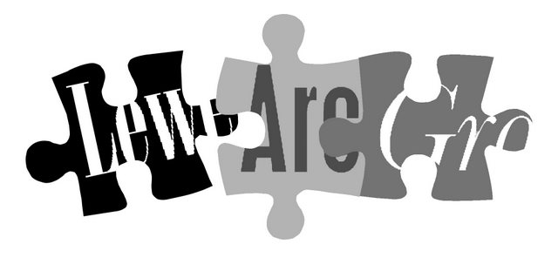

www.lewesarchaeology.org.uk

Lewes Archaeological Group
Programme of talks 2014-2015

All talks take place at 7.30pm in the Lecture Room, Lewes Town Hall
(Fisher St entrance, lift access available).
Entrance (including tea/coffee) for members is £3/£2 for concessions.
Non-members are very welcome at £4/£3 for concessions.
FREE entry for those 18 years and under

2014

Fri 3 October The Pelhams of Stanmer c1710-1810 an influential local family with historian Dr Sue Berry. Sue will talk about the Pelham family and its development of the house and grounds at Stanmer. She will set the Pelham family into the broader context of their wider ambitions and their expenditure in order to meet them.

Fri 7 November 1914 Archaeology and Memory around Ploegsteert Belgium with Martin Brown. The first months of the Great War have a character that differs from the trenches and mud of popular imagination. The early phases of the conflict swept up civilians, saw the first destruction of property on a large scale and witnessed the beginnings of trench warfare. Martin, the Ploegsteert Project’s director will explore the first phase of the conflict, as it appears in archaeological and anthropological research into this early phase of the war. He will discuss the physical remains and family histories and legends of the local inhabitants, as well as, the memorial myths that have developed including the football during the Christmas truce.

Fri 5 December The Neolithic of the chalklands - Wessex to Sussex - environmental archaeology re-writes the textbooks with Dr Mike Allen. The talk will cover Sussex to Wessex, embracing some of the work Ken Thomas did from Peter Drewetts excavations on causewayed enclosures and long barrow at Alfriston etc. It will re-examine prehistoric Dorchester, Stonehenge and Avebury, and indicate why these area became centres of prehistoric activity, and why Stonehenge is not only in that locale, but why it is on that spot!

2015
Fri 23 January To the manor born: manors of the Battle area 1066-1925 with Christopher Whittick local historian and archivist.
Fri 6 February Bridge Farm, near Barcombe Mills: Directors of the Culver Archaeological Project: Rob Wallace and David Millum will make a return visit to report on the second year of excavations at the Bridge Farm.
Fri 6 March Old Walls, Wellies and Wasps - Recent Archaeological Work at Lewes Priory with Simon Stevens, Senior Archaeologist at Archaeology South-East. Simon will talk about recent developments at Lewes Priory. To be followed at around 8.45pm by the AGM.
Fri 17 April Whitehawk Hill Excavations with Jonathan Sygrave who is a Project Manager at Archaeology South-East. Jon will talk about the excavation in the summer of 2014 at Whitehawk Hill, Brighton and the collection of objects excavated from the site in the 1920s and 1930s. The neolithic causewayed enclosure at Whitehawk Hill is a rare type of ritual monument predating Stonehenge by around 500 years and marks the emergence of Britain's first farming communities

Directions
Fisher Street is up the hill from Lewes railway station, just over the crossroads by Ask restaurant in the centre of town. The nearest parking is in the West Street car park – continue along Fisher Street then turn right, then shortly right again into the car park.

Membership of Lewes Archaeological Group costs just £6

You can renew or join at any of our meetings, or send a cheque (payable to Lewes Archaeological Group) and sae to: Brian Phillips, 2 Peronne Court, High St, Uckfield, East Sussex, TN22 1BL or by hand to:
Fiona Marsden, 13 Lansdown Place, Lewes, East Sussex, BN7 2JT (01273 473946).

