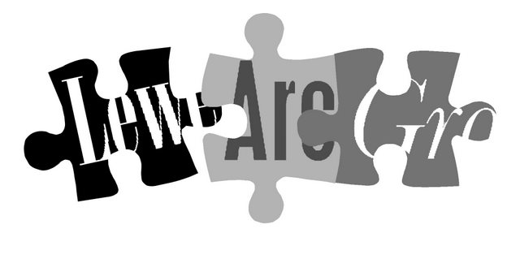

Lewes Archaeological Group
Programme of talks 2013-2014 www.lewesarchaeology.org.uk

All talks take place at 7.30pm in the Lecture Room, Lewes Town Hall
(Fisher St entrance, lift access available).
Entrance (including tea/coffee) for members is £3/£2 for concessions.
Non-members are very welcome at £4/£3 for concessions.

2013
Fri 29 November Cowrie Shells to Credit Cards: the archaeology of money with David Rudling, excavator of Roman villas at Beddingham and Barcombe, and authority on Roman coinage, now co-Director of the Sussex School of Archaeology following many years as convenor of archaeology programmes at the University of Sussex.
2014
Fri 31 January Roman Roads in the Lewes Area. New research results from geophysics expert David Staveley, who has worked extensively across Sussex and developed his own pioneering software for processing his survey results.
Fri 28 February Bridge Farm, near Barcombe Mills: a truly momentous year. Directors of the Culver Archaeological Project: Rob Wallace and David Millum will make a return visit to report on the first year of excavations at the Bridge Farm. 2013 proved to be truly memorable not only for the archaeology revealed but also for the terrific response from 180 volunteers of all ages and experience who signed up for a total of over 1000 work days. Come along and find out what was discovered.
Fri 28 March East is East and West is West? The formation of the different characters of East and West Sussex. Local historian and archivist Christopher Whittick will explore how history has shaped the physical and human differences between the two counties
To be followed at around 8.45pm by the AGM, including discussion on the future direction of the Lewes Archaeological Group.
Directions
Fisher Street is up the hill from Lewes railway station, just over the crossroads by Ask restaurant in the centre of town. The nearest parking is in the West Street car park – continue along Fisher Street then turn right, then shortly right again into the car park.
Membership of Lewes Archaeological Group costs just £6
You can renew or join at any of our meetings, or send a cheque (payable to Lewes Archaeological Group) and sae to: Brian Phillips, 2 Peronne Court, High St, Uckfield, East Sussex, TN22 1BL or by hand to:
Fiona Marsden, 13 Lansdown Place, Lewes, East Sussex, BN7 2JT (01273 473946).

