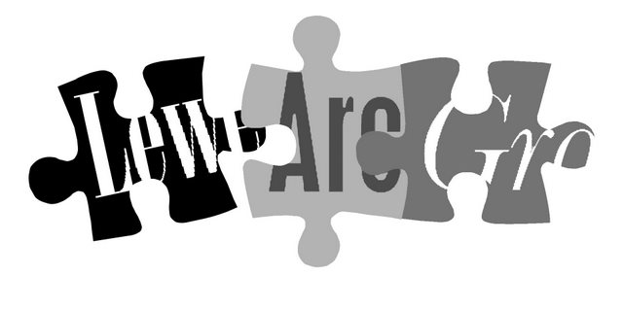

Lewes Archaeological Group
Programme of talks 2012-2013 www.lewesarchaeology.org.uk

2012
All talks take place at 7.30pm in the Lecture Room, Lewes Town Hall
(Fisher St entrance, lift access available).
Entrance (including tea/coffee) for members is £3/£2 for concessions.
Non-members are very welcome at £4/£3 for concessions.
Please note that, as last year, some talks this season are on Wednesdays rather than Fridays.

Fri 28 September The Early Roman Empire and its Sussex connections. With Helen Poole, archaeologist and historian. This talk looks at the Roman Empire in the 1st century AD, and how its influence spread as far as Sussex, with the superb buildings at Fishbourne and others along the coast.
Wed 31 October Putting the Priory on the map. Tony Freeman and Kate Hickmott from Lewes Priory Trust will review the experience of the Lottery-funded Priory restoration project, what has been learned and plans for the future, including opportunities to get involved with the site.
Fri 30 November Woodland archaeology and Lidar. Landscape archaeologist Vivienne Blandford will illustrate how the Lidar aerial survey of the High Weald has discovered well preserved archaeological features in woodland which can barely be seen on the ground.
2013
Fri 1 February The archaeology of the Friston to Folkington water pipeline. Tim Allen of Kent Archaeological Projects will talk about his archaeological work for South-East Water ahead of the installation of the pipeline, uncovering evidence of previously unknown prehistoric and medieval settlement along and below the South Downs.
Wed 13 March Major excavations in Lewes: Baxters, Lewes Library and Lewes House. With Dan Swift of Archaeology South-East, who led the Lewes House excavation and is writing the forthcoming monograph on the prehistoric, Roman, medieval and post-medieval findings from the three sites.
Fri 19 April Romano-British discoveries in the Barcombe area. A return visit for local archaeologists David Millum and Rob Wallace, involved in excavations at Barcombe bath house and Culver Farm, who will present exciting new findings from the nearby area.
To be followed at around 9pm by the AGM.
Directions
Fisher Street is up the hill from Lewes railway station, just over the crossroads by Ask restaurant in the centre of town. The nearest parking is in the West Street car park – continue along Fisher Street then turn right, then shortly right again into the car park.
Membership of Lewes Archaeological Group costs just £6
You can renew or join at any of our meetings, or send a cheque (payable to Lewes Archaeological Group) and sae to: Brian Phillips, 2 Peronne Court, High St, Uckfield, East Sussex, TN22 1BL or by hand to:
Fiona Marsden, 13 Lansdown Place, Lewes, East Sussex, BN7 2JT (01273 473946).

