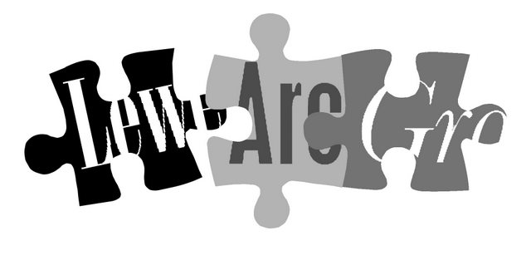

Lewes Archaeological Group
Programme of talks 2011-2012

All talks take place at 7.30pm in the Lecture Room, Lewes Town Hall
(Fisher St entrance, lift access available).
Entrance (including tea/coffee) for members is £3/£2 for concessions.
Non-members are very welcome at £4/£3 for concessions.
Please note that, as last year, some talks this season are on Wednesdays rather than Fridays.

Fri 30 September Bignor Roman Villa 1811 – 2011: 200 years of archaeology and tourism. With David Rudling, Senior Lecturer in Archaeology at CCE, University of Sussex. Discovered by ploughing in 1811, Bignor Roman Villa was one of Britain’s earliest heritage tourism attractions: the thatched buildings put up to shelter the fine mosaic floors are now protected in their own right.
Wed 26 October Medieval Discoveries in the Cuckmere Valley. A talk by local archaeologist Peter Bidmead. While the lower Cuckmere valley is notable for having resisted modern development and industrial activity, recent archaeological research is beginning to reveal a very different picture in Medieval times.
Wed 30 November Beyond Piltdown: ice age archaeology in the Ouse Valley. Dr Matt Pope, Senior Research Fellow, Institute of Archaeology, UCL, will discuss the ancient human occupation of the Ouse Valley in the ice age, the development of its dramatic ice age land forms– and why the site of the Piltdown man hoax still has the potential for genuine Palaeolithic discoveries.
2011
Wed 15 February Barcombe Roman Bathhouse and its surroundings. Local archaeologist David Millum will present the latest findings from this season’s excavations at the bathhouse, where he was site supervisor, and other exciting new discoveries about Romano-British activity in the Barcombe area.
Wed 21 March Gold and Garnets: Anglo-Saxon metalwork and its cultural setting. A talk by Judie English, tutor in archaeology with the University of Sussex and the WEA, on the significance of the designs and workmanship of metalwork from the Anglo-Saxon period.
Fri 20 April Farming the Lewes Downs: the development of landed estates and farms c.1750–1930 with Dr Sue Berry, historian and author of Georgian Brighton, who has researched the South Downs during this period.
To be followed at around 9pm by the AGM.
Directions
Fisher Street is up the hill from Lewes railway station, just over the crossroads by Ask restaurant in the centre of town. The nearest parking is in the West Street car park – continue along Fisher Street then turn right, then shortly right again into the car park.
Membership of Lewes Archaeological Group costs just £5/£4 concessions
You can renew or join at any of our meetings, or send a cheque (payable to Lewes Archaeological Group) and sae to: Brian Phillips, 2 Peronne Court, High St, Uckfield, East Sussex, TN22 1BL or by hand to:
Fiona Marsden, 13 Lansdown Place, Lewes, East Sussex, BN7 2JT (01273 473946).

