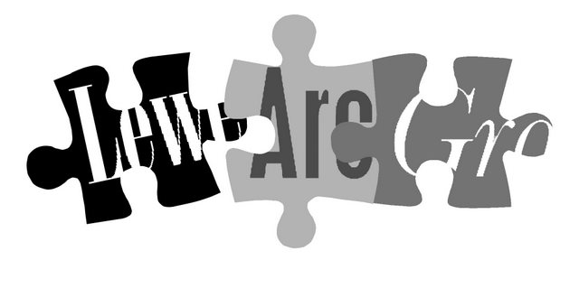

Lewes Archaeological Group
Programme of talks 2009-2010

All talks take place at 7.30pm in the Lecture Room, Lewes Town Hall
(Fisher St entrance, lift access available).
Entrance (including tea/coffee) for members is £2/£1 for concessions.
Non-members are very welcome at £3/£2 for concessions.
Please note that, as last year, some talks this season are on Wednesdays rather than Fridays.

2009
Fri 25 September Battle Tanks and Burial Grounds. A return to East Sussex for Martin Brown, formerly Assistant County Archaeologist, to talk about his extremely varied experiences in his present job as Ministry of Defence archaeologist across southern England (this is the talk originally scheduled for February 2009 and cancelled because of snow).

Wed 28 October Feasting at the ball-game: ten years digging at the Amerindian ceremonial site at Belmont, British Virgin Islands. Peter Drewitt, Emeritus Professor of Archaeology, University of Sussex, on his excavations in the Caribbean.

Wed 25 November A Great and Terrible king: Edward I and the forging of Britain. Marc Morris, historian and broadcaster, talks on his latest book. In 2003 Marc presented the Channel 4 series Castle and wrote the accompanying book.
2010
Fri 29 January The History of Sussex Inn Signs. With Janet Pennington, Sussex historian, archivist and buildings specialist, on the social and architectural history embodied in inn signs – with special reference to Lewes hostelries.

Wed 10 March Church memorials around Lewes. Professor Nigel Llewellyn FSA, currently Tate Head of Research, who taught art history at Sussex University from 1978 to 2002 and has a particular interest in commemorative art.

Fri 23 April Brunel: his life and work Dr Steven Brindle, English Heritage inspector and author of Brunel: the man who built the world (2005).
To be followed at around 9pm by the AGM.
Directions
Fisher Street is up the hill from Lewes railway station, just over the crossroads by Ask restaurant in the centre of town. The nearest parking is in the West Street car park – continue along Fisher Street then turn right, then shortly right again into the car park.
Membership of Lewes Archaeological Group costs just £4/£3 concessions
You can renew or join at any of our meetings, or send a cheque (payable to Lewes Archaeological Group) and sae to: Brian Phillips, 51 Manor Way, Uckfield, East Sussex, TN22 1DQ or by hand to:
Fiona Marsden, 13 Lansdown Place, Lewes, East Sussex, BN7 2JT (01273 473946).

