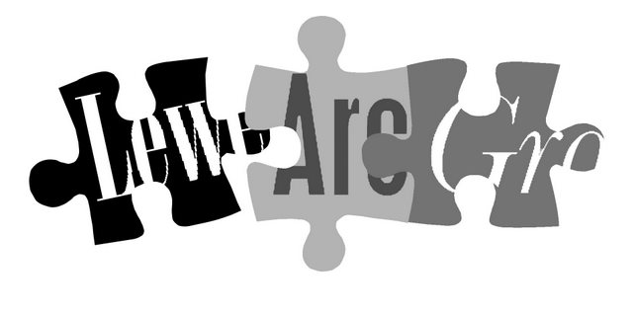

Lewes Archaeological Group
Programme of talks 2008-2009

All talks take place at 7.30pm in the Lecture Room, Lewes Town Hall (Fisher St entrance).
Entrance (including tea/coffee) for members is £2/£1 for concessions.
Non-members are very welcome at £3/£2 for concessions.
Please note that some talks this season are on Wednesdays rather than Fridays.

2008
Fri 19 September East Sussex Under Attack. Chris Butler, Sussex archaeologist and author, will talk about the archaeological remains of defence sites in and around Lewes, particularly those from the Second World War.

Wed 22 October The Cloth Industry of the Weald of Kent. By Tony Singleton, Hawkhurst-based historian of the development of the industries of the Weald.

Fri 5 December Short talks by members: John Funnell on Excavations at the 13th century manorial complex at Ovingdean, and Anne Locke on Inclusive Archaeology. Plus informal discussion and Christmas social (all welcome).
2009
Wed 14 January The Settlement of Sussex: what place-names tell us. Judie English, landscape archaeologist teaching at Sussex University, will speak on her latest research on place-names and what they may say about movement into the Weald and the early history of Sussex.

Fri 6 February Battle Tanks and Burial Grounds. A return to East Sussex for Martin Brown, formerly Assistant County Archaeologist, to talk about his extremely varied experiences in his present job as Ministry of Defence archaeologist across southern England.

Wed 18 March Recent excavations in Lewes Town. The County Archaeologists will present emerging findings from the three massive excavations in the heart of the historic town over recent years: Lewes Library, the Baxters site and Lewes House.

Fri 24 April Easter Island: landscapes of construction. Dr Sue Hamilton, Reader in Prehistoric Archaeology at the Institute of Archaeology, will talk about her latest fieldwork on Easter Island, investigating how its iconic statues were constructed, transported and positioned. To be followed at around 9pm by the AGM.

Membership of Lewes Archaeological Group costs just £4/£3 concessions
You can renew or join at any of our meetings, or send a cheque
(payable to Lewes Archaeological Group) and sae to:
Brian Phillips, 51 Manor Way, Uckfield, East Sussex, TN22 1DQ or by hand to:
Fiona Marsden, 13 Lansdown Place, Lewes, East Sussex, BN7 2JT (01273 473946).

