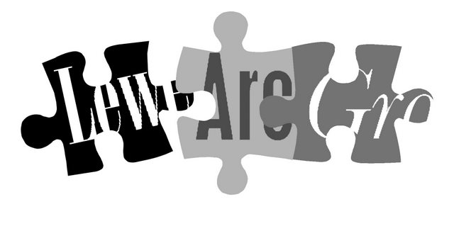
No. 145
September 2012

Affiliated to the Sussex Archaeological Society and the Council
for British Archaeology www.lewesarchaeology.org.uk

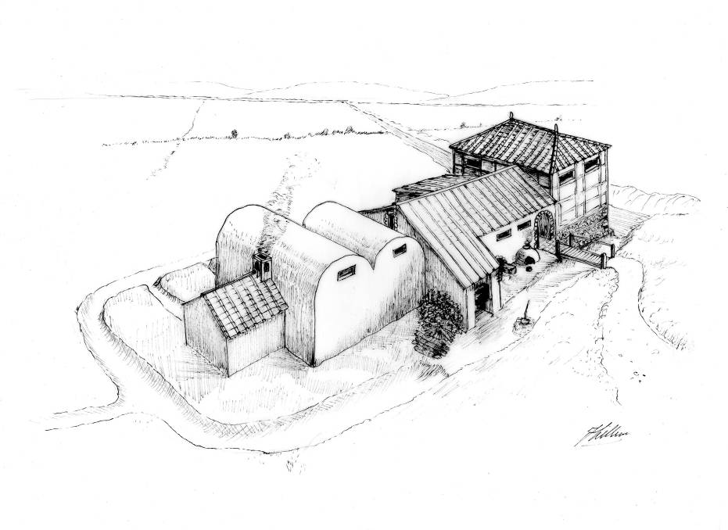
Lecture programme
This season’s talks, all at 7.30pm in the Town Hall lecture room, Lewes (Fisher Street entrance) are on:
Fri 28 September 2012
Wed 31 October 2012
Fri 30 November 2012
Fri 1 February 2013
Wed 13 March 2013
Fri 19 April 2013 (plus AGM)
See separate coloured insert for programme details, and please note that some talks are on Wednesdays.
Next lecture: Fri 28 Sept, 7.30pm
Helen Poole, archaeologist and historian will talk on The Early Roman Empire and its Sussex connections.
This talk looks at the Roman Empire in the 1st century AD, and how its influence spread as far as Sussex, with the superb buildings at Fishbourne and others along the coast.

Barcombe Roman Bath House?
Based on the results of the 2011 excavations, David Millum produced this striking speculative impression of how this intriguingly large and multi-phased building might have appeared when in use. As the rains this summer revealed, the surrounding ditch still readily becomes a moat. You can see the site just downhill from the new church hall by St Mary’s Church, Barcombe (BN8 5TS).
Following on from his very well supported talk to us last February, David and his colleague Rob Wallace will be back on Friday 19 April 2013 with news of some exciting new discoveries nearby. This may help to explain more about what could have been going on in Romano-British Barcombe to support a building on this scale.
Annual membership runs from 1 April 2012 to end March 2013 and costs £6
If there is a cross here
your membership for 2012/2013 is now due (according to our records). Thank you for your support.
If you have paid in the last few weeks, please disregard a cross as I may not have caught up with you!
You can renew or join at any of our meetings, or send a cheque
(payable to Lewes Archaeological Group) and sae to:
Brian Phillips, 2 Peronne Court, Uckfield, East Sussex, TN22 1BL
or by hand to:
Fiona Marsden, 13 Lansdown Place, Lewes, East Sussex, BN7 2JT (01273 473946).
NB if you have received this by email and are not sure if you have paid this year,
please email anne.locke@talktalk.net to check, or ask Brian at one of our meetings

Thoughts from the Chair

After all our efforts to prevent the closure of archaeology courses at Sussex University’s CCE, it feels very sad not to have their usual programme of courses and day schools to put in our autumn newsletter this year. Brighton University, which has a good reputation in the study of heritage management, will be launching of a new full-time degree in Geography and Archaeology from September 2013, but for now there is a notable gap. However as you will see from the back of this newsletter there is a great deal else going on in local archaeology, including a very useful set of practical Saturday sessions run by Brighton and Hove Archaeological Society (book early, they can fill up) and a full programme of talks nearly every week between Eastbourne and Brighton.
This brings me to something I’ve been mulling over for some years – how much should LAG be trying to do? Our group has a loyal membership of around 70, a figure which has been growing gradually in the last few years, but that’s only a fifth of the size of BHAS. For a town with only 16,000 people to Brighton and Hove’s 256,000, that’s doing very well – but we really don’t seem to have enough available people to cover all the jobs that would need to be done to arrange a full programme including summer walks and visits, outreach, research and fieldwork. Quite a number of our members are involved in these kinds of activities – but through their membership of other groups. In principle, I’d like to do more, but I have more than enough to do organising the speaker programme, newsletter and
membership records, especially now I have a job in London. And I don’t want to do these LAG roles for ever. So there are questions to ponder in the run-up to next April’s AGM:
- should LAG continue much as at present, arranging a programme of winter talks and circulating news of what else is going on in the area, with members who wish to be part of excavations etc joining other groups? In this case, do we still need our fieldwork insurance, which is now nearly £300 a year?
- should LAG aim to be an active fieldwork group again? Do we have sufficiently trained and available people to take responsibility? Can we meet modern requirements for post-excavation work, finds analysis, storage and publication? (for example, our finds from past excavations are stored at no charge by East Sussex County Council’s Archaeology Section, for which we are very grateful, but the future of their store is not secure).
- are there ways forward in partnership with other local archaeological groups – BHAS, the University of Sussex Archaeological Society and Mid-Sussex Field Archaeology Team being our nearest neighbours?
If you have any thoughts on this please do get in touch. We look forward to seeing you at our talks again this year, and do bring your friends along.
Anne Locke, Chair
73 Paddock Lane, Lewes BN7 1TW
01273 475381 anne.locke@talktalk.net

Alex’s mystery photographs, part 3
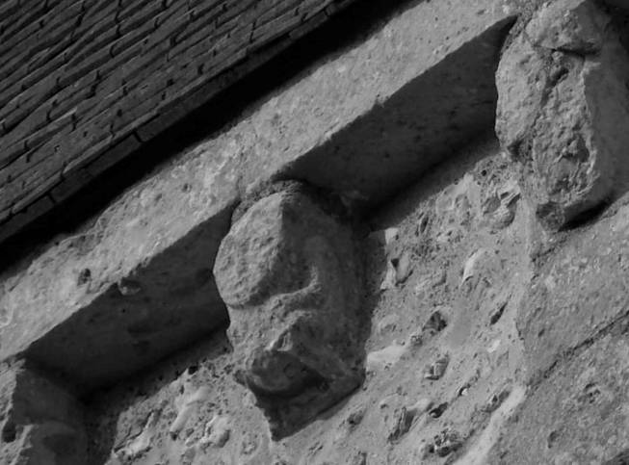
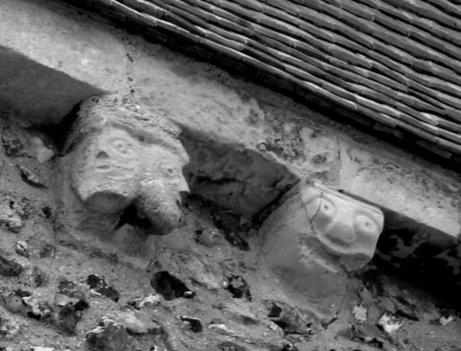

Picture 1
Our Secretary Alex Sutherland has taken these two images of corbels from the same church (answer at the bottom of the last page of this newsletter). Clue: possibly the earliest church in Sussex – some say it could have been built earlier than the 8th century AD – with some stunning Anglo-Saxon and Norman architectural features.
Picture 2
Picture 1
Finds processing
In 2011 we carried out an archaeological watching brief behind a house at 7 Keere Street, Lewes. Close to the back of the former Britannia Inn at 9 Keere St, new foundation trenches were being dug into the former town ditch, once used for rubbish. As a result we now have several bags of interesting pottery sherds from the 17th/18th century onwards and a large quantity of butchered animal bone to analyse. Before we can ask our experts to take a look it all needs washing! This is a pleasant and sociable seated task involving brushing the finds gently with old toothbrushes and water. You don’t need to have any previous knowledge at all.
If you would like to help please contact Anne on 01273 475381 or anne.locke@talktalk.net and we can arrange some convenient times. Interested children are welcome to come along too.
Archaeological training
Brighton and Hove Archaeological Society (BHAS) has arranged another series of excellent day schools for the New Year, all running from 10am to 4pm in Patcham, on the northern edge of Brighton near the by-pass, and costing £25 each. Parking nearby or buses 5 or 5a from central Brighton, bring your own lunch:
Sat 12 Jan Coins from the Iron Age to the
Patcham Com- early post-medieval period with
munity Centre, David Rudling.
Ladies Mile Rd
Sat 2 Feb Introduction to the identification
Methodist of animal bones with Sarah
Church Hall Green.
Ladies Mile Rd
Sat 9 March Metalwork from the Iron Age to
Patcham Com- the early post-medieval period
munity Centre, with Luke Barber.
Ladies Mile Rd
Fieldwork opportunities
The Sally Christian Archaeology Bequest
Funding may be available for practical archaeology training through a fund set up by the late Sally Christian, a former CCE student.
Further details about the fund and how to apply can be obtained from David Rudling d.r.rudling@sussex.ac.uk or 01273 873527.
Brighton and Hove Archaeological Society (BHAS) invite volunteers to join their field unit on weekend work in and around Brighton. No experience necessary. Contact Norman Phippard 01903 877442 or John Funnell 01273 607127, or see the BHAS website www.brightonarch.org.uk

Mid-Sussex Field Archaeology Team (MSFAT) often has opportunities for weekend volunteers at local sites – including excavation, finds processing, field walking and resistivity surveys. No experience necessary. Membership £8. Chris Butler 01323 871021, website www.cbasltd.co.uk

The Tidemills Project is a community project open to all, engaged in both historical research and on-site survey and recording of this important site between Newhaven and Seaford, usually on Thursdays. Contact Luke Barber on 01273 405733 or email research@sussexpast.co.uk

Talks and events 2012–2013
See separate sheet for details of LAG lectures.
For the USAS venue (tbc), please contact Lisa Fisher on Lisa@prehistorygirl.freeserve.co.uk
Fri 28 Sept LAG: The early Roman Empire
BHAS Brighton & Hove Archaeological Society
CBA Council for British Archaeology
ENHAS Eastbourne Natural History and Archaeological Society
FOAC Friends of Anne of Cleves House
LAG Lewes Archaeological Group
SAS Sussex Archaeological Society
USAS University of Sussex Archaeological Society
Lecture Room, and its Sussex connections
Lewes Town with Helen Poole.
Hall, 7.30pm
Tue 2 Oct Tudor Taste evening talk with
Anne of Cleves recipes, artefacts & opportunities
House, Lewes to taste and touch. Tickets in
7pm; £10 advance from the house.
Sun 7 Oct Tudor Food Day family event
Anne of Cleves with hands-on activities
House, Lewes and resident Tudor Housewife.
11am-4pm Normal admission prices.
Fri 12 Oct BHAS: The Great Escape: an
Unitarian Ch, historical & archaeological view
New St, B’ton with Dudley Moore. 7.30pm. £3.
Sat 13 Oct Marking Past Landscapes
Dorking CBA SE conference and AGM.
Christian Speakers include Paul Garwood
Centre and Judie English. £8/£10 from
2 – 5pm Mrs R Hooker, 59 Thornton Place, Horley RH6 8RZ.
Thu 18 Oct USAS: How to Survive the
Fulton Lecture Next Ice Age with Dr Matt Pope
Theatre B, 7pm The Sally Christian Lecture:
Univ of Sussex Free BUT you need to book on http://www.sussex.ac.uk/alumni/newsandevents/events?id=15105
or tel. 01273 873527

Fri 12 Oct ENHAS: Bignor Roman Villa
7.30pm, with David Rudling. £2.
WRVS, Hyde Rd, Eastbourne.
Fri 19 Oct FOAC: Lewes and the Civil War
Anne of Cleves talk by Michael Chartier
House, Lewes and AGM 7.30pm.
Wed 31 Oct LAG: Putting the Priory on the
Lecture Room, Map with Tony Freeman
Lewes Town and Kate Hickmott of
Hall, 7.30pm Lewes Priory Trust.
Fri 9 Nov BHAS: Rethinking the Late Neo-
7.30pm, lithic monuments of Orkney
Unitarian Ch. with Professor Colin Richards of
New St, B’ton Manchester University. £3.
Fri 9 Nov ENHAS: Discoveries in the
7.30pm, Cuckmere Valley with Peter
WRVS, Hyde Bidmead. £2.
Rd, E’bourne
Thu 15 Nov USAS: Archaeology in Malta
Venue TBC with David Worsell. 7pm, £3.
Fri 30 Nov LAG: Woodland archaeology
Lecture Room, and Lidar with landscape
Lewes Town archaeologist Vivienne
Hall, 7.30pm Blandford.
Fri 14 Dec BHAS members talks, AGM and
Unitarian Ch. Christmas social, all welcome.
New St, B’ton 7.30pm. £3.
Fri 14 Dec ENHAS: Christmas meeting
7.30pm, with four short talk. £2.
WRVS, Hyde Rd, Eastbourne
Sat 22 Dec BHAS: Millbank Wood circular
Biology Rd walk Archaeological sites in the
car park, Univ Stanmer and Falmer area. Meet
of Sussex 10am, possible pub lunch.
Sat 29 Dec BHAS: Alciston to Berwick walk
Alciston along the bottom of the Downs
Church, with possible break at the
10am Cricketers Arms, Berwick.
Fri 11 Jan BHAS: The La Cotte
Unitarian Ch. archaeological site, Jersey
New St, B’ton with Dr Matt Pope. £3.
Fri 18 Jan USAS: The Archaeology of
Venue TBC Discworld with Martin
Brown. 7pm, £3.
Sat 26 Jan BHAS/CBASE: Lewes Ancient
meet at and Historic Town day visit inc.
Barbican Anne of Cleves House, St John
House Mus- sub Castro church, Lewes Priory
eum 10am & site of Lewes Friary. Normal admission prices for non-SAS.
Alex’s mystery photographs
The corbels are from St Andrew’s church, Bishopstone (near Seaford).
Could the one in picture 2 be a Sheela-na-gig?
Fri 1 Feb LAG: Archaeological work ahead
Lecture Room, of the Friston-Folkington pipeline
Lewes Town with Tim Allen of Kent
Hall, 7.30pm Archaeological Projects.
Fri 8 Feb BHAS: The Archaeology
Unitarian Ch, of a chalk downland site, 4000BC
New St, B’ton to AD100, with Diccon Hart. £3.
7.30pm
Thu 21 Feb USAS: Title TBC with a speaker
Venue TBC from Southampton University.
7pm, £3.
Fri 8 Mar BHAS: Flint Mines in Sussex
Unitarian Ch, with Jon Sygrave of Archaeology
New St, B’ton South-East. £3.
7.30pm
Wed 13 Mar LAG: Major excavations in
Lecture Room, Lewes: Baxters, Lewes Library
Lewes Town and Lewes House with Dan
Hall, 7.30pm Swift of Archaeology SE.
Thu 21 Mar USAS: The Bronze Age
Venue TBC Archaeology of the Aegean
with Camilla Briault. 7pm, £3.
Sat 6 Apr SAS study afternoon Sussex
Cliffe Church and the Seaside Resort c. 1740-
Hall, Lewes 1940. 01273 405737 or see
1-5pm, £20 www.sussexpast.co.uk
Fri 12 Apr BHAS: The archaeology of Rapa
Unitarian Ch, Nui (Easter Island) with
New St, B’ton Professor Sue Hamilton of the
7.30pm Institute of Archaeology. £3.
Fri 19 Apr LAG: Romano-British discoveries
Lecture Room, in the Barcombe area with David
Lewes Town Millum and Rob Wallace. To be
Hall, 7.30pm followed by the AGM at c.9pm.
Thu 25 Apr USAS: The Sussex Bronze Age
Venue TBC Hoard with Stephanie Smith, Finds Liaison Officer. 7pm, £3.
Thu 23 May USAS: Excavations on Romney
Venue TBC Marsh with Kevin Fromings. 7pm, £3.
The Lewes History Group holds talks on the second Monday of the month at 7.30pm, at King’s Church, Lewes (between Homebase and Tesco). It was launched in 2009. A project progress group meets on the third Monday of the month, for members carrying out local research and those interested in participating. Details 01273 813388 or email John Kay at johnkay56@googlemail.com.

Next newsletter: March 2013. Contributions to Anne by end February please (contact details front page).

