
No. 143
September 2011

Affiliated to the Sussex Archaeological Society and the Council
for British Archaeology www.lewesarchaeology.org.uk

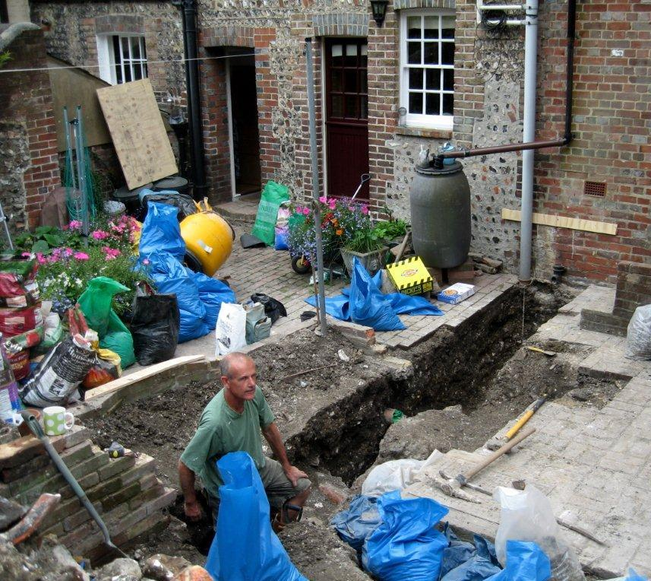
Lecture programme
This season’s talks, all at 7.30pm in the Town Hall lecture room, Lewes (Fisher Street entrance) are on:
Fri 30 September 2011
Wed 26 October 2011
Wed 30 November 2011
Wed 15 February 2012
Wed 21 March 2012
Fri 20 April 2012 (plus AGM)
See separate coloured insert for programme details, and please note that some talks are on Wednesdays.
Next lecture: Fri 30 Sept, 7.30pm
David Rudling, well known to many of us as Senior Lecturer in Archaeology at Sussex University, will talk on Bignor Roman Villa 1811 – 2011: 200 years of Archaeology and Tourism.
Discovered by ploughing in 1811, Bignor Roman Villa was one of Britain’s earliest heritage tourism attractions: the thatched buildings put up to shelter the fine mosaic floors are now protected in their own right.

Finds processing – don’t forget your toothbrush!
This summer we carried out an archaeological watching brief during building works behind a house at 7 Keere Street, Lewes. Close to the back of the former Britannia Inn at 9 Keere St, the new foundation trenches (see above) were dug into the former town ditch, once used for rubbish. As a result we now have several bags of interesting pottery sherds from the 17th/18th century onwards and a large quantity of butchered animal bone to analyse. Before we can ask our experts to take a look it all needs washing! This is a pleasant and sociable seated task involving brushing the finds gently with old toothbrushes and water, the best way to get closely acquainted with archaeological artefacts. You don’t need to have any previous knowledge at all.
If you would like to help please contact Anne on 01273 475381 or anne.locke@talktalk.net and we can arrange some convenient times. Interested children are welcome to come along too.
Annual membership runs from 1 April 2011 to end March 2012 and costs £5/£4 concessions
If there is a cross here
your membership for 2011/2012 is now due (according to our records). Thank you for your support.
You can renew or join at any of our meetings, or send a cheque
(payable to Lewes Archaeological Group) and sae to:
Brian Phillips, 2 Peronne Court, Uckfield, East Sussex, TN22 1BL (note change of address)
or by hand to:
Fiona Marsden, 13 Lansdown Place, Lewes, East Sussex, BN7 2JT (01273 473946).
NB if you have received this by email and are not sure if you have paid this year,
please email anne.locke@talktalk.net to check, or ask Brian at one of our meetings

Thoughts from the Chair
I am delighted to report that thanks to the kind donation of expertise by our computer programming member Bryan Creer we now have a functioning website at www.lewesarchaeology.org.uk. This is now a basic requirement for people wishing to find any organisation and we will be developing it to become more visual. Many thanks Bryan!
Following my report in the last newsletter on the financial pressures we face from increasing room hire and insurance costs, we had a constructive discussion at the AGM in April. The feeling of the meeting was that, while economies such as using more local speakers and more email distribution should be made, and publicity stepped up, subscriptions could be raised in line with other societies (e.g. to £8 or £10), and concessions should only be offered to the genuinely disadvantaged. Brian Phillips is keeping our accounts under review in the run-up to the next AGM to confirm how far we need to do this: in the meantime any donations and waiving of concessionary rates would be very welcome. I’d like to thank the 26 members who have already agreed to have their newsletters by email – this is saving us a substantial sum already.
Greg Chuter organised a few of us to carry out a resistivity (geophysics) survey of the lawn at the Pells Pool, Lewes, in April, to establish the precise position of the old Free Bath which used to be alongside the present pool. The results looked slightly unclear, probably indicating that it was backfilled with mixed, rubbly material, but it is evident from the survey and old maps that there would have been absolutely no room for sunbathing – archaeological evidence, perhaps, that lounging by the poolside was not a priority for 19th-century swimmers! Fiona Marsden is researching a history of the pool and I hope to include more on this in the next issue. Some of us also enjoyed joining the BHAS summer evening walk to Caburn and Helen Poole’s tour of Lewes Priory.
Finally I’m sorry to say that we have not yet been able to re-schedule the English Heritage talk on the Stonehenge Survey which we had to cancel because of snow last December. Both potential speakers remain uncertain about their posts at present: we wish them both well for when the organisation’s restructuring is completed in October and hope to welcome one of them next season. Meanwhile I hope that as many of you as possible will enjoy our season of talks and introduce your friends.
Anne Locke, Chair
73 Paddock Lane, Lewes BN7 1TW
01273 475381 anne.locke@talktalk.net
Alex’s mystery photographs, part 2
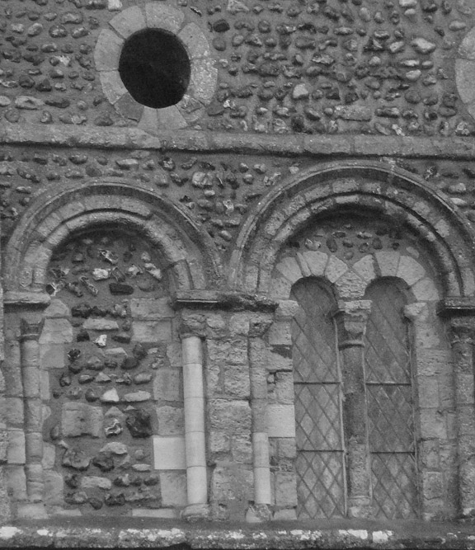
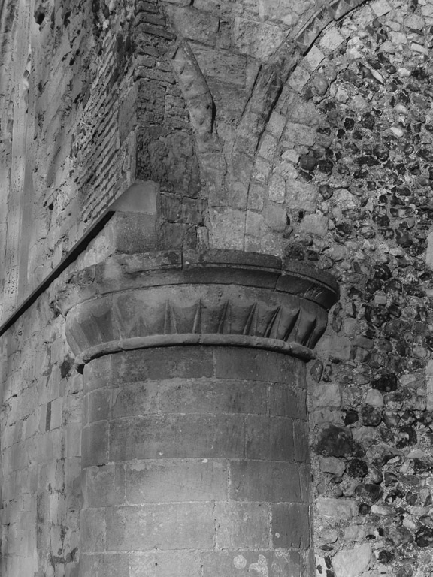

Our Secretary Alex Sutherland has drawn on her art history background to contribute the second our informative pictorial puzzles (answers at the bottom of the last page of this newsletter). Clue: Both are from fine but different early churches in the same Sussex town.

Picture 1
Picture 2
Starting imminently
Programme in Practical Archaeology 2011 – 2012
This part-time programme is ideal both for those who wish to begin in field archaeology, and also those who have experience as volunteers but who now wish to develop their practical skills and knowledge about how we can record and interpret the past from archaeological data. The programme comprises two core courses, Archaeological Survey and Archaeological Excavation and Post-Excavation (main tutor: David Rudling), that introduce you to some of the main fieldwork, scientific and interpretative methods involved in practical archaeology. An option course taken in the summer enables you to broaden your range of both practical and academic skills. Venue: University of Sussex at Falmer, Three or two terms (depending upon option chosen), Monday evenings, 7–9pm and some weekend day schools/field trips.
Starting Monday 3 October 2011.
www.sussex.ac.uk/cce/practicalarchaeology or 01273 678300.

Programme in Buildings Archaeology 2011 – 2012

News from CCE
Many members of this and other local archaeological societies have benefited enormously from attending archaeology and other courses at Sussex University’s Centre for Community Engagement (CCE, formerly the Centre for Continuing Education), whether attending day schools and evening classes to pursue an initial interest, or progressing to the Certificate in Practical Archaeology and to conducting their own fieldwork as part of the (now sadly discontinued) MA.
David Rudling, Senior Lecture in Archaeology, has continued to work very intensively to preserve a coherent programme in the face of rapid changes in government funding and higher education policy – which have already resulted in the closure of several other university extra-mural departments. The previous Certificate is resurrected as the Programme in Practical Archaeology, and 2011-12 will be the second year of an interesting new programme on Buildings Archaeology. There are also some intriguing short courses and day schools.
David will be giving the first of our autumn lectures, on Friday 30th September, and will be happy to receive any enquiries. We will have copies of the CCE brochures available, or see the CCE website www.sussex.ac.uk/cce/prospectivestudents, or tel 01273 678300.

This part-time programme is ideal both for those who wish to begin in buildings archaeology, and also those who have some experience but who now wish to develop their practical skills and knowledge about how we can record and interpret the past from standing buildings. The programme comprises three courses: Understanding Historic Vernacular Buildings (tutor: Mike Standing), Recording Historic Vernacular Buildings in South-East England (David Martin), and The Archaeological Investigation of a Church (Robert Hutchinson). Those students who successfully complete the spring term course will have matched the English Heritage requirements for its ‘Recording Level 3’. This Programme is recognised by the Institute of Historic Building Conservation for Continuing Professional Development.
Venues: University of Sussex, The Weald and Downland Open Air Museum at Singleton, and site visits. Three terms, various Saturdays, 10am–4 or 5pm. Starting Saturday 8 October 2011. www.sussex.ac.uk/cce/buildingsarchaeology or 01273 678300.
Fieldwork opportunities
The Sally Christian Archaeology Bequest
Funding may be available for practical archaeology training through a fund set up by the late Sally Christian, a former CCE student.
Further details about the fund and how to apply can be obtained from David Rudling d.r.rudling@sussex.ac.uk or 01273 873527.
Brighton and Hove Archaeological Society (BHAS) invite volunteers to join their field unit on weekend work in and around Brighton. No experience necessary. Contact Norman Phippard 01273 671608 or John Funnell 01273 607127, or see the BHAS website www.brightonarch.org.uk

Mid-Sussex Field Archaeology Team (MSFAT) often has opportunities for weekend volunteers at local sites – including excavation, finds processing, field walking and resistivity surveys. No experience necessary. Membership £8. Chris Butler 01323 871021, website www.msfat.com

The Tidemills Project is a community project open to all, engaged in both historical research and on-site survey and recording of this important site between Newhaven and Seaford, usually on Thursdays. Contact Luke Barber on 01273 405733 or email research@sussexpast.co.uk
Talks and events 2011–2012
See separate sheet for details of LAG lectures.
Fri 30 Sept LAG: Bignor Roman Villa 1811 –
Lecture Room, 2011 with David Rudling
Lewes Town
Hall, 7.30pm
Sun 2 Oct Tudor Day with family activities
Anne of Cleves all round the house. Normal
House, Lewes admission prices. 11am – 4pm
Thu 13 Oct USAS: The Archaeology of
Fulton A Blg Hong Kong with Professor
University of Emeritus Peter Drewitt.
Sussex, 7pm FREE, all welcome.
Fri 14 Oct BHAS: A Tale of Two
Unitarian Ch, Cities: Pompei and Herculaneum
New St, B’ton with Michael Hughes. 7.30pm.
Fri 21 Oct Friends of Anne of Cleves House
Anne of Cleves The Phoenix Iron Works talk
House, Lewes and AGM 7.30pm.
Wed 26 Oct LAG: Medieval Discoveries in
Lecture Room, the Cuckmere Valley with local
Lewes Town archaeologist Peter Bidmead
Hall, 7.30pm
Fri 11 Nov BHAS (title TBC) with
7.30pm, Professor Chris Stringer, research
Unitarian Ch. leader in human origins at the
New St, B’ton Natural History Museum.
Fri 11 Nov ENHAS: New Research on Chalk
7.30pm, Downland with Dr Michael Allen
WRVS, Hyde environmental archaeologist and
Rd, E’bourne geoarchaeologist.
Sat 12 Nov CBA South East conference
10am – 5pm, Policing the Past. Details on
University of www.sussex.ac.uk/cce or
Sussex 01273 678300. £20
Thu 17 Nov USAS: The Great Escape
Fulton A blg – the history and archaeology of
University of Stalag Luft III with Dudley
Sussex Moore. 7pm, £3.
Wed 30 Nov LAG: Beyond Piltdown: Ice Age
Lecture Room, Archaeology in the Ouse Valley
Lewes Town with Dr Matt Pope.
Hall, 7.30pm
Fri 9 Dec BHAS members talks, AGM and
7.30pm, Uni- Christmas social, all welcome.
tarian Ch. , New St, B’ton
Fri 13 Jan BHAS: South-east Shanty
Unitarian Ch. Towns: track and shack,
BHAS Brighton & Hove Archaeological Society
CBA Council for British Archaeology
ENHAS Eastbourne Natural History and Archaeological Society
LAG Lewes Archaeological Group
SAS Sussex Archaeological Society
USAS University of Sussex Archaeological Society
New St, B’ton hutments and plotlands: informal landscapes of settlement in the south-east with Geoff Mead.
Fri 10 Feb BHAS: The Archaeology
Unitarian Ch, of Libya with Dr Paul Bennett,
New St, B’ton Director of Canterbury Archaeo-
7.30pm logical Trust.
Wed 15 Feb LAG: Barcombe Roman Bath-
Lecture Room, house and its surroundings
Lewes Town with David Millum.
Hall, 7.30pm
Fri 9 Mar BHAS: Piety in Peril: the
Unitarian Ch, archaeology of Reformation
New St, B’ton church monuments in Sussex
7.30pm with Bob Hutchinson.
Wed 21 Mar LAG: Gold and Garnets: Anglo-
Lecture Room, Saxon metalwork and its cultural
Lewes Town setting with Judie English.
Hall, 7.30pm
Fri 13 Apr BHAS: Palaeolithic
Unitarian Ch, Cave Art: with Dr Liz Somerville,
New St, B’ton University of Sussex.
7.30pm
Sat 14 Apr SAS Conference The Battle of
Lewes Town Lewes, a conference with leading
Hall, 10am – experts, in the run-up to the 750th
5pm, £30 anniversary. 01273 405737 or see www.sussexpast.co.uk
Fri 20 Apr LAG: Landed estates and farm
Lecture Room, formation on the Downs around
Lewes Town Lewes c. 1750 – 1930 (title TBC)
Hall, 7.30pm with Dr Sue Berry, to be followed by the AGM at around 9pm.
The Lewes History Group holds talks on the second Monday of the month at 7.30pm, at King’s Church, Lewes (between Homebase and Tesco). It was launched in 2009. A project progress group meets on the third Monday of the month, for members carrying out local research and those interested in participating. Details 01273 813388 or email John Kay at johnkay56@googlemail.com.

Next newsletter: March 2012. Contributions to Anne by end February please (contact details front page).
Alex’s mystery photographs
Picture 1 is of a Norman window – some say earlier – at St Nicolas’ church, Old Shoreham.
Picture 2 is a door pillar at St Mary de Haura, Shoreham, dating from c. 1100 – 1225.

