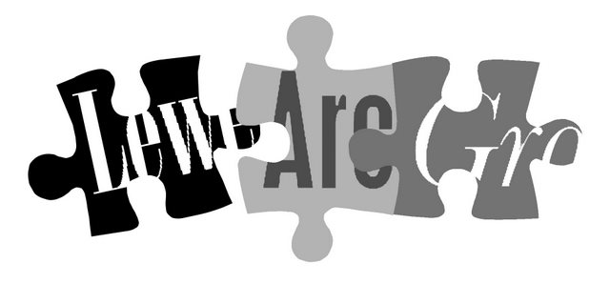
No. 141
September 2010
Affiliated to the Sussex Archaeological Society
and the Council for British Archaeology

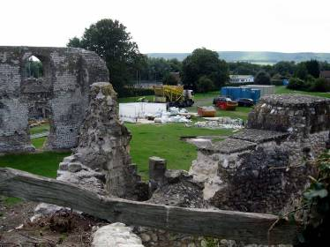
Lecture programme
This season’s talks, all at 7.30pm in the Town Hall lecture room, Lewes (Fisher Street entrance) are on:
Fri 1 October 2010
Wed 3 November 2010
Wed 1 December 2010
Fri 4 February 2011
Wed 2 March 2011
Fri 15 April 2011 (plus AGM)
See separate coloured insert for programme details, and please note that some talks are on Wednesdays.
Annual membership runs from 1 April 2010 to end March 2011 and costs £5/£4 concessions
If there is a cross here
your membership for 2010/2011 is now due (according to our records). Thank you for your support.
You can renew or join at any of our meetings, or send a cheque
(payable to Lewes Archaeological Group) and sae to:
Brian Phillips, 51 Manor Way, Uckfield, East Sussex, TN22 1DQ
or by hand to:
Fiona Marsden, 13 Lansdown Place, Lewes, East Sussex, BN7 2JT (01273 473946).

Next lecture: Fri 1 October, 7.30pm
Another return to East Sussex for Martin Brown, Ministry of Defence archaeologist and former chairman of this group, to talk on Digging up Plugstreet: the archaeology of a Great War battlefield.
In 1916 soldiers from Australia trained on Salisbury Plain before going to fight in Flanders. Martin and other archaeologists from the ‘No Man’s Land’ group have been following them from training to combat, seeking evidence of the men and exploring the landscapes they inhabited.

Lewes Priory restoration works
As many of you will know, the Lewes Priory Trust has obtained a major Heritage Lottery Fund grant to make the Lewes Priory remains safe and open them up for public access and interpretation. The panels will feature extensive new reconstruction drawings from our member Andy Gammon.
During September a few of us were invited by the site manager, Sy Morse-Brown, to join a small tour while scaffolding was up giving access to the top of the reredorter. This is the largest surviving structure on site – the monks' multi-storey lavatory block. It was fascinating to see the work that is going on to stabilise the walls, using traditional lime mortar in place of previous cement repairs, and the features being re-discovered.
The site will re-open to the public in November, and you can view progress on the Trust’s new website www.lewespriory.org.uk
Thoughts from the Chair
I hope that all those who wanted to have been out and involved in the many fieldwork opportunities in the area this summer. Barcombe Roman Bathhouse is looking like the largest rural bathhouse ever found outside military sites like Hadrian’s Wall, and is ever more intriguing.
Historic Character Assessments
I still have some copies on CD, supplied by Greg Chuter of East Sussex County Council, of the historic character assessment reports for Lewes, Ditchling, Newhaven, Peacehaven and Seaford completed by Roland B Harris in 2005.
This is part of the Sussex Extensive Urban Survey that examines 41 towns across the ancient county and forms part of a national programme initiated by English Heritage in 1992. The reports, in pdf form, include summaries of the setting, archaeology and history of each town, drawing on existing work, as well as Dr Harris’s characterisations of the built environment in different areas of the towns, numerous photographs and historic maps, and suggestions for future research questions. These questions – see below – should give a wealth of inspiration to anyone considering a project on the historic environment of Lewes or other Sussex towns.
If you would like a CD please contact me on 01273 475381 or anne.locke@talktalk.net
Anne Locke
My apologies for a rather late newsletter, and for the absence of the usual March one. I have been doing two, sometimes three jobs in parallel since the spring and simply have not had time to write or chase up contributions. Hopefully we will find a way round this problem in the coming year (see below – contact me if you’d like to discuss).
One of my jobs has been a maternity cover role at the English Heritage headquarters in London, a most interesting experience. I was in the same room as the authors of the new Planning Policy Statement 5, Planning for the Historic Environment, as they awaited news as to whether it would get published at the final possible moment before ‘election purdah’ took effect. Eventually it was, to great rejoicing. This statement merges two previous planning documents to promote a ‘holistic’ approach to the historic environment, rather than drawing a sharp line between historic buildings and buried archaeology. The original sense of archaeology (as in the name of this group) always encompassed standing buildings and history, so in a sense the government has now caught up!
Anne Locke, Chair
73 Paddock Lane, Lewes BN7 1TW
01273 475381 anne.locke@talktalk.net

How you can help
There are a couple of roles where I would really welcome some help. Volunteers would be invited to join our committee, but wouldn’t be obliged to.
Newsletter editor: someone to produce a newsletter twice a year, one before the April AGM and one before the talks start in the autumn. You could use the pre-existing word template (or apply your creativity to develop a new format). Articles would be supplied, but you will need to chase authors up sometimes. You’d also need to arrange photocopying and envelope stuffing though help could be available with this. The membership coordinator would keep the existing excel tables of members’ contact and subscription details up to date (on the basis of information supplied by the treasurer), report membership figures to the committee (three times a year) and transcribe any new or changed addresses onto the label list, currently in word.

Excavations in Lewes
Archaeology South East is working on the vast task of pulling together the findings from the major development excavations in Lewes in recent years: Baxter’s, Lewes Library and Lewes House. Luke Barber will be analysing the hundreds of boxes of pottery, and this job alone is estimated at 80 days. The final report will be in the form of a combined monograph, or stand-alone volume, and we hope there will also be an accessible summary aimed at the general public.
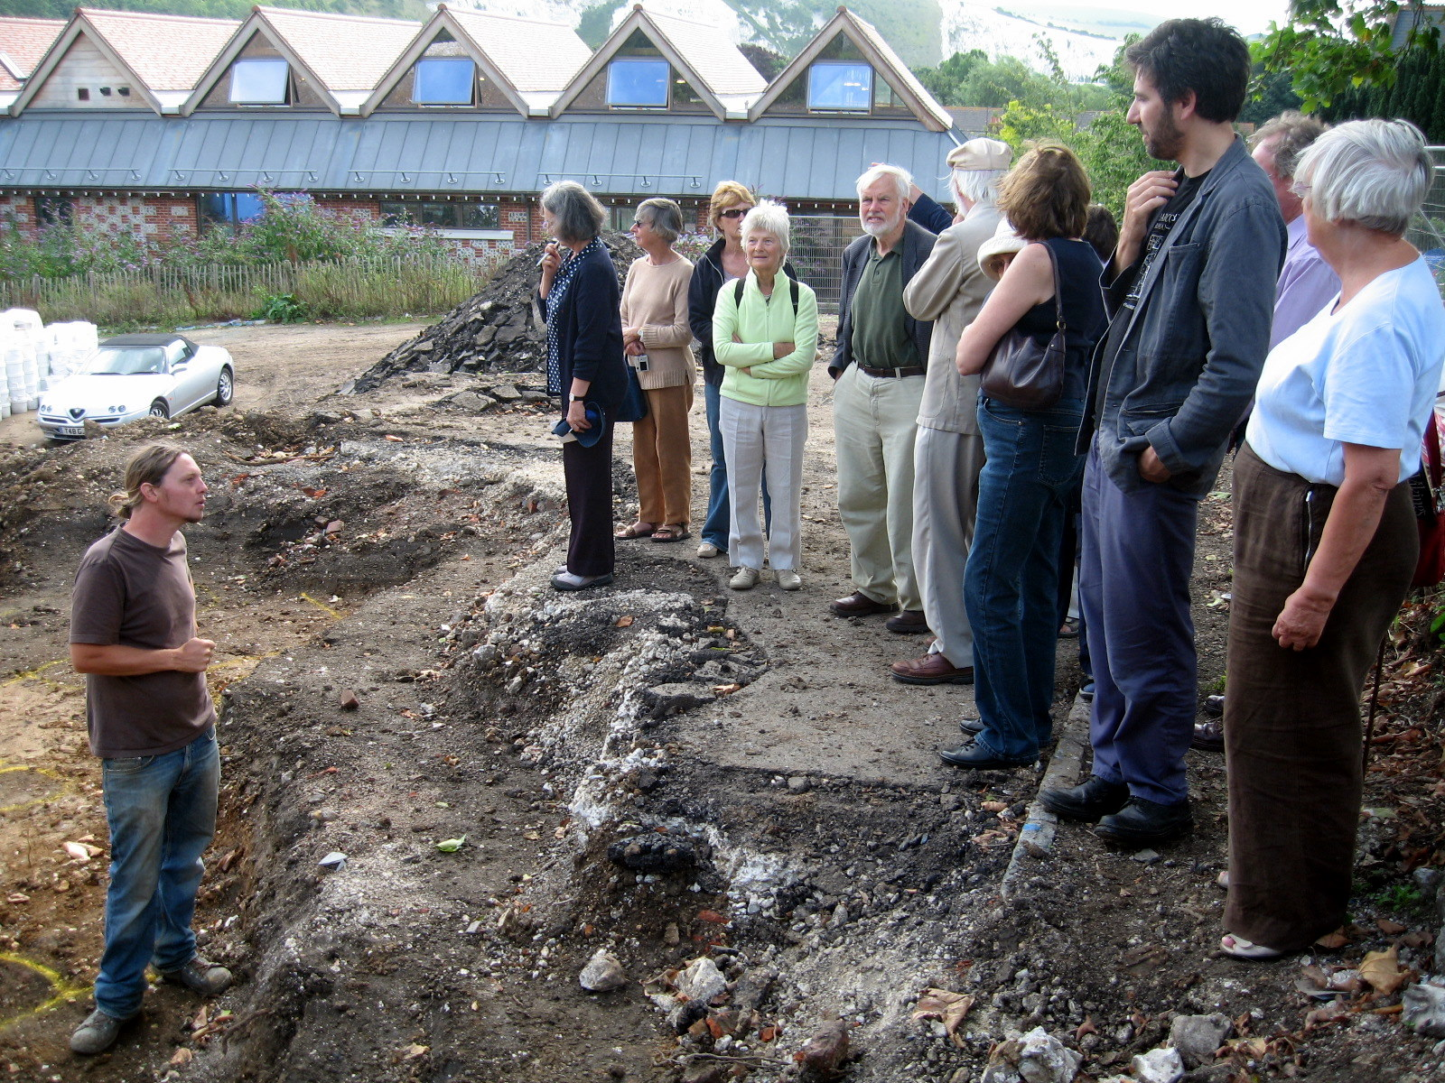
It would have been almost inconceivable ten years ago, but we have now had a substantial wedge of the historic core of the town excavated, and look forward eagerly to hearing about the final results, hopefully in next season’s lecture programme.
Our visit to the Lewes Library excavation in 2008
Saturday Day Schools (held on campus at Falmer unless stated otherwise)
- 25 September: Wild Foods [discover and sample at Arlington] (Ian Dunford & Anna Richardson)
- 9, 16, 23 & 30 October: Hunters and Landscapes of Ice Age Sussex (Matthew Pope)
- 9 October – 12 February (8 Sats): Exploring the Roman World: History and Culture [at Fishbourne] (Keith Robinson & Gillian Partington)
- 6 & 20 November: Animal Bones [an introduction] (Sarah Green)
- 13 November: What the Public Thinks about Archaeology and Why it Matters (Anne Locke) – your own Chair’s first public day school. It is based on her MA course in Public Archaeology and her experiences working in government and with a project involving ethnic minorities in archaeology.
The Sally Christian Archaeology Bequest
Funding may be available for practical archaeology training through a fund set up by the late Sally Christian, a former CCE student.
Further details about the fund and how to apply can be obtained from David Rudling d.r.rudling@sussex.ac.uk or 01273 873527.
Many other day courses follow in 2011: see www.sussex.ac.uk/cce/prospectivestudents/
shortcourses/subject
Continuing Education Programme in Buildings Archaeology

News from CCE
Archaeology courses at Sussex University’s Centre for Community Engagement (CCE, formerly the Centre for Continuing Education) are continuing, though as the re-branding suggests there have been some changes in the courses and costs, with more open courses and day schools now than award-bearing courses.
Many members of this and other local archaeological societies have benefited enormously from CCE, whether attending day schools and evening classes to pursue an initial interest, or progressing to the Certificate in Practical Archaeology and to conducting their own fieldwork as part of the (now sadly discontinued) MA.
David Rudling, Senior Lecture in Archaeology, and his CCE colleagues have been working very intensively over the past year or so to preserve a coherent programme in the face of rapid changes in government funding and higher education policy – which have already resulted in the closure of several other university extra-mural departments. The previous Certificate is resurrected as the Continuing Education Programme in Practical Archaeology, and there is an interesting new programme on Buildings Archaeology, as well as some intriguing Saturday day schools at £50 (£25 concessions for those on income-related benefits).
We will have copies of the CCE Short Courses and day schools brochure available at the autumn lectures, or see the CCE website www.sussex.ac.uk/cce/prospectivestudents/shortcourses/subject, or tel 01273 678300.

This new one year part time programme of study for 2010/11 entry will increase your knowledge of the fabric, form and context of historic buildings in Sussex and teach you how to record and interpret them. Building recording skills are taught to English Heritage Levels 2 and 3. The Programme comprises three courses:
- Understanding Historic Vernacular Buildings (Mike Standing)
- Recording Historic Vernacular Buildings in South-East England (6 Saturday sessions; David Martin) and
- The Archaeological Investigation of a Church (4 Saturday sessions; Robert Hutchinson).
Two of the courses can be taken as stand-alone/CPD modules.
60 credits at undergraduate level 1 or 2.

Continuing Education Programme in Practical Archaeology
Hands-on fieldwork and workshop exercises combine with more traditional classroom teaching to enable you to develop a working knowledge of modern archaeology and its methods. This two year part time programme of study comprises:
- Archaeological Survey (David Rudling)
- Archaeological Excavation and Post-
Excavation (Chris Butler)
- The Recording and Analysis of the Archaeology of Past Societies (Caroline Wells)
- Artefacts and Pottery (various tutors) and an Option course.
120 credits at undergraduate level 1 or 2. Ideal CPD training for commercial site assistants, amateurs, etc, this programme will enable participants to gather much of the evidence needed for the National Occupational Standards Level 3 Qualification in Archaeological Practice.

Applications for F/T or P/T MPhil or DPhil archaeology research degrees are welcome.
Contact: Centre for Community Engagement, University of Sussex, Falmer, Brighton, BN1 9RF; 01273 678300; cce@sussex.ac.uk; www.sussex.ac.uk/cce/prospectivestudents/cep

Fieldwork opportunities
Brighton and Hove Archaeological Society (BHAS) invite volunteers to join their field unit on weekend work in and around Brighton. No experience necessary. Contact Norman Phippard 01273 671608 or John Funnell 01273 607127, or see the BHAS website www.brightonarch.org.uk

Mid-Sussex Field Archaeology Team (MSFAT) often has opportunities for weekend volunteers at local sites – including excavation, finds processing, field walking and resistivity surveys. No experience necessary. Membership £8. Chris Butler 01323 871021, website www.msfat.com

The Tidemills Project is a community project open to all, engaged in both historical research and on-site survey and recording of this important site between Newhaven and Seaford, usually on Thursdays. Contact Luke Barber on 01273 405733 or email research@sussexpast.co.uk

Talks and events 2010–2011
See separate sheet for LAG lecture list.
USAS talks are being finalised as we go to press: contact Lisa Fisher for details on Lisa@prehistorygirl.freeserve.co.uk
Sun 3 Oct Tudor Day with family activities at Anne of Cleves House, details 01273 474610 or www.sussexpast.co.uk

Fri 8 Oct BHAS lecture: East Sussex Under
7.30pm, Attack: the archaeology of local
Unitarian Ch, defensive sites, with Chris Butler.
New St, B’ton

Fri 8 Oct Friends of Anne of Cleves House
Anne of Old Inns of Lewes with John
Cleves House Davey/AGM 7.30pm.

Mon 11 Oct Lewes History Group
The new Lewes History Group holds talks on the second Monday of the month at 7.30pm, at King’s Church, Lewes (between Homebase and Tesco). It was launched last year by John Kay of the Ringmer History Study Group. A project progress group meets on the third Monday of the month, for members carrying out local research and those interested in participating. Details 01273 813388 or email John at johnkay56@googlemail.com.

7.30pm, King’s Lewes Priory: its wealth and
Church, Lewes influence with Graham Mayhew.

Wed 27 Oct Narnia Day with family activities at Michelham Priory, details 01323 844224 or www.sussexpast.co.uk

Thu 28 Oct USAS talk, 7pm, Falmer (TBC)
Mon 8 Nov Lewes History Group Gems
7.30pm, King’s Lewes Architecture and Design
Church, Lewes 900-1900 with Colin Brent.

Fri 12 Nov BHAS lecture: Underwater
7.30pm, Archaeology (possibly the Ouse
Unitarian Ch. Valley Project, with Ted
New St, B’ton Crosbie.

13/14 Nov Christmas Gift and Craft Fair at Michelham Priory, details 01323 844224 or www.sussexpast.co.uk

Fri 19 Nov Friends of Anne of Cleves House
Anne of Quaker Personalities in Lewes
Cleves House with David Hitchin and Joyce Fisher, 7.30pm.

Fri 10 Dec BHAS AGM and
7.30pm, Christmas social,
Unitarian Ch. non-members welcome.
New St, B’ton

Mon 13 Dec Lewes History Group
7.30pm, King’s Lewes Castle 1600-1850
Church, Lewes with John Farrant.
BHAS Brighton & Hove Archaeological Society
CCE Centre for Continuing Education, University of Sussex
LHG Lewes History Group (see bottom right)
SAS Sussex Archaeological Society
USAS University of Sussex Archaeological Society
Fri 14 Jan BHAS Lecture:
7.30pm, Prehistoric and Roman
Unitarian Ch. Brighton and Hove with
New St, B’ton David Rudling (as postponed from last Jan).

Fri 11 Feb BHAS lecture: Intertidal
7.30pm, Archaeology on the Thames: with
Unitarian Ch, Dr Fiona Haughey, Director of
New St, B’ton Archaeology on the Thames Project.

Fri 11 Mar BHAS lecture: King Arthur: the
7.30pm, Truth at Last: Dr Miles Russell.
Unitarian Ch,
New St, B’ton

Fri 8 April BHAS lecture: The Iron Industry
7.30pm, in the Weald: with Jeremy
Unitarian Ch, Hodgkinson.
New St, B’ton

