
No. 140
September 2009
Affiliated to the Sussex Archaeological Society
and the Council for British Archaeology

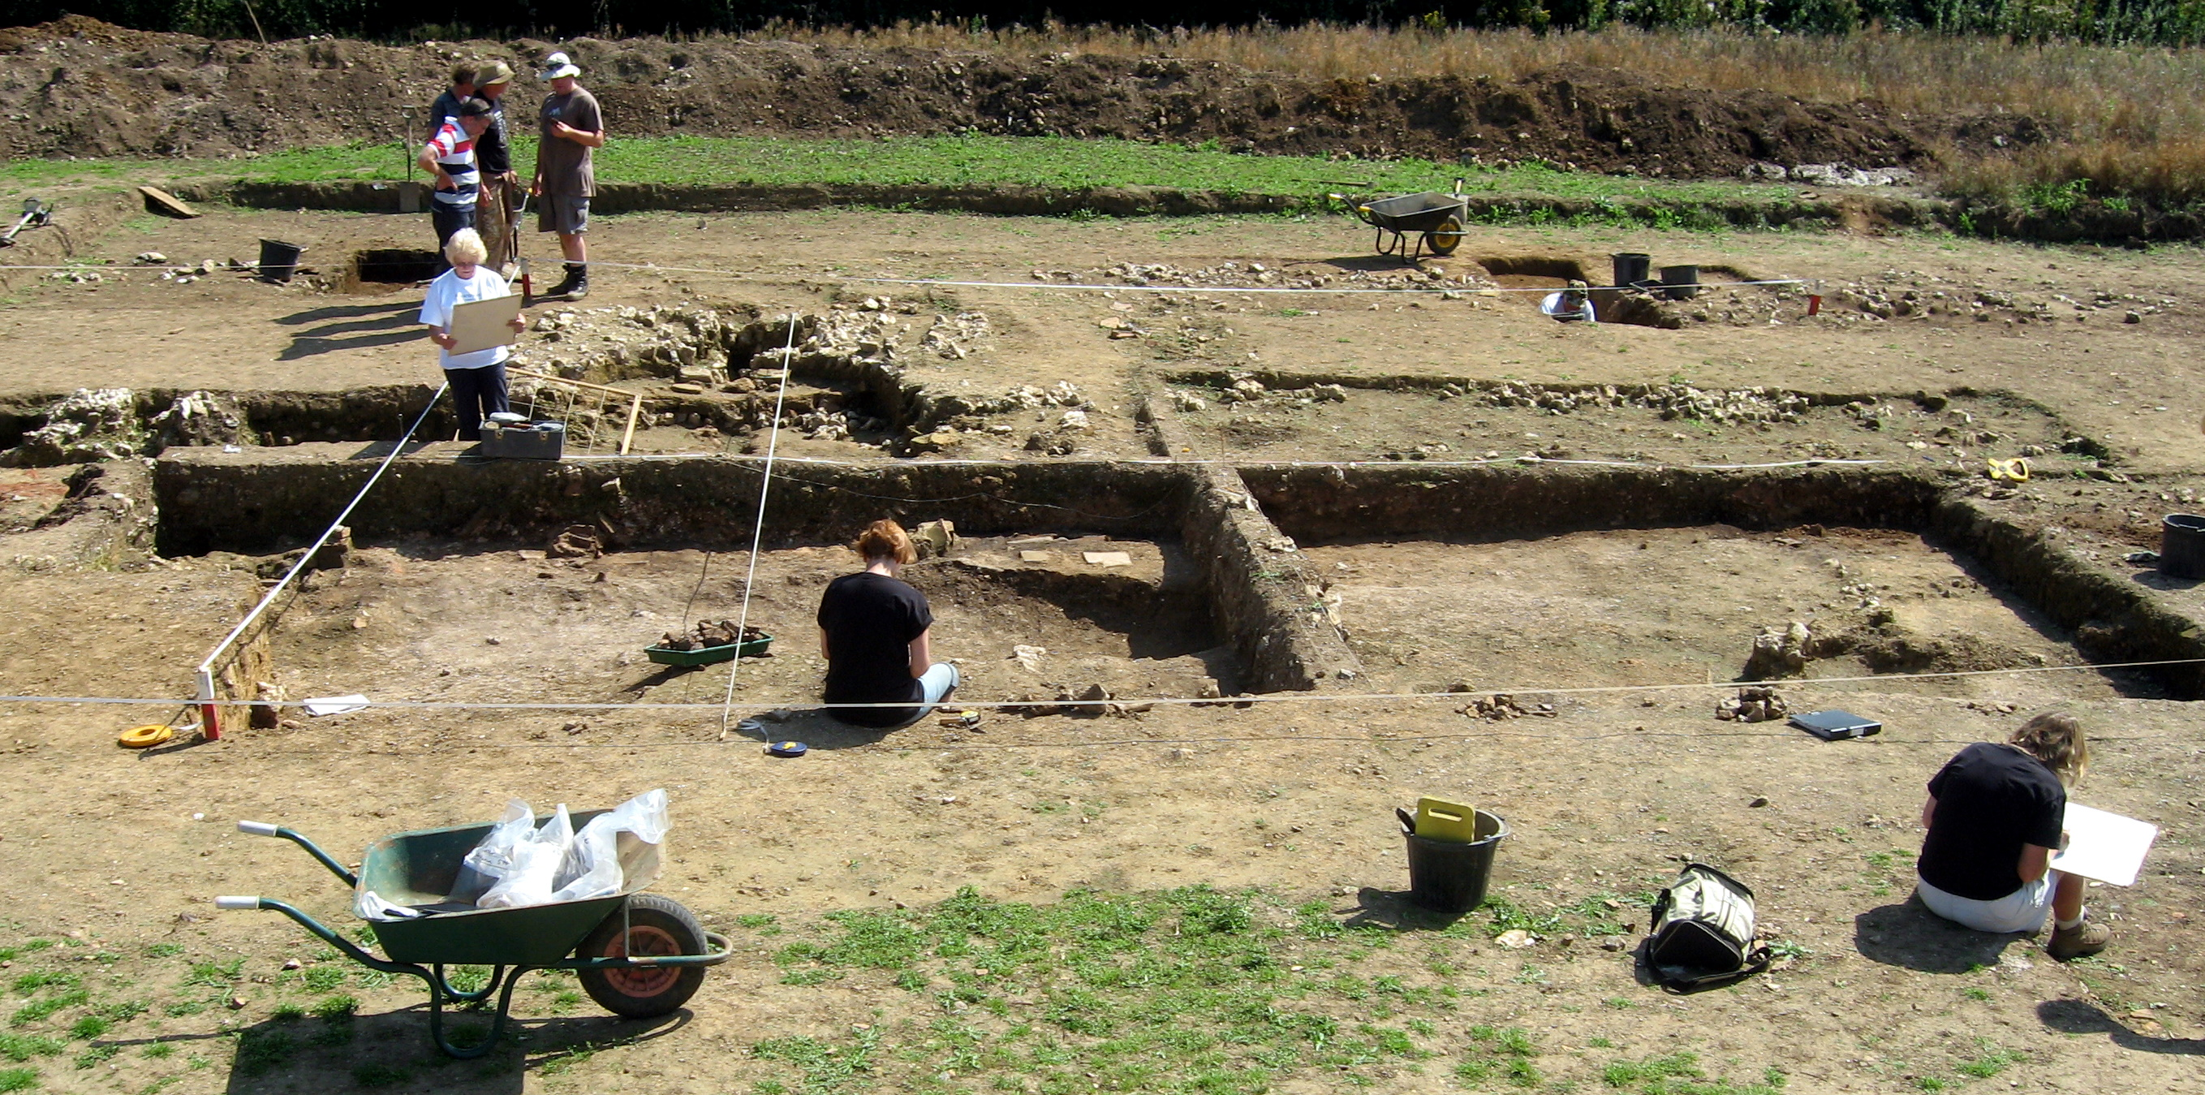
Lecture programme
This season’s talks, all at 7.30pm in the Town Hall lecture room, Lewes (Fisher Street entrance) are on:
Fri 25 September 2009
Wed 28 October 2009
Wed 25 November 2009
Fri 29 January 2010
Wed 10 March 2010
Fri 23 April 2010
See separate coloured insert for programme details, and please note that some talks are on Wednesdays.
Annual membership runs from 1 April 2009 to end March 2010 and costs £4/£3 concessions
If there is a cross here
your membership for 2009/2010 is now due (according to our records). Thank you for your support.
You can renew or join at any of our meetings, or send a cheque
(payable to Lewes Archaeological Group) and sae to:
Brian Phillips, 51 Manor Way, Uckfield, East Sussex, TN22 1DQ
or by hand to:
Fiona Marsden, 13 Lansdown Place, Lewes, East Sussex, BN7 2JT (01273 473946).

Next Lecture: Friday 25 September 2009, 7.30pm
A return to East Sussex for Martin Brown, formerly Assistant County Archaeologist (and chairman of this group), to talk on Battle Tanks and Burial Grounds, or his extremely varied experiences in his present job as Ministry of Defence archaeologist across southern England. As some of you will recall, this is the talk originally scheduled for last February and cancelled because of snow.
NB Friday 25 is correct – not Friday 23 as in the SAS Past and Present newsletter.

Barcombe Roman Site – latest news, Sat 12 Sept
On Saturday, 12 September project leaders David Rudling and Rob Wallace will be leading a walk and talk on the Barcombe Roman landscape taking in the bath-house, the Roman road (reportedly ‘stupendous’) and new investigations into archaeology at the Ouse. Meet at 11am at the car park by Barcombe church. The whole walk will take about two hours and include stiles and rough grassland, but the bath house itself is very near the car park. No charge, but donations towards excavation costs welcome.

Whitehawk Enclosure open day, Sun 20 Sept
The outstanding Neolithic causewayed enclosure at Whitehawk Hill, East Brighton, is the focus for displays, activities and tours on Sunday, 20 September from 10am to 4pm to bring alive the archaeology and wildlife of this often neglected site and show visitors how they can get involved. Prehistory expert Dr Matt Pope of University College, London and Brighton and Hove Archaeological Society will be on hand to explain things.
The family-friendly event will be signposted from the top of Manor Hill and Freshfield Road, East Brighton. For a map and more information see www.ucl.ac.uk/caa/whitehawk
Thoughts from the Chair
I hope that you have enjoyed your summer breaks and that all those who wanted to have been out and involved in the many fieldwork opportunities in the area this summer.
It’s been some years since this group launched a new project itself, apart from small watching briefs. In some ways this isn’t a problem, when there is so much else going on. Many of our members are very active in other societies’ fieldwork, and nobody wants to become over-extended and fail to complete a project.
However if we are perceived simply as an ‘armchair’ or ‘walks-and-talks’ organisation we may be missing out on being more involved with discoveries taking place in our own area and on attracting and keeping potential new members. We usually have around 60 members, with a few very welcome new recruits recently, but it’s mostly the same loyal people. We are most grateful to them, but it’s not realistic to depend upon them indefinitely to keep the Group going.
Some of you have already been in touch with about joining in with short-notice opportunities such as field walking with ESCC archaeology section, and we’re investigating the idea of doing some walkover surveys in the Pells to complement Fiona Marsden’s historical research. Please do keep in touch if you are interested.
As you will see from the enclosed programme, we have some very interesting lectures for 2009–2010, including the re-scheduled talk by Martin Brown, a report by Peter Drewett on his excavations in the Caribbean, and several speakers recommended by new committee member Sabrina Harcourt-Smith who has heard them herself in London.
As last year, our lecture season includes some Wednesday evening dates as well as Fridays. This is a compromise: some members prefer Fridays, others have commented that they would rather keep them free for family, socialising or film nights. I find Wednesday dates mostly easier to arrange, as they don’t clash with other societies such as Brighton and Hove or the Ringmer History Study Group, and the Town Hall is less booked up – but some speakers from further afield may prefer Fridays. Anyway, I hope that the present arrangement will suit most of you.
Very best wishes,
Anne Locke, Chair
73 Paddock Lane, Lewes BN7 1TW
01273 475381
anne.locke@talktalk.net
Rapa Nui: Landscapes of Construction
Dr Sue Hamilton’s lecture in April introduced her project on the iconic archaeology of the remotest inhabited place on earth – Rapa Nui (Easter Island). This work is the first British archaeological research project on Rapa Nui since Katherine Routledge’s pioneering expedition which departed from Falmouth on the 25th March 1913 in the specially build 27 m-long Schooner named Mana.
The Rapa Nui Landscapes of Construction Project is jointly directed by Sue Hamilton (UCL London) and Colin Richards (University of Manchester) in co-ordination with Rapa Nui colleagues. The project seeks to re-examine the quarrying and construction process associated with the island’s colossal statues (moai), and with the ceremonial platforms (ahu) on which they are set up – activities that have a dating centring on the 12th-16th centuries AD. The project offers a distinctively different approach to previous and current work on the Island. It uses an integrated landscape approach which combines mutiple science-based survey and recording techniques – Global Positions Satellite Mapping, Deep Ground Penetrating Radar, Laser Scanning, Geophysical Survey, with walk-over survey and excavation on an island-wide basis. There are over 1000 statues, most of them quarried from the Rano Raraku volcano. The lecture covered the issues of meaning that the construction these massive statues raises from their quarrying in volcanoes, to their transport along roads, and their ultimate setting-up on ahu, with their backs to the sea. It is only at the ceremonial platforms that the moai are then given eyes which gaze over the ahu landscapes of elite houses and the more everyday settlement structures chicken houses, ovens and rock gardens beyond. Many of the moai are adorned with monumental red scoria hats and we were given the results of the project’s recent excavations in January/February 2009 at the statue hat quarry at the Puna Pau volcano. The lecture began and ended with a consideration of Rapa Nui’s past and present connections with the outside world(s) and their past and present consequences – accompanied by a recording of Rapa Nui music.
Dr Sue Hamilton, Institute of Archaeology, UCL

Next newsletter, March 2010
If you have any articles, listings, comments or fieldwork opportunities for the next issue, please send them to me by
1 February 2010.
Anne Locke (see opposite)

Excavations at North Street car park
Readers of the local press might think that archaeological requirements were entirely to blame for the closure of the public car park at North Street so far in advance of any visible progress on the development of Lewes’s new Police Station. In fact the initial investigations by Thames Valley Archaeological Services were completed over a couple of weeks in April 2009.
The pictures below show the footings of the walls of some of the cells from the former prison here. This was originally a late 18th century ‘house of correction’, extended in the 1830s and 1840s, and acted as the main county gaol from 1845 to 1853, when it was replaced by the present Lewes prison. It housed Crimean prisoners of war from Finland (1854-6), and became a naval prison until 1910. The Territorial Army later used the main buildings, and it was demolished in 1963.
Greg Chuter, Martin Brown’s successor as Assistant County Archaeologist at East Sussex County Council and an ex officio member on our committee, has some excellent volunteer placements which would suit those looking for some experience in working with modern historic environment records systems and interested in the ‘grey literature’ resulting from archaeological investigations carried out through the planning system, like the one at like North Street car park.

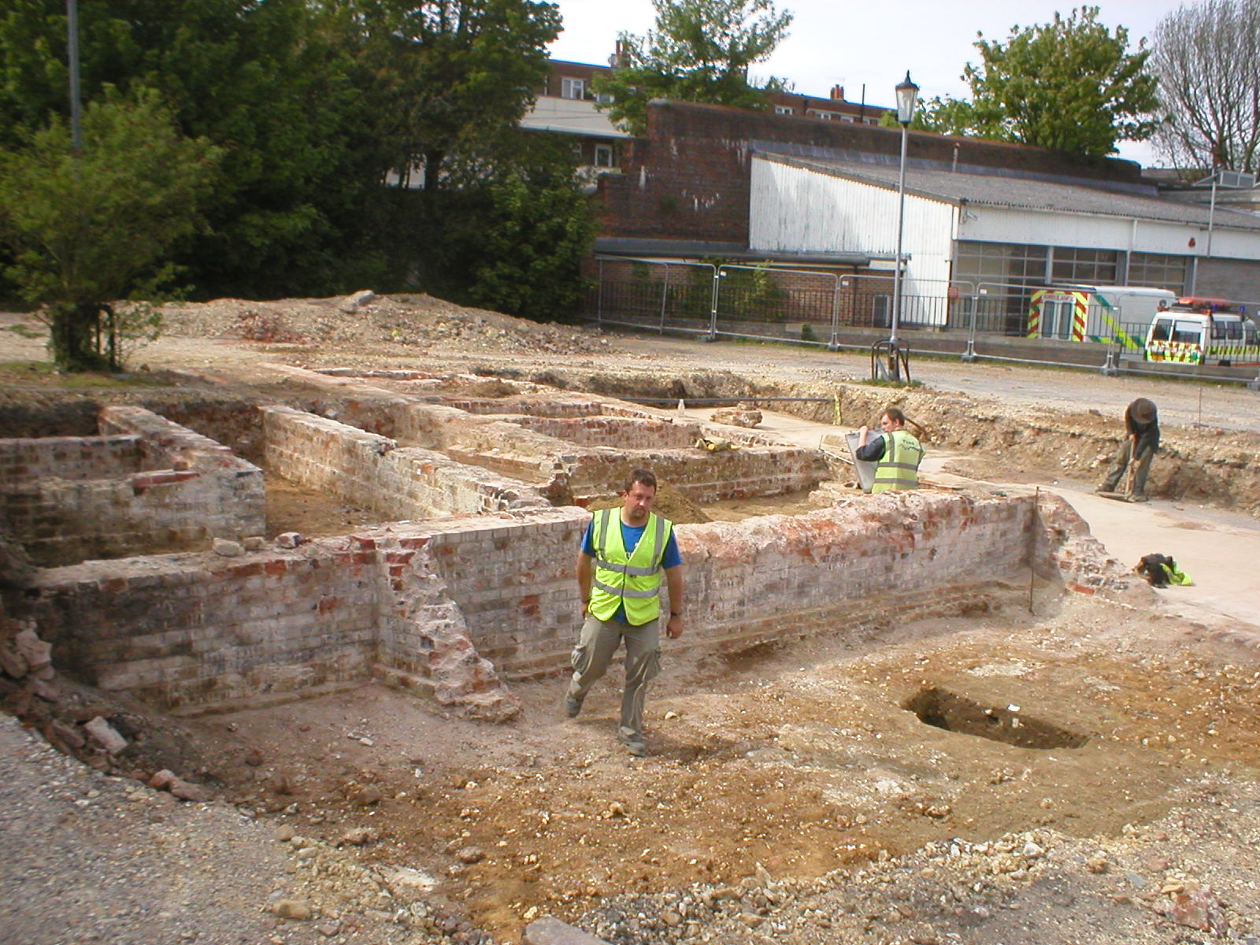
Excavations showing the cells of the former prison
Archaeologists might have looked forward to finding artefacts left by prisoners over the years, but the site in fact looked remarkably clean of any debris at all, perhaps suggesting a very thorough, military-style sweep-out before demolition.
Medieval pit underlying a wall of the old North Street prison (photos: Greg Chuter)
Underneath the prison walls were found some earlier pits containing medieval pottery. Similar pits were found during earlier excavations in the North Street area. The precise dating of the contents and any further discoveries once construction starts may help establish when the area was first settled and whether it was an inhabited suburb throughout the medieval period, or was abandoned after the Black Death as has previously been conjectured.
A full report will be lodged with the County Archaeologists and entered on the East Sussex Historic Environment Record – see below, and we hope to be able to arrange a site visit for members.
Anne Locke
New volunteering and training
opportunities with East Sussex County Council
Here in the ESCC Archaeology Section we are looking for some volunteers with a good knowledge of their local area to help add archaeological reports to the computerised Historic Environment Record (the HER, formerly known as the Sites and Monuments Record or SMR).
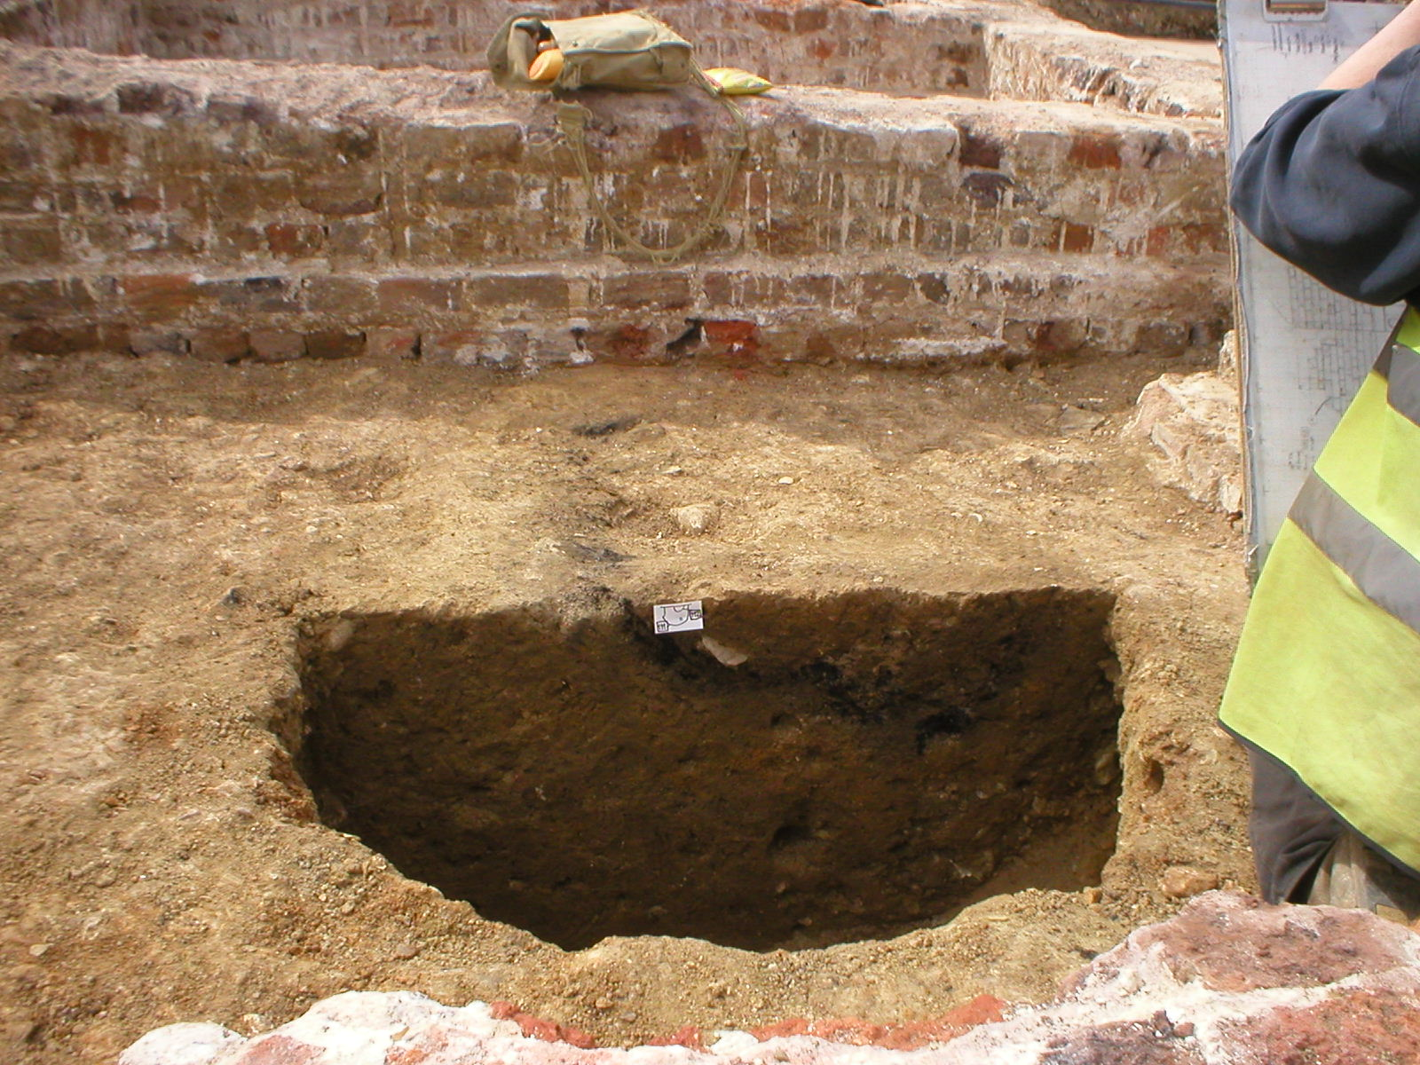
We are working through reports from archaeological work such as watching briefs and excavations carried out through the planning system, summarising them and linking them to our electronic map or Geographical Information System (GIS). We’d provide training which would give you a very good introduction to modern archaeological software and how HER records are kept. You'd also get access to the most up-to-date archaeological information about your area and make a great contribution to the important work of making this more available.
You wouldn’t need previous experience of using the HER or GIS, but you’d need general computer skills like using a mouse, Word and Excel and locating files on a network. If you’ve used Google Earth or processed your digital photographs you’ll probably find it relatively straightforward to pick up.
Other qualities we’re looking for – and we know there are plenty of people with them out there in our local societies – are:
- local knowledge of the history/archaeology of an area of East Sussex and/or Brighton and Hove
- writing skills; ability to summarise complex information in comprehensible English
- archaeological knowledge; familiarity with archaeological terms and interpreting archaeological reports
- familiarity with large-scale OS mapping (interpreting contours, field boundaries etc accurately) and a good understanding of grid references.
Because we need access to the HER system the work would have to be during the day Monday-Friday at County Hall, Lewes – but within this days and hours can be arranged to suit the volunteers.
For a discussion please contact me, Greg Chuter, on 01273 336177 or 07500 123 634 or email gregory.chuter@eastsussexcc.gov.uk. If you’re interested, but not available just yet, please do still get in touch as this project is likely to run for a year or two. Many thanks and I look forward to hearing from you,
Greg Chuter
Assistant County Archaeologist
East Sussex County Council

Research questions for Lewes
from the Historic Character Assessment report, Roland B Harris, 2005.

Origins
- What was the nature of the palaeoenvironment (ancient environment), and the prehistoric, Roman, and Early Anglo-Saxon human activity in the area?

Pre-urban activity
- What was the location, form and construction detail (e.g. sculpture) of the Anglo-Saxon church(es)?
- Was there an identifiable minster precinct at St John-sub-Castro (or elsewhere), what was its nature, and how and when was it secularized and reduced to the present churchyard?
- What evidence is there for the location of the defences of the Alfredian burh?
- What evidence is there for Anglo-Saxon secular settlement (and its economy), both within and without the burh?
- What was the road layout, how did this evolve, and how did it relate to east-west routes, river crossings, a transhumant Downland-Wealden economy, and the burh?

Late Anglo-Saxon and Norman town
- What was the extent of the town and its suburbs in the 11th and 12th centuries, and to what degree did it change over this period?
- What evidence is there for the evolution of the street plan during this period, especially in relation to the expanding settlement and the development of suburbs?
Historic Character Assessments
Greg has supplied us with some copies on CD of the historic character assessment reports for Lewes, Ditchling, Newhaven, Peacehaven and Seaford completed by Roland B Harris in 2005.
This is part of the Sussex Extensive Urban Survey that examines 41 towns across the ancient county and forms part of a national programme initiated by English Heritage in 1992. The reports, in pdf form, include summaries of the setting, archaeology and history of each town, drawing on existing work, as well as Dr Harris’s characterisations of the built environment in different areas of the towns, numerous photographs and historic maps, and suggestions for future research questions. These questions – see right – should give a wealth of inspiration to anyone considering a project on the historic environment of Lewes or other Sussex towns.
If you would like a CD please contact me on 01273 475381 or anne.locke@talktalk.net
Anne Locke
- What evidence is there for early burgage plots, and when and where did built-up street frontages first occur?
- What different zones (especially with reference to the suburbs) were there during this period, and how did they change (assessing the value of the Domesday Book evidence for late 11th-century change)?
- What archaeological evidence is there for the origins of the priory?
- What evidence is there for the origins and early development of the castle especially with reference to the Brack Mount)?
- What evidence is there for the origins and form of the parish churches and hospitals?
- What was the location and form of the port, and what was the nature of the seaborne trade?
- What evidence is there for the economy of the town, especially with regard to its Downland and Wealden hinterland?

Later medieval town
- How have tenements/burgage plots developed from the first built-up street frontages to the plots that survive today?
- What different zones (e.g. social differentiation, or types of activity: especially consider industry) were there during this period, and how did they change?
- What evidence is there for the development and of institutions, such as the castle, priory, friary, hospitals, chantries, and grammar school?
- What documentary and archaeological evidence is there for late medieval decline?
- What evidence can the standing buildings provide for their function and date (i.e. through dendrochronology), especially those on the main commercial streets?
- How and when did the town walls, gates and associated ditches develop?

Post-medieval town
- What different zones (e.g. social differentiation, or types of activity: especially consider the brewing and tanning industries) were there during this period, and how did they change?
- How were the medieval and early postmedieval buildings adapted for new functions and changing status (e.g. creation of carriageways, or subdivision of hall houses)?

Archaeology courses at CCE
www.sussex.ac.uk/cce or 01273 678300
A) A wide range of short open accredited courses throughout Sussex (see our Short courses brochure) including:
- Early Buildings and Ancient Technologies, one week (5 day) intensive practical course starting Monday 28 September at Bentley
- Practical Introduction to Animal Bones in Archaeology, Mondays, 7–9pm, starting 5 October on the Falmer campus
- Historic Vernacular Buildings, Wednesdays, 7–9pm starting 7 October at Lewes
- The Iron Industry of the Weald, Tuesdays, 7–9pm, starting 29 September on campus.

B) A return of non-accredited dayschools (all on campus) – the three in the autumn term comprise:
- The Romans (Saturday 3 October)
- Medieval Abbeys and Churches (Saturday 17 October)
- Practical Archaeology (Saturday 14 November).
C) New for 2009: A part-time 2-year Programme of Practical Archaeology (based on the core courses of the old Certificate in Practical Archaeology) – again see website for details.
D) Continuing Professional Development (CPD) Stand-alone accredited courses: this autumn:

News from CCE
Contrary to our fears expressed earlier this year, archaeology courses at Sussex University’s Centre for Community Engagement (CCE, formerly the Centre for Continuing Education) will continue, though as the re-branding suggests there have been some changes in the courses and costs, and the accredited courses look noticeably more expensive than they did a few years ago.
Many members of this and other local archaeological societies have benefited enormously from CCE courses, whether attending day schools and evening classes to pursue an initial interest, or progressing to the Certificate in Practical Archaeology and to conducting their own fieldwork as part of the (now sadly discontinued) MA.
David Rudling, Senior Lecture in Archaeology, and his CCE colleagues have been working very intensively over the past months to preserve a coherent programme in the face of rapid changes in government funding and higher education policy – which have already resulted in the closure of several other university extra-mural departments – and has sent us the following update. We will have some copies of the CCE Short Courses and day schools brochure available at the autumn lectures.

- Archaeological Survey (Mondays, 7–9pm, Campus)
- Industrial Archaeology (Tuesdays, 7–9pm, Campus)
- Maritime Archaeology (Wednesdays, 7–9pm, Campus, plus Saturday day schools)
- Past Societies (Tuesdays, 7–9pm, Campus, plus Saturday day schools)
- (at MA level) Archaeological Reporting Fridays, 10am–4pm plus two Saturdays 10am–12.30pm on campus and Saturday/Sunday day school at Fishbourne.
E) Research degrees in archaeology: M.Phil and D.Phils, either full-time or part-time.

Dates for your Diary (both events on campus):
- Wednesday 17 February 2010: Holleyman Lecture by Professor Barry Cunliffe
- Saturday 20 March 2010: Sussex Archaeology Symposium 2010. Offers of papers or suggestions for speakers/topics are most welcome (contact David Rudling on 01273 873527 or d.r.rudling@sussex.ac.uk).
Fieldwork opportunities
Brighton and Hove Archaeological Society (BHAS) invite volunteers to join their field unit on weekend work in and around Brighton. No experience necessary. Contact Norman Phippard 01273 671608 or John Funnell 01273 607127, or see the BHAS website www.brightonarch.org.uk

Mid-Sussex Field Archaeology Team (MSFAT) often has opportunities for weekend volunteers at local sites – including excavation, finds processing, field walking and resistivity surveys. No experience necessary. Membership £8. Chris Butler 01323 871021, website www.msfat.com

The Tidemills Project is a community project open to all, looking at both the historical background and on-site survey and recording of this important site between Newhaven and Seaford. Contact Luke Barber on 01273 405733 or email research@sussexpast.co.uk

Talks and events 2009–2010
See separate sheet for LAG lecture list
Sat 12-Sun 13 Sept Heritage Open Days Behind the scenes at public buildings and sites inc. Lewes Courts and Priory (Sat) and All Saints (Sun).

Sat 19 Sept SAS Annual Conference
University Change in Rural Sussex:
of Sussex medieval to modern
£30/£20 students. Book with Lorna Gartside 01273 405737 or www.sussexpast.co.uk

Sun 20 Sept Whitehawk enclosure open day
10am–4pm (see front page for details).

Sat 3 Oct Tudor family activities at
Anne of Cleves House, details 01273 474610.

Fri 9 Oct BHAS lecture: Scattered squalor
7.30pm, to Downland homes: the
Unitarian Ch, development of Patcham with
New St, B’ton Geoff Mead.
Thu 15 Oct USAS lecture: Consuming the
Sussex Uni- exotic: carrot amphorae, dried
versity, Arts 1 fruit and gift exchange in early
7.30pm: £2/£3 Roman Britain Daniel Howells.

Fri 23 Oct Friends of Anne of Cleves House
Anne of Sussex customs and ways with
Cleves House Barbara Cornwell/AGM 7.30pm.

Fri 23 Oct Ringmer History Study Group
Ringmer The Phoenix Ironworks Project,
Village Hall Lewes with Sarah Hitchings,
8pm. oral historian.

Thu 12 Nov USAS lecture: Small bones and
Sussex Uni- geoarchaeology Dr Mike Allen,
versity, Arts 1 University of Sussex.
7.30pm: £2/£3

Fri 13 Nov BHAS lecture: The Anglo-
7.30pm, Saxon settlements of Cowdery’s
Unitarian Ch. Down and Bishopstone with
New St, B’ton Alan Stevens.

Fri 13 Nov Ringmer History Study Group
Ringmer Recent Local Archaeology
BHAS Brighton & Hove Archaeological Society
CCE Centre for Continuing Education, University of Sussex
SAS Sussex Archaeological Society
USAS University of Sussex Archaeological Society
Village Hall with Casper Johnson, County
8pm. Archaeologist.

Fri 20 Nov Friends of Anne of Cleves House
Anne of The Fireman’s Mistress: Christie
Cleves House, Dickason reads from her novel.
7.30pm.

Fri 8 Dec Friends of Anne of Cleves House
Anne of Christmas Party with mulled
Cleves House wine and fine food. 7.30pm.

Thu 10 Dec USAS lecture: Dismantling and
Sussex Uni- re-erection of Longport,
versity, Arts 1 Farmhouse Richard Harris,
7.30pm: £2/£3 Director of the Weald & Downland Museum.

Fri 11 Dec BHAS AGM and
7.30pm, Christmas social,
Mon 5 Oct–7 Dec, 7.30pm, King’s Church, Lewes (between Homebase and Tesco) Launch of new Lewes History Group: ten talks on the ancient and more modern history of Lewes, run by John Kay of Ringmer History Study Group. Small charge, probably £2 a meeting. Details 01273 813388 or j.e.kay@bsms.ac.uk

Unitarian Ch. non-members welcome.
New St, Brighton

Fri 8 Jan 2010 BHAS Lecture:
7.30pm, Prehistoric and Roman
Unitarian Ch. Brighton and Hove with
New St, B’ton David Rudling.

Thu 14 Jan USAS lecture: Sussex Stone Age
Sussex Uni- Sites Dr Matt Pope, UCL.
versity, Arts 1 7.30pm: £2/£3

