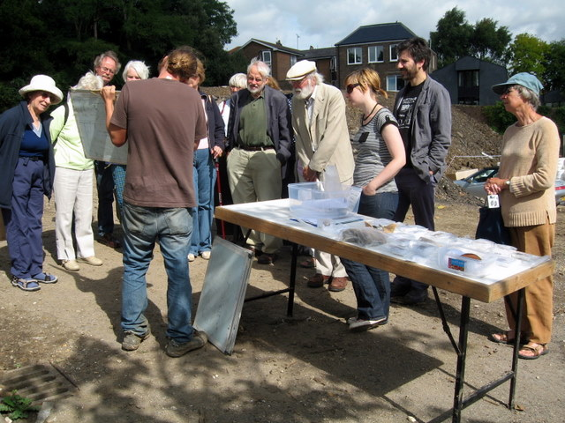

Membership runs from 1 April 2008 and costs £4/£3 concessions
If there is a cross here
your membership for 2008/2009 is now due (according to our records). Thank you for your support.
You can renew or join at any of our meetings, or send a cheque
(payable to Lewes Archaeological Group) and sae to:
Brian Phillips, 51 Manor Way, Uckfield, East Sussex, TN22 1DQ
or by hand to:
Fiona Marsden, 13 Lansdown Place, Lewes, East Sussex, BN7 2JT (01273 473946).

Lewes Archaeological Group newsletter
No. 138
September 2008
Affiliated to the Sussex Archaeological Society
and the Council for British Archaeology
Directions
As usual, the talk will be at 7.30pm in the lecture room, Town Hall, Lewes (entrance off Fisher Street).
Fisher Street is up the hill from Lewes railway station, just over the crossroads by Ask restaurant in the centre of town. The nearest parking is in the West Street car park – continue along Fisher Street then turn right, then shortly right again into the car park.

Next Lecture
Friday 19 September 2008, 7.30pm
Local archaeologist Chris Butler will give a talk drawn from his recent book 'East Sussex Under Attack: anti-invasion sites 1550-1990' on defence sites he has researched in and around Lewes, particularly those from the Second World War.
Admission (including tea/coffee)
LAG ordinary members £2, £1 for concessions.
Non-members welcome at £3/£2 for concessions.

Lecture programme
This season’s talks, all at 7.30pm in the Town Hall lecture room, are on:

Fri 19 September 2008
Wed 22 October 2008
Fri 5 December 2008
Wed 14 January 2009
Fri 6 February 2009
Wed 18 March 2009
Fri 24 April 2009

See separate coloured insert for programme details, and please note that some talks are now on Wednesdays.
Andy Margetts and Trista Clifford of Archaeology South-East
show us finds and plans at the Lewes House site on our special tour in August. See page 3 for more about this exciting excavation.

Thoughts from the Chair
Lewes Phoenix Project
Any members interested in helping with this community arts and oral history project about the Phoenix Iron Works and its successors in Lewes is invited to contact Sarah Hitchings, the project's Oral Historian, on sarahhitchings@live.co.uk or 01273 479639
I hope that you have all enjoyed your summer breaks. As you will see from the enclosed programme, we have some very interesting talks scheduled for 2008–2009, including a welcome return to Lewes by Martin Brown, who will talk about his present role as the Ministry of Defence archaeologist covering much of southern England. We’ll also have an early update from the County Archaeologists on the emerging results from the Lewes Library, Baxters and Lewes House excavations, which have uncovered a significant area of the historic town in recent years.

You will see that our lecture season includes some Wednesday evening dates interspersed with the usual Fridays. Here we are experimenting with mid-week dates in response to comments from some of you about preferring to keep Fridays for socialising or family, or for going to the film evenings at All Saints in Lewes. Others may feel that Fridays are traditionally for lectures – we will be very interested to see how attendance is on the Wednesday dates and to have your feedback.

Over the summer we also experimented with a few outdoor activities – meeting up with Brighton and Hove Archaeological Society for their midsummer evening walk on Mount Caburn, complete with readings and ‘libations’, and taking the opportunity of a special guided tour of the Lewes House excavations. These went very well and we are keen to have more suggestions for next summer.

You may have noticed that I haven’t been able to cover all last season’s lectures in the last couple of newsletters. I know these reports are a popular feature, but I find now that with chairing the meetings, looking after the speaker and operating the new data projector it is difficult to take proper notes as well. If you do feel that you could produce a short write-up of a past or forthcoming talk that interests you please let me know and I will gladly include it. And of course I would love to have more newsletter items generally – particularly recollections of the Group in its earlier years, as 2008 marks its 40th anniversary.

Anne Locke
Chair
73 Paddock Lane
Lewes BN7 1TW
01273 475381
anne.locke@talktalk.net

Medieval Shipping and Harbours
Gustav Milne FSA, Senior Lecturer in London Archaeology and Maritime Archaeology at the Institute of Archaeology, UCL, joined us last November to give a lecture concentrating on his ‘local’ interests including shipping at Sandwich and Smallhythe in Kent. Shipping was fundamental to medieval life and transporting the supplies of wool, fish and wine on which it depended. Required by the church to eat fish every Friday, the population of London relied on the market on ‘the strand’, then a river beach, from about 600 until 900AD, when the market was moved back inside the City walls because of Viking raids. It remained beach-based until the 12th century: boatmen sold their cargoes direct from shallow clinker-built boats, without port facilities, warehouses or middlemen.

In the late medieval period London’s merchant port was established, with deep water wharfs in timber and stone and large warehouses storing precious goods such as pottery from Saintonge in France and Andalucia. Over time the focus of the port moved east to gain access to deeper water.

Archaeological evidence for medieval ships and harbours is rare and depends on timbers being preserved in waterlogged conditions, either underwater or in silt. At Sandwich a clinker-built medieval ship was found preserved in silt in the 1970s, and the more recent Newport discovery is a complete 15th century vessel. There is still much potential for discovering medieval ships, harbours and ship-building infrastructure buried on silted-up inland sites which are now grasslands, such as the flat land around Winchelsea. Gustav Milne would like metal detectorists to pay special attention when they find the diamond-shaped washers or roves used in medieval ship construction, which are characteristic of shipbuilding sites and will help us locate them.

If you have internet access you can read more on this subject by Gustav Milne on www.britarch.ac.uk/ba/ba61/feat2.shtml
Meeting report by Anne Locke
Lewes House excavations 2008
This excavation site, which runs uphill behind Lewes library and All Saints, has offered archaeologists an unprecedented opportunity to look at a large open area of Lewes. Unlike at the Baxters site in 2006, where they were working virtually alongside the builders in cramped and wintry conditions, Archaeology South-East has had uninterrupted access over the summer to investigate the area. Lewes Archaeological Group had a special tour on 9 August with excavator Andy Margetts and finds specialist Trista Clifford.

Described as a ‘medieval suburb’, just outside the town walls, the area seems to have been quite intensively settled in the early medieval period up until the Black Death of the mid-14th century. It is pockmarked with numerous medieval rubbish/cess pits, which might have originally been wells – some are four to five metres deep. The way they are clustered indicates where the backyards were. There are also a couple of medieval quarry pits where flint and chalk would have been extracted, and very interestingly – since there is so little archaeological evidence from pre-Norman Lewes generally – some boundary ditches dating from the Iron Age.

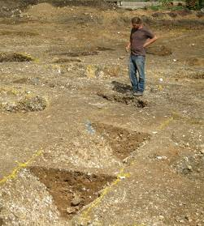
Andy Margetts of Archaeology South-East
by the excavated sections of Iron Age ditch

Sieving the soil in the bottom of the ditches for tiny bones, shells and seed remains could tell us more about the local environment and diet in the Iron Age. The ditches curve in a way suggesting that they enclosed something, but there was so much redevelopment in the medieval period that it is unclear quite what they were for.

The archaeologists have also uncovered what is almost certainly the course of the ‘lost twitten’ of Pinwell Street, closed around 1700 by the owner of the land on either side. Lewes historian Dr Colin Brent, who joined our tour, has traced documentary evidence for dwellings pre-dating the Black Death either side of Pinwell Street, and some post holes and wall foundation trenches found on the excavation correspond to where these were. The lack of evidence for occupation after the 14th century suggests that here, as in other medieval suburbs round the town, the inhabited portion shrunk after the Black Death.

Trista Clifford showed us some of the finds so far, including a medieval vessel from the Ringmer potteries, decorated bone artefacts and a silver penny from the 9th-11th century, as well as the bone flute and clay loom weight pictured here.

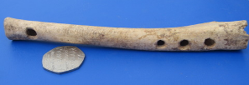A bone flute, probably from the 12th-14th century (50p alongside for scale)

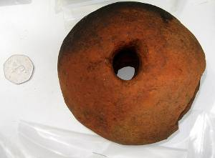A clay loom weight from the 9th-10th century

There will be another opportunity to see the site and some of the finds on Heritage Open Day, 13 September – see back page for details. Many thanks to Andy and Trista for a most interesting and revealing morning at the site.
Visit report by Anne Locke

Next newsletter, March 2009
If you have any articles, listings, comments or fieldwork opportunities for the next issue, please send them to me by
1 February 2009.
Anne Locke, Editor
73 Paddock Lane
Lewes BN7 1TW
anne.locke@talktalk.net 01273 475381

Fieldwork opportunities
Arlington: a Romano-British roadside settlement There may be still opportunities to join Greg Chuter’s weekend excavations this season: contact him on gregory.chuter@eastsussex.gov.uk or 01273 336177 (office) or 07500 123634.

Brighton and Hove Archaeological Society (BHAS) invite volunteers to join their field unit on weekend work in and around Brighton. No experience necessary. Contact Norman Phippard 01273 671608 or John Funnell 01273 607127, john.funnell@brightonarch.org.uk, or see the BHAS website www.brightonarch.org.uk

Mid-Sussex Field Archaeology Team (MSFAT) often has opportunities for weekend volunteers at local sites – including excavation, finds processing, field walking and resistivity surveys. No experience necessary. Membership £8. Chris Butler, Rosedale, Berwick BN26 6TB, 01323 871021, website www.msfat.com, email chris@reltub.fsbusiness.co.uk

The Tidemills Project is a community project open to all, looking at both the historical background and on-site survey and recording of this important site, between Newhaven and Seaford. Contact Luke Barber on 01273 405733 or email research@sussexpast.co.uk

Diary dates 2008
See coloured insert for LAG lecture list
Sat 13 Sept SAS Annual Conference
Acronym buster
BHAS Brighton & Hove Archaeological Society
CCE Centre for Continuing Education, University of Sussex
SAS Sussex Archaeological Society
USAS University of Sussex Archaeological Society
NB University People and Place: landscape
of Chichester and identity through time
£25/£20 students. Book with Lorna Gartside 01273 405737 or www.sussexpast.co.uk
Plus field trip to Fishbourne available on Sun 14th.
Courses
CCE’s programmes of part-time open and award-bearing courses cover archaeology, oral history landscape, churches, and classical and ancient civilisations, among other absorbing subjects. www.sussex.ac.uk/cce/ or 01273 877888.
Sat 13 Sept (Heritage Open Day): various venues open in Lewes, including exhibition of some of the finds from the current Lewes House excavations at Lewes House, School Hill, 10am to 5pm, and tours of Lewes House and gardens at 11am and 2.30pm: book tours on 01273 484112 or email ann.spike@lewes.gov.uk

Sat 13 Sept Drop-in session with a focus on
Subud Centre the history and memories of
Station St, Station Street and the Lost
Lewes Parish of St Mary in the Market.
10.30am–2pm.

Fri 26 Sept Friends of Anne of Cleves House
Anne of Under the Protection of St
Cleves House, Pancras. Talk by Graham
7.30pm. Mayhew.

Fri 10 Oct BHAS lecture: New ideas about
7.30pm, Bodiam Castle with Casper
Unitarian Johnson, County Archaeologist
Church, New for East Sussex.
St, Brighton

Wed 15 Oct USAS lecture: Excavations
Sussex Uni- at Beedings 2008 Dr Matt Pope,
versity, Arts 1 Senior Research Fellow, UCL
7pm: £2/£3

Fri 24 Oct Friends of Anne of Cleves House
Anne of Postcards of Lewes part III with
Cleves House, Philip Hall, + AGM.
7.30pm.

Wed 12 Nov USAS lecture: Byzantine
Sussex Uni- Mosaics Professor Liz James,
versity, Arts 1 University of Sussex.
7pm: £2/£3

Fri 14 Nov BHAS lecture: The Trojan
7.30pm, War – fact or fiction with
Unitarian Dudley Moore.
Church, New
St, Brighton

Wed 3 Dec Friends of Anne of Cleves House
Anne of Christmas Party and Magic
Cleves House, Lantern Show
7.30pm.

Fri 12 Dec BHAS AGM and
7.30pm, Christmas social,
Unitarian non-members welcome.
Church, New
St, Brighton

