
Lewes Archaeological Group newsletter

Affiliated to the Sussex Archaeological Society
and the Council for British Archaeology

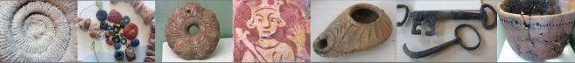

Friday 19 April 2013, 7.30pm

Romano-British discoveries in the Barcombe area
With David Millum and Rob Wallace.

Following their talk last year on the Barcombe Roman Bath House, David and Rob bring news of some exciting new discoveries nearby, which may help explain more about what could have been going on in Romano-British Barcombe.

Lecture room, Town Hall, Lewes
(Fisher Street entrance). Lift available

NEXT LAG LECTURE
Jeremy Hodgkinson
The Wealden Iron Industry from Prehistory to 19th Century
Friday 27th November at 7.30pm,
Lecture Room, Lewes Town Hall,
Fisher Street Entrance

No. 151

November 2015
www.lewesarchaeology.org.uk

www.lewesarchaeology.org.uk

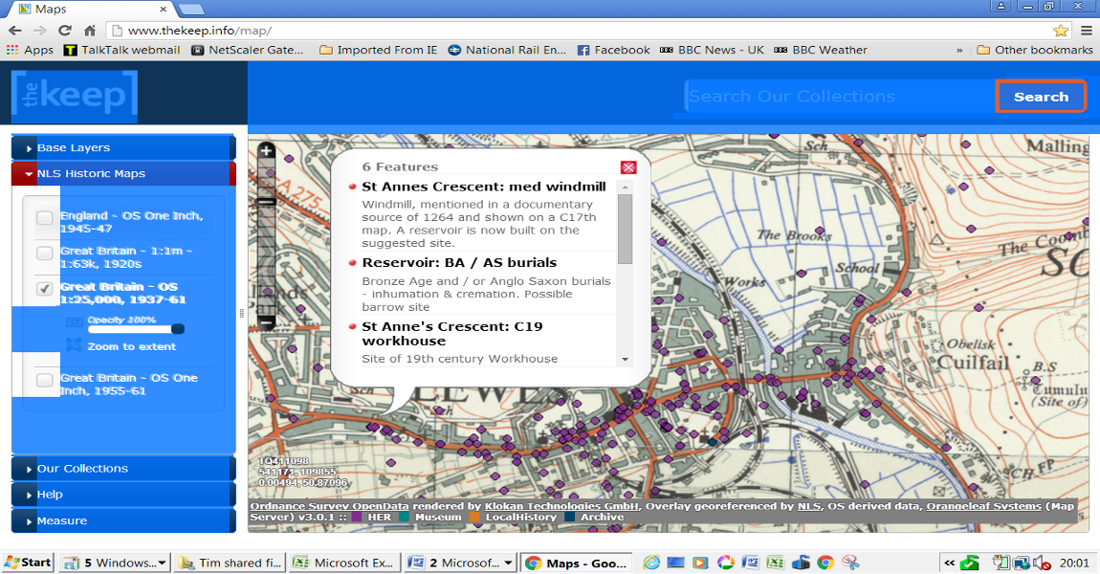

Archaeological and historical mapping online from the Keep

The Keep, which houses the collections of the East Sussex Record Office (ESRO), the Royal Pavilion & Museums Local History Collections and the University of Sussex Special Collections at new premises in Falmer, has developed a new online heritage map. Click on the purple dots which represent archaeological features, demolished buildings, finds and excavations from the Historic Environment Record to bring up a box explaining what they are, An example from St Anne’s, Lewes, is shown here. A great new resource for anyone interested in history and archaeology, the map can be found on: http://www.thekeep.info/map/

Bridge Farm Romano-British Settlement

The Culver Archaeological Project (CAP) continued to excavate the Romano-British settlement site at Bridge Farm, just north of Lewes over the summer.

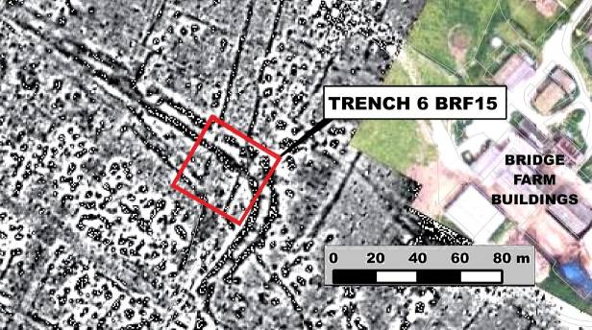
A 40m square trench was opened at the intersection of the double enclosure ditches with the north running roadside ditches in the north east corner of the enclosed settlement. with a view to answering questions on phasing and confirming the date of the enclosure.

The upper surface of the remaining archaeology was immediately below the plough soil. This layer included what appeared to be the remains of Margary’s London road. The possible road surface was very thin and probably only comprised the lower base with no evidence of the 400mm deep flint structure seen on the road running south from Culver Farm, adjacent to Barcombe villa.

One of the major results from the season was the discovery of a layer of flint metalling, which CAP have interpreted as the remains of the north road overlaying the fill of the enclosure ditches. It was discovered below a dark demolition/activity layer, which in places was full of random shaped pieces of burnt clay. With no evidence of a lower road surface this suggests that this road only appeared after the enclosure ditches were refilled. Coins, including an antoninianus of Gallienus, obtained from the dark layer would on initial interpretation seem to suggest a mid-late 3rd century date for this layer with the road earlier. In 2013 the enclosure ditches were dated as late 2nd century from pottery analysis. So this new evidence suggests a relatively short life for the defences before being filled and subsequently having the road laid over the top. A 3rd century date for this road might explain why it enters the settlement at the north east corner rather than down the centre and at an angle out of alignment with the main axis of the earlier, possibly late 1st century, road pattern. It would also seem to favour direct access to the eastern road to Arlington and Pevensey which might suggest an increase in the importance of communications to the east over the west at this later phase.
There were an amazing number of finds. Which included an oval red jasper intaglio from a ring. It shows a draped bust of either a female or a youthful male deity, crisply carved in reverse.
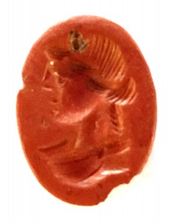
Two copper alloy intaglii and a long fibula brooch and a fragmented ring key were also found. The pottery from this area also held surprises with quite a high proportion of Samian ware, including some with maker’s marks, being found amongst the more usual black burnished and East Sussex wares. There were also a good number of larger indented beakers of quite coarse manufacture in a sandy grey fabric rather than the finer colour coated beakers found in other areas of the site.
Once again the seemingly large trench represents only a small fraction of the site and a true perspective may only be achievable after many more years of investigation.
Plumpton Roman Villa
Members of LAG and the Brighton and Hove Archaeology Society were given a tour by David Rudling of the summer’s excavations at the site of Plumpton Roman Villa. The most exciting feature was the uncovering of the foundations of an apsidal room. Sadly, the mosaics have all been ploughed out.
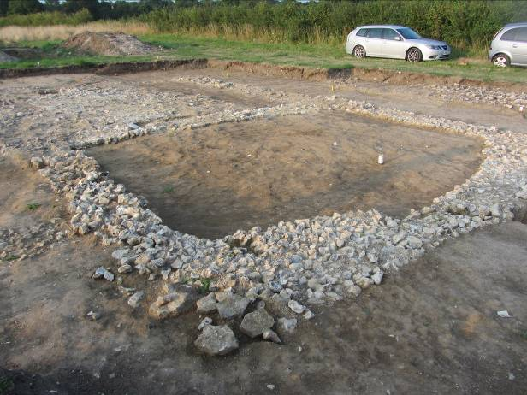
Priory Trust Excavation
Last year Lewes Priory Trust commissioned Archaeology South-East and a specialist team from Survey Design Services to carry out a survey and investigation of a culvert which belonged to the original 11th century reredorter (or communal latrine!) using remote sensing and remotely operated CCTV tractor units.

The investigation established that the reredorter appeared to have been deliberately blocked off at a distance of 19 metres north of where it had discharged into the main east-west outflow sewer.

Contamination of the sediments meant that it was not possible to retrieve archaeologically valuable samples from the floor of this culvert for analysis. However the information gathered was useful in providing further information about the complex water system of the Priory. The sewer itself is depicted on Brakspeare’s plans and was believed to have been only partly excavated by Richard Lewis between 1969 and 1980. Among the deposits he found was a 12th skillet with associated fruit stones, pottery, animal bones and fragments of tile, but much of this has not survived.

In August of this year an attempt was made to re-examine the sewer to try to establish the relationship between this sewer and the Infirmary to the east and to see whether fresh archaeological material could be retrieved from beyond a retaining wall that had been constructed (possibly following Richard Lewis’ excavation) across the arch of the sewer. It proved almost impossible to hand auger the deposits between the infirmary and the reredorter but samples taken suggested modern rubbish and rubble infill. The retaining wall was found to be too substantial to remove without the material above and beyond it collapsing. Therefore it was not possible to establish that there were recoverable medieval sediments surviving beyond the retaining wall

The two investigations, funded by the Heritage Lottery Fund and endorsed by Heritage England highlight the difficulties of working within the remains of the Priory and in trying to establish the relative floor levels of the component parts of the priory. Since the destruction of the Priory, spoliation, railway construction and the deposition of material following antiquarian and modern excavation as well as the constraints that rightly exist to protect scheduled monuments have contributed to the difficulties facing the investigation of all aspects of the physical remains of the Priory.

Excavations in Lewes
Dr Jim Leary from the University of Reading is undertaking a project which seeks to unlock the history of monumental mounds in the English landscape. This project covers 20 mounds in total and includes the Mount in Lewes (which is near the Dripping Pan).
In September his team undertook a power auger borehole survey removing a number of cores from the top to the bottom of the mount. In places, this was difficult as large flints prevented a sample being taken.
The aim of the research project is to uncover prehistoric mounds that were adapted for medieval defence or have been misidentified as later mottes. The project could lead to a re-writing of the understanding of both the later Neolithic and Norman periods. Results are not expected before Spring next year.
The National Monuments Records (NMR notes that there is as yet no conclusive evidence as to the origin and purpose of the Mount. It says that there are different theories as to its origin and purpose. According to Horsfield the mound was formed of earth excavated from the Dripping Pan, and was by tradition, erected by one of the Earls of Dorset. Allcroft considers the earthwork to be the original castle of William de Warrenne (the builder of Lewes castle) but Salzman disagrees on the grounds that even if it had been a purely temporary castle some trace of a ditch would be expected. He himself inclines to the view that it was connected with the Priory of St Pancras, with the spiral path round it, to a chapel or calvary, or even a summer house or gazebo.

It is suggested in Victoria County History that there may have been a salt-pan. However, the NMR notes that the situation of 'The Dripping Pan', now a sports ground, rules out any probability of it having been a salt pan. It has been cut out of the lower slopes of the spur, whereas a salt pan could more easily have been created upon the water meadows immediately below. It may have been no more than a chalk or clay pit.

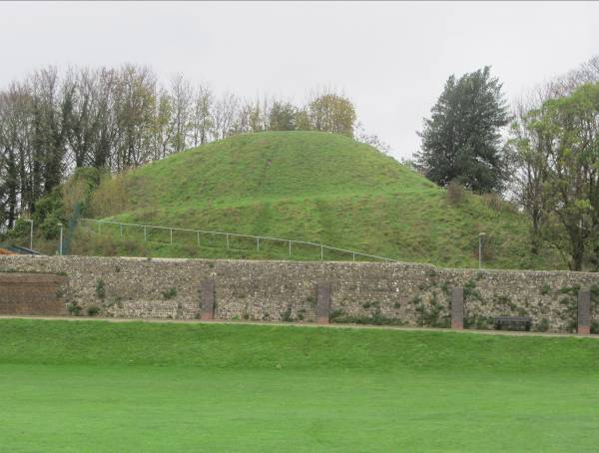

The NMR also refers to Colin Brent and his view that the Mount may have been created by Sir Thomas Sackville, then owner of Lord's Place the former Prior's Lodging. Mounts were a feature of formal Elizabethan gardens and the Dripping Pan was "a likely setting for bull baiting & bowling".

The above explanations all are premised on the mound not being pre-historic in origin. It is situated at the eastern end of a low spur of land at the northern edge of the Brooks, a wide expanse of land which, in Magdalenian times (15,000 to 10,000BCE), was covered by sea water at high tides. The position commands the entrance to three valleys, to the west, north and south east.

The construction of the new all weather football pitch near Convent Field was subject to archaeological overview by Archaeology South East. The eastern precinct wall of the Priory was confirmed. There is also a water course going across Convent Field in a north-south direction, which has been mapped and which has been interpreted as going from the Priory to the Ouse. The site also appears to have been used as a dump including material stretching to the medieval to 20th century. ASE intend to write up its findings once further work has been carried out in the Dripping Pan.
Archaeology Services Lewes carried out three watching briefs. The first at 29 Highdown Road, Lewes. Only modern features and finds except for one possible fragmented prehistoric hammer-stone from the sub-soil. Little Theatre, Lancaster Street. Evidence for former Victorian terraced cottages was encountered and a small section of cobbled road was excavated. In addition, a former medieval feature may have been compromised by the Victorian building as evidenced by a background scatter of 13^{th-} to 14^{th-} century pottery recovered from the site. 2 Green Wall, Lewes. Only 19^{th-} to 20^{th-} century artefacts were recovered apart from a few 18th century brick fragments.

Membership of LAG
As a member of LAG you are able to take advantage of LAG’s membership of the Council for British Archaeology. This includes accessing a digital subscription of the CBA,s magazine and back issues (http://new.archaeologyuk.org/british-archaeology-online. If you are a member of LAG you need to e-mail Paula Stanyer (paulawodcohen@yahoo.co.uk) to get the log in information. You also access a range of other benefits from free entry to heritage venues and discounts on publications. To find out more see http://new.archaeologyuk.org/offers-and-discounts
You can renew or join at any of our meetings, or send a cheque for £6 (payable to Lewes Archaeological Group) and sae to Brian Phillips, 2 Peronne Court, High St, Uckfield, East Sussex, TN22 1BL or Fiona Marsden, 13 Lansdown Place, Lewes, East Sussex, BN7 2JT. Please deliver by hand to Fiona.

Impressions of the Temples in Malta

When I was a child I used to play hide and seek and chase bright green lizards in these temples, not knowing their significance, but returning to Malta a few months ago I found them protected by tall fences, sometimes tents and always an entrance fee. These temples go back to before Stonehenge and before the Egyptian pyramids, definitely 3,500BCE and with some finds to 5,000 BCE. There are six or seven magnificent temples on the Unesco Heritage list, and many more temples, graves and megaliths on Malta and the even smaller island of Gozo. Malta may only be 14 miles long but it has more cars than people so it takes an hour and half to drive those 14 miles!

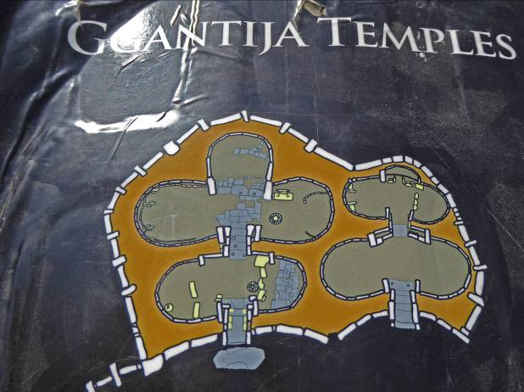

Ggantija (3,600 – 3,200 BCE) [dates and dimensions taken form David H. Trump ‘Malta Prehistory’] on Gozo is one of the earlier temples and as its name suggests has huge megalithic orthostatic slabs and so some of the surviving walls are over 7 metres high. It was first excavated in 1827. Like Ggantija, Mnajdra on Malta is a cluster of temples, but Mnajdra has the most atmospheric settings near the southern cliffs. Here there are suggestions of astronomical alignments with the winter solstice dawn’s rays sent through a narrow shaft, similar to New Grange in Ireland. There are also interesting rectangle portholes and the use of a drilled pitted decoration. Such patterning becomes more obvious in the later Tarxien temple (3,150 -2,500 BCE) with spirals and engraved images of sheep, pigs and bulls. There are sections from a statue that would have been 3 metres high too.

These temples cut from the Coralline and the soft yellow Globigerina Limestone are often shaped into five apses and because the temples were scattered with small and large female figures some have suggested that when you enter the temple one passes though womanly shapes to the alter at the head of a female deity! Some older archaeologists are embarrassed by this concept, but don’t deny the similar shape, particularly to what have become known as the ‘seated fat ladies’.

Another buxom figure made of terracotta and 12.2 cm long is called the ‘Sleeping Lady’ and is particularly sensitive. She lies on a bed with her arm under her head in a state of dreaming or trance. She was found in 1906 in the underground chambers of the Hypogeum (3,300 -3,000 BCE) below a suburban house in Paola. These labyrinths of oval chambers are cut directly into the solid rock on three levels and descend 10.6 metres below the surface. Although at some point sections were used for burials, what is quite unique it that the site was clearly carved to imitate the temples above the ground. The Hypogeum shows us the corbelled roofing created for the temples above, although here carved into the rock rather than built. There are carved trilithons and the same rectangular portholes that we see above. Even the interior decoration of spirals and honeycombed painted patterns in red ochre or black and white survive, which of course, no longer can be seen above ground. Reverberations can be heard in the ‘Oracle Room’ that may have played a part in religious ceremonies. Interpretation is problematic but adds to the mystery and awe that the place inspires.

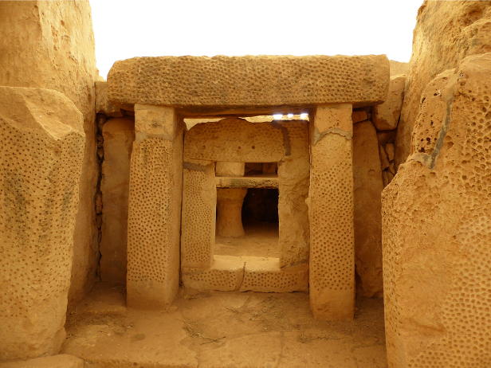

There are many more Neolithic sites in Malta I could mention in greater detail, but perhaps you already know them; after all I am only an enthusiast!
Alex Sutherland

Talks and events

BHAS Brighton & Hove Archaeological Society
ENHAS Eastbourne Natural History and Archaeological Society
FOAC Friends of Anne of Cleves House
LHG Lewes History Group
LAG Lewes Archaeological Group
SAS Sussex Archaeological Society
SSA Sussex School of Archaeology
USAS University of Sussex Archaeological Society

DECEMBER
Fri 4 Dec BHAS AGM and reports on Plumpton and Ovingdean excavations. Unitarian Church, Brighton. 7pm.
Fri 11 Dec ENHAS – Xmas meeting with four speakers. St Saviours Church Hall, Spencer Road, Eastbourne. 7.15pm. £2.50/free.
Sat 12 Dec SSA Julian Richards – Stonehenge. Plumpton College. 10-4. Cost £40/35.

JANUARY
Fri 8 Jan BHAS Carol White and Hayley Forsyth – Animal and Human Bones from BHAS excavations. Unitarian Church, Brighton. 7.30pm. £3/free.
Mon 11 Jan LHG John Bleach – Lewes in Art. Kings Church, Lewes. 7.30pm. £3/2.
Fri 15 Jan LAG Rob Wallace and David Millum - Excavations of the Romano-British settlement at Bridge Farm, Barcombe. Lewes Town Hall, 7.30pm. £4/3/2.
Thurs 21 Jan USAS Scott McLean – Reconstructing Medieval Herstmonceux. Lecture Theatre A, Fulton Building, Uni Sussex. 7pm £3/2.
Sat 23 Jan BHAS Peter Hill – Sussex Windmills, Central United Reform Church, Hove. 2.15pm. Free/£3.

FEBRUARY
Mon 8 Feb LHG Ian Everest – Life on a Sussex Farm in the 1950s. Kings Church, Lewes. 7.30pm. £3/2.
Fri 12 Feb BHAS Oliver Gilkes – excavations at the Roman site in Butrint, Albania. Unitarian Church, Brighton. 7.30pm. £3/free.
Fri 19 Feb LAG John Skelton - the excavation of a 13th century manorial complex in Ovingdean. Lewes Town Hall. 7.30pm. £4/3/2.
Thurs 25 Feb USAS John Manley - The Maori. Lecture Theatre A, Fulton Building, Uni Sussex. 7pm £3/2.
Sat 27 Feb BHAS Maureen Morris – the Lunatic Asylums of Sussex. Central United Reform Church, Hove. 2.15pm. Free/£3.

MARCH
Mon 14 March LHG Greg Chuter – death, burial and farming on a South Downs hillside. Kings Church, Lewes. 7.30pm. £3/2.
Fri 11 March BHAS Giles Dawkes – excavations at Pocock Field, Eastbourne. Unitarian Church, Brighton. 7.30pm. £3/free.
Fri 18 March LAG Tom Dommett - the Seven Sisters Archaeological Project. Lewes Town Hall. 7.30pm. £4/3/2. And AGM
Sat 19 March SAS Sussex Archaeolgoical Symposium. Uni of Brighton. All day.
Sat 26 March BHAS Stephen Durnford – Fossil Landscapes. Central United Reform Church, Hove. 2.15. Free/£3.
Thurs 31 March USAS – Miles Russel – The Durotriges Project (Iron Age, Dorset). Lecture Theatre A, Fulton Building, Uni Sussex. 7pm £3/2.

APRIL
Sat 9 April SAS Roadside Settlements in Roman Britain and Beyond. All day. Kings Church, Lewes. £40/25.
Mon 11 April LHG Stewart Angell – Secret Sussex Resistance. Kings Church, Lewes. 7.30pm. £3/2.
Fri 15 April LAG David Rudling - Bignor Roman Villa. Lewes Town Hall. 7.30pm. £4/3/2
Thurs 21 April USAS - Holleyman Lecture. Lecture Theatre A, Fulton Building, Uni Sussex.

The Sussex School of Archaeology also runs practical day schools on all aspects of field archaeology including illustration, geo physics, finds preservation and field walking as well as holding other events. To find details of these courses visit - http://www.sussexarchaeology.org
The Lewes History Group holds talks on the second Monday of the month at 7.30pm, at King’s Church, Lewes. A project progress group meets on the third Monday of the month for members carrying out local research (for details tel 813388 or email John Kay at johnkay56@googlemail.com. Jane Lee is responsible for publicity and can be contacted by e-mail at jane.lee@dexterity.co.uk or phone 487617. Further information can be obtained from - http://leweshistory.org.uk/

