

Lewes Archaeological Group newsletter

Affiliated to the Sussex Archaeological Society
and the Council for British Archaeology

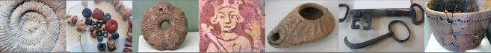

Friday 19 April 2013, 7.30pm

Romano-British discoveries in the Barcombe area
With David Millum and Rob Wallace.

Following their talk last year on the Barcombe Roman Bath House, David and Rob bring news of some exciting new discoveries nearby, which may help explain more about what could have been going on in Romano-British Barcombe.

Lecture room, Town Hall, Lewes
(Fisher Street entrance). Lift available

Bridge Roman Settlement
.
Over the summer, excavations continued at Bridge Farm, Barcombe with the excavation of a single 31m by 22m trench.

The excavation uncovered the previous existence of a large timber framed building. Thirteen postholes were identified which contained the water logged basal remains of large posts and one contained a section of a large beams and two very interesting ogival carved timbers set as a post-pad below the Romano-British period post remains. The Culver Project directors Rob Wallace and David Millum are keen to gain comparable evidence for the reuse of timbers on Roman sites and for the design and former use of carved timbers.

No. 149
November 2014
www.lewesarchaeology.org.uk

www.lewesarchaeology.org.uk

NEXT LAG LECTURE
Dr Mike Allen – The Neolithic Chalklands – Wessex to Sussex –
environmental archaeology re-writes the textbooks

Friday 5th December at 7.30pm,
Lecture Room, Lewes Town Hall,
Fisher Street Entrance

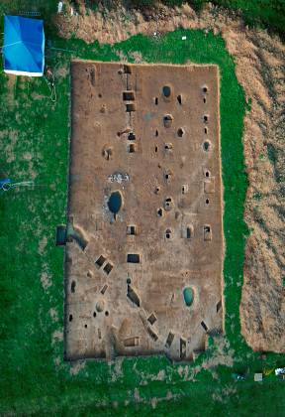

The trench also revealed two large pits that may have been shallows wells. Also, uncovered ere two hearths, one of which contained forging slag.

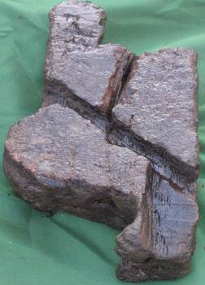

The artefacts which were found were exclusively Roman. There was a great variety of pottery which included a number with pierced bases, beaker sherds and fragments of Samian ware. Also found was a well preserved hare brooch, several Roman coins (four plus dating from the mid 2nd century), a finger ring, whorl, a rear of a leather sandal with hobnails, animal bones as well as corroded iron pieces, slag and quern stone fragments.

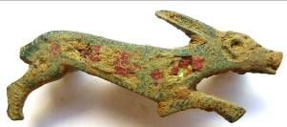

Volunteers are needed for analyzing the flot residues – contact the Culver Project via its website (www.culverproject.co.uk).

Otherwise find out more about the excavation by attending the LAG talk on Friday 6th February 2015.

Road to nowhere?
In 2011 some members of the Ringmer History Study Group formed the Ringmer Roman Group to investigate possible Roman activity in the village. They had been spurred on by the discoveries of the Roman Villa and Bath House at Barcombe. Further, David Millum had put forward the theory that there was a Roman road running west/east across the northern part of Ringmer parish that crossed Margary’s London to Lewes road at Barcombe Mills.

The road was quickly discovered by field walking at Downsview Farm just off the Laughton Road - some 50 metres south of David’s projected line. The big question was about its termini. The Group traced the road’s eastern route to Laughton Place where it turned south and joined the known Ripe/Chalvington network at Mark Cross not far from the Roman Villa. From there it ran on to Pevensey and Hastings.

Turning west, the Group tracked the route through Barnfield Farm, across Moor Lane by the Sewage Works, where the road is lost under houses to the south and business premises to the north of the Laughton Road before it traverses Fingerpost Farm and its former fields beyond the B2196. The discernible scatter of its flints continued to Norlington Lane which the road crosses and is then mainly under field boundary hedges until it reaches the A26.

In late 2012 work for the Culver Project, primarily by David Staveley, lead to the discovery of the Bridge Farm settlement over the Ouse at Wellingham within Ringmer’s boundary. The road is clearly emanating from the centre of this developed area. And so, its western terminus is now solved.

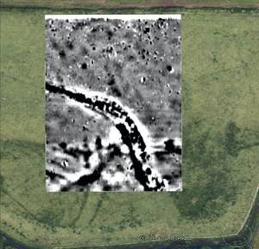
The road is by and large straight and has been GPS plotted over most of its discovered route. A small test pit at Downsview Farm exposed large compacted flints 15 inches below the surface and two courses of flint were found in a nearby boundary ditch.

Both Allcroft and Margary suggested a Roman road across Stoneham and southern Ringmer to Glynde. To find it is the Group’s next task after the final part of the Bridge Farm road has been plotted.
Contact Bob Cairns 01273 812784 rjandljcairns@btinternet.com

Excavation at the Priory
On Friday 20th June archaeologists from Archaeology South-East and a specialist team from Survey Design Services Ltd. began an investigation of a mediaeval drainage culvert at St Pancras Priory in Lewes. Lewes Priory Trust commissioned the project which is funded by the Heritage Lottery Fund and endorsed by English Heritage. The Trust is hoping to discover both the direction and purpose of this culvert which lies beneath the monks’ latrine block and to discover more about the eating habits of the monks and the environment in which they lived.

Remotely-operated cameras were sent into the stone-lined vaulted culvert and detailed images were relayed and recorded for closer examination and the direction of the drain was plotted from signals sent to the surface. After a distance of seventeen metres the culvert appeared to have been deliberately blocked, possibly as a result of the building of the monks’

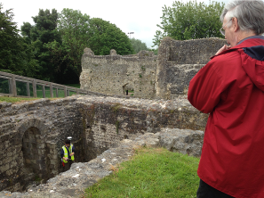
Refectory. Archaeologists will now study the results of this survey to determine whether to extract sediments from the floor of the culvert for analysis and whether to re-open a partial excavation made in the 1970’s of one of the main drains of the Priory.

Simon Stevens, Senior Archaeologist at Archaeology South East will talk about this excavation at LAG’s talk to be held on Friday 6th March 2015.

Free LAG talks
Anyone aged 18 or under can attend LAG talks for free. So, please do let your children or grandchildren or other young person who might be interested in archaeology know.

Jean Petrie remembered
Jean, formerly a high ranking civil servant, was a fine raconteur with an engaging Scottish accent and was also an unlikely member of LAG committee for about a decade from the 1990s.

Jean’s war work, loading guns and operating search lights brought her to Shoreham and introduced her to Sussex and this influenced her decision to retire to Lewes. In the homelier atmosphere of LAG Committee, her experience was respected but her kind and generous personality was much more in evidence. She could spot a wonky balance sheet at a glance no doubt due to her having advised a Chancellor of the Exchequer or two during her time working in the Treasury. She enjoyed excavating and helped on LAG sites at the Friary, Mote Park and notably Norlington kiln, followed by punishing post-excavation analysis of all the pottery.

Jean’s holidays in Scotland, often on Iona, introduced her to Brian Moffat’s work on the medieval hospital at Soutra and she persuaded him to come to Lewes where he gave a lecture so full of fascination that the audience stayed mute in their seats as he overran for an hour or more.

Near Lewes Hoard
The Barbican Museum will shortly announce the opening
of their exhibition on the 'near Lewes' Middle Bronze Age hoard. So, look out for details!

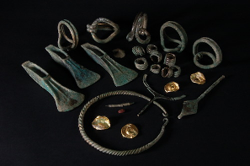

Membership of LAG
As a member of LAG you are able to take advantage of LAG’s membership of the Council for British Archaeology. This includes accessing a digital subscription of the CBA,s magazine and back issues (http://new.archaeologyuk.org/british-archaeology-online. If you are a member of LAG you need to e-mail Paula Stanyer (paulawodcohen@yahoo.co.uk) to get the log in information. You also access a range of other benefits from free entry to heritage venues and discounts on publications. To find out more see http://new.archaeologyuk.org/offers-and-discounts

You can renew or join at any of our meetings, or send a cheque for £6 (payable to Lewes Archaeological Group) and sae to Brian Phillips, 2 Peronne Court, High St, Uckfield, East Sussex, TN22 1BL or Fiona Marsden, 13 Lansdown Place, Lewes, East Sussex, BN7 2JT. Please deliver by hand to Fiona.

Alex’s Mystery Photographs
Where are these? The landscape tells you that they are not so far away as most.

Picture 1
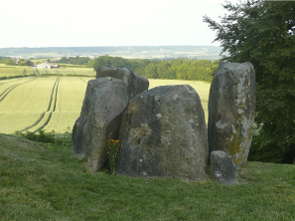
Picture 2
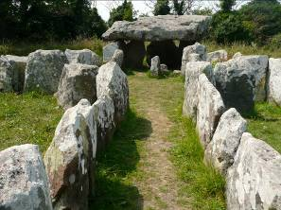

Fieldwork and post-excavation opportunities
As winter approaches, attention switches from excavations towards field walking and geophysics and post-excavation sorting out. As mentioned above, volunteers are sought for analysing flot residues following the dig at Bridge Farm, near Barcombe. For further details see www.culverproject.co.uk.
Brighton and Hove Archaeological Society (BHAS). BHAS is intending to undertake surveying and geophysics and finds sorting over the winter period. Newcomers welcome whatever their experience. Cost is £15 full and £7.50 for students and people must have a current tetanus inoculation. Age from 16 years upwards. Contact John Funnell at john.funnell@brightonarch.org.uk for more details or visit http://www.brightonarch.org.uk/.
E
Talks and events 2014

BHAS Brighton & Hove Archaeological Society
ENHAS Eastbourne Natural History and Archaeological Society
FOAC Friends of Anne of Cleves House
LHG Lewes History Group
LAG Lewes Archaeological Group
SAS Sussex Archaeological Society
SSA Sussex School of Archaeology
USAS University of Sussex Archaeological Society

DECEMBER

Fri 5 Dec LAG – Mike Allen – The Neolithic Chalklands – Wessex to Sussex – environmental archaeology re-writes the text books – 7.30pm at Lewes Town Hall, Fisher Street Entrance. £4/£3/2.
Mon 8 Dec LHG AGM and Sun Street Story by Rosemary Page and Sue Weeks. 7.00 – 9.00pm at Kings Church building, Brooks Rd, Lewes, BN7 2BY. £2/£3 (members/non-members).
Fri 12 Dec ENHAS Four brief talks by members. 7.30pm at St Saviour and St Peters Church Hall, South Street (entrance Spencer Road), Eastbourne.
Fri 12 Dec BHAS AGM and John Skelton - Ovingdean excavations and PeteTolhurst about Egypt. 7pm Unitarian Church, New Road, Brighton. Free to members, visitors £3.

2O15

JANUARY

Fri 9 Jan ENHAS Lawrence Stevens – The Archaeology of Poplin Marsh. 7.30pm at St Saviour and St Peters Church Hall, South Street (entrance Spencer Road), Eastbourne.
Fri 9 Jan BHAS John Shepherd - Mithras Temple, London. 7.30pm at Unitarian Church, New Road, Brighton. Free to members, visitors £3.
Thurs 15 Jan USAS Chris Carey – Geochemistry and Metal Working. 7pm at Lecture Theatre A, Fulton Building, Uni of Sussex. £3/2.
Mon 12 Jan LHG Geoff Mead – Sussex Industrial History: a different perspective. 7.00 – 9.00pm at Kings Church building, Brooks Rd, Lewes, BN7 2BY. £2/£3 (members/non-members).
Sun 17 Jan BHAS Day school. Chris Butler – Flint Recognition and Recording. 10-4 Patcham Community Centre. £25/30.
Fri 23 Jan LAG Christopher Whittick – To the Manor Born: manors of the Battle area 1066-1925. 7.30 at Lecture Room, Lewes Town Hall, Fisher Street, Lewes. £4/3/2.
FEBRUARY
Fri 6 Feb LAG Rob Wallace and David Millum – Bridge Farm, Barcombe 2014 Summer Excavation. 7.30 at Lecture Room, Lewes Town Hall, Fisher Street, Lewes. £4/3/2.
Sat 7 Feb SAS Keith Whitlock – The Romano-British and Saxon settlers of Sussex: do place names challenge the conventional historical narrative? 2.30pm Barbican House, Lewes.
Mon 9 Feb LHG John Kay – MPs from Lewes Past. 7.00 – 9.00pm at Kings Church building, Brooks Rd, Lewes, BN7 2BY. £2/£3 (members/non-members).
Thurs 12 Feb USAS David Fisher – The Screen Map of Brighton and Hove. 7pm at Lecture Theatre A, Fulton Building, Uni of Sussex. £3/2.
Fri 13 Feb ENHAS Patricia Stevens – Eastbourne’s extensive early Anglo-Saxon cemetery and the discovery of an Iron Age settlement in 1990. 7.30pm at St Saviour and St Peters Church Hall, South Street (entrance Spencer Road), Eastbourne.
Fri 13 Feb BHAS Paul Bennett - Archaeology in Libya . 7.30pm at Unitarian Church, New Road, Brighton. Free to members, visitors £3.
Sat 14 Feb SAS Vivienne Blandford a woodland walk around the iron working sites in Forewood. 11am.
Sat 14 Feb BHAS Day school. Mike Allen – Environmental Archaeology – a view from the trench. 10-4 Patcham Community Centre. £25/30.

MARCH
Fri 6 March LAG Simon Stevens – Recent Archaeological Developments at Lewes Priory. 7.30 at Lecture Room, Lewes Town Hall, Fisher Street, Lewes. £4/3/2.
Mon 9 Mar LHG Brigitte Lardinois – Reeves Photographic Archive. 7.00 – 9.00pm at Kings Church building, Brooks Rd, Lewes, BN7 2BY. £2/£3 (members/non-members).
Thurs 12 Mar USAS Ernest Black – The Vici of Lowland Roman Empire. 7pm at Lecture Theatre A, Fulton Building, Uni of Sussex. £3/2.
Fri 13 Mar ENHAS John Manley – Iron Age Sussex. 7.30pm at St Saviour and St Peters Church Hall, South Street (entrance Spencer Road), Eastbourne.
Fri 13 Mar BHAS Jaime Kaminski – Digital Archaeological: 3D scanning for archaeologists. 7.30pm at Unitarian Church, New Road, Brighton. Free to members, visitors £3.
Sat 14 Mar BHAS Day school. Paola Ponce – a study of human bones. 10-4 Patcham Community Centre. £25/30.
Sun 15 Mar SAS John Manley visit to the Trundle, Middle Iron Age hill fort north of Chichester. 2pm.
Sat 28 Mar SAS Peter Hill guided tour of West Blatchington windmill.

APRIL

Thurs 16 April USAS/SAS/SSA The Holleyman Archaeological Lecture 2015. Gabor Thomas – A Portal to the Anglo-Saxon Past – village core excavations at Bishopstone and Lyminge. 7pm at Lecture Theatre A, Fulton Building, Uni of Sussex. £10/8.
Fri 17 April LAG Jonathan Sygrave – Whitehawk Hill Excavations. 7.30 at Lecture Room, Lewes Town Hall, Fisher Street, Lewes. £4/3/2.
Fri 24 April ENHAS AGM and Life and Archaeology of Pitt Rivers. 7.30pm at St Saviour and St Peters Church Hall, South Street (entrance Spencer Road), Eastbourne.
MAY
Thurs 7 May USAS Richard Bridgland and John and Kim Brinded – The Imperial Roman Army in the south of Britain.
Sat 9 May SAS Tudor and early Stuart Country Houses. All day event. Kings Church, Brooks Road, Lewes.
Mon 11 May LHG Geoff Bridger – World War I Territorial Army. 7.00 – 9.00pm at Kings Church building, Brooks Rd, Lewes, BN7 2BY. £2/£3 (members/non-members).

Mon 8 June LHG Graham Mayhew – A day, a year, a lifetime for a monk at Lewes Priory. 7.00 – 9.00pm at Kings Church building, Brooks Rd, Lewes, BN7 2BY. £2/£3 (members/non-members).

The Sussex School of Archaeology also runs practical day schools on all aspects of field archaeology including illustration, geo physics, finds preservation and field walking as well as holding other events. To find details of these courses visit - http://www.sussexarchaeology.org
The Lewes History Group holds talks on the second Monday of the month at 7.30pm, at King’s Church, Lewes. A project progress group meets on the third Monday of the month for members carrying out local research. See http://leweshistory.org.uk/
Answers to the picture quiz

Picture 1: Coldrum Long Barrow, nr. Trottiscliffe, Kent. Early Neolithic.
Picture 2: La Pouquelaye de Faldouet, Parish of St. Martin, Jersey. Neolithic. The capstone is 24 tons according to the Jersey Archaeological site!

