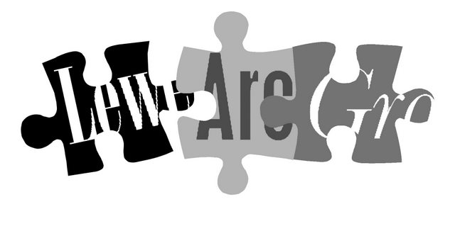

Lewes Archaeological Group newsletter

No. 148
May 2014
www.lewesarchaeology.org.uk

Affiliated to the Sussex Archaeological Society
and the Council for British Archaeology

NEXT LAG LECTURE

Friday 29th November at 7.30pm,
Lecture Room, Lewes Town Hall, Fisher Street Entrance

Cowrie Shells to Credit Cards: the Archaeology of Money with David Rudling, excavator of Roman villas at Beddingham and Barcombe, and authority on Roman coinage, now co-director of the Sussex School of Archaeology following many years as convenor of archaeology programmes at the University of Sussex.

Friday 19 April 2013, 7.30pm

Romano-British discoveries in the Barcombe area
With David Millum and Rob Wallace.

Following their talk last year on the Barcombe Roman Bath House, David and Rob bring news of some exciting new discoveries nearby, which may help explain more about what could have been going on in Romano-British Barcombe.

Lecture room, Town Hall, Lewes
(Fisher Street entrance). Lift available

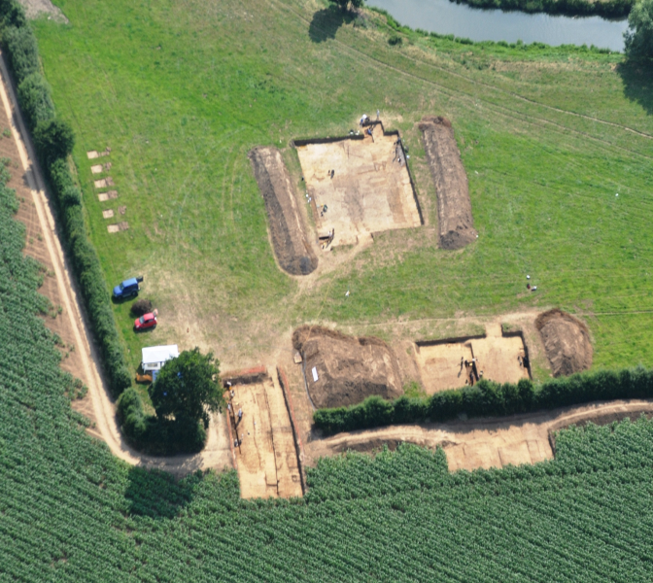

Bridge Farm Excavation

Many LAG members enjoyed Rob Wallace’s and David Millum’s talk in April about Romano-British discoveries in the Barcombe area. The lecture focussed, in particular, on Bridge Farm, Barcombe

Mill. They spoke about the proposed excavation of the site that was to take place over the summer.

A large community excavation funded by a Heritage Lottery Fund grant did indeed take place. It ran from July 1st to August 10th with 180 volunteers clocking up over 1000 days of work. One hundred and twenty people attended twenty four free workshops. There were over 400 site visitors and 150 pupils visited the site from five local schools on experiential day trips.

Four trenches were opened totalling 1150sq.m to evaluate the archaeology shown on geophysics and establish the phasing between the open settlement and double enclosure ditches to the south of the main settlement area.

The open settlement was shown to date from the 1st century AD whilst the ditches of the square enclosure were much later, possibly 3rd century. Awaited specialist reports should elucidate this.

Features discovered were all from the Roman period and included a possible tile kiln, and tiled rectangular pit, roadside and enclosure ditches, road surfacing, flint-packed postholes, a possible building base and post holes, a variety of deep pits.

A human cremation in virtually complete urn was lifted whole. It contained 652g of burnt human bone representing one adult.
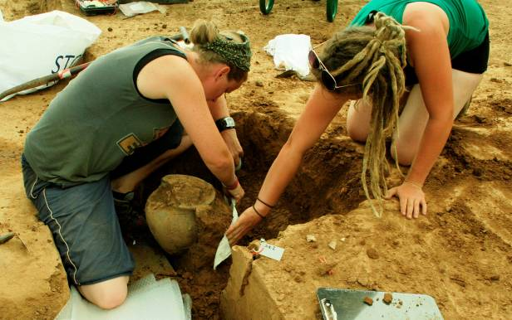

Other artefacts found included water-logged timber fragments, marked samian, a quern stone, shale bracelet and bronze brooch fragments, coins, glass fragments, a large assemblage of pottery sherds and a mass of badly fired tile. A greasy substance was taken from the kiln which is thought to be waste animal fat from tallow production.

There was also a surface scatter of prehistoric worked flint including a tanged and barbed arrow head dating to the Bronze Age.

Recollections of Peter Drewett – a legacy for Sussex

In the 1970s there was virtually no professional archaeological presence in Sussex – the archaeological scene was largely run by amateurs. However, the local archaeological scene was vibrant, working largely at weekends. So, the news of a new professional team of archaeologists (Sussex Archaeological Field Unit) lead by Peter Drewett was received with some anxiety. It would have been very easy for two quite separate and individual cultures of professional and amateur to have developed. But Peter met this head on … with a clear excitement and drive for archaeology, Peter traipsed up to the LAG excavations at Round-the-Down in the cold and wet to introduce himself.

Peter significantly swelled archaeology both professional and amateur in Sussex. His excavations on Bullock Down embraced the amateur community, Peter ran evening classes for LAG on prehistoric pottery and Lys Drewett on archaeological illustration. Amateur, student and professional alike sweltered at Offham. Whether student, professional or amateur all were afforded the same interest and the same level of explanation and instruction.

At Offham Neolithic causewayed enclosure in 1976, I considered myself almost an old hand (I’d been digging for nearly 4 years and not yet turned 16!). I dug ditch sections and we were told about the Neolithic of Sussex, worms and worm sorting. Students were given weekly subsidies. I was asked to sign on the dotted line and received my first archaeological ‘pay’!

Peter visited my own dry valley excavations the Bourne Valley, Eastbourne when I was a schoolboy and LAG excavations at Ashcombe Bottom when I was a recent archaeology graduate. I remember that we had had a number of serious, but professional debates. It was because scepticism, and Peter’s professionalism and enthusiasm that I asked him to supervise my undergraduate dissertation on the Boureb valley excavations, rather than someone in the environment archaeology department at the Institute of Archaeology.

Peter’s encouragement and enthusiasm for archaeology led not to a division in archaeology in Sussex, but a blossoming in research and participation. It’s a legacy that can strongly been seen in Sussex today.

Mike Allen

LAG programme 2013-14

Anne Locke has organised another interesting lecture programme for LAG for the coming year. All talks take place in the Lecture Room, Lewes Town Hall, Fisher Street Entrance and start at 7.30pm.

The year commences on Friday 29th
November with a talk by David Rudling on the archaeology of money.

The second talk on Friday 31st January
2014 is on Roman roads in the Lewes area. David Staveley will present new research results from geophysical evidence.

The third talk will take place on Friday 28th February 2014 and will be given by Rob Wallace and David Millum. They will speak about the Bridge Farm excavation mentioned above.

The final lecture of the season will be given by Christopher Whittick who will explore how history has shaped the human and physical differences between East and West Sussex. The talk is to take place on Friday 28th March.

Membership for 2013/14 was due in April. If you are not sure if you have re-joined please ask Brian on the door at the next talk or contact him on 01825 762008 or Anne on anne.locke@talktalk.net.

You can renew or join at any of our meetings, or send a cheque for £6 (payable to Lewes Archaeological Group) and sae to-

Brian Phillips, 2 Peronne Court, High St, Uckfield, East Sussex, TN22 1BL;

Fiona Marsden, 13 Lansdown Place, Lewes, East Sussex, BN7 2JT. Please deliver by hand to Fiona.

Thoughts from the Chair

The newsletter is later than usual – this is by no means a reflection on our newsletter editor Paula Stanyer, but results from my being late with the talks programme and my other contributions such as this one. Working in London and my parents’ state of health has left me with insufficient spare time for such commitments and I am looking to lessen them over the coming year.
When I took on the talks programme and the chairmanship in 2007 I had in mind ‘putting something back’ after having enjoyed and learned a great deal from the Group’s programme since I moved to Lewes in 1995. I wonder if there are a few readers of this newsletter, perhaps recently retired or otherwise with more time than they used to have, who would now be interested in taking over one or both of these roles? If you are interested at all please do get in contact for an informal chat. We would also welcome new members onto the committee in any capacity.
Depending on the response to this appeal the Committee will be considering what to propose under the ‘discussion on the future direction of the Group’ scheduled for the AGM on Friday 28th March 2014.
A number of the present committee have now served for many years – long pre-dating me in some cases – and do not feel able to take on organising the talks or chairing the group. If there is no-one to take over we will need seriously to consider questions such as:
- can the group continue as at present, arranging a programme of winter talks and circulating news of what else is going on in the area?
- should the Group continue as a membership-based organisation, with the associated administration burden, or become more an email-based information service?
- should LAG aim to be an active fieldwork group again?
- are there ways forward in partnership with other local archaeological groups?

This is not the first time I have raised these questions in this newsletter, but I do feel that this year will be crucial in answering them. Please do let me know your thoughts before the end of the year.
Finally, we look forward to seeing you at the November talk.

Anne Locke
73 Paddock Lane, Lewes BN7 1TW
01273 475381, anne.locke@talktalk.net

New Books!

Scarpfoot Parish: Plumpton 1830-1880
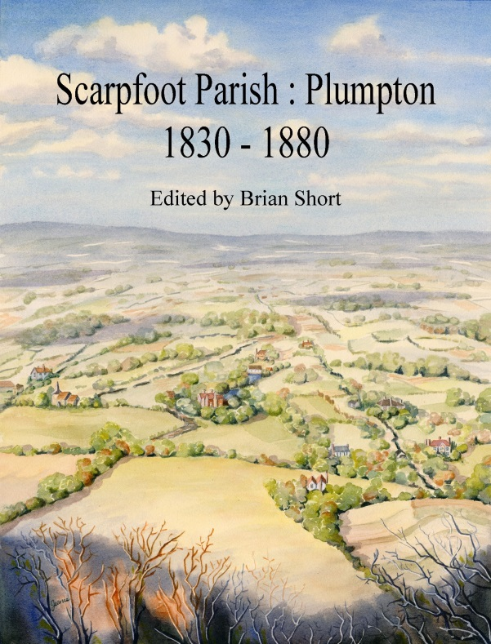

This book opens a unique window into a bygone age in Sussex - from the time when Plumpton Green was the manorial common scattered with a few isolated farmsteads, to the coming of the railway, brickyards, pubs, shops and ‘modern’ houses. It shows the decline of the ancient parish centre at the scarpfoot epitomised by the use of Plumpton Place as tenements for agricultural workers.

The book was produced from original research by University of Sussex CCE students in 1981 and edited by Professor Brian Short.

It is available at Castlebooks, Barbican House, Lewes at £11 or from David Millum, Grebe, Station Road, Plumpton Green, East Sussex. BN7 3BT at £12.50 including p & p).

Archaeology and Land-use of South-East England to 1066 eds Michael J Allen & David Rudling
This book is published as a tribute to Peter Drewett. It aims to provide a new authoritative textbook on the archaeology of South East England by the recognised and leading authorities in their field. Over 30 leading authors provide a truly comprehensive overview of the South East as an informed narrative and interpretation of the history of the region.
The chronological chapters tell the story of the development of the South East by period. Other chapters focus on either specific areas within the region, or aspects of material culture and the economy.

It is the first book to look at the region as a whole for a generation and will have an important place in the archaeology of the South East.

There is a special pre-publication price of £26.25 details of which can be obtained by e-mailing aea.escargots@gmail.com. The likely publication price is £35.00.
Alex’s Mystery Photographs
How are you on mosaics? I know you know your Sussex mosaics (picture 1), but can you say where picture 2 is from? Picture 3 is from the same place.

Picture 1
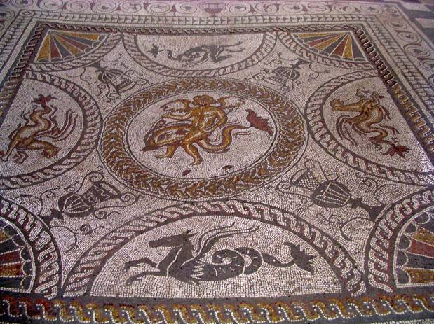
Picture 2
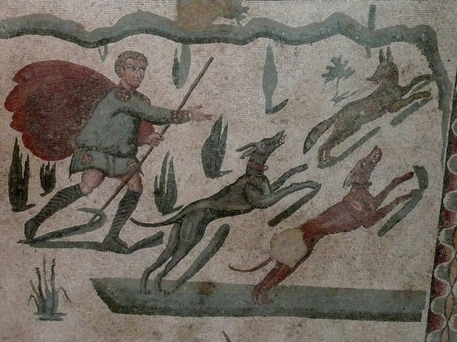

Picture 3

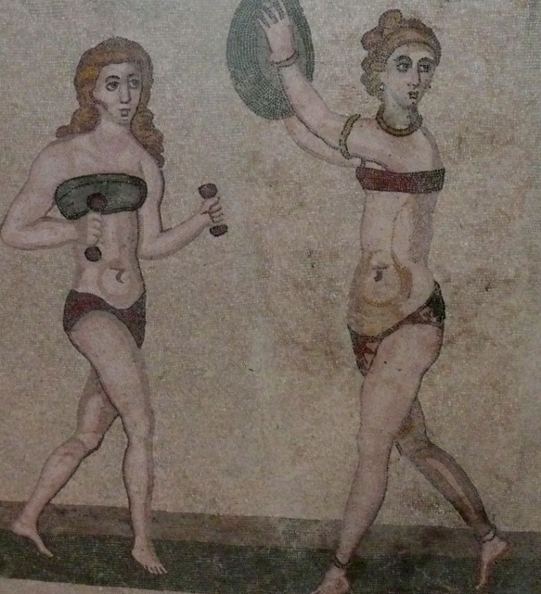
Fieldwork opportunities

Brighton and Hove Archaeological Society (BHAS) Although, LAG does not carry out any fieldwork at the moment, BHAS is active on this front. In April excavations commenced at Ovingdean and geo physics in Whitehawk. Newcomers welcome whatever their experience. Cost is £12 full and £6 student and people must have a current tetanus inoculation. Age from 16 years upwards. Contact John Funnell at john.funnell@brightonarch.org.uk for more details.
ARCHAE
The Tidemills Project is a community project open to all, engaged in both historical research and on-site survey and recording of this important site between Newhaven and Seaford, usually on Thursdays. Contact Luke Barber on 01273 405733 or email research@sussexpast.co.uk

Talks and events 2013

BHAS Brighton & Hove Archaeological Society
FOAC Friends of Anne of Cleves House
LHG Lewes History Group
LAG Lewes Archaeological Group
SAS Sussex Archaeological Society
SSA Sussex School of Archaeology

Sat 9 Nov SAS: Walk to the Bronze Age – Plumpton. 10.30-12.30am.
Sat 16 Nov SAS: Christmas Fair at Michelham Priory.
Fri 22 Nov SAS: Ghost walk. Michelham Priory. 7pm. Adults £15, children £10.
Sat 23 Nov SSA: Identifying animal bone: Sarah Green. Linklater Pavillion, 10am – 4pm. Cost £30.
Fri 29 Nov LAG: Cowrie Shells to Credit Cards: the archaeology of money with David Rudling. 7.30pm Lecture Room, Lewes Town Hall, Fisher Street. Cost £2-4.
Sat 30 Nov SSA: Identifying human bone: Sarah Green. Linklater Pavillion, 10am – 4pm. Cost £30.

Fri 6 Dec SAS: Ghost walk. Michelham Priory. 7pm. Adults £15, children £10.
Sat 7 Dec SSA: How to write an archaeological report: Simon Stevens. Linklater Pavillion, 10-4pm. Cost £30.
Sat 7 Dec SAS: Tudor Christmas at Michelham Priory.
Mon 9 December LHG: AGM &Telling Lewes History to Children. 7pm Kings Church Building, Brooks Rd, Lewes. £2/£3.

2014

Mon 13 January LHG: Ale and Hearty, Sam Carroll. 7pm Kings Church Building, Brooks Road, Lewes. Cost £2-3.
Fri 10 January BHAS: From Round House to Roman Villa, David Rudling. 7.30pm. Unitarian Church, New Road, Brighton. Free to members, visitors £3.
Fri 31 January LAG: Roman Roads in Lewes, David Staveley. 7.30pm Lecture Room, Lewes Town Hall, Fisher Street. Cost £2-4.

Fri 14 February BHAS: Tribe and Prejudice – excavating the late Iron Age, Miles Russell. 7.30pm. Unitarian Church, New Road, Brighton. Free to members, visitors £3.
Fri 28 February LAG: Bridge Farm, near Lewes, David Millum and Rob Wallace. 7.30pm, Lecture Room, Lewes Town Hall, Fisher Street. Cost £2-4.

Fri 14 March BHAS: Stonehenge Hidden Landscapes Project – new visions and horizons in landscape archaeology, Paul Garwood. 7.30pm. Unitarian Church, New Road, Brighton. Free to members, visitors £3..
Fri 28 March LAG: East is East and West is West Sussex, Christopher Whittick. 7.30pm, Lecture Room, Lewes Town Hall, Fisher Street. Cost £2-4.

Sat 26 April SAS: The Home Front: Sussex in the First World War. 10am-5pm. Lewes Town Hall, Fisher Street. £30.

The Sussex School of Archaeology had not at the time of writing this newsletter finalised its events programme for next year. So, please refer to its website for more information shortly -http://www.sussexarchaeology.org
The Lewes History Group holds talks on the second Monday of the month at 7.30pm, at King’s Church, Lewes. A project progress group meets on the third Monday of the month for members carrying out local research (for details tel 813388 or email John Kay at johnkay56@googlemail.com.
Jane Lee is responsible for publicity and can be contacted by e-mail at jane.lee@dexterity.co.uk or phone 487617.
Further information can be obtained from - http://leweshistory.org.uk/
Answers to the picture quiz

Picture 1: Of course, is from Fishbourne Roman Palace, Chichester.

Picture 2: The hunting scene mosaic is at Villa del Casale, Piazza Armerina, Sicily 3rd -4th century AD.

Picture 3: The female gymnasts.

Contributions to Paula Stanyer at paulawodcohen@yahoo.co.uk by end January please

