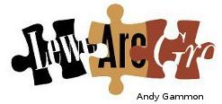
Lewes Archaeological Group newsletter

Affiliated to the Sussex Archaeological Society No 152
and the Council for British Archaeology May 2016
www.lewesarchaeology.org.uk

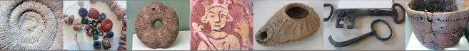

Friday 19 April 2013, 7.30pm

Romano-British discoveries in the Barcombe area
With David Millum and Rob Wallace.

Following their talk last year on the Barcombe Roman Bath House, David and Rob bring news of some exciting new discoveries nearby, which may help explain more about what could have been going on in Romano-British Barcombe.

Lecture room, Town Hall, Lewes
(Fisher Street entrance). Lift available

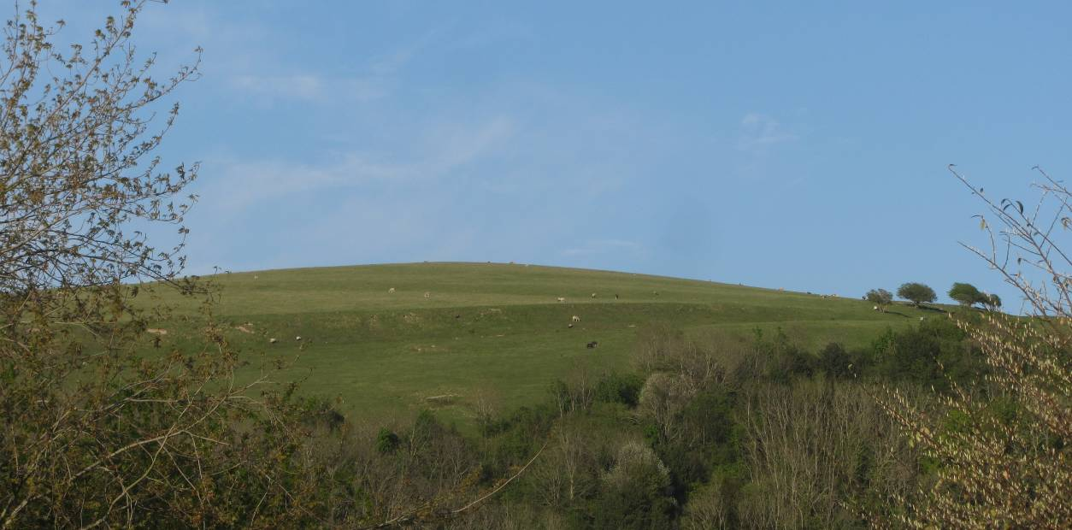
Mallling Down and Norse Raiders?

Greg Chuter, Assistant County Archaeologist, will give a guided walk of Malling Down to LAG members and members of Brighton and Hove Archaeological Society (BHAS) and the Lewes History Group on Sunday 10th July (see further details below).
Greg led a project in 1994 with help from LAG and BHAS which re-examined a site partly excavated in the 1970s following the finding of a skull by a school boy on Malling Down. The excavations identified the site as a mass execution grave pit. The pit contained the remains of 12 burials. All the burials had their hands tied behind their backs and were face down. They were young men who were relatively healthy.
At the end of the project funding was found for carbon dating and osteo analysis, but sadly nothing further, which was frustrating as the carbon dates suggested a date around 980- - 1020 AD. Greg formed a theory that the burials were of Norse raiders executed by the local militia.
Following renewed publicity about the site in the Medieval Dead TV series in April 2015 and thanks to the further generosity of both the societies, two historical societies and other benefactors, the money was raised for isotopic analysis on teeth samples from the excavation. There is still a double checking of the results to be carried out, but the initial results support the Norse raider theory.
With the addition of the new evidence the site is ready for publication in Sussex Archaeological Collection.
The walk led by Greg will take place on Sunday 10th July, 2pm. Meet at Mill Road car park. The walk should take between one and one and half hours and will look at the archaeology on the hill up to the long barrow on the golf course. There are a few steep climbs down on the way back, but these can be bypassed.
St John Sub Castro
Archaeology South-East has undertaken a GPR survey in attempt to determine the outline of the medieval church. Using the chancel slab which is the only visible feature remaining above ground and a drawing made by William Figg in 1816 and copied by Richard Gilbert in 1964, a grid was laid out for the purposes of the GPR survey.

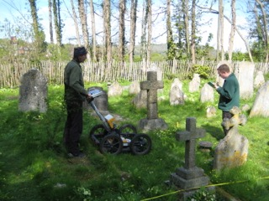
If the outline can be sufficiently identified, it will be delineated with marker stones in due course, much as has been done at Lewes Priory in recent times.
LAG members were invited to observe the carrying out of the GPR which took place on 4th and 5th May.

Whitehawk Hill – An Art Installation

The archaeology of Whitehawk hill became the focus for an evocative and mesmerising art film installation projected on three simultaneous screens at Brighton Museum and Art Gallery, during March and April of this year. The project created by artists from Red Earth, Simon Pascoe, Caitlin Easterby and Anna Lucas and also archaeologist, Matt Pope from UCL who was brought up near the hill, interlaced archaeology, art and the local community. It is marvellous to see this interdisciplinary cultural multi-layering. Even a generational boundary slid away as the children who participated in the filming came into the gallery to see themselves depicted and so became more acquainted with a gallery environment and ancient history.

The film captures the stark open landscape of the hill against the sea and attempts to conjure up the day-to-day activity of Neolithic times of hunting, feasting, drumming and ritual. Archaeology is gently illustrated rather than lectured, with visual overlays of the Whitehawk camp from 5,500 years ago and images of the pottery and flint tools found in the early 20th century, together with Matt Pope describing Neolithic hunting while skinning a deer. To remind us of one of the burials that were excavated, a pregnant woman sings to herself as she wanders the hilltop silhouetted against the sky, before she lies down, delicately positioning objects to represent the carved pendent that was unearthed beside the bones. Those participants or ‘actors’ are locals from Whitehawk, particularly those from a charity called ‘abanadofbrothers’ which is committed to positive social change in a community where young men may feel marginalised. It is exciting to find archaeology utilised in such an enthralling manner that moves through temporal, cultural, artistic and social confines.

Matt Pope wrote of his experience: “Working with Caitlin and Simon of Red Earth Arts is always an enlightening and magical experience. I see my role as a consultant on their projects to frame past human activity in a landscape within a framework of possibilities and waymarkers of archaeological record. What they achieve isn’t any kind of hollow reconstruction, it’s very much a work of landscape engagement and activation taking place in the present, but you can feel the weight of ancient resonance coursing through it. For me there is definitely a dynamic of feedback, their work gives human scale to landscapes and monuments, three dimensionality to low-relief traces of the past and an understanding of how sound, light and movement are such important parts of human use of space”.

Matt Pope will be giving a talk to Lewes Archaeological Group in November 2016 titled ‘A Land of Ice and Earth: Thoughts on the formation of the Chalk Downland Landscape in Prehistory.’

Alex Sutherland

Lewes Priory Trust Discovery Day and Walk

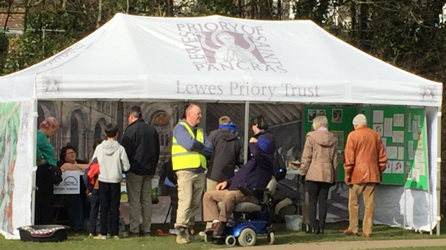

Lewes Priory Trust staged a free Archaeology Discovery Day in Priory Park on 12th March. Visitors learnt about the recent investigations of one of the drains from the first reredorter and there were displays of images and information from previous investigations on the site. Expert explanations and advice were on hand from archaeologist Simon Stevens who has been involved with the Priory for a number of years.

A new “virtual archaeology” game- Invisible Buildings- was launched on the day. Players use a computer tablet to play and the game uses GPS (Global Positioning System- like that used in car sat-navs) to locate the player on the Priory site. Players have to “find” (virtually) various objects on the site by searching the area. Some of these objects are interesting, some only modern rubbish and players have to make decisions about what to do with what they have found. Players also “uncover” the hidden walls of buildings that we know are located under the surface of the park. The game culminates with the virtual reconstruction of the bakery and brewhouse that would have been located on the site in the time of the monks. Although there is no real digging to be done in the game, players took to it enthusiastically and Lewes Priory Trust will use the game with groups in the future.

The Trust also unveiled a spectacular new teaching model which shows the development of the Priory until its destruction in 1538, as well as a new board game based on the lives of the monks at the priory.

Over 200 people attended the day and success of the event demonstrates the high level of interest in archaeology amongst all ages. Lewes Priory Trust are excited to be able to give people a taste of virtual digging in Priory Park where actual digging is so rare.

The Trust is also calling on people to sign up to a sponsored walk from Pyecombe to the Priory on Saturday 4th June starting at 11am. If you are interested please email enquiries@lewespriory.org.uk. The aim is to raise funds towards the development of a Kitchen Garden which will complement the Herb Garden in Priory Park.

Excavations in Lewes

21 High Street. An ongoing watching brief is being maintained during redevelopment of the site. Cobbled surface and masonry structures have been identified.

The Coach House, Brack Mound House, Castle Precincts. An archaeological watching brief recorded the grubbing up of the existing ground floor in the Coach House, with maximum excavation to a depth of approximately 500mm in order to lay a damp proof membrane and create a new floor surface. A large linear pit was excavated although the full extent of the feature disappeared underneath the main supporting north wall of the Coach House. Proof that the feature continues under the wall was obtained by utilizing an auger Also excavated were a tree-throw hole and a small burnt feature. Amongst the artefacts retrieved were a large animal bone assemblage and a well sealed assemblage of early medieval pottery from the fills of the pit and the tree-throw dating between AD1050-1150 which possibly dates the construction of the mound. Environmental sampling produced a good range of carbonised cereals and charcoal. Further survey work will hopefully define whether the pit lies underneath Brack Mound or on the edge of it.

Land rear of 25a Priory Street. Watching brief currently underway following previous evaluation of the site. Further structural remains possibly associated with Lewes Priory identified.

Former Lewes Magistrates Court. A watching brief was maintained on deep excavations during re-development of the site, historically occupied by a Franciscan Friary. The surface of the floodplain alluvium was recorded at around 2.18m OD. A range of domestic refuse was recovered from this deposit, including pottery animal and fish bone, oyster and charred plant remains. The pottery recovered is broadly dated to c.AD 1200-1275. The charred plant remains indicate a relatively dry environment, albeit one with a range of wetland habitats in the immediate vicinity. A single north-south masonry structure of chalk rubble was recorded at the level of the top of the alluvium. The structure remains difficult to interpret within the confines of the investigation but may represent either a clay capped embankment associated with the nearby river Ouse or a foundation associated with an early constructional phase of the medieval Lewes Friary. This was sealed by a 19th- century layer of chalk rubble which may be related to the construction of a railway line across the site. 20th- century deposits associated with the construction of the magistrates’ court in the 1980s sealed the sequence.

2A Chapel Hill. A test pit and building recording undertaken on the site of ‘Baldy’s Garden’ an 18^{th-} century pleasure garden and adjacent remains of a contemporary warehouse. The test pit exposed the brick-built remains of a mid-18th to mid-19th century cellar, characterised by a large number of blind alcoves which were later adapted for shelving. Part of an internal cellar wall was identified, displaying cuts within the brickwork, presumably for more shelving. There was also evidence of former beam-slots measuring c. 0.2m across, which would presumably have accommodated timbers running north-south to bear the floor above. The cellar was infilled and, by deduction therefore, demolished in c. 1900 to 1920.

A right worthy Gentleman and a truly pious lady in Folkington Church

In his seminal Catalogue East Sussex Church Monuments 1530-1830, published by the Sussex Record Society in 2009-2010, Professor Nigel Llewellyn reminds us that ‘church monuments are rich sources for local historians ‘ and that they ‘create lasting images about individuals…and families’. When he spoke to the LAG a few years ago he highlighted the glories of small rural churches full of unexpected treasures within.

Saint Peter ad Vincula in the hamlet of Folkington lies to the east of the Long Man of Wilmington, hidden in woodland at the foot of the downs. John Betjeman called this church ‘ancient and rustic’. The plain Early English flint walls belie the diversity and the high quality of the monuments inside. On stepping down the shallow steps into the nave the visitor is aware of a sense of uncluttered space. This is due to the seamless blending of the interior chancel and nave roofs and to the light which shines through the clear glass of the side windows. Our glance is drawn to the upper level of the chancel and to the Thomas monuments on the north and south walls, next to the altar. They are indeed the stars of the show in St Peter’s.

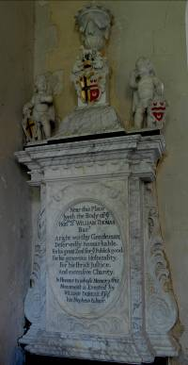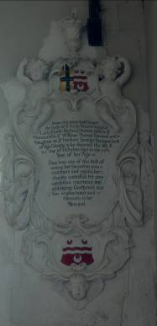

Images – Jon Murrell

Llewellyn says ‘The …monuments to the Thomas family…preserved in the sanctuary of Folkington church are a surviving group of great importance; they have been restored to the highest standard … are of exceptional quality, almost certainly made in London and shipped round the south coast and up a navigable river.. probably the Ouse, to be set up in St. Peter’s’. Sussex offered poor building stones.
Both memorials are made of the finest marbles; the ornate cartouche for Lady Barbara Thomas to the north is carved from a beautiful white stone, the larger work for Sir William is of four subtle shades of marble. The evidence of such costly materials and the professional standard of the work, and the position of the monuments in the grandest and most privileged place in the church - the chancel – tells us that Sir William and Lady Barbara Thomas were highly regarded in Folkington.

The inscriptions on the monuments fill in the story. The tribute to Lady Barbara Thomas records, ‘Near this place lieth interred the body of ye truly pious lady. Ye Lady Barbara Thomas, wife of the Honourable Sir William Thomas Bt., and daughter of Sir Herbert Springett Bt., both of this county, who departed this life 25th October 1697 in the 57th year of her age. She was one of the best of wives, her devotion was constant and regular, her charity extensive, her conversation courteous and obliging. Goodliness was her imployment and heaven is her reward.’

The engraved inscription on the William Thomas memorial reads, ‘Near this place lieth the body of the Hon. Sir William Thomas., Bart., A right worthy Gentleman, deservedly remarkable for his great zeal for ye Public good. For his generous Hospitality, for his strict Justice and extensive Charity. In Honour to whose Memory this Monument is erected by WILLIAM DOBELL Esq., his nephew & Heir.’

In 1653 Sir William had acquired the two Estates of Folkington village. After his death in 1705 his will left ‘an almshouse for three poor widows..and also 40 shillings ..and one load of wood to be given annually to each poor widow.’ He also gave into the care of the churchwardens ‘5 pounds per annum to A School Dame for the Instruction of the Poor Children of the said Parish.’ The Almshouses were in use until c.1885. A watercolour of 1889 by G.de Paris shows them as a flint, plaster and timber dwelling still in good condition. Sir William and his wife truly deserve their grand place in the chancel.

Sabrina Harcourt Smith

Pubs in Lewes

I have received an e-mail from Kevin Newman of All-Inclusive History who is
writing a book for Amberley Publishing called 'Lewes Pubs'.

He is interested in receiving any images, suggestions and information that he might be able to use in this book. He can be contact at info@allinclusivehistory.org or visit his website at www.allinclusivehistory.org

Summer Excavations in the Lewes area

If you are interested in becoming involved with an excavation this summer then here are three possible sites that may be of interest.

Bridge Farm Romano-British Settlement

The Culver Archaeological Project (CAP) will continue excavation of the Romano-British settlement site at Bridge Farm, just north of Lewes.
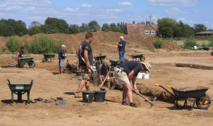
The 2016 season will be extended to 8 weeks from Monday 27th June to Sunday 21st August. Excavation Fees will be £25 for up to 7 days; £40 for up to 14 days or £60 for the whole season. See further at www.culverproject.co.uk.
Plumpton Roman Villa
The Sussex School of Archaeology is also continuing its excavation of the Plumpton Roman Villa from 18th June to 30th July. Volunteering costs £25 for one week/five days or £50 for the season. It is also running five day excavation techniques courses and Saturday taster days as well as other practical training courses. See www.sussexarchaeology.org

Ovingdean

The Brighton and Hove Archaeological Society will be excavating the site of a medieval manorial complex at Ovingdean. Excavations takes place on Wednesdays and at the weekends. For more information please see www.brightonarch.org.uk

Membership of LAG
As a member of LAG you are able to take advantage of LAG’s membership of the Council for British Archaeology. You can renew or join at any of our meetings, or send a cheque for £6 (payable to Lewes Archaeological Group) and sae to Brian Phillips, 2 Peronne Court, High St, Uckfield, East Sussex, TN22 1BL or Fiona Marsden, 13 Lansdown Place, Lewes, East Sussex, BN7 2JT. Please deliver by hand to Fiona.

Talks and events

BHAS Brighton & Hove Archaeological Society
ENHAS Eastbourne Natural History and Archaeological Society
FOAC Friends of Anne of Cleves House
LHG Lewes History Group
LAG Lewes Archaeological Group
SAS Sussex Archaeological Society
SSA Sussex School of Archaeology
USAS University of Sussex Archaeological Society

JUNE
Sat June 4 Lewes Priory Trust Sponsored Walk Pyecombe to Lewes (see article above).
Sat June 4 CBA – Pett Levels coastal tour and Winchelsea. Further info from events@cbasouth-east.org. Cost £5/free.
Fri June 10 ENHAS – the Artefacts of Pococks Field by Giles Dawkes. 7.30pm. St Saviours Church Hall, Eastbourne.
Sat June 11 SAS Tour of Lewes. 2.30pm
Wed June 15 SAS Tour of Stanmer House. 10.30am Cost £13.

JULY
Sun 10 July 2pm LAG, LHG, BHAS Malling Down Walk led by Greg Chuter. Meet at Mill Road car park.
Sat 16 July Brighton Museum Open Day. http://brightonmuseums.org.uk/discover/events/event/dig-it-family-archaeology-day/ Anybody and everybody is welcome and if you know of anyone that likes dressing up as a Roman or Saxon – we’d love to have them participating on the day.
Sun 17 July 8am BHAS Summer Outing to Piddiington Roman Villa led by Roy Friendship-Taylor. Members/non-members £25/28.
Sat 30 July ENHAS Symposium - the Society’s Medieval Excavations between 1977 and 1984. Birley Centre, Eastbourne.

AUGUST
Sun 7 August 8am BHAS Summer Outing to Roman Colchester. Members/non-mmbers £34/£31.
Tues 16 August SAS Tour of Slindon House. 10am. Cost £16.

SEPTEMBER
Sat 17 Sept CBA Ovingdean excavation and Lewes Town Tour. Further info from events@cbasouth-east.org. Cost £5/free.

OCTOBER
Sun 2 Oct Sussex Industrial Archaeology Society Sussex Mills and their preservation
Sat 8 Oct SSA Neolithic Study Day with Chris Butler 10-5pm. Redoubt Fortress, Eastbourne. Cost £35/30.
Sat 15 Oct SAS Autumn Conference. The Age of Luxury: the Georgian Country House and its Setting c1700-1820. Kings Church, Lewes.

The Sussex School of Archaeology also runs practical day schools on all aspects of field archaeology including illustration, geo physics, finds preservation and field walking as well as holding other events. To find details of these courses visit - http://www.sussexarchaeology.org
The Lewes History Group holds talks on the second Monday of the month at 7.30pm, at King’s Church, Lewes. A project progress group meets on the third Monday of the month for members carrying out local research (for details tel 813388 or email John Kay at johnkay56@googlemail.com. Jane Lee is responsible for publicity and can be contacted by e-mail at jane.lee@dexterity.co.uk or phone 487617. Further information can be obtained from - http://leweshistory.org.uk/

