

Lewes Archaeological Group newsletter

No. 148
May 2014
www.lewesarchaeology.org.uk

Affiliated to the Sussex Archaeological Society
and the Council for British Archaeology

NEXT LAG LECTURE

Friday 3rd October at 7.30pm,
Lecture Room, Lewes Town Hall,
Fisher Street Entrance

Friday 19 April 2013, 7.30pm

Romano-British discoveries in the Barcombe area
With David Millum and Rob Wallace.

Following their talk last year on the Barcombe Roman Bath House, David and Rob bring news of some exciting new discoveries nearby, which may help explain more about what could have been going on in Romano-British Barcombe.

Lecture room, Town Hall, Lewes
(Fisher Street entrance). Lift available

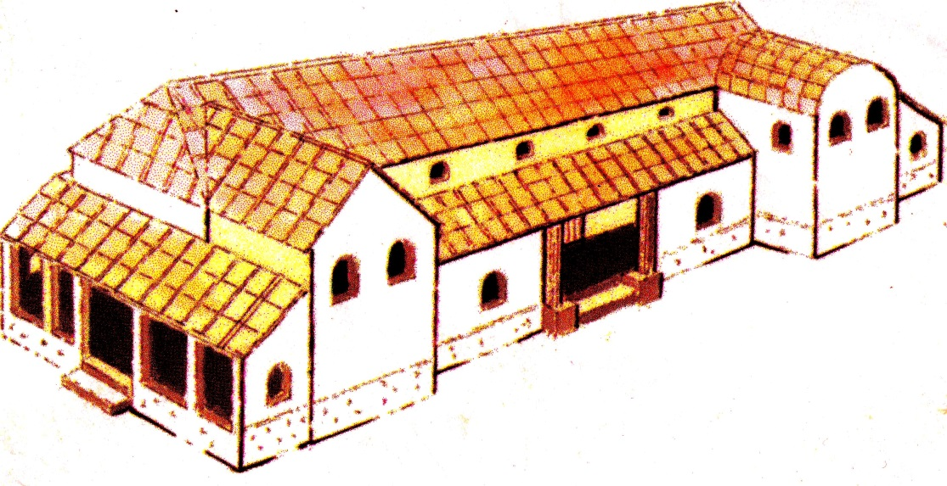

Plumpton Roman Villa

The image above is an imaginative reconstruction of Plumpton Roman Villa. The site of the villa lies below the fields between the Downs at Plumpton Agricultural College and the Roman road along the Greensand Ridge. The existence of the villa has been known since the mid-1970s when chalk and flint were brought to the surface by ploughing. A geophysical survey was carried out over the winter by volunteers under the

supervision of David Millum, for the Sussex School of Archaeology, as part of a wider survey by Chris Butler Archaeological Services on behalf of the College. This survey has provided new images that show the layout of the villa in much more detail. The image appears to show a building of 8 to 9 rooms, around 40 metres wide facing south with protruding wings at each end. The more intense readings to the western wing may indicate a heated room or even a small bath suite.
The Sussex School of Archaeology have a programme of exciting courses planned for 2014 which will include week long excavation training at the villa site during July and early August (see further below under heading “Fieldwork Opportunities”).
Recent developments at Bridge
Farm Roman Settlement

Activities have continued to take place at Bridge Farm since the end of last summer’s excavation.

At Cowlease, the farm to the south of Culver, further work took place to continue to trace the ‘Culver’ Roman Road to the south. The road excavated in 2009 proved to be far more substantial than had been expected with a large Downland flint layer over 400mm thick suggesting that this was far more than just an estate road. The work last autumn has established the slightly curving course of the road in a field called Northend which is two fields south of the villa in Dunstalls Field. As with the roads at Bridge Farm the magnetometry survey results only show the ditches. This work has allowed the plotting of the route of the road from Pond Field to Northend and to project its course further south.

Further geophysics was carried out at Bridge Farm itself. This showed the continuation of the Roman road through Ringmer and Laughton with some field boundaries.

Excavations will commence at the settlement site from 30th June and will go on until 9th August (see further below under heading “Fieldwork Opportunities”).

Feasting, Fighting and Freedom

Children from St Pancras School had their very own Battle of Lewes Feast of St Pancras as part of the latest education initiative from the Lewes Priory Trust. Called “Feasting, Fighting and Freedom” the project brought to life the preparations for the Battle for local school children. The whole day event involved pupils making food for the Feast of St Pancras and decorating the hall to be fit to welcome King Henry III. The King descended on the Priory with thousands of his knights and soldiers, much to the consternation of the monks who were busy preparing for the important celebration of their patron saint.

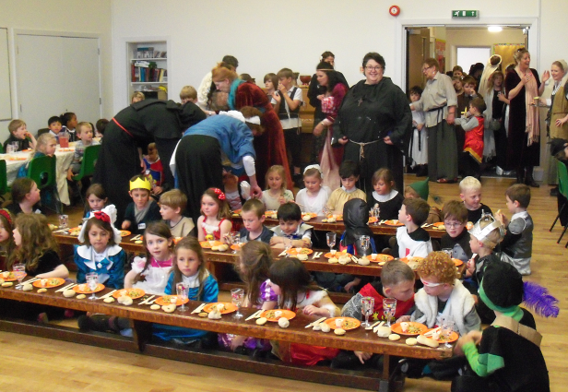

Once the feast and the hall were ready the children, all in medieval costume, welcomed the King with a trumpet fanfare and then tucked in to the delicious delicacies they had prepared. Children also learned how the monks used herbs to tend the wounded from the Battle.

Lewes Priory Trust is keen that local school children are all able to experience aspects of the Battle and life at the time for themselves. The Trust’s education officers, Helen Chiasson and Kate Hickmott will take the event to other schools- contact them at education@lewespriory.org.uk for further details. The project is supported by the Heritage Lottery Fund.

LAG programme 2013-14

Paula Stanyer is in the process of organising the lecture programme for LAG for the coming year. All talks take place in the Lecture Room, Lewes Town Hall, Fisher Street Entrance and start at 7.30pm.
It is intended to have speakers talking about a diverse range of subjects and periods.

Although, the programme is not fixed, the dates have been booked with the Town Hall. The first lecture will take place on Friday 3rd October.

Membership of LAG now due

Membership for 2013/14 was due in April. If you are not sure if you have re-joined please ask Brian on the door at the next talk or contact him on 07749 625 101 or Anne at anne.locke@talktalk.net.

You can renew or join at any of our meetings, or send a cheque for £6 (payable to Lewes Archaeological Group) and sae to-

Brian Phillips, 2 Peronne Court, High St, Uckfield, East Sussex, TN22 1BL;

Fiona Marsden, 13 Lansdown Place, Lewes, East Sussex, BN7 2JT. Please deliver by hand to Fiona.

As a member of LAG you are able to take advantage of LAG’s membership of the Council for British Archaeology. This includes accessing a digital subscription of the CBA,s magazine and back issues (http://new.archaeologyuk.org/british-archaeology-online. If you are a member of LAG you need to e-mail Paula Stanyer (paulawodcohen@yahoo.co.uk) to get the log in information. You also access a range of other benefits from free entry to heritage venues and discounts on publications. To find out more see http://new.archaeologyuk.org/offers-and-discounts)

Thoughts from the new Chair
Paula Stanyer was elected the new Chair of LAG at LAG’s AGM at the end of March.
Anne Locke stood down as Chair after seven years service. Anne did a splendid job and LAG has benefited enormously from her expertise and enthusiasm. Happily Anne will remain very much involved with LAG. She was elected Vice Chair of LAG, she will maintain various records, including membership records and she intends to work on the sorting out of various finds.

Paula has no radical plans for the future of LAG. The lecture programme attracts a good audience and offers something different and additional to talks by other Groups in Lewes. Organising one or two walks to or around places of archaeological interest would supplement the talks well. It would be good to try and broaden the appeal of LAG’s talks, particularly to a younger audience. Whilst LAG is no longer as a Group involved in fieldwork, there are many opportunities for Lewesians to take part in excavations taking place in the local area as are mentioned in this newsletter.

Paula would very much welcome ideas and suggestions, both in relation to topics for the lecture programme and for other activities that LAG might become involved in. You can e-mail her at paulawodcohen@yahoo.co.uk.

Alex’s Mystery Photographs
Two church stained glass windows, one near (picture 1) and one far (picture 2). Do you know where they are from and from which period?
Picture 1 
Picture 2
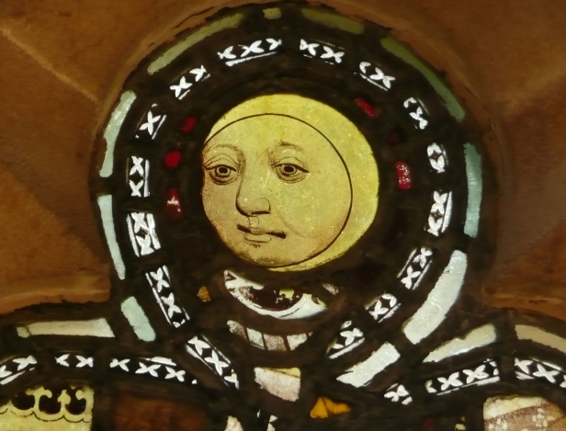

Fieldwork opportunities

Excavations will continue at the Roman settlement site at Bridge Farm, near Barcombe from 30th June until 9th August (see photo below of last year’s dig). As the excavations are not supported with Lottery funding this year, there will be a charge of £30 for one week or £50 for the whole season. There is also the possibility of camping at £50 per week which includes the excavation fee. For further details see www.culverproject.co.uk.

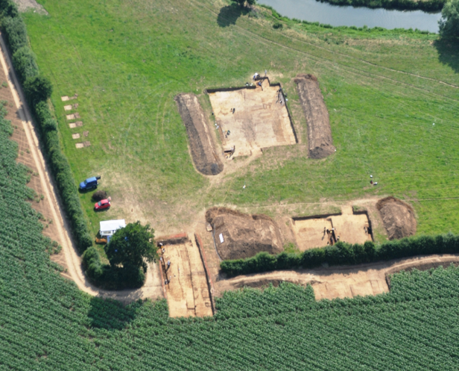

The Sussex School of Archaeology will be running in July an excavation at Plumpton Roman Villa, which will be a venue for four 5-day excavation training courses beginning Monday 7th July (tuition fee: £150; 9.30am-5pm). There will also be weekend courses which will include one day taster training courses on Saturday 12th and 26th July (10-4; cost £40). Other courses at Plumpton will include archaeological surveying - the basics (5th July); first aid for finds (19th July); planning and section drawing (16th August); and photography for archaeologists (23rd August).
The School will also run other excavations as either training venues or for academic research as opportunities arise, and during the year it is hoping to arrange an excavation related to the centenary of the start of the First World War. Details of these excavations, and the associated training courses available, will be posted on the School’s website as soon as they are available - http://www.sussexarchaeology.org/#!excavatios--2014/csg

Brighton and Hove Archaeological Society (BHAS) Although, LAG does not carry out any fieldwork at the moment, BHAS is very active on this front. In April excavations commenced at Ovingdean which is a medieval site and geo physics at Whitehawk which is a prehistoric site. Newcomers welcome whatever their experience. Cost is £15 full and £7.50 for students and people must have a current tetanus inoculation. Age from 16 years upwards. Contact John Funnell at john.funnell@brightonarch.org.uk for more details.
ARCHAE
The Tidemills Project is a community project open to all, engaged in both historical research and on-site survey and recording of this important site between Newhaven and Seaford, usually on Thursdays and should be starting again in May. Contact Luke Barber on 01273 405733 or email research@sussexpast.co.uk

Talks and events 2014

BHAS Brighton & Hove Archaeological Society
FOAC Friends of Anne of Cleves House
LHG Lewes History Group
LAG Lewes Archaeological Group
SAS Sussex Archaeological Society
SSA Sussex School of Archaeology

JUNE

Wed 4, 11 and 18 June SSA An Introduction to Ancient Egypt (3 sessions). Venue: May’s Farm Selmeston 10-12am. Fee £40.
Thurs 5, 12 and 19 June SSA An introduction to coins in archaeology by David Rudling (3 sessions). May’s Farm Selmeston 10-12am. Fee £40.
Fri 6 and 13 June SSA Defending the Sussex Coast (2 sessions). May’s Farm Selmeston 10-12am. Fee £25.
Fri 6 June FOAC Lewes Breweries Walk led by Miles Jenner.
Sat 7 June SSA Visit to Fishbourne and Bignor Roman Villas with David Rudling. £40 including entrance fees.
Mon 9 June LHG Victorian and Edwardian Photographers in Lewes by amateur photo-historian, David Simkin. 7.00 – 9.00pm at Kings Church building, Brooks Rd, Lewes, BN7 2BY.
£2/£3 (members/non-members).
Sat 14 June SAS AGM and post AGM tour of either Lewes Priory or Anne of Cleves House.
Sat 14 June SSA One day courses on either Flint Knapping or Saxon Cooking at Bentley Country Park. £40.
Sat 14 June SSA Churchyard Survey at Berwick Church by Chris Butler. £40.
Sat 21 June SSA The Archaeology of Fields various speaker. All day event. Rural Business Centre at Plumpton College. £30.
Wed 25 June BHAS Summer Solstice at Caburn Iron Age hill fort. Meet BHAS at Glynde village car park at 7.30pm for a short and gentle walk past Glynde Place to the top. Bring readings and libations (i.e. drinks!).
Sat 28 June SSA Recording a Church at Arlington Church. Fee £40.

JULY

Sun 6 July SAS Tour of Bignor Roman Villa and Bignor Hill led by David Rudling. £12.
Mon 14 July LHG Racing into History – The inside track on Lewes’ horseracing industry by John Turley. 7.00 – 9.00pm at Kings Church building, Brooks Rd, Lewes, BN7 2BY. £2/£3 (members/non-members).
Sat 19 July SAS Devil’s Dyke from Pleasure Grounds to Bombing Ground guided walk led by Martin Snow. £6.

AUGUST

Sat 2 August SSA Experimental archaeology course – making prehistoric textiles. Bentley Country Park. £40.
Sat 9 August SSA Experimental archaeology course – making prehistoric pottery. Bentley Country Park. £40.
Tues 19 August SAS Military archaeology around Michelham Priory by Chris Butler. Great Barn, Michelham Priory. £6.

SEPTEMBER

Sat 6 Sept SSA Iron Age and Roman Coins by David Rudling. Fishbourne Roman Palace. Fee £40.
Sat 6 Sept SSA 1914 - A War Manoeuvre and Stalemate. Various Speakers. 10am-5pm at Newhaven Fort. £35.
Mon 8 Sept LHG Dripping Yarns – A history of the Dripping Pan, home of Lewes Community Football by David Arnold. 7.00 – 9.00pm at Kings Church building, Brooks Rd, Lewes, BN7 2BY.
£2/£3 (members/non-members).
Sat 13 Sept SSA Sussex Industrial History by Geoff Mead. Venue in Brighton. £40.
Fri 26 Sept FOAC The County Cup and Lewes Racecourse talk by John Turley.
Sat 27 Sept SSA Soils and sediments day school with Mike Allen. May’s Farm, Selmeston. Fee £40.

OCTOBER

Fri 10 Oct BHAS James Cole talk on
Language Development and use of material culture within hominin social signalling during the Pleistocene – recent research. Unitarian Church, New Road, Brighton. Free to members, visitors £3. TBC.
Sat 11 Oct SSA Identifying Human Bones by Sarah Green. Brighton. £40.
Sat 11 Oct SSA Experimental archaeology – hunter-gatherer cooking with Annalie Seaman. Bentley Country Park. £40.
Mon 13 Oct LHG In and Out of the Twittens by Kevin Gordon. 7.00 – 9.00pm at Kings Church building, Brooks Rd, Lewes, BN7 2BY. £2/£3 (members/non-members).
Sat 18 Oct SSA Landscape Archaeology by Vivienne Blandford. Buxted Reading Room. £40.
Fri 24 Oct FOAC AGM and talk on the Commonwealth War Graves Commission by Ian Everest.
Sat 25 Oct SSA Farming Practices and Archaeology. All day event. Various speakers. Falmer Rural Business Centre, Plumpton College.
Sat 25 Oct SSA Maritime Archaeology with Dudley Moore and Sarah Green. May’s Farm Selmeston. £40.

NOVEMBER

Sat 1 Nov Council of British Archaeology South East Conference a tribute in memory of Peter Drewett with speakers drawn from contributors to the new book “Archaeology and Land Use of South East England to 1066”. Venue and time to be confirmed.
Mon 10 Nov LHG The Social Impact of the Great War by Lucy Noakes. 7.00 – 9.00pm at Kings Church building, Brooks Rd, Lewes, BN7 2BY. £2/£3 (members/non-members).
Fri 14 Nov BHAS Luke Barber - WW1. Unitarian Church, New Road, Brighton. Free to members, visitors £3. TBC.
Sat 29 Nov SSA Tudors in Castle by Helen Poole. Lewes Castle. £40.

DECEMBER

Mon 8 Dec LHG AGM and topic to be confirmed. 7.00 – 9.00pm at Kings Church building, Brooks Rd, Lewes, BN7 2BY. £2/£3 (members/non-members).
Fri 12 Dec BHAS AGM and John Skelton - Ovingdean excavations. Unitarian Church, New Road, Brighton. Free to members, visitors £3. TBC.

2O15

Fri 9 Jan BHAS John Shepherd - Mithraic Temple , London. Unitarian Church, New Road, Brighton. Free to members, visitors £3. TBC.
Fri 13 Feb BHAS Paul Bennett - Archaeology in Libya . Unitarian Church, New Road, Brighton. Free to members, visitors £3. TBC.

Fri 13 Mar BHAS Jaime Kaminski - Archaeological Digital Data. Unitarian Church, New Road, Brighton. Free to members, visitors £3. TBC.

The Sussex School of Archaeology also runs practical day schools on all aspects of field archaeology including illustration, geo physics, finds preservation and field walking. To find details of these courses visit - http://www.sussexarchaeology.org
The Lewes History Group holds talks on the second Monday of the month at 7.30pm, at King’s Church, Lewes. A project progress group meets on the third Monday of the month for members carrying out local research (for details tel 813388 or email John Kay at johnkay56@googlemail.com.
Jane Lee is responsible for publicity and can be contacted by e-mail at jane.lee@dexterity.co.uk or phone 487617. Further information can be obtained from - http://leweshistory.org.uk/

Answers to the picture quiz

Picture 1: Detail of window by Marc Chagall 20th century, All Saints Church, Tudeley, near Tonbridge.

Picture 2: Porch stained glass window from medieval period in church pre 1066, St Mary's Church, Burnham Deepdale, Norfolk.

