

Lewes Archaeological Group newsletter

No. 146
March 2013
www.lewesarchaeology.org.uk

Affiliated to the Sussex Archaeological Society
and the Council for British Archaeology

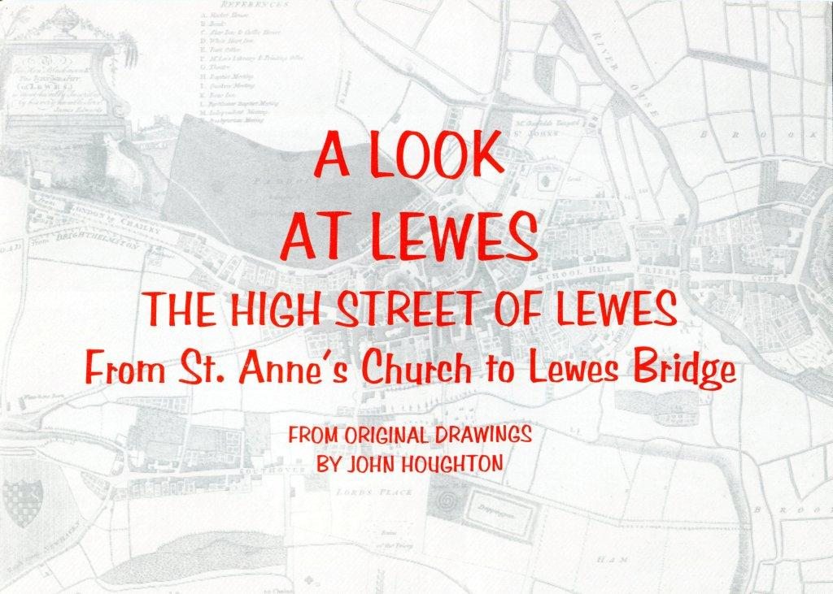

Next lecture

Friday 19 April 2013, 7.30pm

Romano-British discoveries in the Barcombe area
With David Millum and Rob Wallace.

Following their talk last year on the Barcombe Roman Bath House, David and Rob bring news of some exciting new discoveries nearby, which may help explain more about what could have been going on in Romano-British Barcombe.

Lecture room, Town Hall, Lewes
(Fisher Street entrance). Lift available
Annual membership is now due – it runs from 1 April 2013 and costs only £6
Please renew promptly
You can renew or join at the next meeting, or send a cheque
(payable to Lewes Archaeological Group) and sae to:
Brian Phillips, 2 Peronne Court, Uckfield, East Sussex, TN22 1BL (note change of address)or by hand to:
Fiona Marsden, 13 Lansdown Place, Lewes, East Sussex, BN7 2JT (01273 473946).
Tribute to John Houghton
John Houghton, who died in February, was a leading figure in establishing the Lewes Archaeological Group in about 1969. At the time he was a keen amateur historian, principally of Lewes’ medieval past, and he ran an attractively modern interior design and kitchenware shop, close to the Whitehart Hotel. As John used to tell it, the dishevelled figure of Jock Knight-Farr (who worked as a road mender) came into the shop rather too often for comfort, bringing his latest finds from utilities trenches from across Lewes and further afield. Eventually, John and Jock, together with others such as Ted O’Shea (who was manager of the building firm Llewellyns) and Richard Lewis (a graphic designer) set up LAG at a time when rescue archaeology was gathering momentum in response to the 1960s building boom and widespread redevelopment of historic towns.
In 1970s, LAG carrying out fieldwork, become a serious bone of contention amongst LAG committee members. John, who as a historian, did no digging, was above these battles and he proved an able chairman able to keep the peace. He also did his best to smooth the path of the Sussex Archaeological Unit, a professional team set up by the
Institute of Archaeology in London in 1974/5, when
it too started to excavate in Lewes.

An enduring memory of those years is John puffing
his way through endless black cheerots. Later he
prided himself on quitting smoking and he soon
moved on from LAG too taking on an active role in
Local Government and then running the Sussex
Archaeological Society as General Administrator for
several years. He never lost interest in LAG and
helped save it about 10 years ago when it seemed
likely to fold.

Fiona Ramsden

Thoughts from the Chair

This is a short contribution as I am happy to see that our new newsletter editor Paula Stanyer has managed to source an unusually full issue. I am also happy to note that she has agreed to join the committee, along with a return to the committee by David Gregory, who now has a little more time since retiring and completing his write-up of the group’s Ringmer kiln excavation at Norlington Lane. Along with many archaeological societies we now have to face the problem of what to do with the finds long-term, as most museums have long run out of space.

It’s clear that things have moved on rapidly in local archaeology over the winter. Following confirmation of the demise of the University of Sussex’s CCE archaeology course programme, Chris Butler and David Rudling have launched the Sussex School of Archaeology, with an exciting programme listed in this newsletter. We will have brochures at the next talk, where David Millum and Rob Wallace will explain the other exciting local developments at Barcombe – see inside for details. This summer’s excavation there and the usual opportunities with Brighton and Hove Archaeological Society seem to the committee to offer sufficient practical opportunities for local voluntary archaeologists at present, so we have decided for the time being to discontinue our insurance cover for excavation and buildings work. This will save some £200 a year. Meanwhile we hope to arrange a few summer activities, walks and visits ourselves – if we do not already have your email address please let me know it, as this is the easiest way to keep you in touch.

We look forward to seeing you at the April talk and AGM.

Anne Locke
01273 475381, anne.locke@talktalk.net



Launch of the Sussex School of Archaeology
This time last year the LAG’s newsletter noted the demise of the University of Sussex’s Centre for Community Engagement and the end of its courses in archaeology. It is therefore extremely good news that the Sussex School of Archaeology has been launched. The School is run by Chris Butler Archaeological Services Ltd under the Direction of Chris Butler and managed by Lisa Jayne Fisher with David Rudling as Academic Director.

The School will run a series of day schools, evening classes and trips, together with practical training courses to suit the interested armchair archaeologist as well as the keen amateur or professional looking to enhance their existing knowledge and skills. The course tutors are all specialists, most of whom taught recently at the University of Sussex and are very experienced in their fields. The programme for 2013 can be found in the School’s course brochure which can be found at www.sussexarchaeology.co.uk or is obtainable by e-mailing the School at info@sussexarchaeology.co.uk or calling on 01323 811785.

The School will be looking to run a new research excavation following on from the excavation at Barcombe. Plans are already in the pipeline for this and an announcement will be made soon. The School will be looking for volunteers to come forward for this project with roles ranging from excavators to finds supervisors to be filled.
The School will shortly be setting up a new website, but it has a temporary page (which will be the same address) www.sussexarchaeology.co.uk.

The Culver Archaeological Project will be running a six week excavation from Monday 1st July 2013 until Saturday 10th August . The Culver Archaeological Project was formed in 2005 to investigate the archaeology and landscape surrounding Barcombe Roman villa. The project to date has discovered an unknown Roman road, a Roman Industrial site and a Bronze Age landscape.

Through a magnetometer survey and field walking a picture has emerged of a Roman settlement on a bend of the river Ouse. It is thought that the settlement was Roman and was over 300 years duration.

Its location is ideal being on the cusp of the iron producing Weald with easy access for boats to ship the iron and with the Greensand Way heading to Hardham and then on to Chichester linking with London Lewes road and an easterly route to Pevensey. The importance of the site is enhanced by the close proximity of Barcombe Roman villa, a sizable bath house and CAP’s road and industrial site, just across the river. There is a double ditch enclosure which appears to cut the settlement. There is definite phasing to the site and it is this aspect that is the main priority of the CAP’s excavation trenches in 2013.

For further details of the project please see the full project design at www.culverproject.co.uk.

Fruitful times ahead for Lewes Priory Park

Students from Priory School in Lewes learnt about fruit tree planting and the role of orchards in medieval monasteries on 8th February 2013.
Working under the guidance of Brighton Permaculture Trust and Action in Rural Sussex they planted six apple trees in a corner of the site of Priory Park.

The orchard planting is part of Local Fruit Futures, a lottery-funded project which has enabled the planting of over 40 small orchards in schools, parks, housing estates, care homes and village greens.

The small orchard serves as a reminder of the much larger orchard which once existed. The trees are old Sussex varieties, now mostly rare. Monasteries were repositories of orchard skills for hundreds of years and we know from records that apples, pears and plums were all tended by the monks at Lewes Priory. Unlike today they were not often eaten raw, but cooked and many apples were turned into cider.
The planting work was overseen by Simon Stevens, Senior Archaeologist, at Archaeology South East and a number of interesting historical artefacts were unearthed. We are awaiting the final report but items included: white glazed Victorian picnic-ware with a cobalt blue pattern; portions of locally sourced stone roof tiles with mortar on one side; a large triangular shaped metal object yet to be identified! Archaeology South East are also cataloguing and examining the finds from Lewes Priory Park unearthed in summer 2010. It is hoped that some of these key pieces can be used to start a handling collection to support our work in schools.

Alex’s Mystery Photographs, Part 4
Continuing the theme of the British Museum’s Ice Art current exhibition, what are the districts, countries and dates of these images?

Picture 1
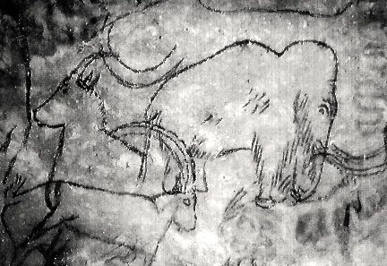
Picture 2
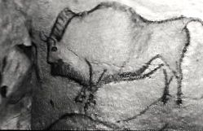

Picture 3
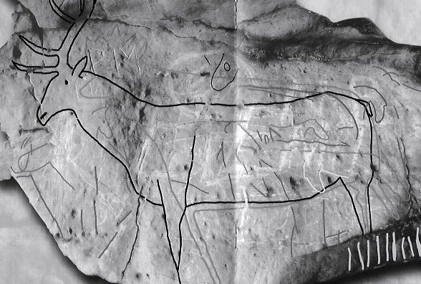

Fieldwork opportunities

Brighton and Hove Archaeological Society (BHAS) BHAS will commence digging at Rocky Clump on Saturday 30th March. It is a Late Iron Age and early Romano-British farmstead. BHAS is currently working within an Iron Age enclosure, which appears to be a early phase of the complex. Newcomers welcome whatever their experience. Cost is £12 full and £6 student and people must have a current tetanus inoculation. Age from 16 years upwards. Contact John Funnell at john.funnell@brightonarch.org.uk for more details.

Mid-Sussex Field Archaeology Team (MSFAT) often has opportunities for weekend volunteers at local sites – including excavation, finds processing, field walking and resistivity surveys. No experience necessary. Membership £8. Chris Butler 01323 871021, website www.cbasltd.co.uk

The Tidemills Project is a community project open to all, engaged in both historical research and on-site survey and recording of this important site between Newhaven and Seaford, usually on Thursdays. Contact Luke Barber on 01273 405733 or email research@sussexpast.co.uk

Talks and events 2013

BHAS Brighton & Hove Archaeological Society
FOAC Friends of Anne of Cleves House
LHG Lewes History Group
LAG Lewes Archaeological Group
SAS Sussex Archaeological Society
SSA Sussex School of Archaeology
USAS University of Sussex Archaeological Society

Sat 6 Apr SAS study afternoon Sussex
Cliffe Church and the Seaside Resort c. 1740-
Hall, Lewes 1940. 01273 405737 or see
1-5pm, £20 www.sussexpast.co.uk
Fri 12 Apr BHAS: The archaeology of Rapa
Unitarian Ch, Nui (Easter Island) with
New St, B’ton Professor Sue Hamilton of the
7.30pm Institute of Archaeology. £3.
Fri 19 Apr LAG: Romano-British discoveries
Lecture Room, in the Barcombe area with David
Lewes Town Millum and Rob Wallace. To be
Hall, 7.30pm followed by the AGM at c.9pm.
Sat 20 April SSA: Paperwork for archaeologists: Simon Stevens. The Bridge Community Centre Brighton, 10am – 4pm. Cost £30.
Thu 25 April USAS: The Sussex Bronze Age
Fulton Lecture, Hoard with Stephanie Smith,
Theatre B, Uni Finds Liaison Officer. 7pm. £2
of Sussex.
Sat 27 April SSA: Sussex Archaeology Symposium. Fulton Building, Lecture Theatre A, Uni of Sussex.
Wed 1 May BHAS walk: The history and more about Hangleton. Meet at Hangleton Library at West Way at 7pm. Leader is Geoff Mead.
5-6 May SAS:Ancient Crafts Festival10.30-5pm
Michelham Priory. www.sussexpast.co.uk
Sat 11 May BHAS walk: Hillforts and Flint Mines – A tour around Cissbury. Meet at the car park at Storrington Rise, Findon at 11am. Leader is John Funnell. This walk will be in conjunction with the CBASE. Stout walking shoe required. (TQ128077).
Sat 11 May SSA: Rock and building stone identification: Luke Barber. Linklater Pavillion, 10-1pm. Cost £30.
Mon 13 May LHG: How the Country Influenced Lewes Town: Sue Berry. 7.30,
Kings Church Building, Brooks Rd, Lewes. £2/£3.
Tues 14 May SAS: March on Lewes. Walk from Fletching to Lewes to commemorate the Battle of Lewes. 9.30-5pm. www.sussexpast.co.uk
Sat 18 May SSA: Researching Historical documents: Dr.Janet Pennington. Linklater Pavillion, 10-4pm. Cost £30.
Wed 22 May BHAS walk: Bramber Castle and Sele Priory. Meet at Bramber village car park at 7pm. Leader John Funnell. Castle ruins, the Adur river and little lanes.
Thurs 23 May USAS: Excavations on Romney Marsh with Kevin Fromings. 7pm at Fulton Building, Lecture Theatre A, Uni of Sussex. £2.
Sat 1 June SSA: Exploring the Wealden Iron Industry: Jeremy Hodgkinson. Nutley Memorial Hall., 10-4pm. Cost £30.
Wed 5 June BHAS walk: The history and more about Coldean. Meet at Coldean Library, Beatty Avenue at 7pm. Leader is Geoff Mead.
Sat 8 June SSA: Flint knapping: Paul Saddleton. Bentley Woods., 10-4pm. Cost £30. Stay the night in a prehistoric roundhouse offer.
Mon 10 June LHG: A Turbulent History of Pub Life in Lewes.7.30, Kings Church Building, Brooks Rd, Lewes. £2/£3.
Wed 12 June BHAS Walk: The Devils Dyke – Iron Age hillfort, pleasure ground, military activities and more. Meet at The Devils Dyke Car park at 7pm (you may have to pay to park if you are not a National Trust member). Leaders are Martin Snow and John Funnell.
Sat 15 June SSA: The Tudors by Helen Poole. Linklater Pavillion. 10am – 4pm. Cost £30.
Wed 19 June BHAS walk: Ovingdean – Meet at Ovingdean church at 7pm. A walk around the hills and valley of this ancient settlement. Leader is John Funnell. One steep climb and descent.
Sat 22nd June SSA: Making prehistoric toolkits: Paul Saddleton. Bentley Woods, 10-4pm. Cost £30. *SPECIAL OFFER* stay the night in a prehistoric roundhouse!
Sat 22 June SSA: Traditional surveying for beginners: David Millum. Excavation site, 10-4pm. Cost £30.
Wed 26 June BHAS walk: Caburn Summer Solstice- Poems, libations and a celebration of summer. Meet at Glynde Village car park at 7pm.
Wed 3 July BHAS walk: Scheduled Ancient Monuments at Ditchling Beacon. Meet at Ditchling Beacon car park at 7pm. A short walk to examine the collection of barrows and earthworks along the South Downs Way.
Sat 6 July SSA: Four churches in the Cuckmere Valley: Rachel Butler. Various sites, 10-4pm. Cost £30
Wed 10 July BHAS walk: The history and more about Saltdean. Meet at Saltdean Library, Saltdean Park Road at 7pm. Leader isGeoff Mead.
Sat 13th July SSA: Site photography for archaeologists: Lisa Fisher. Excavation site, 10am – 4pm. Cost £30.
Sat 13 July SSA: Introduction to archaeology: David Rudling. Field trips, 10am-4pm. Cost £30.
Sat 20 July SSA: Conservation in the field: Chris Cleere. Excavation site, 10-4pm. Cost £30.
Sat 27 July SSA: Excavation techniques for beginners: Lisa Fisher. Excavation site, 10am – 4pm. Cost £30.
Sat 3 August SSA: Planning and section drawing: Jane Russell. Excavation site, 10-4pm. Cost £30.
Sat 10 August SSA: Churchyard recording: Chris Butler. Field venue, 10-4pm. Cost £30.
Sat 20 August SSA: Finds recording and management: Luke Barber. Field venue, 10am – 3pm. Cost £30.
Sat 7 Sept SSA: Snails, shells and slugs. Dr.Michael Allen. Linklater Pavillion, 10-4pm. Cost £30.
Sat 7 September SSA: Iron Age and Roman coins by David Rudling. The Bridge Community Centre, Brighton, 10-4pm. Cost £30
Mon 9 September LHG: The Romans at Ringmer: David Millum. 7.30, Kings Church Building, Brooks Rd, Lewes. £2/£3.
Sun 14 September SSA: Soils and sediments: Dr.Michael Allen. Linklater Pavillion, 10-4pm. Cost £30.
Sat 28 Sept- 2nd Oct Lewes Priory Trust: Tour of Iona, St Ninian and St Columba, Dr Anthony Freeman. For info contact: afreeman@tesco.net.
Sat 12 October SSA: Landscape archaeology: Vivienne Blandford. The Reading Room, Buxted. 10-4pm. Cost £30.
Mon 14 October LHG: Chapel Hill - Street Story
An update from Meg Griffiths & two colleagues.
7.30, Kings Church Building, Brooks Rd, Lewes. £2/£3.
Sat 19 October SSA: Finds illustration: Jane Russell. Linklater Pavillion 10am – 4pm. Cost £30.
Sat 26 October SSA: Hunter gatherer cooking: Annalie Seaman. Bentley Woods, 10-4pm. Cost £30. *SPECIAL OFFER* stay the night in a prehistoric roundhouse!
Sat 2 Nov SSA: Military archaeology: Simon Stevens. Pevensey Castle and Battle, 10-4pm. Cost £30.
Sat 9 Nov SSA: Woodland survey: Vivienne Blandford. Nutley Memorial Hall, 10-4pm. Cost £30.
Mon 11 November LHG: Lewes and the Railway
John Hollands & Ian McClelland. 7.30, Kings Church Building, Brooks Rd, Lewes. £2/£3.
Sat 23 Nov SSA: Identifying animal bone: Sarah Green. Linklater Pavillion, 10am – 4pm. Cost £30.
Sat 30 Nov SSA: Identifying human bone: Sarah Green. Linklater Pavillion, 10am – 4pm. Cost £30.
Sat 7 Dec SSA: How to write an archaeological report: Simon Stevens. Linklater Pavillion, 10-4pm. Cost £30.
Mon 9 December LHG: AGM & Update on East Sussex Records Office relocation to The Keep. 7.30, Kings Church Building, Brooks Rd, Lewes. £2/£3.

The Lewes History Group
The Lewes History Group holds talks on the second Monday of the month at 7.30pm, at King’s Church, Lewes. A project progress group meets on the third Monday of the month for members carrying out local research (for details tel 813388 or email John Kay at johnkay56@googlemail.com.
Jane Lee is responsible for publicity and can be contacted by e-mail at jane.lee@dexterity.co.uk or phone 487617.
Further information can be obtained from - http://leweshistory.org.uk/

Answers to the picture quiz

Picture 1: Covaciella Cave, Austurias, Spain. Maybe 14,000BP or earlier.

Picture 2: Woolly mammoth - Rouffignac, Dordogne, France. 13,000BP.

Picture 3: Stag - Creswell Crags, Derbyshire, England. 11,000BP.

Next newsletter: September 2013.

Contributions to Paula Stanyer at paulawodcohen@yahoo.co.uk by end August please.

If you could receive this newsletter by e-mail and don’t already do so, that would be very helpful and save LAG some time and costs. Please e-mail Alex at asutherland3@sky.com if you would be willing to do so.

