

Lewes Archaeological Group newsletter

No. 144
March 2012
www.lewesarchaeology.org.uk

Affiliated to the Sussex Archaeological Society
and the Council for British Archaeology

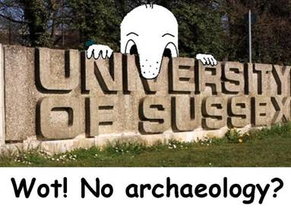
Annual membership is now due – it runs from 1 April 2012 and will be rising to a flat rate of £6, but renewals before the end of April will be accepted at the old rate of £5/£4 concessions
Please renew promptly
You can renew or join at the next meeting, or send a cheque
(payable to Lewes Archaeological Group) and sae to:
Brian Phillips, 2 Peronne Court, Uckfield, East Sussex, TN22 1BL (note change of address)or by hand to:
Fiona Marsden, 13 Lansdown Place, Lewes, East Sussex, BN7 2JT (01273 473946).
NB membership will be rising to a flat rate of £6 but
Many readers of this newsletter have had their lives touched and enhanced by the work of the University of Sussex’s Centre for Continuing Education (CCE, more recently re-christened the Centre for Community Engagement). Running evening and weekend courses and day schools in archaeology, local history and landscape, along with other subjects such as creative writing, CCE provided for some 20 years a hugely important resource for adults in this area, of all ages and backgrounds. Under David Rudling’s leadership, the Certificate in Practical Archaeology was a route through to further study and archaeological discovery, whether through a professional career or voluntary interest. Sussex’s archaeologists stayed in their area for the most part, applying a solid background of field training to produce local research which few if any other areas of the country can match.
Now the University of Sussex has decided to withdraw from running these short courses, which will effectively mean the end of archaeology there, as there are no full-time undergraduate courses. The University blames central government rule changes, but with a profit last year of more than £11 million, it is not in a financial crisis. In reality they are choosing to pursue the most lucrative full-time students, particularly those from outside the EU.
I, along with Sussex Archaeological Society and Brighton and Hove Archaeological Society, wrote expressing our dismay to the Vice Chancellor before the crucial votes were taken, but have yet to receive any reply…
NB: CCE will however be running a full programme, including excavations at Barcombe, until September 2012 – see back page for details. If you have not been on a course before, now is (sadly) your last chance.
Anne Locke (‘Chad’ image thanks to David Millum)

Next lecture
Friday 20 April 2012, 7.30pm
Farming the Lewes Downs: the development of landed estates and farms c. 1750 – 1930
With Dr Sue Berry, local historian and author of Georgian Brighton.
Sue is consultant editor to the Victoria County History for Sussex; her doctoral thesis was was about estate management and farming on the eastern South Downs.
Lecture room, Town Hall, Lewes
(Fisher Street entrance) Lift available

Thoughts from the Chair
I am very pleased to say that the Group is in a better financial position than this time last year. Brian Phillips, our Treasurer, will report at the AGM, but the improvement seems to be due to:
- some very well-attended talks with popular local speakers
- economies on copying and postage through greater use of emailed newsletters
- good luck with the weather, resulting in no cancellations of talks because of snow and ice
- some kind donations from members, and a couple of donations paid for watching briefs
- an upturn in new members (welcome all!)
Nevertheless we feel we need to build up more of a reserve to cope with contingencies (a new bulb for the data projector would cost well over £200, for example, and room hire and insurance costs go up every year) so we will be raising the annual membership subscription to £6 for 2012/13. However anyone paying before the end of April is welcome to join at the old rate of £5/£4 concessions. Talk admission charges will be held at the same price and retain the concession.
Now on a very sad note I have to report the recent death of Alan Stevens, who stepped down as Chairman in 2007. He had taken over that role and arranging the lecture programme a few years before. As a long-standing member of BHAS and the British Archaeological Association, he drew on his wide range of contacts to bring in expert speakers and he did us a very great service in securing a grant from the Town Council for the data projector, rapidly becoming a necessity.
Alan did another great service in introducing us to our present Secretary, Alex Sutherland, when she moved to Lewes from Brighton, where they shared an enjoyment of sea bathing.
Alan had a particular interest in medieval buildings. He had taught at Kent University; his talk to LAG on the crown-post roof explained the complexities of timber construction quite memorably. He was also the BHAS representative on the Brighton and Hove City Council Conservation Advisory Group.
Alan had very wide interests and a great respect for scholarship; he would undoubtedly have been able to achieve more formal qualifications if his Asperger’s Syndrome had been diagnosed earlier in life. He did not find life’s practicalities easy and had been in poor health, so we were very pleased to see him at one of the talks last autumn.
Anne Locke
01273 475381, anne.locke@talktalk.net
The Free Bath at the Pells
When it was thought that the Pells Pool and Park might qualify for a Heritage Lottery Grant, a history of the area was needed. By the time it was clear that the Pells and its cold-water pool did not meet the criteria the history had grown surprisingly interesting and it seemed worth continuing. At about the same time swimming pool studies in general received a boost with the publication of Liquid Assets – The lidos and open air swimming pools of Britain by Janet Smith (English Heritage 2005). Janet was able to confirm the local belief that the Pells was the oldest freshwater public swimming pool still in use in Britain, and she wished that more was known about it, not least because of the unusual Free Bath.
When the decision to build a Lewes swimming pool, funded by public subscription was taken in 1860, two pools side by side were planned and built. They opened in May 1861. The surviving pool, still in use today, is the former Subscription Bath, for which users had to buy a season ticket. This income broadly covered the costs of the Free Bath, for which there was no charge. It was intended to double as a swimming pool and a place where people could wash themselves in the days when few homes had piped water. At the time there was a useful health craze for icy cold baths, even in the new middle class homes that were being built with proper plumbing.
The Subscription Bath was a standard rectangular shape, 50 yards in length. The Free Bath was the same length but wider. Its ground plan and position are clearly shown on old Ordnance Survey maps and they indicate that it was rectangular on three sides but adapted on the eastern side to the incurving boundary of the plot on which it stood. It may originally have been more of a clay-lined lake than a cement-lined pool, and it was never more than about two feet deep. Sadly very little is now known about the experiences of those who used the Free Bath, although some people who knew it as children are still alive. One lively newspaper account does survive and describes it c.1900, when there was no mixed bathing, but it was clearly incredibly popular, at least for men and boys. The description came from a man who was looking back on his childhood in St John Street, and the impression given is that the Free Bath in its heyday was a great deal more fun than the sedate Subscription Bath.
Men and boys habitually bathed in the nude, not least because swimwear and even male underwear was a luxury for many of the working poor with large families to support. In order to deter peeping Toms, women may have had to bathe in shifts or petticoats, which were everyday wear for them. Old towels were donated for use at the Free Bath, and looked after by a resident Pool Keeper and his wife, who had a purpose built cottage on the site of the present ticket kiosk.
In the days before filtration there were often complaints about water quality in both Baths, especially in dry summers. When this happened the Subscription Bath had priority if there was any clean water, but as the demand for piped water in homes and industry increased and the water table sank, the pool pump no longer necessarily reached deep enough to engage with the fresh water springs on which the pools depended. More powerful pumps were installed periodically, but soon the water table was lower still and once again a dry summer would result in dirty, unchanged water in both Baths. Sometimes water from the L-shaped lake, muddied by well-fed ducks, was used to top up and refresh the bathing pools.
Free swimming lessons for the town’s primary school children after World War One, gradually opened up use of the Subscription Bath, where the lessons were held. The children became used to it and the sort of behaviour expected there, and those who actually learnt to swim were given a free season ticket for the following year. By 1928, when a very hard winter damaged both pools very few people were still using the Free Bath and the decision was taken to repair only the Subscription Bath.
For about 25 years the old concrete shell of the Free Bath lay open and derelict, overgrown with brambles and largely screened off behind a corrugated iron fence, although an old changing hut in the area remained in use for school parties. It was only after World War Two that the surviving pool and its facilities were upgraded in imitation of the lido pools with lawns and sun terraces that had become fashionable in the 1930s. The Free Bath was filled in, the lawn was laid in its place, and some years later the northern boundary of the pool enclosure was pushed back to create the stepped terrace, and new changing rooms behind. This layout is still familiar today, but once again the whole complex is showing its age. It remains very popular as long as the sun is shining, and a growing number of hardier swimmers recognise that the Victorians who favoured icy cold baths may have been on to something.
Results of the resistivity survey were probably unclear because of the amount of underlying rubble
In the spring of 2011, Lewes Archaeological Group members led by Greg Chuter, the assistant county archaeologist for East Sussex County Council, carried out a resistivity survey to try and establish the precise boundaries of the buried Free Bath, with a view to investigating a small section of the pool’s shell and its construction. In the event the rubble infill veiled rather than revealed the outlines, but it was an enjoyable morning in an attractive tree lined corner of Lewes, with morning coffee kindly served by Phil Ransley, the Pool Manager. Alongside us the Subscription Pool had been drained so that huge cracks in the concrete shell could be identified and plugged. Round the edges, damaged sections of iron pipe-work dating to a 1970s refurbishment were being dug up and replaced with modern heavy duty plastic. This revealed that everything is bedded in thick blue clay, which is thought to be natural. When freshly dug it is a dark, slate grey colour but it quickly dries to a pale golden grey. In due course a small trial excavation may be possible, in order to find and examine a section of the edge of the Free Bath.
The Pells Pool Community Association, which has run the Pool for the Town Council since 2000, hopes to publish at least a preliminary history of the Pells as soon as possible. Perhaps, once written it will jog the memories of those who used the Free Bath as children, or those who remember stories that parents or grandparents told them. Photographs of this era are probably too much to hope for, although the Reeves Collection has one or two of the Subscription Bath decently free of dressed or undressed swimmers. However any photographs of people or events at the Pells pool even in the recent past would be welcome.
Fiona Marsden
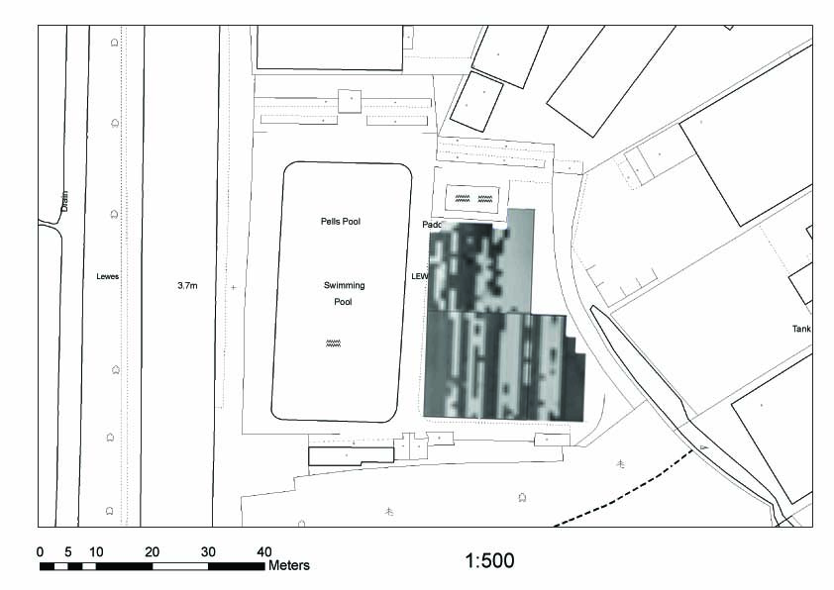
Fieldwork and practical courses
Ancient Crafts and Technologies exciting hands-on course held mostly outdoors at Michelham Priory, near Hailsham, 9-13 July, covering pottery, textiles, woodworking, building technologies, boat building and flint knapping. £230/£163. Contact CCE 01273 678300, email cce@sussex.ac.uk or see website www.sussex.ac.uk/cce/prospectivestudents/shortcourses/x9006
Barcombe Roman bathhouse
- Volunteer days on Saturdays from late May to late August; volunteer weeks from 25 June.
- Open afternoon Sun 15 July, 1–5pm. Tours, finds on display and children’s activites.
- Excavation Training weeks Mon–Fri 25-29 June, 2–6, 9–13, 16–20 and 23–27 July and 30 July–3 August. £230/£130.
- Introduction to Field Archaeology over four Saturdays 30 June, 14 and 28 July and 11 Aug.
- Introduction to Archaeological Surveying 2-6 July; Total Station Surveying 16–20 July.
- Geoarchaeology in Detail 9–13 July.
- plus shorter courses on surveying, drawing, photography and geoarchaeology
All suitable both for beginners and those with some experience. Contact CCE 01273 678300, email cce@sussex.ac.uk or see website www.sussex.ac.uk/cce/research/current/barcombe
The bathhouse is in a field next to Barcombe church (BN8 5TS for satnavs), with parking available close by in the church car park.
Brighton and Hove Archaeological Society (BHAS) invite volunteers to join their field unit for mainly weekend work in and around Brighton. Rocky Clump Iron Age/Romano British site will be excavated throughout the summer on Weds and Sats. No experience necessary. John Funnell 0844 5888 277, co-ordinator@brightonarch.org.uk or see the BHAS website www.brightonarch.org.uk
Culver Archaeological Project is researching the wider landscape around Barcombe, contact Rob Wallace at rob@culverproject.com or see website www.culverproject.co.uk
The Tidemills Project is a community project open to all, looking at both the historical background and on-site survey and recording of this important site, between Newhaven and Seaford. Fieldwork usually takes place on Thursdays. Contact Luke Barber on 01273 405733 or email research@sussexpast.co.uk
Next newsletter: Sept 2012. Contributions to Anne by end August (contact details front page).
Diary dates Spring–Summer 2012
Fri 13 Apr BHAS lecture: Why draw
7.30pm, Uni- mammoths? Talk on cave art
tarian Church, by Dr Liz Somerville. £3
New St, Brighton
Sat 14 Apr Battle of Lewes Conference:
Assembly Room The Beginnings of Democracy
Lewes Town Day conference organised by
Hall, 9.30am– Sussex Archaeological Society,
4.40pm, £30/£20 contact Lorna on 01273 405737
or members@sussexpast.co.uk
Sat 14 Apr Battle of Lewes Experience in
Lewes Castle 4D sound and light show,
7.30, 8.15, 9.00 tickets Lewes TIC, Anne of
and 9.45pm. Cleves House or Barbican House.
£6/£5 NB not suitable for under-11s.
Thu 19 Apr USAS lecture: Cluniac Mona-
Sussex Univ. steries & Funerary Treatment:
Fulton Blg from the depths of Burgundy to
Lecture A the heart of London Ellie
7pm; £1/£2 Williams, Southampton Univ.
Thu 3 May USAS lecture: Operation
Sussex Univ. Nightingale with Diarmaid
Fulton Blg Walshe. MOD project
Lecture A rehabilitating wounded
7pm; £1/£2 soldiers through archaeology.
Thu 17 May USAS lecture: English
Sussex Univ. Fossil Landscapes: how
Fulton Blg place-names deep-freeze the
Lecture A past with Stephen Durnford.
7pm; £1/£2
Fri 25 May Friends of Anne of Cleves House
Anne of Cleves The Norfolks and the Arundels
House, 7.30pm. Talk by Philip Marshall on ‘the
£5 most executed family in history’.
Sat 26 May Battle of Lewes Day with family
Lewes Castle fun and children’s activities.
10am–4.30pm
Sat 11 Aug Archaeological walk with John
Stanmer Park Funnell of BHAS. Meet at Upper
11am–2pm, £3 Lodge car park on Ditchling Rd, N of Brighton. Details
john.funnell@brightonarch.org.uk or 7789245106
The Sally Christian Archaeology Bequest
Funding may be available for practical archaeology training through a fund set up by the late Sally Christian, a former CCE student who studied archaeology at Sussex University.
Further details about the fund and how to apply can be obtained from David Rudling d.r.rudling@sussex.ac.uk or 01273 873527.

