

Lewes Archaeological Group newsletter

No. 142
March 2011
Affiliated to the Sussex Archaeological Society
and the Council for British Archaeology

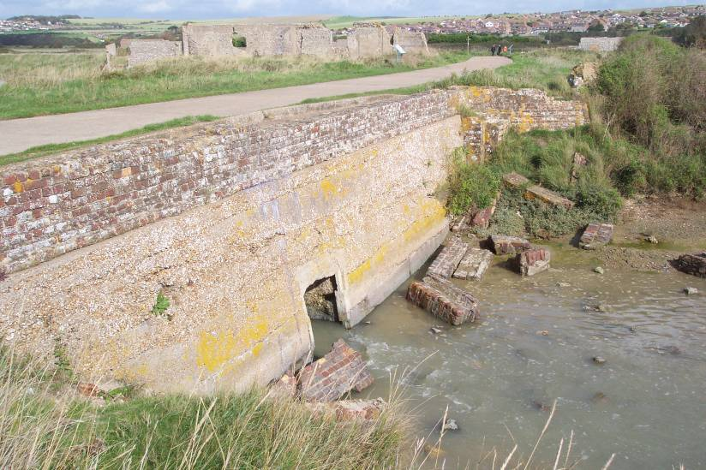
Next Lecture Friday 15 April 2011, 7.30pm
Tidemills: a lost industrial village
Joanna Wilkins, Education Officer with Sussex Archaeological Society and member of the Tidemills excavation team, will talk about their work tracing the history of this evocative ruined site which lies on the shore between Bishopstone and Newhaven.
The tide mill itself was established in the 1760s and continued in use until the later 19th century. The village remained inhabited until its demolition during the Second World War. Nearby on the beach are the remains of a First World War sea plane base and a childrens’ hospital. Our AGM will follow the talk at about 9pm.
Lecture room, Town Hall, Lewes (Fisher Street entrance)
Admission (including tea/coffee)
Lewes Archaeological Group members £3/£2 for concessions
Non-members welcome at £4/£3 for concessions
Lift available

Annual membership is now due – it runs from 1 April 2011 and costs £5/£4 concessions
Please renew promptly
You can renew or join at the next meeting, or send a cheque
(payable to Lewes Archaeological Group) and sae to:
Brian Phillips, 51 Manor Way, Uckfield, East Sussex, TN22 1DQ
or by hand to:
Fiona Marsden, 13 Lansdown Place, Lewes, East Sussex, BN7 2JT (01273 473946).
The ruins of the Tide Mills tidal mill sluice from the mill pond side on a rising tide. Photo by Tim Trent.

June walks
Join Brighton and Hove Archaeological Society (BHAS) for these June walks:
Wed 22 June Summer Solstice at Caburn Iron Age hill fort. Meet BHAS at Glynde car park at 7.30pm for a short but steep walk, or for a longer (2 mile) walk meet at Cliffe corner (by Bag of Books) at 6.45pm. Bring readings and libations (i.e. drinks!).
Wed 29 June Tour of the re-vamped Lewes Priory with medieval expert Helen Poole, meet Anne of Cleves House, 7pm.
Small charge (probably £3) for non-BHAS.
Geophysics at the Pells Pool
On Sunday 17 April at 10am we will be doing a resistivity survey at the Pells Pool to find out more about the old ‘free bath’ which used to be alongside the present pool. The history has been researched by our Vice-Chairman and Pells Pool historian Fiona Marsden, and the survey will be directed by Greg Chuter, Assistant County Archaeologist for East Sussex.
If you’ve seen Time Team doing ‘geofizz’, resistivity is one of the most common techniques, used to locate features below ground by the difference in resistance to an electric current. It will be an easy morning involving slow walking and taking readings on a machine. If you’d like to help please let Anne know on 01273 475381 or anne.locke@talktalk.net so that we can tell you if there is a change of plan.
The nearest car park is at North Street.

Thoughts from the Chair
The last two years have been difficult financially. Despite raising subscriptions and admission charges by £1 at the 2010 AGM we are still facing a similar deficit this year. Reasons include:
- flat membership numbers of around 60-65
- two unfortunate postponements because of snow and ice of what would probably have been popular and profitable talks, the English Heritage speaker on Stonehenge (Nov 2010) and Martin Brown’s talk (Feb 2009), plus some rather poorly attended meetings recently
- rising costs of room hire, copying and postage
- very sharply rising costs of the public liability and personal injury insurance we need to participate in archaeological fieldwork – this year’s quote is up 27% on last year’s.
If this continues we will have barely another year’s worth of funds to cover our expenses. We are now looking at reducing costs all round and in particular at choosing the most reliably popular subjects and inexpensive speakers for next year. In addition two committee members (who wish to remain anonymous) have very kindly offered help, one paying for us to continue our affiliation to the Sussex Archaeological Society, and another to pay for the next speaker’s pre-meeting supper.
If you have any views or comments on how else we might address the situation I would be grateful to have them either at the AGM or personally (contact details below). Clearly the aim must be a growing membership coupled with better-attended talks and activities which at least break even.
If this doesn’t happen, there are a number of less palatable options we need to consider:
- raising annual subscription rates to a more realistic level, e.g. £10, comparable with other groups like BHAS and MSFAT, and abolishing the concessionary rate
- running fewer lectures – say four a year – and avoiding mid-winter dates
- discontinuing our insurance – this would mean that members who wished to take part in fieldwork could only do so through joining other archaeological groups
- merging with another group so as to share costs – however this would mean a higher subscription rate and some loss of identity
On a happier note however there is still plenty going on in local archaeology this summer, and I hope to see many of you out in the field.
Anne Locke
73 Paddock Lane, Lewes BN7 1TW
01273 475381, anne.locke@talktalk.net
New Finds Liaison Officer for Sussex
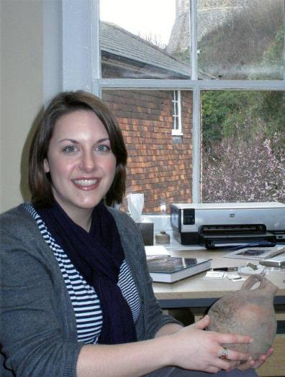
Stephanie Smith is the new Finds Liaison Officer for East and West Sussex and gave us a talk in February this year.
The Finds Liaison Officer identifies and records all reported objects that are determined to be more than 300 years old onto the Portable Antiquities Scheme (PAS) database and is responsible for caring for items of treasure as stipulated under the Treasure Act. In addition to items that are eligible for recording on the database, Stephanie is happy to identify other objects that are found in Sussex.
Most of the objects she identifies are a result of metal detecting; however, she also works closely with members of the community to record finds discovered during different activities, such as gardening. The information gathered under the Scheme is used by hundreds of researchers every year to help enrich our understanding of our shared past.
Stephanie recently graduated from the MA Program in Artefact Studies from University College London and was awarded an MA in Classical Art & Archaeology in 2007. During her time at UCL, she worked on PAS-affiliated projects and wrote her dissertation on artefact assemblages from the Roman fortress in Caerleon, Wales. Although Stephanie has a special interest in Roman periods of activity, she looks forward to exploring small finds from all periods within Sussex and the surrounding region.
Stephanie would love to hear from anyone who has found objects they would like to identify and record on the Portable Antiquities Scheme database. She is located at the Barbican House Museum in Lewes, East Sussex and will be scheduling finds events in conjunction with multiple local museums and clubs throughout the year. For further details about the Portable Antiquities Scheme or to arrange an appointment you can contact her at 01273 405731, or by email: flo@sussexpast.co.uk. You can visit the PAS database at: http://finds.org.uk
Alex’s mystery photographs
Our Secretary Alex Sutherland has drawn on her art history background to contribute the first in what we hope will be a series of informative pictorial puzzles (answers at the bottom of the last page of this newsletter). Clue: Both 'hold up' the church, but where? One is local (i.e. in Sussex) and the other 130 miles north as the 'angel' flies!
Picture 1
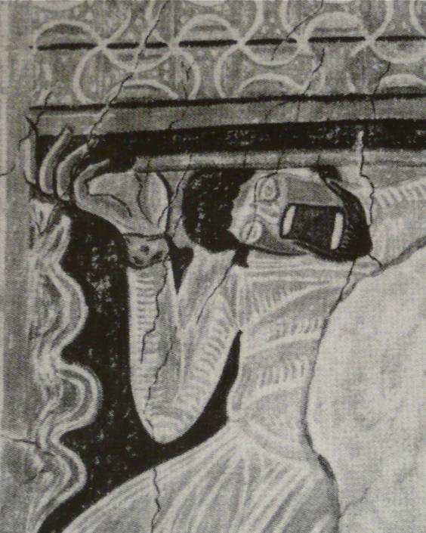
Picture 2
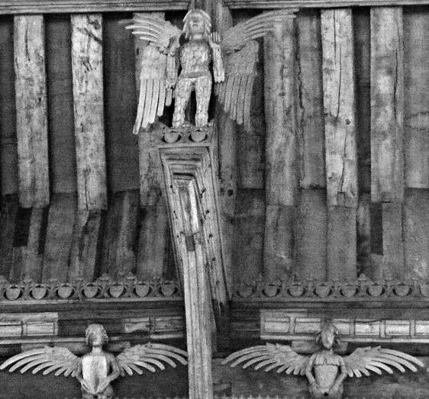

The Sally Christian Archaeology Bequest
Funding may be available for practical archaeology training through a fund set up by the late Sally Christian, a former CCE student who studied archaeology at Sussex University.
Further details about the fund and how to apply can be obtained from David Rudling d.r.rudling@sussex.ac.uk or 01273 873527.
LAG and the digital age
Our member Bryan Creer has very kindly offered to set up a website for the Group. The address will be www.lewesarchaeology.org.uk
At present you will see the site is ‘under construction’ but do keep looking as we hope to have it populated soon. In the meantime, if you would be happy to save us money and receive your newsletters by email, please contact me at anne.locke@talktalk.net. Some 30 members have already agreed, which will save us a useful amount of around £50 a year.

Barcombe Roman Bathhouse excavation – the final year?
Since 2008 MSFAT and the University of Sussex have been investigating a large Roman bath house located in Church Field, which lies between the Barcombe Roman villa site previously excavated and St Mary’s Church, Barcombe. Excavations in 2008, 2009 and 2010 revealed a structure in excess of 20m long and 6m wide. If it is a single building, then this represents one of the largest bath houses in southern Britain, with a capacity way beyond the needs of the adjacent villa and its workforce. Similar sized bath houses on Hadrian’s Wall served garrisons of 500 men or more. With the emerging evidence for an adjacent tidal creek are we now looking at a facility which served travellers and traders, perhaps functioning as part of a mansio (roadside accommodation) complex? The 2011 excavations may well be our last at the site, but we hope to answer the remaining questions about this enigmatic bath house.
Excavations this year will start with volunteer days on Saturdays from late May to late August. During July and August there will be a range training courses which are ideal for beginners or those with some experience, and there will be a public open afternoon on Sun 31 July. For more details see below and next page.
from the Barcombe Roman bathhouse interim report by Chris Butler and David Rudling
Fieldwork and practical courses
Barcombe Roman bathhouse
- Excavation Training weeks Mon–Fri 4–8, 11–15, 18-22 and 25–19 July and 1–5 August.
- Introduction to Field Archaeology over four Saturdays 11 and 25 June and 9 and 23 July
- Introduction to Archaeological Surveying 4-8 July
- plus shorter courses on surveying, drawing, photography and geoarchaeology
Suitable both for beginners and those with some experience. Contact CCE 01273 678300, email ccc@sussex.ac.uk or see website www.sussex.ac.uk/cce/research/current/barcombe
The bathhouse is in the field next to Barcombe church, with parking available close by.
Ancient Crafts and Technologies hands-on course held mostly outdoors at Michelham Priory, 11-15 July, covering pottery, textiles, woodworking, building technologies, boat building and flint knapping. Contact CCE 01273 678300, email cce@sussex.ac.uk or see website www.sussex.ac.uk/cce/prospectivestudents/shortcourses/x9006
Volunteering opportunities
Mid-Sussex Field Archaeology Team (MSFAT) volunteers will also be working at Barcombe bathhouse on Saturdays from early May to late August. No experience necessary. Membership £8. Chris Butler 01323 871021 or chris@reltub.fsbusiness.co.uk, website www.msfat.com
Brighton and Hove Archaeological Society (BHAS) invite volunteers to join their field unit for mainly weekend work in and around Brighton. No experience necessary. John Funnell 0844 5888 277, co-ordinator@brightonarch.org.uk or see the BHAS website www.brightonarch.org.uk
The Culver Archaeological Project is taking a break from excavating this year but is likely to return with fieldwork projects in the wider landscape around Barcombe next year.
The Tidemills Project is a community project open to all, looking at both the historical background and on-site survey and recording of this important site, between Newhaven and Seaford. Fieldwork usually takes place on Thursdays. Contact Luke Barber on 01273 405733 or email research@sussexpast.co.uk
Diary dates Spring–Summer 2011
Fri 8 Apr BHAS lecture: The iron industry
7.30pm, Uni- in the Weald
tarian Church, Talk by Jeremy Hodgkinson.
New St, Brighton
Sat 9 Apr Sussex Archaeology Symposium
University of Latest discoveries from across
Sussex, Chich- Sussex, from the Bronze Age to
ester Lecture the Medieval, with a focus on the
Theatre, 10am Roman period, and some exciting
–5pm; £30/£20 news from the Barcombe area.
concessions/£8 Bookings 01273 872718/678300
18 or under. or www.sussex.ac.uk/cce
Thu 28 Apr USAS lecture: Rethinking
Sussex Uni- Roman Britain: the potential of
versity, Arts 2 the Portable Antiquities Scheme
7pm; £2/£3 Sam Moorhead, British Museum
Sat 14 May Lewes Priory Grand re-opening
Lewes Priory, a celebration with talks, activities
Southover. and childrens’ trails, and the Southover Bonfire Society fayre.
Sat 14 May Sussex Archaeological Society
St Thomas hall half day conference: Medieval
Cliffe, 1.30– Churches: Lewes in the Sussex
5.30pm; £20 context. Bookings 01273 405737
or members@sussexpast.co.uk
Fri 20 May Friends of Anne of Cleves House
Anne of Cleves Southover and the Battle of Lewes
House, 7.30pm. Talk by Mike Chartier.
Thu 26 May USAS: Round up of excavation
Sussex Uni- work/projects by USAS committee
versity, Arts 2 members
7pm; £2/£3
Fri 17 June Lewes Priory Trust Emil Godfrey
Lecture room, memorial lecture The Anglo-
Lewes Town Norman church in Lewes: priests
Hall, 7.45pm; of St John or monks of St Pancras
free with John Bleach.
Sat 18 June Lewes Priory Day with guided
Lewes Priory, tours and childrens’ activities.
Southover.
Wed 22 June BHAS Summer Solstice walk to
Glynde, 7.30pm Caburn, with readings and
or Cliffe, 6.45pm libations – see front page.
Fri 24 June Friends of Anne of Cleves House
Anne of Cleves Anne of Cleves – Henry VIII’s
House, 7.30pm. discarded bride. A talk by the author Elizabeth Norton.
Wed 29 June BHAS Lewes Priory walk
Anne of Cleves with Helen Poole – see front
House, 7pm page.
Sun 31 July Barcombe Roman Bathhouse
parking by Open afternoon. All are
Barcombe welcome for free tours, finds
church car displays and childrens’ activities.
park, 1-5pm Last year the site will be open!

Alex’s mystery photographs
Picture 1 is from the wall paintings at Coombes church, near Lancing, West Sussex, maybe c. 1120.
Picture 2 is at St Agnes, Cawston, Norfolk, where the 8ft high wooden figures are in a 15th century church, although Pevsner thinks the angels are later.
Next newsletter: Sept 2011. Contributions to Anne by end August (contact details front page).

