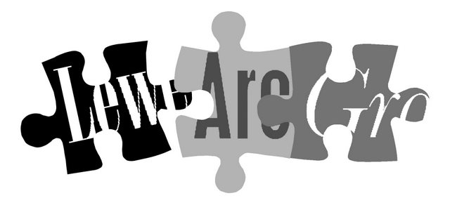

Lewes Archaeological Group newsletter

No. 139
March 2009
Affiliated to the Sussex Archaeological Society
and the Council for British Archaeology
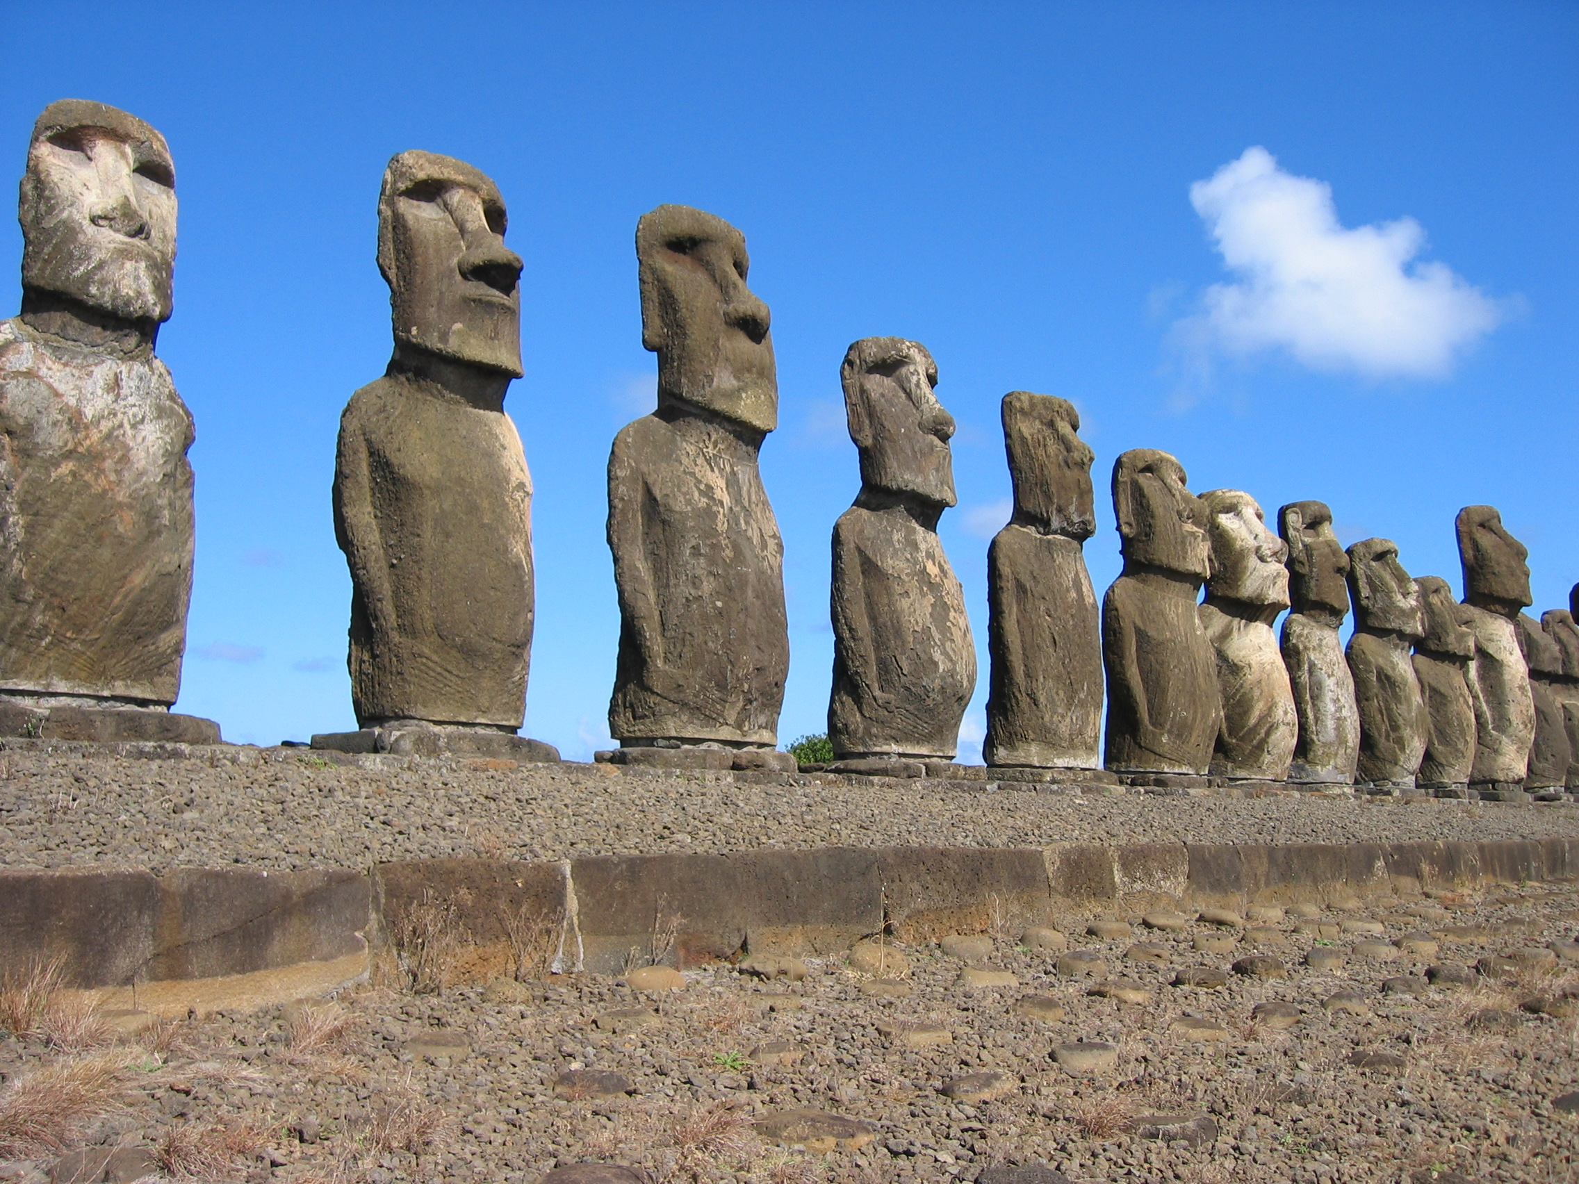
2009/2010 Lecture programme
Next season’s talks, all at 7.30pm in the Town Hall lecture room, will be on:

Friday 25 September 2009
(with Martin Brown, see next page)
Wednesday 28 October 2009
Wednesday 25 November 2009
Friday 29 January 2010
Wednesday 10 March 2010
Friday 23 April 2010

See next newsletter for programme details, and please note that, again, some talks will be on Wednesdays.

Please send any items for the next newsletter to Anne Locke (details next page) by Saturday 1 August.
Annual membership runs from 1 April 2009 and costs £4/£3 concessions
You can renew or join at any of our meetings, or send a cheque
(payable to Lewes Archaeological Group) and sae to:
Brian Phillips, 51 Manor Way, Uckfield, East Sussex, TN22 1DQ
or by hand to:
Fiona Marsden, 13 Lansdown Place, Lewes, East Sussex, BN7 2JT (01273 473946).
Next Lecture Friday 24 April 2009, 7.30pm
Easter Island: landscapes of construction

Lewes-based archaeologist Sue Hamilton will give a talk based on her latest fieldwork, the first British archaeological project on the island for 90 years. Dr Hamilton is Reader in Prehistoric Archaeology at the Institute of Archaeology, University College London. Her project is the first to look at the construction activities associated with the famous Moai (statues), mapping, surveying, and excavating on an island-wide basis.
Admission (including tea/coffee)
Lewes Archaeological Group members £2/£1 for concessions.
Non-members welcome at £3/£2 for concessions.

Of nearly 900 known Moai, nearly half were never installed,
and remain at the quarry where they were originally crafted

Directions
As usual, Sue Hamilton’s talk will be at 7.30pm in the lecture room, Town Hall, Lewes (entrance off Fisher Street, lift access available). Fisher Street is up the hill from Lewes railway station, just over the crossroads by Ask restaurant in the centre of town. The nearest parking is in the West Street car park – continue along Fisher Street then turn right, then shortly right again into the car park. The AGM will follow the talk – see enclosed notice.

Thoughts from the Chair

My most anxious moment in this season of lectures came during the unusually snowy week in early February. Guest speaker Martin Brown, former chairman of this group and now an archaeologist with the MOD, was due to travel from Salisbury Plain to talk about his work, but found himself snowed in. We did fleetingly discuss borrowing a helicopter from his employer but it was not to be – we were in the end very fortunate that Peter Drewett was able to step in at short notice with a much enjoyed substitute lecture on Caburn and its eastern landscapes.

A second anxious moment was before Judie English’s excellent talk on place-names in January. I don’t know whether it was the subject or the publicity, but the audience just kept on coming. I think we packed in 95 people, including the ones sitting on the table and the radiator. The official limit is 85 (or 55 if we intend dancing!) so please arrive a little early to be sure of a seat.

For next season Martin Brown has kindly agreed to reschedule his talk at our first session, Friday 25 September, when snow at least is unlikely. We are currently booking other speakers and also summer activities such as walks and site visits which we will publicise later in the spring.

As ever I am most grateful to all my fellow committee members, without whom we would be quite unable to run the lecture series or indeed the group. We would be delighted to hear from anyone else who would like to become more actively involved. This might be on the committee, or through occasional tasks as writing for this newsletter (sadly I can no longer write up talks regularly, now that I am operating the data projector and chairing the meetings) or taking part in fieldwork and watching brief projects.
Anne Locke
73 Paddock Lane, Lewes BN7 1TW
01273 475381, anne.locke@talktalk.net

When child met Childe

My great-uncle had a farm near Elgin in Morayshire. He was interested in antiquity and the farm produced many Stone Age artefacts, some of which went to the National Museum of Antiquities in Edinburgh.
There were a couple of hummocks on the farm, growing white heather – where this grows there is said to be a grave! So he dug, and found pots and artefacts. The result was that I played with them. I remember particularly a polished sandstone hand axe and a small basalt axe (neither were any use for chopping things down!), a ‘hammer’ which I now know was a mace head, flint scrapers, leaf and tanged flint arrowheads useful for tipping my own arrows, and a large and a small quern – lovely for grinding dock seed.

With the help of the custodians of Elgin Museum I learned a fair bit about the Stone Age, so that when I was eight and we spent a holiday in Orkney I was thrilled to visit Skara Brae. Standing looking at one of the houses I imparted some knowledge to Mother, and hearing me one of the archaeologists looked at this child and said “Are you interested?”. On my saying “yes”, he took me by the hand and gave me a guided tour of the house, encouraged me to crawl through one of the passages and, when I came back, gave me a trowel and taught me how to scrape carefully. It was all very exciting, and when one of the excavators said “Did you know that was Gordon Childe?” my cup of ‘thrill’ was full, as I was indeed aware of who he was.
by Jean Petrie

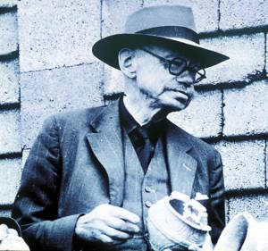
Vere Gordon Childe (1892-1957), pictured right, was an Australian-born archaeologist who built up enormously comprehensive and influential theories on the development of prehistoric civilisation.
He was the first professor of prehistoric archaeology at Edinburgh University, from 1927 to 1946, during which time he excavated the Neolithic site of Skara Brae in Orkney.

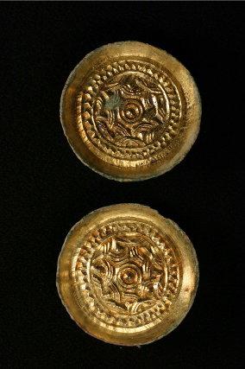
Saxon burials found near Lewes
In October 2008 metal detector enthusiasts Bob White and Cliff Smith discovered pagan Saxon burials on farmland close to Lewes. The precise location is being kept under wraps to deter looting by ‘nighthawks’.
The first sign of the finds was a tiny portion of a metal bowl and skull fragment, which was enough for the detectorists to alert the police and the East Sussex County Archaeologists Casper Johnson and Greg Chuter. Laura Burnett, the Sussex Finds Liaison Officer with the Portable Antiquities Scheme, was also on hand to advise.
They were able to establish that the remains were likely to be Saxon burials and, to avoid the risk of looting, they decided to excavate the graves immediately, with the permission of the landowner and farmer.
By the next morning Greg had assembled a team of Brighton & Hove Archaeological Society volunteers. They were joined by Bob and Cliff’s metal detecting club colleagues to scan the remainder of the field and begin excavation of the graves. Some of the team camped out on the site for three days to protect it from intruders.
The ‘knotwork’ decoration on these gilded brooches is unusual for Sussex
The most impressive grave contained the remains of a woman, buried with an unusual bronze bowl in remarkable condition with still working handle as well as gilded brooches and silver belt decorations. A male was buried with a spear and shield. All point to the fact that the individuals were relatively wealthy and of high status within their local community.
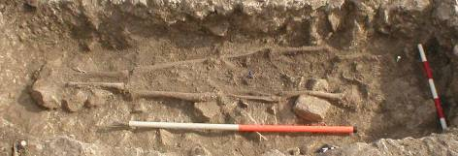
The brooches are late 5th to 6th century gilded bronze saucer brooches with 'knotwork' decoration. This is fairly rare in Sussex where most of the brooches tend to have the more typical spiral decoration motifs.
Three graves were excavated, one of a man and two of women
Report and pictures contributed by Greg Chuter/ESCC

The English Heritage laboratories in Portsmouth are analysing and conserving the finds, and it is hoped that they will eventually go on public display at Lewes’ Barbican House Museum. English Heritage and the County Archaeologists have commended the detectorists’ responsible approach to reporting their discoveries, and the two enthusiasts may eventually receive some reward under the Treasure Act – but they have said that “to find the unknown is reward enough. That’s priceless”.
If you have digging experience and would like to be part of the team of volunteers which the County Archaeologists sometimes call on at short notice when urgent rescue excavations like this arise, please contact Anne Locke (details on page 2).

Fieldwork opportunities:
three ways to get involved in excavation at Barcombe this summer

Barcombe Roman bathhouse: archaeology training weeks Mon–Fri 13–17, 20–24 and 27–31 July and 3–7 August. Suitable both for beginners and those with some experience. Contact CCE 01273 678527 or si-admissions@sussex.ac.uk
Website www.sussex.ac.uk/cce/archaeology
The Culver Archaeological Project is investigating three other sites close to Barcombe Roman villa from Sat 8 August–Sat 19 September. Sign up on www.culverproject.com or contact Rob Wallace on rob@culverproject.com
Mid-Sussex Field Archaeology Team (MSFAT) often has opportunities for weekend volunteers at local sites, including Barcombe, for excavation, finds processing, field walking and resistivity surveys. No experience necessary. Membership £8. Chris Butler 01323 871021 or chris@reltub.fsbusiness.co.uk, website www.msfat.com

Other opportunities

Brighton and Hove Archaeological Society (BHAS) invite volunteers to join their field unit for mainly weekend work in and around Brighton. No experience necessary. Contact Norman Phippard 01273 671608 or John Funnell 01273 607127, john.funnell@brightonarch.org.uk, or see the BHAS website www.brightonarch.org.uk
Lewes Phoenix Project A community arts and oral history project about the Phoenix Iron Works and its successors in Lewes. Contact Sarah Hitchings on sarahhitchings@live.co.uk or
01273 479639
The Tidemills Project is a community project open to all, looking at both the historical background and on-site survey and recording of this important site, between Newhaven and Seaford. Contact Luke Barber on 01273 405733 or email research@sussexpast.co.uk
University of Sussex The Centre for Continuing Education (CCE) has programmes of part-time courses covering archaeology, oral history landscape, churches, and classical and ancient civilisations, among other absorbing subjects. Previous qualifications not usually necessary.
Acronym buster
BHAS Brighton & Hove Archaeological Society
CCE Centre for Continuing Education, University of Sussex
SAS Sussex Archaeological Society
USAS University of Sussex Archaeological Society
www.sussex.ac.uk/cce or 01273 877888.
Young Archaeologists Club for 8–16 year olds: YAC Wealden Branch meets most months at sites around Sussex for archaeological activities. Subscription £10, contact organiser Anton Brown 01444 452216 or anton.brown@btconnect.com
Diary dates Spring–Summer 2009

Sat 28 Mar Sussex Archaeology Symposium
University of Latest discoveries from across
Sussex, Chich- Sussex, incl. an Iron Age warrior
ester Lecture burial and more from our recent
Theatre, 9.15am speakers Judie English, Peter
–5pm; £25/£15 Drewett and Chris Butler.
concessions/£10 Booking required 01273 877888
under 18s. or www.sussex.ac.uk/cce
Wed 8 Apr USAS lecture: Culver Roman
Sussex Uni- Road update Talk by Rob
versity, Arts 1 Wallace (see also Fieldwork
7pm; £2/£3 opportunities, opposite)
Fri 17 Apr Friends of Anne of Cleves House
Anne of Cleves Brides, Booty and Battle: the
House, 7.30pm. Tudors and Spain Talk by Helen
Poole.
Fri 17 Apr BHAS lecture: The Anglo-Saxon
7.30pm, Pagan burial site at Eastbourne
Unitarian Talk by Chris Greatorex,
Church, New excavator.
St, Brighton
Sat 25 Apr Joint SAS/Prehistoric Society
2.30pm, Cliffe lecture: Living at the Limit – a
church hall, Sussex perspective on the Palaeo-
Lewes; £3 lithic. Talk by Dr Matt Pope.
Booking required: Lorna 01273 405737 or members@sussexpast.co.uk
Wed 13 May USAS lecture: Animal bones:
Sussex Uni- use, refuse or no use Talk by
versity, Arts 1 Sarah Green, University of
7pm; £2/£3 Southampton.
Fri 5 June Lewes Priory Trust Emil Godfrey
Lecture room, memorial lecture The Bloody
Lewes Town Significance of the Battles of
Hall, 7.45pm; Lewes and Hastings with Prof.
free John Gillingham.
Sat 6 June Lewes Priory Trust open after-
1.45–4pm noon: tours from 2-3pm
£2; children from the ‘helmet’ memorial.
free.
Fri 19 June Friends of Anne of Cleves House
Anne of Cleves Sussex Firebacks Talk by
House, 7.30pm Jeremy Hodgkinson, Wealden
Iron Research Group.
4–14 July Tom Paine festival. See
Various www.thomaspaineandlewes.com Lewes venues or Tourist Information Centre.

