
Lewes Archaeological Group newsletter

Affiliated to the Sussex Archaeological Society
and the Council for British Archaeology

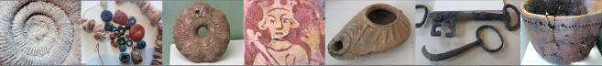

Friday 19 April 2013, 7.30pm

Romano-British discoveries in the Barcombe area
With David Millum and Rob Wallace.

Following their talk last year on the Barcombe Roman Bath House, David and Rob bring news of some exciting new discoveries nearby, which may help explain more about what could have been going on in Romano-British Barcombe.

Lecture room, Town Hall, Lewes
(Fisher Street entrance). Lift available

Plumpton Roman Villa

Last summer excavations were undertaken for the first time on the site of Plumpton Roman villa. This Roman-period settlement is located to the north of the South Downs, just to the south of the Greensand Way - an important Roman road which connected Hardham to the west with Barcombe / the River Ouse to the east. Dating mostly to the 3rd-mid 4th centuries, the villa is of the winged-corridor type. Found by F.G. Burton in 1973, the site has been partly investigated on several occasions by the use of various survey techniques including: field walking; the recording of soil marks; and geophysics. The first such investigations, which took place in April 1977, were undertaken by LAG under the supervision of Mike Allen and Simon Garrett (Allen 1984). Further investigations took place last year as reported in the Spring edition of the LAG newsletter.

No. 150
April 2015
www.lewesarchaeology.org.uk

www.lewesarchaeology.org.uk

NEXT LAG LECTURE

Jonathan Sygrave – Whitehawk Hill Excavations
Friday 17th April at 7.30pm,
Lecture Room, Lewes Town Hall,
Fisher Street Entrance

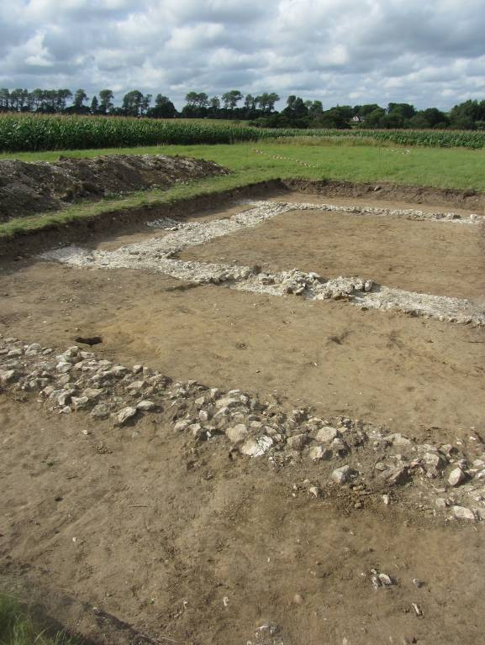

The excavations in 2014 were designed to investigate plough damage. The work undertaken by the Sussex School of Archaeology concentrated upon the locations of the winged-house and the settlement enclosure ditches on its western and northern sides. The excavation of part of the main villa building exposed parts of two, possibly three rooms, and part of the front (southern) corridor which flanked them. The exposed foundations comprised of flints above a deposit of chalk, ie as previously discovered at the Barcombe villa. In all cases the surviving footings were below floor level. Evidence for the nature of some of the flooring, however, included both large and small (mosaic) tesserae. A trial trench to the west of the rooms described above revealed that very compact foundations and demolition continues at a shallow depth under the crop. These deposits, together with traces of the western enclosure ditch, which have not yet been excavated or sampled, are further evidence that the currently protected area needs to be extended westwards. A third trench, to the south of the second one, also located the shallow remains of the western boundary ditch. A fourth trench revealed and sampled part of the east-west orientated northern boundary ditch as previously located by the magnetometer survey.

This summer it is intended to further such investigations, hopefully to fully reveal the plan of the winged-house. For further details on how to participate see pages 4-5 below “Fieldwork and excavation opportunities”.

Bridge Farm Romano-British Settlement
The Culver Archaeological Project (CAP) has now set the dates for the 2015 summer excavation at the Romano-British settlement site at Bridge Farm, just north of Lewes, being 29th June to 8th August.

Over the winter CAP have been negotiating with farmer, Mark Stroude, for access to part of the main settlement site, despite this being in the middle of his sweetcorn crop. The area agreed will target the junction of the London/Wealden ‘Iron Way’ with the bivallate enclosure and an east west internal road. It is hoped that this area will answer some of the still outstanding questions about the changes that occurred to the settlement during the late 2nd-early 3rd centuries.
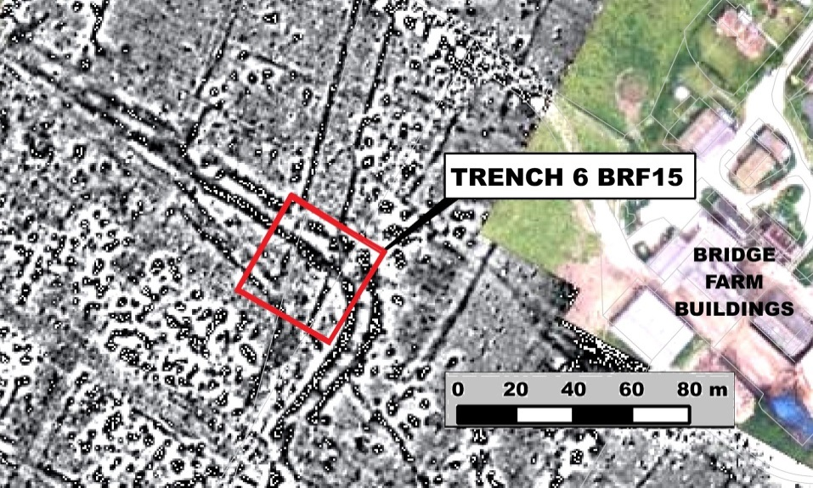
Priory Trust Excavation
Lewes Priory Trust has commissioned Archaeology South East to conduct a new archaeological investigation of the mediaeval east-west drain of the first reredorter (communal latrine) which was originally partly excavated by Richard Lewis between 1969 and 1982.

The project, funded by the Heritage Lottery Fund and supported by English Heritage, hopes to recover environmental samples from within the arched sewer that will throw new light on the environment and life within the monastic community. It should also provide new insight into the water management system of the Priory.

A culvert which flowed into this drain from the north was surveyed and digitally photographed during an investigation carried out by the Lewes Priory Trust and Archaeology South East last year. This culvert was blocked approximately nineteen metres from where it discharged into this sewer and surviving deposits from within it were not considered suitable for sampling.
It is hoped that this latest investigation which is due to take place in May or June will prove more fruitful.

Recording Rememberance Project
The Recording Remembrance project launched by East Sussex County Council and West Sussex County Council Historic Environment Record teams gives people whose relatives died in the two World Wars the chance to create a permanent online record of their relative. Information about them can be added, such as their date and place of birth, marriage or death, where they lived or other details and photographs. The aim is to bring to life Sussex war memorials and those whose names are engraved on the memorials.

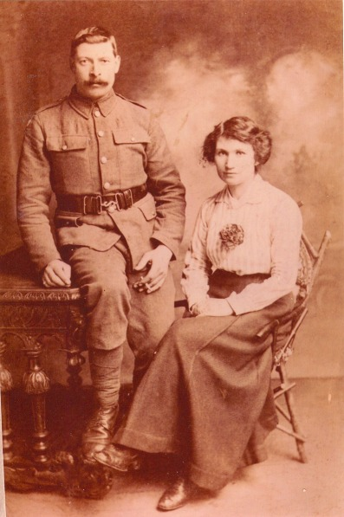

This is a photograph of Ernest and Elizabeth Saunders. Private Ernest Saunders of the Suffolk Regiment died in May 1917 aged 31 and appears on several war memorials in Hailsham. He was one of the first men to be recorded on the Recording Remembrance project website.

Casper Johnson, East Sussex County Archaeologist, who manages the project, said: “War memorials come in many different forms and are not just the obvious ones in the centre of a village or town. They can also be in the form of a stained glass window in a church, a roll of honour or even a water garden.” There is a list of the existing memorials but it will also be possible to create a new record for a memorial that is not currently listed.
To take part follow the link to Recording Remembrance online at www.eastsussexww1.org.uk/take-part and registering their details.

Excavations in Lewes
An historic buildings survey was carried out by Archaeology South East at 49B Cliffe High Street. The site provides an example of an early/mid-19th century outbuilding, which has been modified and extended during the early and mid-20th century. The building is thought to have functioned as a bakehouse at one stage; however, evidence for this former function is now either lost or masked by later alterations.

An intermittent archaeological watching brief was undertaken by Archaeological Services Lewes at 65-66 Priory Street during ground works for the construction of a rear extension. The west footing was the most interesting and contained half of a well in the middle of the trench. This was built using two different materials, chalk and brick and they were both bonded with the same mortar which matches that of the house. This feature probably dates from 19thcentury when the house was built and would have been shared with the property next door, as it lay on the boundary between the two buildings. The trenches were excavated to a depth of approximately 1550mm down through to the natural geology with no other features or finds of any great age found, except for a small late 19th- century rubbish pit which lay on the edge of the trench boundary to the north .

Report from the Chair
Overall, it has been a positive year. We have had a number of interesting and thought-provoking talks. The LAG website has been revamped by Bryan Creer – see http://www.lewesarchaeology.org.uk/. The current membership of the Group is 47 people. This represents a pretty stable situation. Financially LAG is on a sound footing at the moment.

I would welcome offers to participate in the organisation of the Group. It doesn’t need to be as a committee members, but the offer to give a talk, organise a talk or walk would be most gratefully received. Also very happy to receive suggestions for speakers. Just let me know – paulawodcohen@yahoo.co.uk.

Membership of LAG
As a member of LAG you are able to take advantage of LAG’s membership of the Council for British Archaeology. This includes accessing a digital subscription of the CBA,s magazine and back issues (http://new.archaeologyuk.org/british-archaeology-online. If you are a member of LAG you need to e-mail Paula Stanyer (paulawodcohen@yahoo.co.uk) to get the log in information. You also access a range of other benefits from free entry to heritage venues and discounts on publications. To find out more see http://new.archaeologyuk.org/offers-and-discounts

You can renew or join at any of our meetings, or send a cheque for £6 (payable to Lewes Archaeological Group) and sae to Brian Phillips, 2 Peronne Court, High St, Uckfield, East Sussex, TN22 1BL or Fiona Marsden, 13 Lansdown Place, Lewes, East Sussex, BN7 2JT. Please deliver by hand to Fiona.

Battlefield Walk on Saturday 16th May
Last year the 750th anniversary of the Battle of Lewes included walks on the Battlefield areas. This year’s walk is organised by the Battlefield’s Trust in conjunction with Sussex Archaeological Society and will be led by Michael Chartier (Chair of SAS) and John Freeman.

The walk is free and can be done as the day or just the morning or afternoon parts. For further details please contact John on 07957829997 or email him on johnfreeman11@hotmail.co.uk.

The Seven Sisters Archaeology Project
The National Trust has commenced a major project to investigate and to record the archaeology of the Seven Sisters which is under threat from erosion. \The project will be running until September 2016.

The project will focus on Gayles Farm (iron age and Roman site and where RAF Friston was based during the Second World War); Crowlink Coastguard Cottages; Baily’s Hill Barrow (dating to the Neolithic and Bronze Age) and the hill top enclosure at Belle Tout which remains a bit of an archaeological mystery.

This is a community archaeology project and so there are many opportunities to volunteer both in relation to activities and locations. There will also be guided tours of the sites. To find out more see http://www.nationaltrust.org.uk/birling-gap-and-seven-sisters/our-work/seven-sisters-archaeology-project/

Alex’s Mystery Photographs
Guttering, near and far, but do you know where?
Picture 1
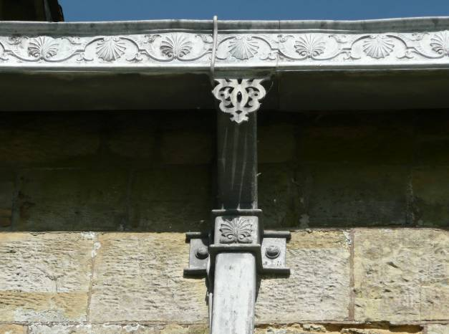
Picture 2
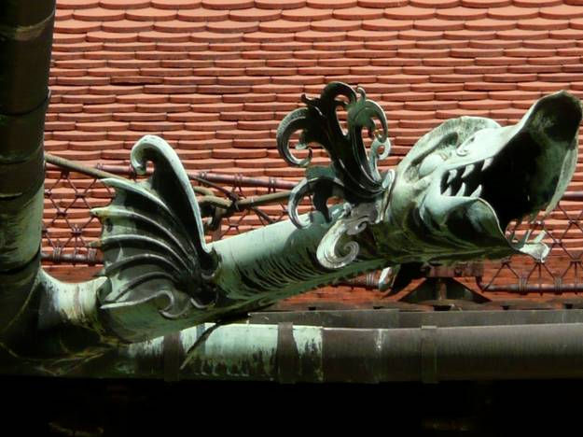

Fieldwork and excavation opportunities

There are lots of opportunities for fieldwork in the Lewes area over the summer.

Bridge Farm: As noted above excavations at Bridge Farm, near Barcombe will recommence on 29th June and will continue until 8th August. The 2015 dig will be run on similar lines to previous years with volunteers and members of local societies, such as LAG, encouraged to take part. As in 2014 a modest fee of £25 will be charged for up to seven days site participation with the amazing offer of just £50 for the whole season. For further details see www.culverproject.co.uk.

Plumpton Roman Villa: As mentioned above it is intended that further investigations take place over the summer. The plan is to fully reveal the plan of the winged-house. Excavations will take place between Saturday 20th June and Saturday 1st August. If you want to be kept informed of excavation opportunities you should register an interest with the Sussex School of Archaeology (info@sussexarchaeology.co.uk) or visit its website: www.sussexarchaeology.org.
To note that a range of courses will be offered by SSA including one day taster courses on certain Saturdays.

Ovingdean: Brighton and Hove Archaeological Society (BHAS) will be continuing with its investigation of a 13^{th-} century manorial complex consisting of stone manor house and timber structures all bounded by earth banks at Ovingdean. Work commences on 11th April and will be on-going for several months (Wednesdays and Saturdays). Newcomers welcome whatever their experience. Cost is £15 full and £7.50 for students and people must have a current tetanus inoculation. Age from 16 years upwards. Contact John Funnell at john.funnell@brightonarch.org.uk for more details or visit http://www.brightonarch.org.uk/.
E
Talks and events 2015

BHAS Brighton & Hove Archaeological Society
ENHAS Eastbourne Natural History and Archaeological Society
FOAC Friends of Anne of Cleves House
LHG Lewes History Group
LAG Lewes Archaeological Group
SAS Sussex Archaeological Society
SSA Sussex School of Archaeology
USAS University of Sussex Archaeological Society

APRIL
Fri 10 April FOAC John Bleach – Mid 13th Century Lewes. 7.30pm. Anne of Cleves House, Lewes.
Sat 11 April SSA Rory Mortimer – Geology for Archaeologists. 10-4. Venue to be confirmed. £40.
Mon 13 April LHG David Smith – Lewes through the eyes of a flint knapper. 7.30pm. Kings Church, Lewes. Cost £3/2.
Thurs 16 April USAS/SAS/SSA The Holleyman Archaeological Lecture 2015. Gabor Thomas – A Portal to the Anglo-Saxon Past – village core excavations at Bishopstone and Lyminge. 7pm at Lecture Theatre A, Fulton Building, Uni of Sussex. £10/8.
Fri 17 April LAG Jonathan Sygrave – Whitehawk Hill Excavations. 7.30 at Lecture Room, Lewes Town Hall, Fisher Street, Lewes. £4/3/2.
Sat 18 April SSA Julian Richards – Landscapes of the Stonehenge Environment. Plumpton College. 10-4. Cost £40.
Fri 24 April ENHAS AGM and Life and Archaeology of Pitt Rivers. 7.30pm at St Saviour and St Peters Church Hall, South Street (entrance Spencer Road), Eastbourne.
Wed 29 April SAS Michelham Priory Garden Tour by James Neal (head gardener). 11- 12.30. Cost £15/10.

MAY
Thurs 7 May USAS Richard Bridgland and John and Kim Brinded – The Imperial Roman Army in the south of Britain.
Fri 8 May FOAC Christopher Whittick – The last prior of Lewes. 7.30pm. Anne of Cleves House, Lewes.
Sat 9 May SAS Tudor and early Stuart Country Houses. All day event. Kings Church, Brooks Road, Lewes.
Sat 9 May SSA Mike Allen – Environmental Archaeology, the basics. Mays Farm, Selmeston. 10-4. Cost £40.
Mon 11 May LHG Geoff Bridger – World War I Territorial Army. 7.00 – 9.00pm at Kings Church building, Brooks Rd, Lewes, BN7 2BY. £2/£3 (members/non-members).
Tues 12 May ENHAS Gary Enstone – Preservation of Historic Buildings. 7.30pm at St Saviour and St Peters Church Hall, South Street (entrance Spencer Road), Eastbourne.
Sat 16 May SAS Battle of Lewes Walk 2-4.30 pm led by Michael Chartier and John Freeman. For details e-mail johnfreeman11@hotmail.co.uk.
Sat 16 – Sun 17 May SSA David and Barbara Martin - Understanding Vernacular Buildings. Weald and Downland Museum. Four day course. £250.
Sat 23 May SSA Dr Damian Goodburn – Saxon Woodworking. Bentley Country Park. 10-4. Cost £40.
Sat 23 May SSA Rod Hughes – Bronze Casting. Bentley. 10-4. Cost £55.

JUNE
Fri 5 June David Rudling – Exploring Roman Sussex course over a number of Fridays. To be held at Rottingdean Whiteway Centre. For further info – rwc.org.uk.
Sat 6 June SAS Colin and Judy Brent – tour of Danny House, Hurstpierpoint. 2-5pm. £10.
Mon 8 June LHG Graham Mayhew – A day, a year, a lifetime for a monk at Lewes Priory. 7.30pm. Kings Church, Lewes. £2/£3.
Fri 12 June FOAC Martin Pett - A Tudor Garden for the 21st Century. 7.30pm. Anne of Cleves House, Lewes.
Sat 13 June SSA Paul Saddleton – Flint Knapping. Bentley. 10-4. Cost £40.
Fri 26 June SAS Tour of Glynde Place. 2.30-4.30. Cost £16.
Sat 27 June SSA John Shepherd- Roman Glass. Selmeston. 10-4. Cost £40.

JULY
Sun 12 July BHAS visit to Hollingbourne excavation and Lullingstone. All day.
Sat 25 July ENHAS The Eastbourne and Willingdon Prehistoric Lagoon. Birley Centre, Eastbourne. All day. Cost £10.

AUGUST
Sun 2 Aug BHAS visit to Folkestone Roman Villa and Bronze Age boat exhibition at Dover Museum. All day.
Tue 4 Aug SAS Tour of Firle Place. 10.30-12.30. Cost £14.
Sun 9 Aug BHAS visit to Avebury and surrounding monuments. All day.

SEPTEMBER
Sat 12 Sept SSA Chris Butler – Intro to Prehistoric Flintwork. Selmeston. 10-4. Cost £40.
Mon 14 Sept LHG Stephanie Smith – Portable Antiquities Scheme. 7.30pm. Kings Church, Lewes. Cost £3/2.
Sat 19 Sept SSA Luke Barber – How to phase buildings. Tidemills. 10-4. Cost £40.

OCTOBER
Sat 3 Oct SSA Steve Patton – Palaeolithic Ritual in Britain. Selmeston. 10-4. Cost £40.
Fri 9 Oct BHAS Judy English – Hill forts of the Weald. 7.30pm. Unitarian Church, Brighton. £3/free.
Sat 10 Oct SSA Jeremy Hodgkinson – Iron Fire-backs. Anne of Cleeves House. 10-4. Cost £40.
Mon 12 Oct LHG Mat Homewood – Sports and past times in Old Lewes. 7.30pm. Kings Church, Lewes. Cost £3/2.
Sat 24 Oct SSA Jaqui Pearce – Ceramics from 1900 and clay pipes from 1600. Selmeston. 10-4. Cost £40.

NOVEMBER
Sat 7 Nov SSA Mike Allen – Wetland Archaeology in the South East. Selmeston. 10-4. Cost £40.
Mon 9 Nov LHG Simon Stevens – Recent Archaeological Developments at the Priory. 7.30pm. Kings Church, Lewes. Cost £3/2.
Fri 13 Nov BHAS Dudley Moore – Crete. 7.30pm. Unitarian Church, Brighton. £3/free.
Sat 14 Nov SSA Steve Patton – Bronze Age and Iron Age Ritual. Selmeston. 10-4. Cost £40.
Sat 21 Nov SAS Artists and the Sussex Landscape c1750-1960. All day at Kings Church, Lewes. Cost £40/25.
Sat 21 Nov SSA Chris Butler – analysis and recording of prehistoric flintwork. Selmeston. 10-4. Cost £40.
Sat 28 Nov SSA Helen Poole – The Civil War in Sussex. Selmeston. 10-4. Cost £40.

The Sussex School of Archaeology also runs practical day schools on all aspects of field archaeology including illustration, geo physics, finds preservation and field walking as well as holding other events. To find details of these courses visit - http://www.sussexarchaeology.org
The Lewes History Group holds talks on the second Monday of the month at 7.30pm, at King’s Church, Lewes. A project progress group meets on the third Monday of the month for members carrying out local research (for details tel 813388 or email John Kay at johnkay56@googlemail.com. Jane Lee is responsible for publicity and can be contacted by e-mail at jane.lee@dexterity.co.uk or phone 487617. Further information can be obtained from - http://leweshistory.org.uk/
Answers to the picture quiz

Picture 1: Wakehurst Place.
Picture 2: Krakow, Poland.

