
Lewes Archaeological Group newsletter

Affiliated to the Sussex Archaeological Society
and the Council for British Archaeology
No. 157
November 2018
www.lewesarchaeology.org.uk
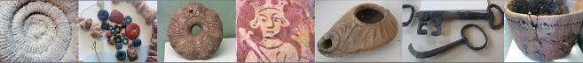

Friday 19 April 2013, 7.30pm

Romano-British discoveries in the Barcombe area
With David Millum and Rob Wallace.

Following their talk last year on the Barcombe Roman Bath House, David and Rob bring news of some exciting new discoveries nearby, which may help explain more about what could have been going on in Romano-British Barcombe.

Lecture room, Town Hall, Lewes
(Fisher Street entrance). Lift available

NEXT LAG LECTURE
Dr William Harcourt Smith
WHAT THE “HOBBITS” OF INDONESIA CAN TELL US ABOUT HUMAN EVOLUTION AND WHY IT MATTERS
Friday 4th January 2019 at 7.30pm
Lecture Room, Lewes Town Hall, Fisher Street Entrance

The Long Journey Home: Edith Cavell and the “Cavell Van”
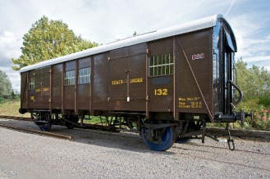 The The Long Journey Home: Edith Cavell and the “Cavell” Van
Cavell and the “Cavell” Van

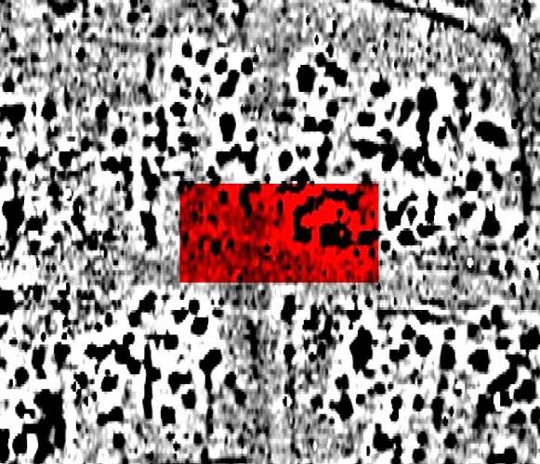
The recording Remembrance project is aiming to record all First World War memorials across East Sussex. Memorials recorded by the project can be crosses, plaques or more unusual objects. One such unusual object is the railway van pictured above. The railway carriage which is known as the “Cavell Van” can be found at Bodiam Railway Station. It commemorates the life of nurse Edith Cavell.

On 15th May 1919, a South Eastern & Chatham railway van left Dover on its way to London, carrying a very important passenger. Her name was Edith Cavell and, after a long and arduous war, she was finally being brought home to be laid to rest.

Edith Cavell was an English nurse, working in Belgium at a Red Cross hospital. Between 1914 and when she was arrested on the 5th August 1915, she had helped over 200 allied soldiers escape. She was shot by firing squad on October 12th 1915. She was 49 years of age.

Following her journey home from Dover to London, railway vans of the same type became known as “Cavells”. The fully restored railway van now sits in a siding at the rear of Bodiam Station. Inside, a single coffin sits in the centre, an eerie reminder of the cost of war.

This memorial, along with many others, is recorded on the Recording Remembrance database. With the help of the public, we are working hard to ensure that these physical representations of the sacrifice of war are preserved for future generations. Volunteers across the county can record the condition, physical nature and inscriptions of memorials and report them to the website. https://www.recordingremembrance.org.uk/.

Emily Manser

Bridge Farm Excavations 2018

The 2018 summer season has seen the excavation of the upper layers of the seventh trench to be opened at the intriguing Romano-British settlement site at Bridge Farm, near Barcombe Mills.

Trench 7 is located in the very centre of the area enclosed by the second century double ditch defences and it was hoped that this 45 by 20 metre area over the central crossroads could reveal important new evidence. However we have to remember that this site represents over 300 years of activity and this year we have only been able to penetrate the upper layers of this trench which seem to mainly feature industrial remains. These consist of large pits, areas of fired clay, series of postholes with large flint packing and deposits with high carbon content. Some of the postholes appear to be in rows suggesting possible rectangular structures.

One area was of particular interest as a deposit of fired clay appeared surrounded by lumps of chalk and Downland flint. The feature had the appearance of some kind of hearth or kiln with the presence of chalk leading us to think that it may be the remains of a simple clamp-type lime kiln. The only previous occurrence of chalk at the site was in the walls of the well excavated in 2017 but the chalk in this instance could not be argued as a structural element as it was in an obviously fired environment.
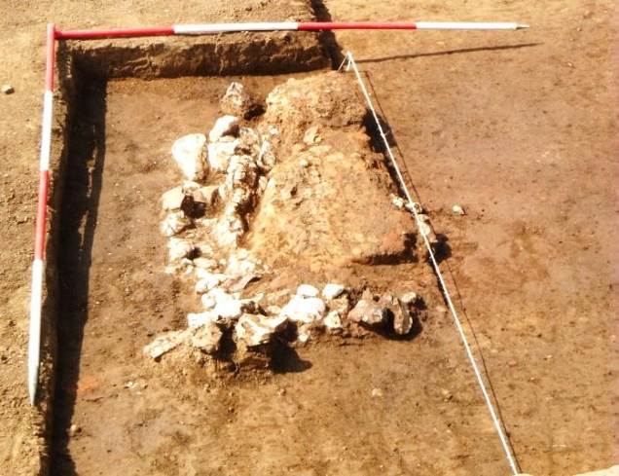

The initial clean back of the whole trench surface produced a great deal of pottery and an area of road structure at only 200mm below the current ground level. The upper layer of this consisted of flint pebbles and small nodules which had been disturbed by ploughing but at the eastern end was an under-layer of compressed flint gravels which seemed to form the main base structure of the road. This however was not found anywhere else along the trench at this shallow depth and may have been ploughed and/or robbed out.

Many large pits were found and one in the northwest corner of the trench proved to be not only multi-layered but very deep. Most of the pit and postholes discovered were half-sectioned and recorded but still need fully excavating, offering a busy time from the very start of next season.

Amongst the varied assemblage of over 17,000 pottery sherds we observed a greater percentage of fine wares than in previous seasons. This includes a good quantity of samian, some with embossed decoration, maker’s marks and scratched graffiti.

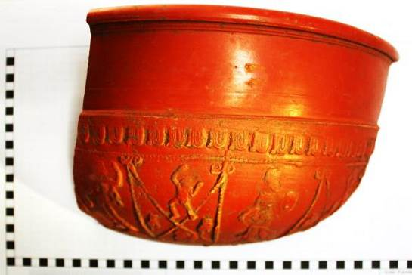

Close to our possible lime kiln was a pile of black colour-coated white fineware beaker sherds with a number of large amphora sherds nearby.

We also had more mortaria sherds than before including one almost complete mortarium in a light buff/cream fabric.

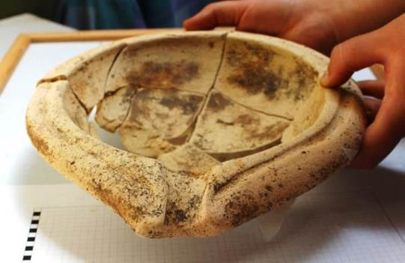
Because this is obviously going to be another 2-3 year trench we will have to be patient before commissioning the pottery analysis.

David Millum, MCIfA, CAP Deputy Director ©CAP August 2018

Plumpton Roman Villa

The Sussex School of Archaeology continued its excavations of the Plumpton Roman Villa over the summer.

One fine evening in August LAG and members of the Brighton and Hove Archaeological Society visited the site and were given a tour by David Rudling and Jan Oldham.

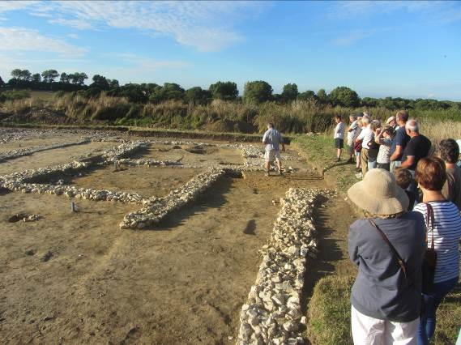

This year’s excavation centred around the bath house. David explained the outline of the bath house. In addition, the area to the south of the western end of the main villa building and bath house was investigated.

The north-south orientated bath suite, which was approximately 10.4m long and 4.5m wide internally, may have been multi-phased. It comprised a probable entrance room at its south-east corner. To the west of the suggested entrance room was the cold room which had a very solid mortared floor and along its west wall a semi-circular apsidal area partly paved with thin slim slabs of Horsham sandstone.

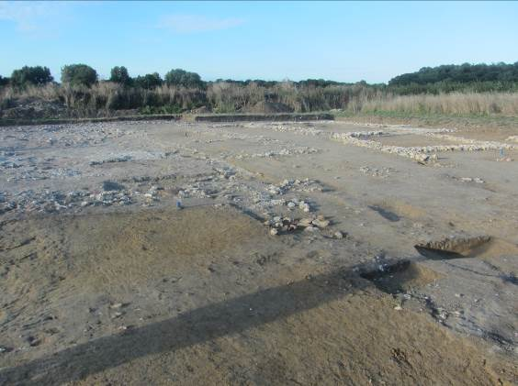

To the south of the baths were discovered two ditches or gullies. Other discoveries to the east of these features included some flint packed post holes and some pits containing a lot of charcoal. There were also remains of a bread oven.

Jan showed us some of the finds which included a lovely piece of painted wall plaster.

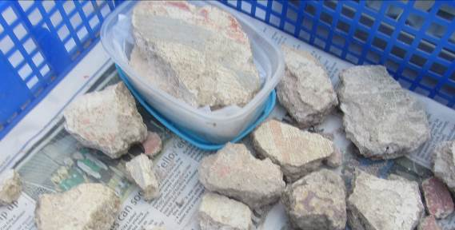

Excavations in Lewes

Just the one to report -

212 High Street (TQ 41764 10216). (Director: Diccon Hart). An archaeological watching brief was carried out in September and October 2018 during groundworks associated with the conversion of the property to residential use. An area measuring c. 5m by 2m to the rear (north) of the property was reduced to 2m below existing ground level, exposing c 1.80m of natural alluvial deposits overlying river terrace gravels. Archaeological features encountered included the eastern wall of a possible medieval chalk built cellar, an adjacent chalk lined well and probably cess pit (also of probable medieval date) and a post-medieval rubbish pit. The cellar appears to have been backfilled in the later 18th or 19th century, and a thick landscaping of the rear garden of the present Georgian bulidn fronting the High Street. Internal alterations to the building were also monitored in order to record any exposed historic fabric.

Fieldwork at Rocky Clump (Stanmer) by the Brighton and Hove Archaeological Society
These excavations are of a Late Iron Age/early Romano-British enclosure. The enclosure is defined by ditches, some of which are over 2 metres wide and almost 1.5 metres in depth. This year’s excavations have uncovered the north/east and south edges of the enclosure and possibly its entranceway. Five separate ditches have been revealed, along with pits and a vast number of post and stake holes. The finds include six Roman coins, with an exceptional Sestersius and Barbarous Radiate and a copper alloy bangle. There have also been large finds of animal bone and pottery. One of the highlights has been the discovery of a baby burial in the upper east/west ditch. We are hoping to determine what activities were carried out within this complex series of features. The excavation has a finish date of the 20th October when we will be completing the recording of the site and commencing the post excavation work of processing the finds. The County Archaeologist has kindly granted permission for the excavation to be continued next year, where we hope to finish the area to the south of the enclosure. This will be subject to the agreement of the tenant farmer, Mr David Robinson. There are always opportunities for non-members who, by appointment, can join us for any of our activities throughout the autumn/ winter months and into the 2019 season. Details can be obtained by visiting our website (http://www.brightonarch.org.uk) (BHAS).

Ringmer Brick Kilns

Archaeology South-East held an open day at Bishop’s Lane, Ringmer on 18th November to show to members of the public the excavations that it has been undertaking in a field off Bishop’s Lane that is due to be developed for housing.

ASE have excavated two brick kilns and are intending to excavate another kiln in the vicinity which is thought to be a pottery kiln.

It had been thought prior to excavation that the kiln would be medieval but the current assessment by ASE is that the brick kilns date to around 1650 to 1750.

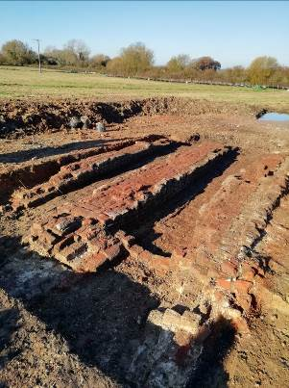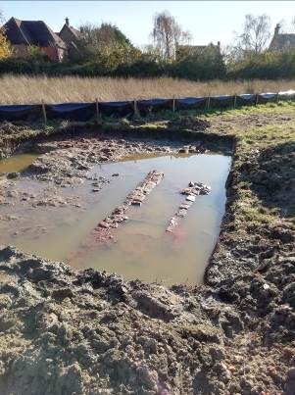

Bishopstone Church

John Blair, Professor of Medieval History and Archaeology at the Queen’s College, University of Oxford and author of “Building Anglo-Saxon England” gave a talk to LAG earlier this year. John mentioned about some remnants of a wall painting in St Andrew’s Church, Bishopstone East Sussex, that he thought might date to the Anglo Saxon period.
The painted plaster is on the west wall of the church beside the archway into the tower.

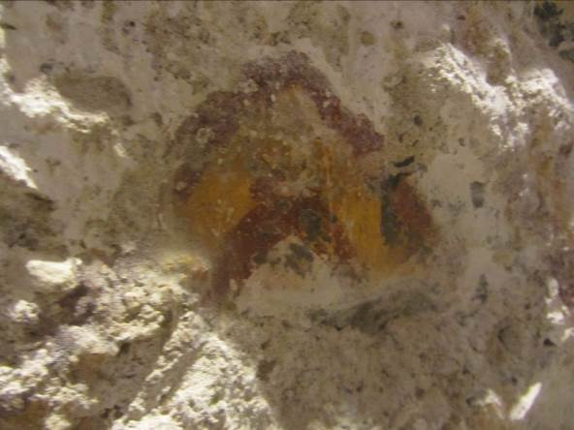

It is not known precisely when Bishopstone Church was built, but following investigations when restoration work was carried out in 2006, it is believed to have been constructed anytime between the 8th and 10th centuries. The church has a Saxon porch with a Saxon sundial inscribed with the name “Eadric”.

The guide to the church notes -

“The nave of the Church is Saxon. The slenderness of the walls, high proportions and large stone quoins to its western angles are thought to give a dating to early 9th century and no later than 10th century and probably before 950AD. Above the War Memorials can be seen a Saxon window that was uncovered during the 2006 restoration. This was an external window before the north aisle was added. Lower down and to the left of the War Memorials are the remnants of a wall painting which was exposed in the 2006 restoration.

The bell tower itself whilst built in the 12th century has Saxon features – the as you go into the bell tower and look back, there are recesses which were Saxon windows which would have illuminated the church prior to the tower being built. The entrance to the tower was made by cutting into a small archway through the Saxon west wall.”

I have been trying to find out more about the paint fragments. Emily Howe from the Courtauld wrote to me that –
“ Professor David Park had corresponded with Bishopstone parish about the discovery of the paint remnants back in 2006. On his recommendation, the wall painting conservator Anne Ballantyne visited site and wrote a brief report detailing her observations. In this she noted that the chevron pattern appeared to have been undertaken over a limewash layer applied directly to the masonry. While this might mean that the painting is broadly coeval with the Saxon (?) wall, there is of course the possibility that the wall remained unpainted until a later date. In his notes, David (who is the expert in these matters) concurs that the painting is difficult to date since chevron patterns were used over quite a long period.
Technical examination of paint samples from the scheme would tell you what materials (pigments and binders) were used, but not really help with questions of dating since the same types of painting materials and techniques were used over many centuries. Examination of a cross-section would be able to confirm whether there are any underlying schemes of limewash or paint, but Anne Ballantyne did not see any evidence of underlying schemes in her own careful examination.”
Do visit the Bishopstone Church and take a look at the wall painting.
Ragstone to Riches by Simon Elliott
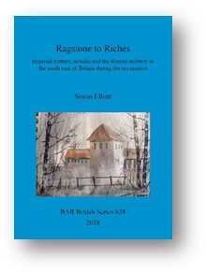Ragstone to Riches tells the story of the huge Roman metalla extractive industries of the south east of the province of Britannia. These provided much of the iron to equip the military there, and ragstone to facilitate the construction of the built environment in the region during the occupation, through to the middle of the 3rd century AD. In the former case this was the Wealden iron industry, which, especially to the north of Hastings, featured sites as large as any industrial enterprise today. Meanwhile, regarding the upper Medway Valley ragstone quarrying industry, the work identifies for the first time the five specific quarries which provided the material to build Roman London. For both, the author also explores the role played by the military in running these enormous metalla enterprises. Simon Elliott is an archaeologist and historian specialising in Roman Britain and the Roman military.

RSP: £32 ISBN: 9781407316529 However, LAG newsletter readers are offered a 15% discount – quote LAG!8 if you put in an order.
https://www.barpublishing.com/ragstone-to-riches.html

The new Archaeology Gallery at Brighton Museum

A new Archaeology Gallery at the Brighton Museum will open in the New Year. Watch out for news in the media!

Talks and events

BHAS Brighton & Hove Archaeological Society
ENHAS Eastbourne Natural History and Archaeological Society
FOAC Friends of Anne of Cleves House
LHG Lewes History Group
LAG Lewes Archaeological Group
SAS Sussex Archaeological Society
SSA Sussex School of Archaeology
USAS University of Sussex Archaeological Society
WAS Worthing Archaeological Society
WBSG Wealden Building Study Group

JANUARY

Fri 4th January – LAG – What the “hobbits” of Indonesia can tell us about human evolution and why it matters with Will Harcourt Smith. 7.30pm Lecture Theatre, Lewes Town Hall, Fisher Street Entrance. £4/3/2/Free (for under 25s)..
Tuesday 8th January – WAS – The Roman Army in Sussex – Edwin Wood. 7.30pm Lecture Theatre, Worthing Library.
Fri 11th January – BHAS – How many??? Bronze Age, Iron Age, Roman buildings at Chalkers Lane, Hurstpierpoint with Simon Stevens. Unitarian Church, New Road Brighton. 7.30pm. £4/free (for members).
Monday 14th January – LHG – Local History with the Path Detectives – with Chris Smith. 7pm Kings Church, Brooks Road, Lewes. £3/1.
Saturday 19th January – BHAS local history forum – Shops and Shopping: the small shop through the ages with Janet Pennington. 2.30pm Ventnor Hall, Central United Reform Church, 102 Blatchington Road.
Sunday 20th January – WBSG – Report on the Buildings Visited by WBSG in 2018. Wivelsfield Church Hall 11am to 2.30pm. £5/free (for members).
Saturday 26th January – BHAS day school – What geologists know that might be useful with Tony Corrigan. £30/25. See BHAS website.

FEBRUARY

Friday 8th February – BHAS – A persistent place: excavating Ice Age archaeology on the Channel Island of Jersey – with Matt Pope. Unitarian Church, New Road Brighton. 7.30pm. £4/free (for members).
Saturday 9th February – BHAS day school – Prehistoric Pottery with Lisa Fisher. £30/25. See BHAS website.
Monday 11th February – LHG – The legacy of Henry and Amon Henry Wilds with Sue Berry. 7pm Kings Church, Brooks Road, Lewes. £3/1.
Friday 15th February – LAG – Where archaeology meets astronomy with Robert Turner. 7.30pm Lecture Theatre, Lewes Town Hall, Fisher Street Entrance. £4/3/2/Free (for under 25s).
Sunday 17th Febuary – WBSG – Peter Varlow followed by Dr Janet Pennington – “Witches, Warlocks and Wellingtons”. Wivelsfield Church Hall, 11am to 2.30pm. £5/free (for members).
Saturday 23rd February – BHAS local history forum – An A to Z of what to see in a Sussex Church with Kevin Gordon. 2.30pm Ventnor Hall, Central United Reform Church, 102 Blatchington Road.

MARCH

Friday 8th March – BHAS – Bridge Farm 2018: into the dark centre with David Millum and Rob Wallace. Unitarian Church, New Road Brighton. 7.30pm. £4/free (for members).
Saturday 9th March – BHAS day school – Death and commemoration with Simon Stevens. £30/25. See BHAS website.
Monday 11th March – LHG – Thomas Cromwell and the dissolution of the Sussex monasteries with Helen Poole. 7pm Kings Church, Brooks Road, Lewes. £3/1.
Tuesday 12th March – WAS – The Clandon Park Project with Tom Dommett. 7.30pm Lecture Theatre, Worthing Library.
Friday 15th March LAG – Prehistoric Act in the Prehistoric Landscape with Professor Richard Bradley. 7.30pm Lecture Theatre, Lewes Town Hall, Fisher Street Entrance. £4/3/2/Free (for under 25s).
Sunday 17th March – WBSG – We the better sort: houses of the emerging parish middle class in the landscape 1350-1550 with David Martin. Wivelsfield Church Hall, 11am to 2.30pm. £5/free (for members).
Saturday 23rd March – BHAS local history forum – The influence of the army and other defences on resort developments in Sussex circa 1770 to 1815 with Sue Berry. 2.30pm Ventnor Hall, Central United Reform Church, 102 Blatchington Road.

APRIL

Fri 12th April – LAG – Lewes to Wessex and Back Again with Dr Mike Allen. 7.30pm Lecture Theatre, Lewes Town Hall, Fisher Street Entrance. £4/3/2/Free (for under 25s)..

The LAG newsletter comes out twice a year in the spring and autumn. The autumn deadline is the end of September and the spring deadline is the end of April. Contributions to Paula at paulawodcohen@yahoo.co.uk
please.

