
Lewes Archaeological Group newsletter

Affiliated to the Sussex Archaeological Society
and the Council for British Archaeology

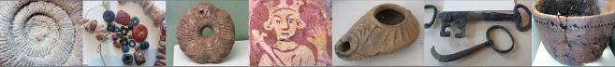

Friday 19 April 2013, 7.30pm

Romano-British discoveries in the Barcombe area
With David Millum and Rob Wallace.

Following their talk last year on the Barcombe Roman Bath House, David and Rob bring news of some exciting new discoveries nearby, which may help explain more about what could have been going on in Romano-British Barcombe.

Lecture room, Town Hall, Lewes
(Fisher Street entrance). Lift available

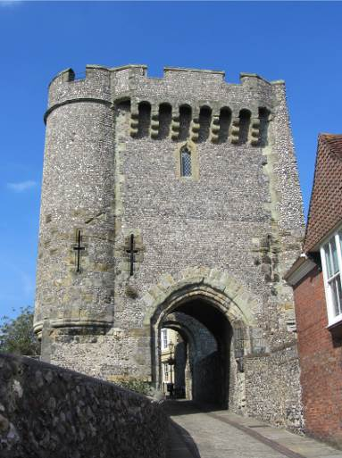 | A Brief History of Lewes  Martin Cohen, author and Lewesian, offers a personal overview of the history of Lewes and particular issues of archaeological interest.

www.lewesarchaeology.org.uk

The Archaeology of Lewes web page on the LAG website has at last been completed.

The idea is to provide a forum for publication of interesting articles and pieces on the history and archaeology of Lewes. To this end, we have created a web page on the LAG website.

To kick the page off we are pleased to include an article by Martin Cohen. Martin is a Lewesian and is an author of a number of philosophy and political books as well as being an author of two picture books for philosophy for children.

No. 156
April 2018
www.lewesarchaeology.org.uk

Martin’s article gives an interesting and entertaining account of the history and archaeology of Lewes. It provides an excellent place to start learning about Lewes’ past and gives a lively interpretation of the existing sources to excite debate. To visit the LAG website and to read Martin’s article click on www.lewesarchaeology.org and choose Archaeology of Lewes and then click on the highlighted in blue “A Brief History of Lewes”.

If you would like to have your article or piece included on the LAG website please send it to paulawodcohen@yahoo.co.uk.

AGM News

The AGM took place on Friday 16th March.

The following officers and committee members were appointed –

Hon President: Mike Allen
Chair: Paula Stanyer
Vice Chair: Anne Locke
Hon Secretary: Wendy Muriel
Hon Treasure: Brian Phillips

Committee: Sabrina Harcourt-Smith, Fiona Marsden, David Gregory, and Chris Greatorex.

Sheila O’Sullivan was appointed as the Independent Examiner of Accounts.

Brian reported that the Group was in a good financial position with a healthy bank balance.

New Hon President: Mike Allen

I was honoured and flattered to be asked to be your President. I know a number of members having been involved in archaeology in the Lewes area for about 45 years but there are some don’t know me, and who I heard asking questions like, who is he?, what has he done anyway? … so to you don’t know me so I thought I’d say a few words.

I started my interest in archaeology as an 11 year old schoolboy in Lewes, and in 1973/4 started digging at the Groups rescue excavation of the Bronze Age round barrow on Round-the-Down with Richard Lewis, and subsequently at the Priory with him. Both my parents were interested and also started digging; regularly turning up on sites as a family. My mother had started adult evening classes – I would wait up for her to return to read her notes – it was decided this was pointless so, with permission from County Education Officer, I attended archaeology adult evening classes from the age of 13.

I read archaeology at university and then went on to study at the Institute of Archaeology concentrating on environmental archaeology (esp., soils, sediments and snails).

Following graduation and excavation of Ashcombe Bottom dry valley with LAG, I did a PhD at Southampton University then was the first environmental manager at Wessex Archaeology running that section for nearly 20 years before becoming being a freelance environmental and geoarchaeological specialist and building my own lab.

I have worked on and am working in the Stonehenge and Avebury landscape, and Dorchester and Cranborne Chase and in Sussex on the Westhampnett bypass. I’ve worked in France, Germany, Malta and Cape Verde and published widely (about 15 monographs/books, many articles and 100s of contributions), with my recent local books include Eastbourne; aspects of archaeology, history and heritage (2014), Archaeology of the Ouse Valley (Moore, Allen & Rudling, 2016), and my textbook Molluscs in Archaeology (2017).

I am a Fellow of the Linnaean Society, awarded fellowship of the Society of Antiquaries (FSA), and have been a member of IFA (MCIfA) since c 1996). I am member of the executive council of the Prehistoric Society, former President, and now Vice President, of the Conchological Society of Great Britain & Ireland, Series Editor of the Prehistoric Society peer-reviewed Research Papers Monograph series and, in an unpaid capacity, am Series editor of Oxbows Studying Scientific Archaeology Series, and their Insights series.

I followed both my parents onto the committee of LAG (my mother was the newsletter editor for 23 issues over 4 years, and a former VC), becoming Vice Chairman in 1984-7, during which time I excavated Ashcombe Bottom (SAC 2005), ran a Lewes symposium and a Lewes Archaeology week.

So I was honoured to have been asked to be your president, and as I feel the Group gave me many opportunities (which I readily took) - it nurtured and helped me into my subsequent career; in my term as President I advise the Group with is work, and with celebrating its 50th anniversary.

Mike Allen

A Musical Diva in Folkington and Lewes around 1900

The small Early English church of Saint Peter ad Vincula in Folkington lies at the foot of the Downs, set in woodland at the edge of rolling grassland. Among the many wall monuments inside the church, the simplest but one of the most distinctive is a fine plaque of soft green Westmorland slate on the north nave wall. This commemorates the gifted musician Violet Gordon Woodhouse. The words of the epitaph to her by the distinguished man of letters Sacheverell Sitwell, brother of Osbert and Edith encapsulate her genius -

“In loving Memory of Violet Gordon Woodhouse. Born 23 April 1871. Died 9 January 1948. Born with a rare genius for music. Her playing of the harpsichord and clavichord revealed a forgotten world of beauty and imagination and the echoes of her music will sound forever in the hearts of those that loved her.”

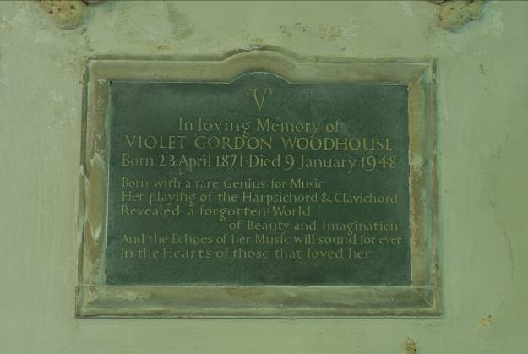

Violet’s grave stone is outside in St. Peter’s churchyard, set in the south-west wall. It was recently conserved by Sussex Letter-Cutter and Stonemason Geoffrey Aldred.

Violet was one of three daughters and four sons of James E.A. and May Gwynne of nearby Folkington Manor, a handsome early Victorian mansion acquired with its village and lands by James Gwynne in 1876.

Since her own time onwards, Violet has been acclaimed for her magical skill at playing on the harpsichord, the clavichord and other early keyboards, thereby influencing the revival of early music in England. Her brilliant interpretations of the composers for these instruments place her among the 20th century’s greatest musicians. The biography Violet – The Life and Loves of Violet Gordon Woodhouse by one of her great-nieces. Jessica Douglas-Home, traces the path of Violet’s unconventional life and the influences that affected her. The book was first published in 1996 by the Harvill Press and tells the whole unusual story.
Violet’s musical genius was inherited from her maternal grandmother, the beautiful and exotic Cornelia Purvis, born to Theunis and Anna Int’veldt in Sumatra. May Gwynne nurtured Violet’s musical genius from a young age, later introducing her into the world of 1890’s musical London, with its concerts, salons and rising singers. Her tutors included Agustin Rubio, father-figure of Spanish émigré musicians in London.

The Early Music Revivalist Arnold Dolmetsch’s discovery of Violet and her genius in 1895 was a milestone in her career. In 1920 he made the first ever recording of the harpsichord in England with Violet at the keyboard.

Although for most of her life she moved in stylish and elegant musical circles, Violet never forgot her early years in rural Sussex. Following their marriage in 1895, she and Gordon Woodhouse moved into her father’s Wootton Manor, a 17th-century farmhouse in a historic settlement at the northern end of Folkington village. Gordon loved the countryside and horses, but Violet grew restless in village surroundings.

After a wonderful Christmas Day family party of 1900 at Wootton hosted by Gordon and Violet and described by her sister Dorothy, in the spring of 1901 they moved to 16th-century Southover Grange in Lewes. For the next five years Violet performed tirelessly in their London house and at Southover, fast acquiring a reputation in musical circles for her exquisite keyboard playing. During these Sussex years the Gordon Woodhouse home slowly metamorphosed into the fascinating ‘ménage a cinq‘ with Violet’s dashing admirers. This exotic entourage was the rock which nurtured her through her remarkable life and career.

Sabrina Harcourt-Smith.

Bridge Farm: Mud, Glorious Mud

Those who braved the elements to participate in the excavations at Bridge Farm last year will recall that we had a problem of recurrent downpours during July. This was the final year in Trench 6, an area of 1400sq.m located at the intersection of Margary’s London road (M14) and the late 2nd century double ditch enclosure. The 2017 investigations were specifically of features at the deeper level which of course got completely flooded each time it poured hard. Despite the weekly setbacks a large work force of students and the more determined of our volunteers battled on to reveal a complex palimpsest of roads, ditches and pits.

A layer of flint heading south from the London road and overlaying the internal enclosed ditch was uncovered on removing the baulk to the east of the London road in the northern half of the trench. The consolidated area of flints suggested that this could be a side road constructed at some time after the inner enclosure ditch was backfilled; possibly providing a link to the eastern road to Arlington. Further excavation to the eastern side of the trench showed that the flints became sparser as its route left the sunken level above the enclosure ditch and came up to a level potentially affected by plough damage. However, the base of a probable southern roadside ditch was clearly indicated as a narrow band of flints.

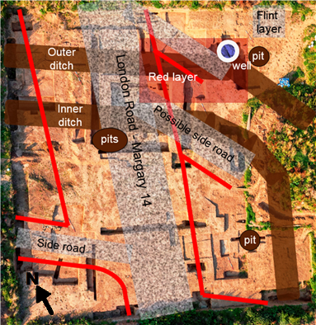

The excavations of 2017 seem to have produced less pottery than previous years with the usual amounts of cbm and iron production waste, a.k.a. slag, probably reflecting the concentration on cleaning the various areas of road. The pottery data will be fully explored once the specialist report has been undertaken, but it was interesting to see that more amphora sherds were found. In all 120 special finds were recorded in 2017 compared to 162 in 2016 and 120 in 2015, giving a total of 420 for Trench 6 over the 3 years. The special finds for 2017 were mainly coins and bronze dress ornaments with a collection of pins and brooches. These included SF326, a whole pin with a glass setting to its head and two oval disk brooches, one of which still had its central setting despite having lost most of the surrounding decorative bands.

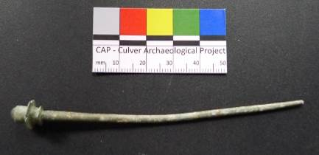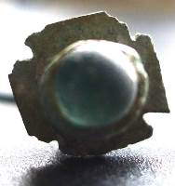
Complete bronze pin with setting in head

The main purpose of this trench was to investigate the intersection of the London road with the enclosure ditches and this has been accomplished with some surprising results. It became clear in the first season that the pre-excavation hypothesis, based on the published results from a restricted excavation of the road by Ivan Margary in the 1930s, that the late 2nd century earthworks would cut a late 1st to early 2nd century road was unsound. The remains of the road clearly overlaid the backfilled ditches and over the 3 years no evidence of an older road on this alignment was found. The precise dating of this road, if that is possible, and its overlying layers must wait for the artefact reports, but the initial assessment by the excavators is that this section of the London road was built during the first half of the 3rd century and that the earthwork defences in at least this area were not long-lasting. A more precise dating of the earthworks, both in construction and closure, is a continuing aim of the project with further research into the wider provision of these short-term defences and the development of a plausible reason for their construction a longer term, if optimistic, research objective. Trench 6 not only achieved its principal aim but has taught us a vast amount about the technique of excavating this alluvial site and the nature of the archaeology available. This knowledge will be utilised in future seasons. The shallowness of much of the archaeology and the depth of intrusion from deep-rooted crops and alluvial penetration has confirmed concerns about the durability of the archaeological record and justifies continued excavation of specifically targeted locations at this site.

For details on how to participate in this year’s excavations at Bridge Farm – see further below “Summer Excavations”. A full version of this article can be found at www.culverproject.co.uk.

finds archive
LAG will be 50 in 2019

The fact the Group will be celebrating its 50th birthday in 2019 is a great achievement. When it was established a number of long standing archaeological societies already existed. The Sussex Archaeological Society was founded in 1846, the Eastbourne Natural History and Archaeological Society was founded in 1867 and in the early 20th century there followed the Brighton and Hove Archaeological Society in 1906 and soon after the Worthing Archaeological Society in 1922.

LAG was founded by John Houghton a local historian, Jock Knight Farr who was a local council worker (digging roads, hedging and ditching) and Ted O’Shea who was a professional surveyor. LAG soon enlisted Richard Lewis to run its excavations. This though, is not the time to review our 50 years, but it is a great achievement. The Group has undertaken many activities, held events and produced publications.

We are just starting to plan how we might celebrate LAG’s silver jubilee. Please help with your ideas, and with organising and participating in our events – just email Paula (paulawodcohen@yahoo.co.uk) or phone on 07814 463 259. We like ideas but we also like offers to help provide activities!
Possible research project

John Blair recently asked the question where might there have been a crossing point between Malling and Landport in the Anglo-Saxon period. Other speakers have also speculated about the existence and whereabouts of such a crossing point.

LAG was wondering about starting a research project to look into the question. The group would be led by Paula Stanyer and we would look at historical and other records and speak to local historians.

If you might be interested in participating (or if you have information that might help), please contactPaula (paulawodcohen@yahoo.co.uk) or phone 07814 463 259.

Lewes Priory Lavatorium Tunnel

The Priory Trust received the excellent news on the 18th January 2018, that Historic England will provide research support from its Geospatial Imaging Team to carry out a 3D laser scanning project on the lavatorium tunnel of the Lewes Priory of St. Pancras. The tunnel was part of an underground drainage and water supply system, an integral part of the 12th century lavatorium complex. It is one of the best preserved undergroundtunnels originating from the medieval period.

The lavatorium was a communal washing area in the Cloisters of medieval abbeys and priories. The monks were required to wash before meals and the lavatorium was usually found close to the refectory. In Lewes, the lavatorium was a small circular building (579 cm in diameter) located in the SW corner of the cloister garth, adjacent to the entrance to the refectory. The monks washing basin was mounted on an inner circular wall of the lavatorium laver (338 cm in diameter, Benjamin & Gammon, unpublished).

Of direct significance for the present project was the mapping of the underground tunnel by the well-known local surveyor W. Figg (SAC 7, pp151-157, 1854). He produced an excellent 2D plan of what is substantial and irregular building structure 36 metres in length. This plan still provides important architectural information for the scan research project.
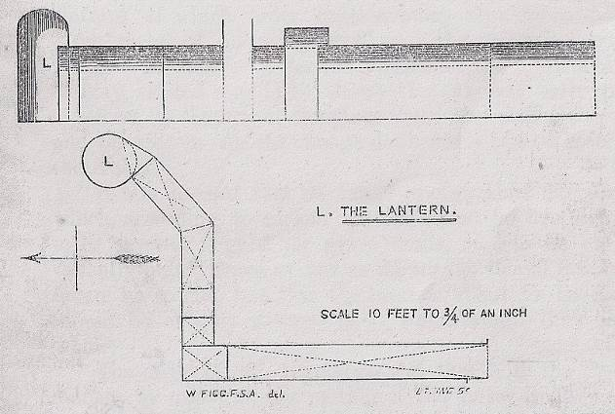

A recent research visit to the lavatorium tunnel (May, 2017) carried out a systematic photographic analysis of the interior of the lantern tunnel –

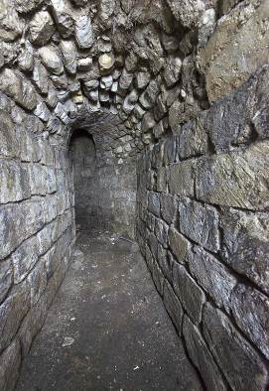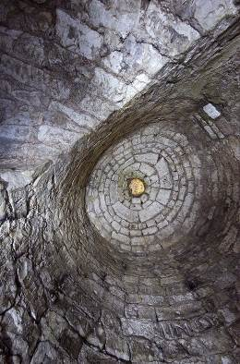

(images by John Crook)). It provided the most important results for the laser-scanning project and showed that N/NE passage is still remarkably intact and ready for a laser scan. The walls of the tunnel consist of horizontal overlapping courses of carved stone (Upper Greensand/Malmstone, TimTatton-Brown). The arched roof consists of rubble and flint stones embedded in mortar. In the lantern chamber, the courses of stones became gradually narrower to eventually form the arched dome. The apex of the dome has been filled-in more recently with another type of building stone (see above image of dome). The previous apical opening of the dome lies immediately beneath the lavatorium.

The 3D laser-scan of the NE tunnel and lantern will allow us to produce a computer-generated set of CAD images in various orientations to update the original plan of Figg. Secondly, we will identify the types of building stones and determine whether they are part of the original of the 12th century lavatorium complex or due to more-recent repairs.Thirdly, there is scattered stone debris on the floor of the NE tunnel and the S tunnel is partially blocked by quantities of soil and several types of stone debris. The archaeological distribution of this material will be assessed using the laser scan. We will determine the archaeological status of this debris. For instance, is it of medieval origin and/or is it due to more recent blocking of the tunnel during the 19th century or earlier? It will also be important to survey the floor levels and slopes of the tunnel by taking sections at multiple sites within the tunnel system. The floor is clearly not at the original level and may be ‘hiding’ pipe-work or a culvert that could be part of a water supply or drainage system for the (above ground) lavatorium laver. Finally, a digital copy of the laser scan will be displayed on the website of the Lewes Priory Trust. It would complement other sets of images that illustrate recent progress in the analysis of the carved Tournai marble stones that form the above-ground lavatorium (see Priory sculpture project: Benjamin and Gammon, see Priory Trust website, links via Research to the Priory Stones).

The Lewes Priory Trust wishes to thank the owners of the lavatorium site, Tim Bishop and Claire Brind, for kindly allowing us to carry out the laser scan project on their land.

Professor Paul R. Benjamin (Trustee of Lewes Priory Trust).
p.r.benjamin@sussex.ac.uk

Excavations in Lewes
St. John the Baptist (TQ 41270 09652). (Director: Lisa Fisher, ASL). In January 2018, ASL maintained a watching brief during the excavation and installation of new drainage against the west wall of the church tower. No features of great age were uncovered but a quantity of human remains were encountered and removed safely for re-burial. In addition, the foundations of the Georgian tower were recorded and a small patch of masonry of unknown date was also recorded adjacent to the south-west buttress. Finds were sparse but some earlier window glass was recovered along with some fragments of earlier Horsham stone roof slabs and Quarr limestone from the Isle of Wight. Several flint flakes were recovered from the made ground (100) but these are likely to be waste flakes from the facing of flint for the churchyard wall, rather than worked prehistoric flints. Fragments of clay tobacco pipe stems dating between the mid 17th century and early-mid 18th century are likely to have come from the workmen who built the new Georgian tower.
The Old Post Office, 65 High Street. (NGR TQ 41451 10032). (Director Maggie Henderson). A historic building assessment was prepared for the Old Post Office in September 2017 to assess the origin, development and significance of the building in advance of a programme of alterations. The greater part of the extant external brickwork, roof-structure and floor-plan of the building dates to the turn of the 19th century and comprises the construction of the north – south oriented main range at the junction of the High Street and Watergate Lane. It is probable that parts of the walls on all but the south side of the building at basement level are surviving elements of earlier buildings. The thinner bricks used as quoins within the vaulted part of the basement indicate earlier activity, the brickwork consistent with 16th and 17th century work contrasting clearly in dimensions to the consistent late Georgian era work of most of the main range. By 1851 the house had been converted to a Quaker School, remaining as such until 1876 when it became the residence of the Morris family and the location of the post office. In 1934 the building underwent a programme of modernisation with a re-opening event dated to the 1st of October that year. The building remained in use as a post office until its closure in 2016 (HBAC).
Court Road Car Park. (NGR 541883 110091). (Director: Gary Webster, ASE). Three trenches were excavated during an evaluation. Though the site has seen obvious truncation, the majority of which is from modern services, there are areas where archaeology survives. A deposit associated with the Franciscan Friary dating back to the 14th century, based on recovered pottery, was located at the base of one of the trenches. Two walls, probably dating to the late 18th to early 19th century were also identified. One of the walls reused a brick dating from the late 16th century. They remain in situ. Railway sleepers likely associated with the former goods depot were also identified. Chinese porcelain identified in the lower deposit in Trench 3 indicate that this area was truncated down to a depth of 2.05m BGL (2.8m AOD).

Lewes: Yew Tree Cottage. (NGR 541238 109667). (Director: Chris Russell, ASE). Medieval and post-medieval remains have been recorded during the monitoring of redevelopment works, including a medieval inhumation burial. Historic building recorded has also taken place. Post-excavation work is ongoing.

Recording Remembrance Project
The Recording Remembrance project began in 2014 with the purpose of recording all aspects of East Sussex and Brighton & Hove’s war memorials including information about location, condition, form and inscription. Our aim is to have as many memorials recorded as we can, including linking digital images (photographs, drawings) of the memorials. Currently there are a total of 31 known memorials recorded in Lewes, with 16 memorial records requiring further information. With the centenary of the end of World War One fast approaching, we would like to encourage members of the Lewes Archaeological Group to volunteer and record the remaining memorials in their local areas.
More information about the Recording Remembrance project can be found at: http://www.recordingremembrance.org.uk/main and further guidance can also be found at: http://www.recordingremembrance.org.uk/help.

The Parish Atlas of England: An Atlas of English Parish Boundaries (2017)
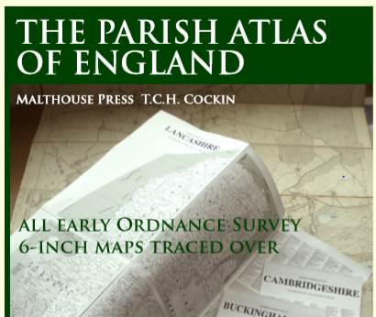

A major new work of reference aimed at family/local historians, taking seven years to write, covering every English county in 900 pages has recently been published. The author, Tim Cockin has traced over the County Series collection of OS map 6 inch to 1 mile maps. The Atlas can be bought from me direct at £45 incl.
Or retail at £60.00 (The National Archives Bookshop and Society of Genealogists bookshop stock it). East and West Sussex Archives (Brighton and Chichester) have copies for viewing.

Summer Excavations

Bridge Farm

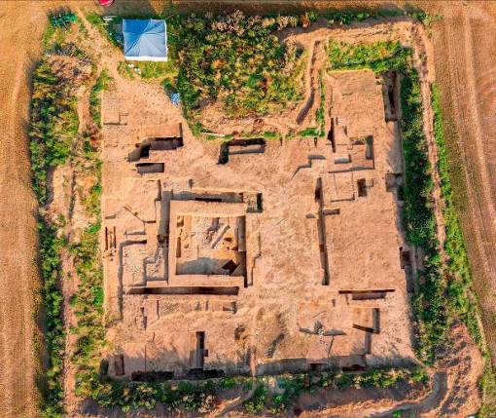

Annual excavation opportunity at the recently discovered, large defended, 1st-4th century Romano-British settlement, just north of Lewes at Bridge Farm, Barcombe. This is the sixth year of excavations at this regionally important green-field site. The excavation starts on 4th June and will finish on 13th July. It is open 7 days per week, Mon-Fri 9-5 & Sat/Sun 10-5. Volunteering fees £25 for 7 days, £40 for 14 days or £60 for the whole season. Camping at £50 per week (to include dig fees) with use of hot showers, flushing WCs and fully equipped kitchen in the site HQ building. Two week training course with camping £500.

See www.culverproject.co.uk for more details or email excavations@culverproject.co.uk.
Plumpton Roman Villa
The Sussex School of Archaeology is also continuing its excavation of the Plumpton Roman Villa 2nd July to 17th August 2018
Excavation Techniques Training Courses and Volunteer opportunities available. This year we are looking to appoint some volunteer assistant supervisors, please contact us if you would like to be part of the team. Email info@sussexarchaeology.co.uk. See www.sussexarchaeology.org
Rocky Clump
The Brighton and Hove Archaeological Society has completed its fieldwork at Ovingdean and has begun work at Rocky Clump, Stanmar. BHAS has excavated at Rocky Clump previous, but the new excavations will investigate the complex entrance to a late Iron Age enclosure. It is hoped to find some evidence for what the ditches were actually enclosing. Excavations takes place on Wednesdays and at the weekends. For more information please see www.brightonarch.org.uk

Jevington Village Research Project
The Eastbourne Natural History and Archaeological Society has a research project relating to Jevington village. It is intended to do research, geophysics and excavations in June. To take part email: bob@eastbournearchaeology.org.uk
Sally Christian Grants to support young archaeologists
Grants are available to individuals starting out in archaeology as either amateurs or students which would include sixth formers or undergraduates to assist with the costs of various types of training, both practical and academic and to enable such individuals to gain experience in archaeological fieldwork and other forms of research in East and West Sussex. Grants are available for: short training courses (normally lasting from one to five days long, but sometimes longer). Further details regarding applications are available from the Research Officer, Luke Barber, of the Sussex Archaeological Society (research@sussexpast.co.uk), to whom all applications should be submitted.

Talks and events

BHAS Brighton & Hove Archaeological Society
ENHAS Eastbourne Natural History and Archaeological Society
FOAC Friends of Anne of Cleves House
LHG Lewes History Group
LAG Lewes Archaeological Group
SAS Sussex Archaeological Society
SSA Sussex School of Archaeology
USAS University of Sussex Archaeological Society

Exploring Roman Britain: series of walks:
Exploring Roman Britain with David Rudling
A Sussex School of Archaeology programme of tutor-led visits to various Roman-period sites and museums in Sussex and London. Dr David Rudling, has been researching Roman Sussex since 1977. No travel costs to any of the sites or entry charges to Fishbourne, Bignor and Pevensey Castle are included in the tuition fees of £8 per session. Contact david.rudling@sussexarchaeology.co.uk
1. Friday 27 April. 11am to 1pm: Fishbourne Roman Palace. Meet at the Palace.
2. Friday 27 April. 2pm-4pm: Roman Chichester. Meet at the Market Cross.
3. Friday 4 May. 11am-1pm: Bignor Roman Villa. Meet at the villa.
4. Friday 4 May. 1.45-3.45pm: Bignor Hill: Stane Street, Barkhale Neolithic causewayed enclosure, Bronze Age barrows, and a Saxon moot mound. Meet at the villa.
5. Friday 25 May. 11am-1pm: Pevensey Castle (a late Roman ‘Saxon Shore’ Fort and medieval castle). Meet by the East Gate to the castle.
6. Friday 8 June. 11.30am-1.30pm: The Iron Age and Romano-British galleries at the British Museum. Meet by the front entrance to the BM.
7. Thursday 5 July. 11am-1pm: Barcombe (sites of villa and bathhouse) and Bridge Farm, Upper Wellingham (Roman roadside settlement). 2.30-3.30pm: Plumpton Villa. Meet at St Mary’s Church car park at Barcombe.

MAY

Saturday 5th May – Surrey Archaeological Group: How did Roman Britain become Saxon England? Day conference in Ashtead. £15. See www.surreyarcheology.org.uk.
Monday 7th May – SAS Ancient Crafts Festival at Michelham Priory.
Sunday 13 May ENHAS Downland Walk with Matt Fenton. A guided walk of two and a half miles, learning about the “lost village” of Lullington, the Rookery, Burlow Castle and some Roman connections. Meet at Alfriston Church gate on the Tye at 10.00am. All welcome. Free but donations to the National Trust welcome.
Monday 14th May – LHG The Station Street Story with Debbie Matthews. 7pm for 7.30. King’s Church building, Brooks Road, Lewes. £3/1.
Saturday 19th May - SSA. Roman period pottery, brick and tile found in Sussex with Gordon Hayden. Rottingdean Whiteway Centre. 10am - 4pm. £25. Please contact Mike Gregory at MikeGregory@rwc.org.uk or 07913 753493.
Monday 28th May – SAS Fishbourne Roman Palace 50th Anniversary at Fishbourne.

JUNE

Sat 2nd and Sunday 3rd June – SAS Gardens in Time at Fishbourne Roman Palace. Talks, tours, demonstrations and workshops.
Monday 11 June – LHG History of the Lewes Workhouse Building with Mat Homewood. 7pm for 7.30. King’s Church building, Brooks Road, Lewes. £3/1.
Saturday 16th June 2018 – SSA. The Prehistoric Archaeology of Orkney with Jane Russell. Rottingdean Whiteway Centre. 10am - 12.30pm. £12.** please contact Mike Gregory at MikeGregory@rwc.org.uk or 07913 753493
Saturday 16th and Sunday 17th SAS – Home Front Weekend at Michelham Priory.
JULY

Saturday 7th July - SSA Practical Flint Knapping with Grant Williams at Plumpton Roman villa £45 (limited spaces available). info@sussexarchaeology.co.uk
Monday 9th July – LHG Landport a Living History with Debbie Twitchen. 7pm for 7.30. King’s Church building, Brooks Road, Lewes. £3/1.

SEPTEMBER

Saturday 8th September SSA Flint Tool Masterclass at the Redoubt Fortress £75 (2 spaces left). info@sussexarchaeology.co.uk
Monday 10th September – LHG Inside Lewes Heritage Buildings, Town Clocks, The Turkish Baths and Gundrada Chapel with John Downie, Judy Mackerras and Marcus Taylor. 7pm for 7.30. King’s Church building, Brooks Road, Lewes. £3/1.

The Sussex School of Archaeology also runs practical day schools on all aspects of field including illustration, geo physics, finds preservation and field walking as well as holding other events. To find details of these courses visit - http://www.sussexarchaeology.org

The LAG newsletter comes out twice a year in the spring and autumn. The autumn deadline is the end of September and the spring deadline is the end of April. Contributions to Paula at paulawodcohen@yahoo.co.uk
please.

