
Lewes Archaeological Group newsletter

Affiliated to the Sussex Archaeological Society
and the Council for British Archaeology

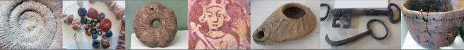

Friday 19 April 2013, 7.30pm

Romano-British discoveries in the Barcombe area
With David Millum and Rob Wallace.

Following their talk last year on the Barcombe Roman Bath House, David and Rob bring news of some exciting new discoveries nearby, which may help explain more about what could have been going on in Romano-British Barcombe.

Lecture room, Town Hall, Lewes
(Fisher Street entrance). Lift available

Our Changing Parish Churches

No. 155
December 2017
www.lewesarchaeology.org.uk

www.lewesarchaeology.org.uk

NEXT LAG LECTURE
Dr Sue Berry FSA
Our Changing Parish Churches c1700-1914 – the work of the Georgians, Victorians and Edwardians in Lewes and nearby
Friday 19th January at 7.30pm,
Lecture Room, Lewes Town Hall,
Fisher Street Entrance

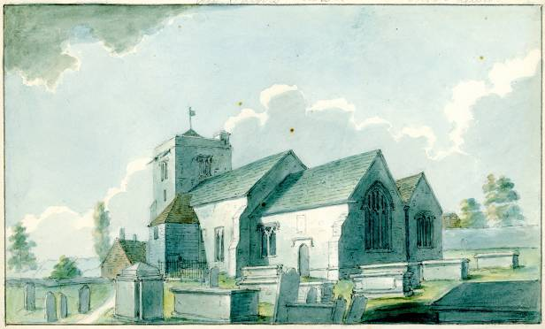

The next LAG talk will be given by Dr Sue Berry on Friday 19th January 2018.

Dr Sue Berry FSA has written about some of the churches in the town and its immediate surrounds and those of Brighton. She is a specialist in 18th century landscape history but also writes about the 19th century.

Sue will talk about how the parish churches in Lewes and nearby changed over the period from around 1700 to 1914.

During the eighteenth century, most of the parish churches were cared for. Bigger congregations were packed in by adding galleries with in some cases pews on them to rent for income. The period was not without controversy, particularly over the future of All Saints (see picture on the left). There, the nave was rebuilt as we see it today by Amon Wilds (father of the better known Amon Henry or 'Henry' Wilds). No new 'proprietary' or parish churches in new parishes were built, although St John's was rebuilt and this makes the story of the churches of Lewes very different from that of Brighton and other rapidly growing towns. A myth developed in the later C19th that the Georgians neglected churches and that is not supported by the evidence. In the mid-later part of the C19th churches were re-ordered because ideas about how worship changed. Services shifted away from the long sermons of the C18th and more ritual appeared. In the process of changing the internal layout, quite a lot of the work by the Georgians was removed, including box pews. The Victorian's passion for Gothic as they understood it also resulted in the loss of some earlier work.

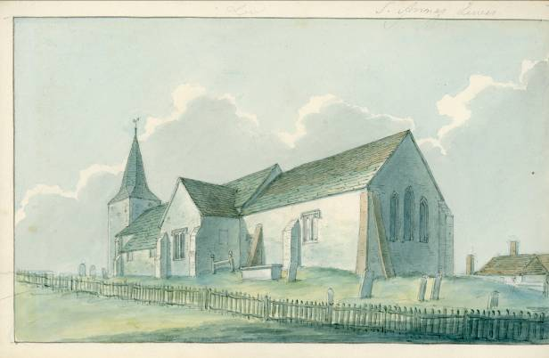
Using many contemporary images and modern photographs Sue will explore how the churches of Lewes changed. By way of another taster, here is an image of St Anne’s Church dating from between 1802 and 1806.

LAG finds archive

During two days, the 23rd and 24th August, volunteers from various societies helped to re-bag, re-box and catalogue nearly all the finds relating to the Lewes Archaeological Group (LAG) finds archive, at Frog Firle, near Alfriston.

The LAG finds archive has now been moved to Hailsham, and the finds are being put on a data base. This has been organised by the County Archaeologist Gregory Chuter, and the Assistant County Archaeologist Chris Greatorex.

The LAG finds archive has suffered badly since it’s conception in 1968, when it was first housed in a damp cellar in Fisher Street, belonging to Lewes District Council (LDC). A lot of the finds were in rotting cardboard boxes, and some even in flimsy paper bags. Most of the tools suffered from rust, and it was far from ideal for any metal work. LDC wanted to make use of the cellar at Fisher Street, and as an alternative, gave the LAG use of some rooms at the Recycling Centre, North Street, Lewes.

Unfortunately, during 2000 the Recycling Centre was badly affected by the major flooding of the Ouse, at Lewes, which flooded to a depth of approximately two metres. Nearly all the paper archive was lost, and many finds were either lost or had to be disposed of. Only the top shelves in the store escaped the flood.

LDC planned to move the Recycling Centre to Newhaven, and Greg Chuter organised the third move to a barn near Frog Firle, which was again, hardly ideal, but at least the remaining finds were kept together.

The job now, apart from putting the finds on a data base, is to publish outstanding sites that have finds relating to them in the finds archive. David Gregory has submitted a report on an assemblage relating to the remains of a waster heap discovered by Jock Knight-Farr in April 1979, at Lower Barn Farmhouse, Ringmer, for inclusion in the Sussex Archaeological Collections. It had been stored with the Lewes Archaeological Group’s (LAG) finds archive, along with a description and plan of the find spot. It would appear that this is the only waster heap assemblage found by Jock Knight-Farr that is still retained in the LAG finds archive.

David has also agreed to look at the pottery finds relating to a rescue dig in 1973 by ‘Ted’ O’Shea, at Delves Field. Unfortunately, it would appear that all the notes relating to this dig have been lost, apart from an overall site plan, and some pottery drawings. Published by David Millum, online, Culver Archaeological Project, Reports, ‘Mapping the Archaeology of Ringmer Parish to AD1349’, (pages 106 to 110). David would be very grateful if anybody remembers helping to dig this site for any information. Please email David at david@culverproject.co.uk

The LAG is very grateful to Gregory Chuter, and Chris Greatorex. For all their help and interest in the LAG finds archive, and to all the volunteers who helped over the two days.

David Gregory

Alex Sutherland

LAG was very fortunate to have Alex Sutherland as its secretary for many years, but unfortunately due to ill health she has had to resign. It was great though to see Alex at Mike Donnelly’s talk.

Mud Glorious Mud: Bridge Farm

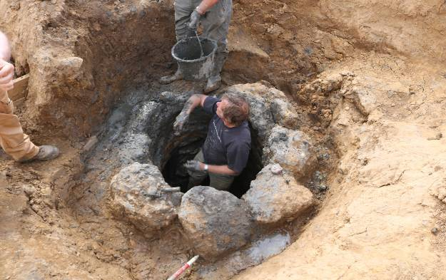
Those who braved the elements to visit Bridge Farm this year will recall the recurrent problem of weekly downpours throughout the digging season. This meant on average loosing at least a couple of days each week either from the site being unsafe or from having to re-excavated and clean areas once more covered with silt.

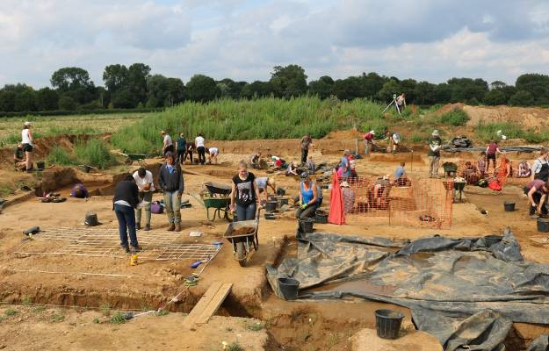
This was (as per 2016) the final year in Trench 6 (1400sq m) which was located at the intersection of Margary’s London road (M14) and the late 2nd century double ditch enclosure. The 2017 investigations were specifically of features at the deeper level so ideal to get completely flooded each time it poured hard. Despite the weekly setbacks a large work force of students and the more determined volunteers battled on to reveal a complex palimpsest of roads, ditches and pits that will require a concentrated period of post-excavation analysis and possibly some lateral interpretation to try and resolve. At least the recurrent drenchings made the various contexts show up as never seen before and many issues from the previous seasons were resolved, but as always new questions were posed.

A layer of flint heading south from the London road (M14) was uncovered suggesting a side road linking with the road to Arlington and constructed after the enclosure ditches were backfilled. This partly explained some of the new ditches discovered and the baulks disappeared. The main London road (Margary 14) was also further cleaned and brilliantly drawn in great detail by two of the students.

The stone-lined well discovered at the end of 2016 season was a prime target for 2017 but the surrounding area had to fully excavated down to 1.8m below trench level (4.8 AOD at 2.2m below ground level) before the top of the well lining could even be re-exposed and work progress safely. This could not be rushed as the contexts above the well were particularly finds-rich and therefore had to be removed with great care as coins, pot sherds and bronze pins and brooches continued to be revealed, declared ‘special finds’ and 3D located before being removed, packaged and recorded. The actual body of the well was not fully revealed until August and through that month a small but dedicated team gradually descended through the layers of dark grey silt to a

depth of 3.2m AOD (3.9m below ground level) where dark blue/grey Wealden clay indicated that we had hit bottom.

The well had a complex lining of courses of chalk blocks, timber planks, iron-rich sandstone and flint conglomerate. Animal bones and iron nails and other fittings, in perfect condition, were recovered from samples by flotation with an assemblage of plank fragments being removed during digging.

The large assemblage of finds from trench 6, including 25,000 sherds of pottery, vast amounts of iron production waste, cbm and burnt clay and over 230 coins, amongst other metal finds, have been processed and stored by our marvellous finds team and now await specialist assessment. Trench 6 has now been backfilled, there’s no going back this time, and Trench 7 (900 sq m) over the centre of the settlement will be readied for the 2018 season (more details on the excavations including details of the well are on our website www.culverproject.co.uk). Trench 7 is chosen for 2018

David Millum, CAP Deputy Director

Plumpton Roman Villa

In 2017 a fourth season of research and training excavations was undertaken by the Sussex School of Archaeology at the site of a Romano-British villa at Plumpton.

These excavations more fully revealed and recorded the winged-corridor house excavated in previous years. This year further investigations were carried out on the mainly chalk foundations/floor which occupies much of the interior of the large room at the eastern end of the original rectangular building. This work demonstrated that these remains, which comprise six parallel crosswalls c. 800mm wide with channels (c. 200mm wide) in between each wall, are parts of a channelled hypocaust system.

At the western end of the corridor fronting the middle three rooms of the villa, the corridor changes orientation and its eastern wall has now been traced for nine metres to the south-west. In this area of the site are a number of large flint-packed postholes and various features containing charcoal rich deposits.

The remains of another masonry building, probably a bath house, were found just to the west of the winged-corridor house, and connected to it by a continuation westwards of the wall forming the rear of the winged-house.

The SSA aims in 2018 to explore these western areas further. It also plans to continue to investigate the large concentration of flints which lies just to the east of the eastern wall of the villa. Two trial trenches across this area in 2017 revealed some masonry footings. Finds recovered from below the flint spread included several large sherds of early (first century AD) East Sussex Ware pottery and some carbonised seeds. These are the first early Roman-period finds from the site, most of the other finds dating to the third to mid-fourth centuries.

Those wishing to take part at Plumpton villa in 2018 should contact the Sussex School of Archaeology: info@sussexarchaeology.co.uk (SSA).

St John Sub Castro, Lewes

Also over the summer work was drainage undertaken at St John’s Sub Castro Church in Lewes. Archaeology South East were engaged on the archaeological front and funded as a Heritage Lottery Funded project.

It had been hoped that the foundations of the original walls of the medieval church might have been located, but they would appear to have been removed in 1839 when the church was demolished. Similarly, it would appear that the pre-1779 floor (some 1200mm below present ground level) was also removed.

Fortunately the route for the drainage along the path was well chosen in that relatively few human remains were encountered. However there were nevertheless some quite interesting discoveries including some medieval floor tiles. Probably the most interesting discovery was a small fragment of statuary with traces of blue and gold paint - the latter looking as fresh as if it had been painted yesterday!

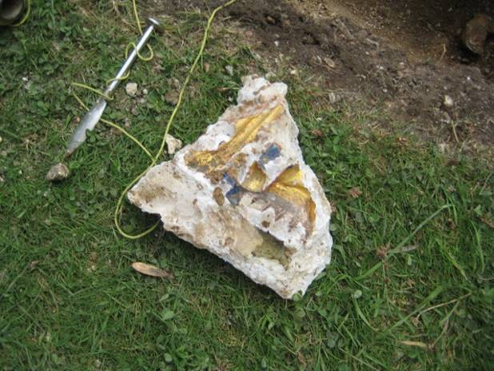

I attach a photo of this. Also some medieval floor tiles.

Looking ahead, the church has funding for a further one week of archaeological excavation if this is felt justified There are some reflectances on the GPR survey which probably merit further investigation, and Richard Gilbert's 1974 and earlier researches suggests some intriguing possibilities which could be looked at.

At the very least it is hoped to mark out the outline of the ancient church on the ground so that one can have a visual impression of where it was. There is a dimensioned drawing of the Nave prepared by William Figg in 1816, which can be related to the currently visible remains in the Chancel area. If the project is carried forward in the Spring then it would be helpful to know if any LAG members would like to be involved. If so, please contact me at paulawodcohen@yahoo.co.uk.

Lost Property: 20 years of the Portable Antiquity Scheme Exhibition

Currently, at Barbican House there is a special exhibition to celebrate 20 years of the Portable Antiquities Scheme (PAS). The exhibition includes finds from metal detectorists from East and West Sussex.

In 1997, the Treasure Act came into force and the Portable Antiquity Scheme was created becoming a national project in 2003. Since then 20,000 finds from across Sussex have been recorded. This has made an important contribution to the knowledge about archaeology in Sussex. The scheme in Sussex is based in Barbican House and the Finds Liaison Officer is Edwin Wood who is assisted by a team of volunteers. They record objects that have been found by metal detectorists, walkers and gardeners amongst others. If you have an object that you think should be recorded then contact Edwin on flo@sussexpast.co.uk. If you are interested to search the data base just visit the PAS webstie at www.finds.org.uk

The exhibition is well worth a visit. It includes items from the near Lewes Middle Bronze Age hoard. The finding of the hoard by a metal detectorist in 2011 is one of the most exciting discoveries in Sussex in the last 50 years. The hoard dates to around 1400-1250 BC and consists of 79 objects in copper alloy, gold and amber. They were contained within a single ceramic vessel that had been buried in the ground. Of particular interest are five Sussex loop bracelets -

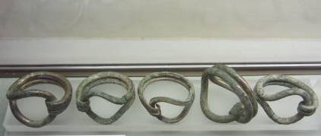

and four gold appliqué discs which were the first such discs to be found in Britain.

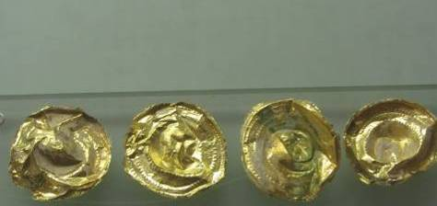

There are a wonderful range of other finds dating from all periods, including flint tools, Roman brooches, coins, horse related things, buckles. Two items that I thought were particularly beautiful were a late medieval silver spoon and a post medieval silver manila bracelet with intricate decoration.

The exhibition is on until at least the end of January 2018.

Excavations in Lewes

Convent Field. A GPR survey revealed a large area of hard standing and an old drainage ditch, along with a possible trackway. (David Staveley).

Cannon O’Donnell Centre. (Director: Caroline Russell, CBAS). Watching brief monitoring the hand excavation of a W-E aligned footing trench for a dividing wall within the westernmost building on site. Three deposits were exposed within the footing trench. A made ground was recorded resting above a redeposited layer of chalk, which lay over the sterile natural chalk rubble. The finds, including a few fragments of human bone, all appear to have derived from the redeposited chalk rubble. No grave cuts and in-situ human burials were found.

Lewes Old Grammar School. (Rose Calis, CBAS). Watching brief monitoring post-holes for the proposed archway and two trenches for a new wall and footpath leading from the archway. The existing flint wall was also recorded and incorporated a gargoyle in its west side, which may have originated from Lewes Priory. The remnant of what looked to be a 20^{th-} century dump cut into the natural was partially excavated by the machine. Flower pot, animal bone and china was recovered from the fill.

Former YMCA Site. (Rose Calis, CBAS). Evaluation excavation of two test pits in the grounds of Lewes Old Grammar School garden in advance of planning application. Underlying made-ground bank material was a post-medieval deposit, which overlay a thick medieval layer with pot and bone. Underlying this was a thin interface, which overlay a chalky rubble deposit rich with animal bone. The base of this deposit was not reached. Test-pit 2 mirrored the top deposits found in TP1. A post-hole, cutting into post-medieval material, was discovered with a clay pipe stem at its base. A shallow pit was also discovered, with a single fill, seen cutting into a medieval deposit. Underlying this was a pit, cut into the chalk natural. Finds included medieval tile and animal bone. The underlying fill was dark orange brown silt loam with patches of sandy gravels and a high percentage of medieval tile.

Hanover House. (Director: Sarah Vine, CBAS). Evaluation excavation of a single trench, inside the existing building. A building survey was also carried out at this site. The trench was excavated to 1.2m deep, with a sondage excavated a further 0.5m deep at one end of the trench. The evaluation trench revealed several layers of made ground, chalk and clay below the existing building. The upper layers appear to be modern in date, while the lower layers may be early post medieval. The lowest context encountered in the trench contained CBM, animal bone and a small amount of pottery, while CBM was also recovered from two other contexts.

Old Rectory Cottage. (Director: Emily Walsh, CBAS). Watching brief monitoring groundworks, reducing the ground level and monitoring of the excavation of footings to the northeast of the building. Two features representing post-medieval activity were recorded. Two cuts containing masonry possibly representing the remains of foundations walls were recorded in the trench to the northeast of the building. A moderate amount of post-medieval CBM, pot, clay pipe, glass and bone was recovered from the topsoil deposit.

Talks and events

BHAS Brighton & Hove Archaeological Society
ENHAS Eastbourne Natural History and Archaeological Society
FOAC Friends of Anne of Cleves House
LHG Lewes History Group
LAG Lewes Archaeological Group
SAS Sussex Archaeological Society
SSA Sussex School of Archaeology
USAS University of Sussex Archaeological Society

Ancient to Modern: the Changing Landscape of Sussex conference

On Saturday 28th April 2018 the Sussex Archaeological Society will hold a conference at the King’s Church in Lewes.
The full programmes are on
https://sussexpast.co.uk/become-a-member/conferences-events. Or email Lorna
Gartside, the Society's Membership and Events Secretary members@sussexpast.co.uk for a pdf copy.

DECEMBER
Mon 11 Dec LHG – South Street, Lewes: a Social History with Heather Downie; The Lewes Streets Projects with Ian McClelland and AGM. Kings Church, Lewes. 7.30pm. £3/2.
Tues 12 Dec Worthing AS The life of a common soldier in the English Civil War with Nigel Rumble. Worthing Library Lecture Theatre at 7.30pm.
Fri 15 Dec BHAS AGM and report and Xmas social and speakers tba Unitarian Church, Brighton. 7pm.

JANUARY 2018
Mon 8 Jan LHG : Postholes, wells and switchback roads – Bridge Farm 2014-2017 with Rob Wallace and David Millum. Kings Church, Lewes. 7.30pm. £3/2.
Tues 9 Jan Worthing AS The first Brexit: how Britain became an island and its effect on Neanderthals, Mesolithic and Neolithic man with Robert Turner. 7.30pm. Worthing Library, Richmond Road.
Weds 10 Jan WEA Mosaics from Rome to Ravenna with Kay Blackburn (10 weeks) from 10 to 12 noon. See: www.southern.wea.org.uk
Fri 12 Jan BHAS Edwin Wood – Finds from the Portable Antiquities Scheme in Sussex in 2017. Unitarian Church, Brighton. 7.30pm. £3/free.
Fri 19 Jan LAG Sue Berry – Our Changing Parish Churches from c1700 to 1914. Lecture Room, Lewes Town Hall at 7.30pm. £4-2/free.
Sat 20 Jan BHAS A Hands on Guide to the Archaeobotany of Saxon and Medieval Lewes with Lucy Allott (forensic archaeologist). In the afternoon “Quakers and WW1 letters. Conservation Challenges from the Brighton Dome with Elena Baldi. Patcham Community Centre.£25.
Thurs 25 Jan USAS Iron Age Memory vs Roman Metaphor: re-reading the archaeology of a client kingdom with Gordon Hayden. Fulton Lecture Theatre A, University of Sussex at 7pm. £2/3.

FEBRUARY
Sat 3 Feb SAS Pett Level Talk with Lara Band (CITiXAN). Barbican House, Lewes. 2-3.30pm. £8.
Fri 9 Feb BHAS Tom Drommett – Heritage on the Edge: the Archaeology of the Seven Sisters. Unitarian Church, Brighton. 7.30pm. £3/free.
Sat 10 Feb BHAS Jeremy Clark will talk about the Archaeology of Standing Buildings. Venue and price tba.
Mon 12 Feb LHG TBA Kings Church, Lewes. 7.30pm. £3/2.
Fri 16 Feb LAG Marcus Taylor – Gundreda and her Chapel. Lewes Town Hall. 7.30pm. £4/3/2/free.
Thurs 22 Feb USAS Late Roman Ramparts in Northern Gaul and their Social Implication with James Bromwich. Fulton Lecture Theatre A, University of Sussex at 7pm. £2/3.
Sat 24 Feb SAS The Sussex Plantsmen’s Gardens c1860-1930 with Sue Berry. Barbican House, Lewes 2-3.30pm. £10.

MARCH
Fri 9 March BHAS Mike Parker-Pearson – Stonehenge and New Discoveries. Unitarian Church, Brighton. 7.30pm. £3/free.
Sat 10 March BHAS Grant Williams will give a course on flint knapping. Venue and price tba.
Tues 13 March Worthing AS The River Adur with Geoff Mead and AGM. Worthing Library Lecture Theatre at 7.30pm.
Fri 16 March LAG John Blair - Sussex in the Mercian Age: the archaeology of power 750-850. Lewes Town Hall. 7.30pm. £4/3/2/free. And AGM
Sat 17 March SAS Sussex Archaeological Symposium. All day. King’s Church, Lewes.
Thurs 29 March SAS Visit to Ashdown House with Sue Berry. 10.30-12noon. £15.

APRIL
Tues 10 April Worthing AS The science of a middle Bronze Age Hoard with Jaime Kaminski. Worthing Library lecture theatre. 7.30pm.
Thurs 12 April SSA Holleyman Lecture – Mark Gardiner – From Sussex to Shetland: the archaeology of the medieval coast transport and trade. 7-9pm £10/8.
Fri 20 April LAG David Millum and Rob Wallace – Bridge Farm, near Barcombe. Lewes Town Hall. 7.30pm. £4/3/2/free.
Sat 28 April SAS Ancient to Modern: the Changing Landscape of Sussex (details see above).
Sun 29 April SAS Visit to Forest Row with members of the Ashdown Forest Research Group. Walk will explore the start of a late medieval village and the influences of the iron industry and forest. 2-4pm. £10.

The Sussex School of Archaeology also runs practical day schools on all aspects of field archaeology including illustration, geo physics, finds preservation and field walking as well as holding other events. To find details of these courses visit - http://www.sussexarchaeology.org

SARDINIA ARCHAEOLOGY TOUR MAY 2018
An 8-day (7-night) Archaeological Study Tour to
Sardinia. Dates: Tuesday 15th –Tuesday 22nd May 2018. Tour Leader: Dr David Rudling, FSA. It will involve visits to: the Neolithic ziggurat style temple and altar at Monte d’Accoddi, the pre-Nuragic rock-cut tombs of Anghelu Ruju (3500-1800 BC), the famous Nuragic complex of Su Nuraxi (XV century BC – a UNESCO World Heritage site), the Nuragic site of Santu Antine, the Nuragic sanctuary and sacred well at Santa
Cristina, several towers at Nuraghe Palmavera, the beautiful city of Nora (Phoenician, Carthaginian and Roman remains), the Roman temple of Antas, San Salvatore di Sinis (a IV century AD church), the Roman bridge at Porto Torres, Trajan’s Roman baths at Fondongiamus, Alghero and Cagliari. Tour price (halfboard)per person: £1599 (£400 deposit) based on two sharing). For bookings: please telephone Baxter Hoare 0207 407 5492 OR see further details and booking form on:
www.sussexarchaeology.org

ROMAN HOLLAND AND GERMANY TOUR
28 August to 4 September 2018.
If you like the Roman-period, this tour to view the impact of Rome in Holland and Germany will appeal. Baxter Hoare Travel Ltd in association with the Sussex School of Archaeology is offering a coach tour from Brighton to see some of the key Roman-period sites and museums in Holland and Germany. Sites to be visited in Holland include: The National Museum of Antiquities, the DOMunder and the Castllum Museum (Utrecht), the Museum Het Valkhof (Nijmegen) and the Thermen [baths] Museum (Heerlen). Sites to be visited in Germany include: Xanten (Archaeological Park), the Romano-Germanic museums at Cologne and at Mainz, Kastell Zugmantel [Limes frontier defences], Saalburg [fort with reconstructions], the Temple of Isis (Mainz), Porta Nigra [gateway], Kaiser Thermen [baths], amphitheatre, Constantine’s basilica and Museum (all at Trier), and Villa Borg (Saarland). The Tour Leader: Dr David Rudling, FSA, MCIfA. The tour fees include transportation, accommodation (half-board), the services of the tour leader and local guides, and entrance charges. Fees: £1399 pp if sharing a room; otherwise £1698 pp. For more information and a booking form please see www.sussexarchaeology.org OR contact Ian Cutts at Baxter Hoare Travel +44(0)20 74035566.

