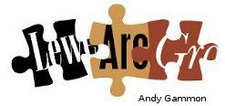

**Lewes Archaeological Group *newsletter***

Affiliated to the Sussex Archaeological Society

and the Council for British Archaeology

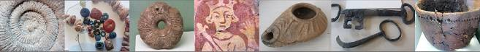

Friday 19 April 2013, 7.30pm

**Romano-British discoveries in the Barcombe area**

With David Millum and Rob Wallace.

Following their talk last year on the Barcombe Roman Bath House, David and Rob bring news of some exciting new discoveries nearby, which may help explain more about what could have been going on in Romano-British Barcombe.

Lecture room, Town Hall, Lewes

(Fisher Street entrance). Lift available

No 154

May 2017

www.lewesarchaeology.org.uk

May 2017

[www.lewesarchaeology.org.uk](http://www.lewesarchaeology.org.uk)

**Pat Stevens**

We are deeply saddened to report that former Chairman and long-term LAG supporter Patricia Stevens passed away on 24 April.

In 2010 Fiona Marsden paid tribute Pat’s well-earned retirement from the Committee after some thirty years of continuous service:

“Pat joined the Committee in 1981 and this link with Eastbourne Natural History and Archaeological Society, where both Pat and Lawrence Stevens had developed their skills to professional levels, has been extremely useful to LAG over the years. At about the same time Pat started to specialise in animal bones and was soon working at the Ancient Monuments Laboratory in London, in addition to teaching LAG enthusiasts the rudiments of bone identification. In 1984 she succeeded Robin Kenward as Chairman of LAG for three years and she transformed the Newsletter by means of her home publishing operation in the days before personal computers. This also enabled LAG to publish the proceedings of its conference on *Aspects of Archaeology in the Lewes Area (1988).* Many members will also remember Pat’s recent talk (March 2008) on her Southdown sheep flock, an interest that developed out of her archaeological work, and we wish her well in both these fields. We are enormously grateful to Pat for the support she has given to LAG for so long, and we look forward to continuing to see her and Lawrence at our lectures.”

A look through the old LAG newsletters (a set is kept in Barbican House library) more than confirms the depth of Pat’s involvement in archaeology at a local, national and international level.

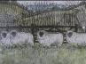

She had taken an extra-mural course in Field Archaeology at the University of London and moved on to specialise in animal bones, studying with renowned zooarchaeologist Professor Tony Legge. In November 1979 she launched a six-week course for members on animal bones in archaeology, held at Barbican House. The next year she and Lawrence led the Bourne Valley excavations in Eastbourne. The couple had worked on excavations together since the 1960s, including on many windmill sites, and became champions of archaeology in Eastbourne and the protection and restoration of the Polegate Windmill. Now-professional archaeologists Mike Allen, Greg

Chuter and Chris Greatorex, along with numerous other volunteers, had their earliest experiences of excavation with the Stevens’; over nine weeks the Bourne Valley dig involved 93 people, the majority of whom had never done any archaeology before.

In one article Pat describes her first trip abroad (“What – me go to Yugoslavia – I’ve never been further than Scotland”) at the suggestion of her London lecturer, to work on animal bones from a Neolithic site. After 2 ½ weeks, precisely 8,499 bones had been identified. A trip to Spain to work on bones from another Neolithic site was to follow.

Pat’s first newsletter piece as Chairman records her concern about destruction by ploughing, as rural sites lacked the protection that Lewes town had: “the ditch of the Bronze Age round barrow at Round-the-Down, excavated by the Group in 1973/74, was in places only a few centimetres deep; thus a single ploughing would have destroyed it”.

Pat’s influence soon became clear, with an upturn in membership and a transformation of the newsletter’s appearance. She took over its production: in June 1985 we had first sight of Fiona Marsden’s trowel-based logo and the very first illustration to appear, of plans, sections and finds from a watching brief at ‘New Place’, Gundreda Road, Lewes, by Mike Allen.

The programme of the Group’s 1985 conference *Archaeology of the Lewes Area* includes a biographical note: “Patricia commutes from Sussex to London where she is employed as an archaeologist in the Ancient Monuments Laboratory of the Historic Buildings and Monuments Commission [the official name of English Heritage] in Savile Row. She analyses faunal remains from archaeological sites all over Britain to ascertain what people were eating in the past and how it was prepared”. Her work included analysing animal bone from the deserted medieval village of Wharram Percy in Yorkshire, excavated over many years.

Pat was unassuming, with a dry humour which comes across in an account of her first day in the English Heritage office:

We tossed for the use of the computer – my luck had run out and I was given the teletype to work on, an amazing contraption with callipers connected to prevent entering wrong measurements, which were added when you pressed a foot-pad and the results emerged on yards and yards of punched tape. The mistakes that first day were endless – with data being entered in the wrong place and the foot-pad being pressed at the wrong time. However by the next day I felt a little more confident, scrapped the first day’s work and started again. After a month I was given a ‘real’ computer to work on; the teletype finally landed in the Science Museum.”

Despite what must have been a demanding professional life Pat remained Chairman of LAG until 1987, when Liz Somerville took over and she became Vice-Chairman, and found time to run another animal bones course for members in 1989. During the 1990s she did a great deal of post-excavation analysis, including teaching and helping David Gregory with the identification of 22 boxes of animal bone from Beddingham Roman Villa, alongside her continuing work in the Eastbourne area, and she remained a stalwart of the Committee until she stepped down in 2010. She will be greatly missed.

In view of Pat and Lawrence’s long association with windmill archaeology, it is eminently appropriate that her interment was at the woodland burial site at Clayton, below the Jack and Jill windmills.

Anne Locke

**Chairs report**

I am sorry to start this year’s report with the news of Christine Gray’s death just at the end of February. Christine had long been an important part of LAG, most latterly as a welcoming person on the door at talks. But she had also been on the committee helping to keep LAG functioning. She helped organising talks and hosted committee meetings. I know I speak for all the committee when I say that we will miss her and her enthusiasm.

Just briefly, it’s been a good year with an excellent programme of talks which have been very well attended. There were also successful tours of Plumpton Roman Villa and Bridge Farm and a talk and walk led by Greg Chuter on Malling Down.

Membership of the Group is at fairly steady – around 36 members and we are expecting another 10-20 members to renew their membership. Some new members have joined over the year. Our finances are healthy too.

We have changes in the membership of the committee. First, with the death of Christine. Secondly, Greg Chuter is standing down but Chris Greatorex has agreed to become a committee member. It is important to us as a small group to have the support of the Assistant County Archaeologist. So, we welcome Chris’ membership. At the same time I wish to thank Greg for his involvement with LAG.

I would also like to thank Bryan Creer for his continued management of the LAG website.

I always welcome contributions for the newsletter or notices etc. And it’s good to have ideas for speakers or topics. Any thoughts?

Paula Stanyer [paulawodcohen@yahoo.co.uk](mailto:paulawodcohen@yahoo.co.uk) or 07814 463 259.

**Any photos or memories of Belle Toute shaft or finds?**

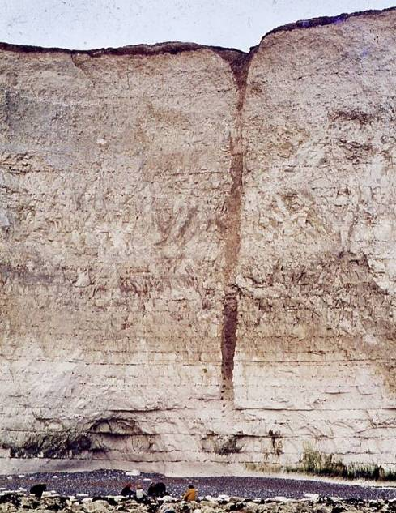

Following Mike Allen’s piece in the last LAG Newsletter he is busily writing up the Belle Tout shaft for publication.

There are relatively few cohesive reports and photographs of the shaft while it was in section in the cliff (1971 c 1984). Has anyone got photographs (colour, black & white, slides), notes and other records, or even finds they are sure that came from the shaft?

Such information may provide vital clues; photographs of the foot holes and cut marks may be invaluable. It will also allow Mike to collate a reasonable collection of images, and information to archive together. He already has copy of notes from Jan 1971 by Martin Bell, and some by Lawrence Stevens for instance.

If you can help Mike, pleases could you email him at [add address] or if you don’t have email please ring Paula on 07814 463 259).

**Medieval Kitchen Garden**

Lewes Priory's Community Medieval Garden project is forging ahead.  Volunteers have already been responsible for shaping the initial idea, planning, preparing the site and building the raised beds. The beds are now filled and seeds have been sown. Members of the project are developing their knowledge of medieval foodstuffs, diet and gardening. If you have a particular interest in medieval plants, herbs, food or history please get in touch.

**On Saturday 24th June 2017 between 10am-4pm** the garden’s official launch day will take place. There are a number of workshops and activities planned, including a wattle making workshop and a medieval food and cookery workshop.

To find out more Tracey Anderson at the Lewes Priory Medieval Kitchen Garden Project (tracyjaneanderson@mac.com)

**New Books**

**Molluscs in Archaeology edited by Mike Allen**

This the first book of its type to include both land and marine shells. Contributors include Martin Bell, Liz Somerville and Terry O’Connor amongst others.

The subject of ‘Molluscs in Archaeology’ has not been dealt with collectively for several decades. This new volume in Oxbow’s Studying Scientific Archaeology series addresses many aspects of molluscs in archaeology.



It will give the reader an overview of the whole topic, both methods of analysis and approaches to interpretation. It aims to be a broad-based text book giving readers an insight into how to apply analysis to different present and past landscapes, and how to interpret those landscapes. It includes marine, freshwater and land snail studies, and examines topics such as diet, economy, climate, environment and land-use, isotopes and molluscs as artefacts.

The book is currently available to LAG members at the reduced pre-publication price of £18.75 (full price £25) until one month after publication (June/July 2017).

For further information and to contact Mike Allen please see website at [www.themolluscs.com](http://www.themolluscs.com/).

**Archaeology of the Ouse Valley, Sussex, to AD 1500** Edited by Dudley Moore, Michael J. Allen and David Rudling.

The Ouse valley, East Sussex, is a key communication route from the Channel coast, via the Downs (and the historic county town of Lewes), to the wide expanse of the Weald. It traverses and encompasses landscapes and archaeological sites of both regional and national importance – all connected by the river Ouse and its valley. This is the first review of the archaeology of this important landscape – from Palaeolithic to medieval times by contributors all routed in the archaeology of Sussex. From hillforts and villas, to medieval rural and urban excavation; the Ouse valley represents a microcosm of the wider region, the contributions collectively reveal the importance and significance of this valley to the development of landscape history and society of a quintessential English county. The narrative concludes with the first detailed research agenda for the Ouse valley.

This book is available at Barbican House bookshop, the High Street, Lewes.

**The Sun Street Story** by Brian Cheesemur, Rosemary Page, Frances Stenlake and Susan Weeks

The result of two years’ research by a team of LHG Street Stories’ members, the book tells the story of one of the lesser known, yet more interesting streets in central Lewes, with its varied architecture styles. The beginnings of the road as we know it today, the construction of the 19th century houses and tales of past and present residents, are all illustrated with maps, photos and drawings.

Order the book online at [www.leweshistory.org.uk/sun-street-book](Https://leweshistory.org.uk/sun-street-book) for £8.50 plus p&p. It can also be bought at the Lewes History Group’s monthly meetings (see the website for details).

**Screen Stories - Lewes at the pictures**

The building of Depot, Lewes’ new community cinema, was the original catalyst for this book. *Reel Lewes*, a group of Lewes-based film-makers and researchers have spent two years investigating the history of the three previous cinemas in the town. The County Theatre (Watergate Lane), Cinema de Luxe (School Hill) and the Odeon (Cliffe) operated from 1910 to 1971.

The team recorded what Lewesians remember about cinema-going in the past. While not intended to be a comprehensive history of Lewes cinemas, Screen Stories does vividly bring to life the importance of film and cinema, both in the life of the town and in the lives of its residents. With the aim of producing an enticing and amusing read, it combines photographs, advertisements, film posters, programmes, newspaper articles and architectural plans along with the enthusiastic and enduring memories of the people who frequented these picture palaces.

Reel Lewes has also produced a short film, ‘Big Screen Memories’, which will be shown at the book launch alongside an exhibition at Depot from 27 May – 30 June.

Available at [www.leweshistory.org.uk/screen-stories/](http://www.leweshistory.org.uk/screen-stories/) for £8.99 plus p&p, or from the Lewes History Group’s monthly meetings and Depot’s foyer.

**Summer Excavations**

**Bridge Farm**

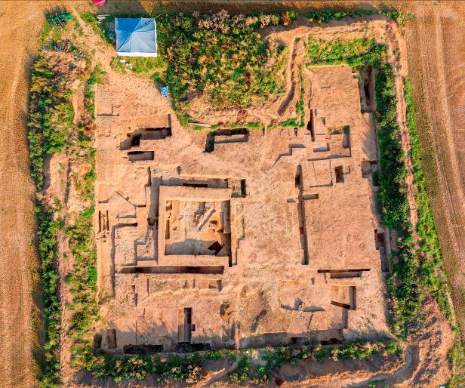

Annual excavation opportunity at the recently discovered, large defended, 1st-4th century Romano-British settlement, just north of Lewes at Bridge Farm, Barcombe. This is the fifth year of excavations at this regionally important green-field site. The excavation starts on 26th June and will finish on 5th August. It is open 7 days per week, Mon-Fri 9-5 & Sat/Sun 10-5. Volunteering fees £25 for 7 days, £40 for 14 days or £60 for up to 6 weeks. Camping at £50 per week (to include dig fees) with use of hot showers, flushing WCs and fully equipped kitchen in the site HQ building. See [www.culverproject.co.uk](http://www.culverproject.co.uk) for more details or email [excavations@culverproject.co.uk](mailto:excavations@culverproject.co.uk).

**Plumpton Roman Villa**

The Sussex School of Archaeology is also continuing its excavation of the Plumpton Roman Villa from 24 June to 4 August. Volunteering costs £5 per day. It is also running five day excavation techniques courses and Saturday taster days as well as other practical training courses. Email [info@sussexarchaeology.co.uk](mailto:info@sussexarchaeology.co.uk). See [www.sussexarchaeology.org](http://www.sussexarchaeology.org)



**Ovingdean**

The Brighton and Hove Archaeological Society is continuing to excavate the site of a medieval manorial complex at Ovingdean. Excavations takes place on Wednesdays and at the weekends. For more information please see [www.brightonarch.org.uk](http://www.brightonarch.org.uk)

**Butt’s Brow**

The Eastbourne Natural History and Archaeological Society has an excavation planned, including training, for members at Butts Brow, Willingdon on the 21, 22 and 23 July. Contact Bob Williams [foordscottage@talktalk.net](https://mg.mail.yahoo.com/neo/b/compose?to=foordscottage@talktalk.net) .

**Sally Christian Grants to support young archaeologists**

Grants are available to individuals starting out in archaeology as either amateurs or students which would include sixth formers or undergraduates to assist with the costs of various types of training, both practical and academic and to enable such individuals to gain experience in archaeological fieldwork and other forms of research in East and West Sussex. Grants are available for: short training courses (normally lasting from one to five days long, but sometimes longer). Further details regarding applications are available from the Research Officer, Luke Barber, of the Sussex Archaeological Society ([research@sussexpast.co.uk](mailto:research@sussexpast.co.uk)), to whom all applications should be submitted.

**Tour of Bridge Farm and Plumpton Roman Villa excavations**

I shall be organising for LAG visits to Bridge Farm and Plumpton Roman Villaexcavations and will send out invitation via email nearer the time of the excavations. Provisional date for the Bridge Farm tour is Sunday 30th July at 3.30pm. If you are interested and won’t receive an email please ring and let me know of your interest (Paula – 07814 463 259).

**Portable Antiquity Scheme Exhibition at Barbican House**

The exhibition will celebrate 20 years since the Treasure Act came into effect and PAS was created. It will display some items of treasure that the museum has acquired over the years but also look at non-treasure artefacts. There will be artefacts displayed that have been lent by metal detectorists who have been asked to choose their own favourite items, to show the range of items found and recorded by the Scheme over the years. This will tie in with a number of exhibitions up and down the country all on the same theme and more information should be available from the Portable Antiquities Scheme Central unit on where to find these. It will run from mid July until the end of August.

**Talks and events**

BHAS Brighton & Hove Archaeological Society

ENHAS Eastbourne Natural History and Archaeological Society

FOAC Friends of Anne of Cleves House

LHG Lewes History Group

LAG Lewes Archaeological Group

SAS Sussex Archaeological Society

SSA Sussex School of Archaeology

USAS University of Sussex Archaeological Society

**JUNE**

**Fri 2 June FOAC** West Firle: Landed Gentry talk by Geoffrey Mead. 7.30pm at the Anne of Cleves’ House.

**Weds 7 June BHAS Walk** Whitehawk Hill. Led by John Funnell. Meet at top of Manor Hill at 7pm.

**Fri 9 June Culver Archaeological Project** talk on Bridge Farm Romano-British Settlement by Rob Wallace and David Millum. 7.30pm at Barcombe Village Hall.

**Sat 10 June SAS** AGM Talk: a Tribute to Ivan Donald Margary at Fishbourne Roman Palace at 2pm.

**Mon 12 June LHG** Lewes at the Pictures by Ruth Thomson, Reel Lewes at 7pm at the King’s Church, Brooks Road, Lewes. £3/2.

**Sun 18 June BHAS** outing to Reculver and Richborough Roman Forts in Kent led by David Rudling. £23-31.

**Weds 21 June BHAS Walk** Summer Solstice Walk to Caburn. Meet Glynde car park at 7pm. Leader John Funnell.

**JULY**

**Weds 5 July BHAS Walk** The Ditchling Beacon Monuments. Meet at Ditchling Beacon car park A at 7pm. Walk led by John Funnell.

**Mon 10 July LHG** Tom Paine in Lewes by Mary Burke. 7pm at the Kings Church, Brooks Road, Lewes. £3/2.

**Sunday 16 July BHAS outing** to Sutton Hoo, Suffolk. £26-36.50.

**Friday 21 July FOAC** talk Thomas Cromwell and the Dissolution of the Sussex Monastries by Helen Poole. 7.30pm at Anne of Cleves’ House.

**Sunday 30 July LAG tour** of Bridge Farm Romano-British settlement excavations. 3.30pm.

**AUGUST**

**Sun 13 Aug SAS** Walk of Pett Level Submerged Forest led by Scott Timpany at 9.30am. £5.00

**SEPTEMBER**

**Fri 22 Sept FOAC**  Anne Boleyn: A King’s Obsession by Alison Weir. 7.30pm at Anne of Cleves’ House.

**OCTOBER**

**Fri 16 Oct LAG** first talk of the season.

**Sat 21 Oct SAS** Day conference. 'The Long Sunset: the Country House c.1840-1940'

**Membership of LAG**

As a member of LAG you are able to take advantage of LAG’s membership of the Council for British Archaeology. You can renew or join at any of our meetings, or send a cheque for £6 (payable to *Lewes Archaeological Group*) and sae to Brian Phillips, 2 Peronne Court, High St, Uckfield, East Sussex, TN22 1BL or Fiona Marsden, 13 Lansdown Place, Lewes, East Sussex, BN7 2JT. Please deliver by hand to Fiona.