
Lewes Archaeological Group newsletter

Affiliated to the Sussex Archaeological Society
and the Council for British Archaeology

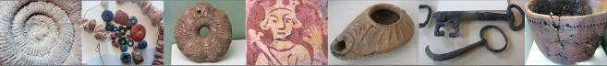

Friday 19 April 2013, 7.30pm

Romano-British discoveries in the Barcombe area
With David Millum and Rob Wallace.

Following their talk last year on the Barcombe Roman Bath House, David and Rob bring news of some exciting new discoveries nearby, which may help explain more about what could have been going on in Romano-British Barcombe.

Lecture room, Town Hall, Lewes
(Fisher Street entrance). Lift available

NEXT LAG LECTURE
Dr William Harcourt Smith, City University of New York, USA
The Curious Case of Homo Naledi
Friday 6th January at 7.30pm,
Lecture Room, Lewes Town Hall,
Fisher Street Entrance

The Belle Tout Shaft - an undatable enigma?

No. 153
November 2016
www.lewesarchaeology.org.uk

www.lewesarchaeology.org.uk

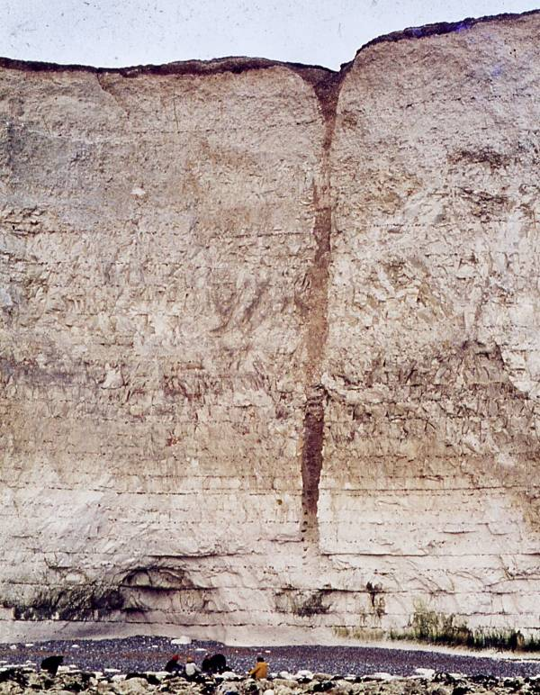
Shortly after the publication of Bradleys excavations at Belle Tout in the Proceedings of the Prehistoric Society for 1970, a cliff fall early in 1971 exposed a vertical chalk-cut shaft, which had been previously mapped as hollow or ‘modern chalk pit’. Beneath a broad weathering cone the vertical-sided cylindrical shaft 43m deep was recorded as having a diameter of about 1.7m and tapered about 9m above the foot of the cliff (see photo by D. Freke 1976), and being about 1m diameter where it met the wave-cut platform. The base of the shaft was excavated in part by the late Arthur Sayers in 1975, and he took odd finds and curios to Bishopstone, where he was volunteering for Martin Bell, to show him. In 1980 Owen Bedwin was lowered over edge by coastguards and collected two soil samples from around 20m down. These were later analysed by JD Hill for land snails as an undergraduate dissertation at the Institute of Archaeology, London. In April 1981, I was lowered precariously over the edge and collected a further five samples (four of which were ultimately analysed). By the end of 1982/3 the shaft was no longer visible. And there the story ended until last year - an undated shaft, of unknown function laying between Belle Tout and Bullock Down.

In 2015, realising that the base of the shaft might still survive on the wave-cut platform a programme to re-find the shaft was instigated. Drawing on the comparison with the Bronze Age shaft at Wilsford (south of Stonehenge) it was hoped that the shaft might contain highly important waterlogged remains such as oak bucket bases, alder bucket staves and rope, as well as important organic palaeo-environmental remains.

In October 2015, volunteers from the CITiZAN project and the Seven Sisters Archaeology Project National Trust together with members of the Southdowns Research Group were informed about the potential importance of the shaft. They were taken on a guided reccy of the site I encouraged them to scour area on regular occasions to look for the shaft. It was not a case of just a single systematic search. The waves and storms bring in cobbles and chalk boulders, and sweep them out again. The foreshore is a constantly changing landscape. I thought that this might take a year or so. Yet, in February 2016 the volunteers announced they’d found it (see photo below), some 15 meters from the current cliff!

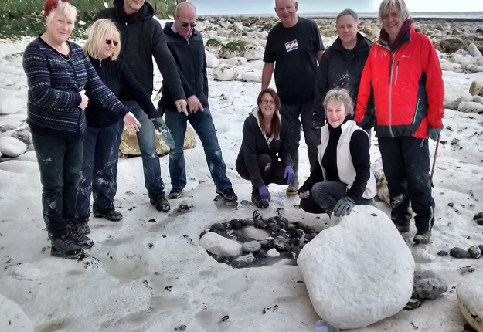

A waterlogged Bronze Age site in south east England is a rarity, but a Bronze Age well would be of national significance. So, we enlisted the help of old friend Prof Martin Bell. In April, we set off our heads full of thoughts about evaluating the nature of those organic deposits with the level of funding we’d need to apply for their recovery and analysis. We were accompanied by a hand selected and very restricted group of volunteers. After another briefing, a health and safety talk and allocating everyone with specific tasks, we marched down to the foreshore and the shaft base ready to expose it, auger it, define its depth, plan it, and go away to seek funds. On exposing the shaft, the modern beach cobbles were lifted out to reveal … the base of the shaft only 15cm deep and full of recent pebbles, a .303 cartridge case, and some copper alloy stains (yet to be investigated).

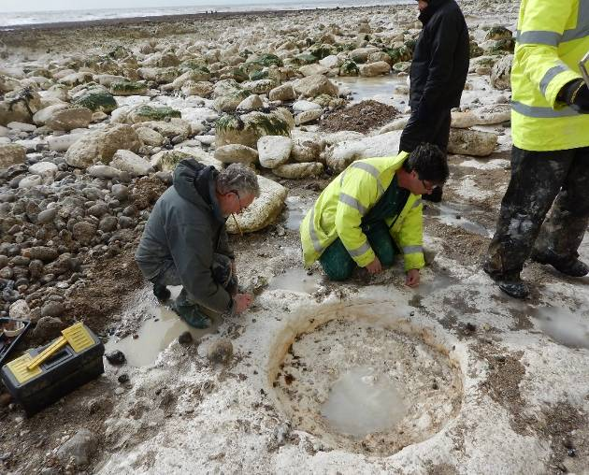
Fig: Martin Bell and the Mike Allen preparing to record and plan the shaft base Aprll 2016

So, no waterlogged organic remains. We were too late - they had been eroded away. No chance of dating the shaft … or was there?

The date of the shaft is unknown. It has been compared with the Bronze Age well at Wilsford. A Roman date has been postulated and some have suggested that it is more likely to be Saxon or medieval origin or even post medieval. It did, however, seem to neatly over (and be later than) the inner Belle Tout valley bottom enclosure, but that enclosure along with the shaft are both lost to the sea. The verticality of the relatively narrow cylindrical shaft, with its base cut into what is now the wave-cut platform are strongly suggestive of a well cutting down to former ground-water level.

Is it possible to ever date it though? Remember, Arthur Sayers had collected odd curios and shown them to Martin Bell in 1975. In 1980, when doing my A levels in Lewes, I was also digging the Bourne Valley, and to save catching a train from Lewes every day, I lived with Arthur in Eastbourne, five minutes’ walk from the excavation. Whist sharing his house for 9 weeks he tried to interest me in two buckets of festering salty gloop and water he had in the house. One of which was in the kitchen by the cooker. The other bucket was kept in the small bedroom that I occupied along with a few discarded clothes (underpants and shirt) of the previously archaeologist (Richard Bradley) who had stayed here 12 years earlier. Both buckets contained slightly odorous mud and light green water. There was green and reddish brown algae on the sides of the buckets, and festering seaweed, bits of twig, twisted plaited trig, small pieces of wood, mud, beach pebbles and sand! Arthur was proud of his two buckets. They’d come from the gloop and stones he’d excavated at the base of the shaft. Lawrence Stevens thinks he dug about 1 meter out. Arthur had carefully carried each bucket back along the foreshore to Birling Gap, caught the bus to Eastbourne, and had brought them home. When Arthur stirred this horrid mess, it burped and bubbled. And he’d picked out from amongst the rancid seaweed and mud, several twigs of wood, a piece of twisted or plaited twig, and a couple of flat pieces of wood which were a couple of inches square. Arthur considered me a budding young and tame archaeologist, and he was keen for me to have these (along with a Shipham’s paste-type jar of smelly black mud). He urged me to ‘test’ them.

At the time I didn’t know what to do with them, and I was also pre-occupied with running my own excavation. From time to time, I’d show them to archaeologists - in the early 1980s Joy Ede identified the twigs and wood pieces as hazel (Corylus), alder (Alnus) and hawthorn (Crataegus) and my PhD supervisor took the larger bits of wood. Over the years some of these items were not returned whilst others have simply been lost. The jar of smelly mud I eventually threw away. Despite this, some 36 years after taking possession of the buckets, I thought I might still have a few twigs or bits of wood. I scoured my attic and more store sheds and amongst a battered box with a pealing label was an old self-seal plastic bag which had lost most of its write-on white bands. And slightly cold and battered were several fragments of round wood twig, broken for identification 30 years ago.

So, I am having the wood re-identified. Then I will seek funds for a radiocarbon date and then finally there will be a date the Belle Tout shaft. This should also help date the small enclosure in the Belle Tout valley bottom, as well as provide some chronology for the land snail samples I analysed and wrote up in 1997. All of the work on the shaft, including other scientific analyses is being prepared for publication in the SAC.

Mike Allen

Charleston Painting?

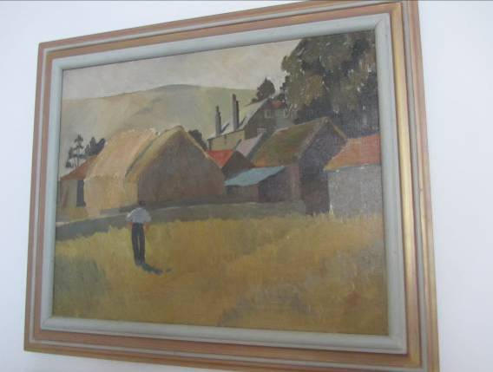

Does anyone know who painted this picture or indeed which farm it is a painting of? Please email me – paulawodochen@yahoo.co.uk.

Bridge Farm Update 2016

This year marks the 40th anniversary of the death of one of the Sussex archaeological community’s most prestigious forebears, Ivan D Margary. He provided many causes for archaeologists, especially Romanists, to celebrate, but possibly his greatest achievement was the research he undertook into Roman roads and particularly those running through the Weald of Sussex. It was a paragraph in his paper of 1933, A New Roman Road to the Coast, in Sussex Archaeological Collections 74, that inspired Rob Wallace to search for and find a previously unrecorded Roman road on the western bank of the Ouse at Barcombe. The paper mainly detailed the route of the London road down the east bank through Bridge Farm at Wellingham where Margary dug a section (No. 14) across the road but was unaware of the large Romano-British settlement lying all around beneath the unremarkable surface of the arable field or that his section was only metres away from the southern end of the road (David Staveley pers.comm.) which he wrongly interpreted as running on towards Lewes and Malling Hill (Fig.1).
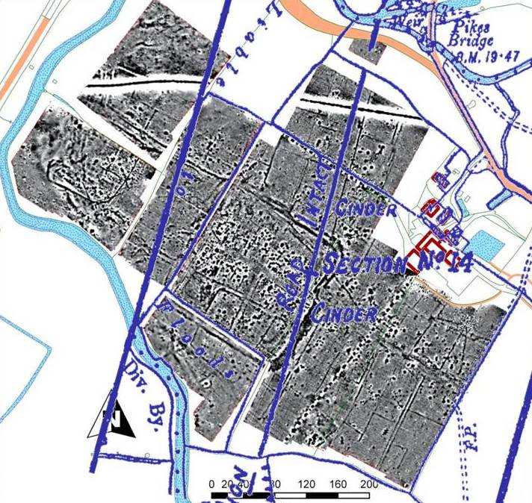
Fig 1. Margary’s 1933 map (in blue) overlaid on 2011 geophysics
Today we have the great advantage of geophysics which allows us to see just how close Margary was to making a momentous discovery, even for him, had he only had the modern technology that we take for granted. Results clearly show the termination of the road in both magnetometer and ground penetrating radar images as it hits the road heading east to Arlington and Pevensey from the centre of the settlement. But it is arguable whether any of these discoveries would have happened without Margary’s pioneering work to guide us and that includes the discoveries made in this, and previous, year’s CAP excavations.
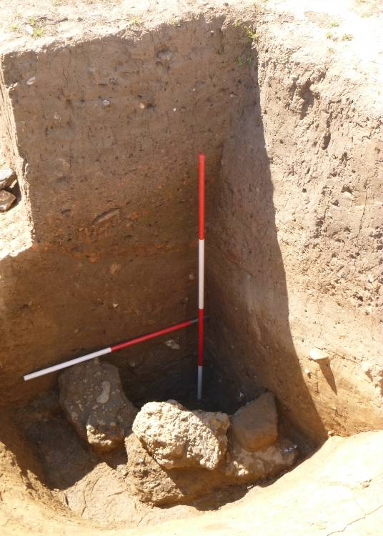
Fig.2. The well, quarter sectioned (scales 1 & 2m)

Due to the amount of outstanding features CAP returned to the trench excavated in 2015 on the intersection of Margary’s London road (M14) and the late 2nd century double ditch enclosure. This gave the opportunity to dig below the shallower features and expand some of the areas opened last year i.e. the road surface. But it was a series of deep pits that became the focus of this year’s dig and in particular one in the NE corner that revealed a quadrant of large lumps of sandstone and tap slag forming the lining of a well some 2m below current ground level (Fig 2).

Another deep pit in the SE corner had also been half sectioned to 2m with the sides stepped back for safety but this did not have any lining or construction within but did yield one of the year’s top finds, an ‘Oldbury type’ glass bead (Fig. 3) probably dating to either 1st century BC or AD but potentially a conserved item so not definitive for dating the feature.

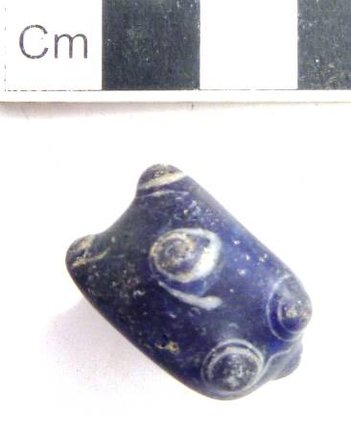
Other remarkable finds included a bronze ‘terret’ ring, i.e. part of the harness of a draught animal, 2 hobnail sole patterns and a small bronze fibular brooch complete with pin.

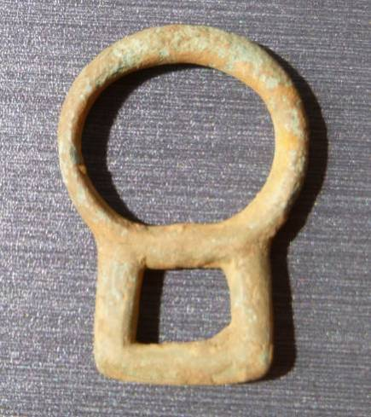

. Bronze terret ring
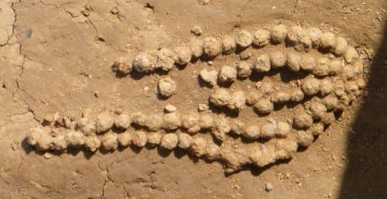
Shoe pattern in iron hobnails

A further 10,000 sherds of pottery, to add to last year’s 10,000, were removed, cleaned, marked and recorded by the hard working finds team, superbly coordinated by Nancy Wiginton and Ann Best, including a delightfully decorated thin-necked jar in a sandy grey fabric probably from the Alice Holt or Farnham group of kilns.
Next year will see us back in the same trench as 2015/16 as we finally hope to complete the excavation of the lower levels of archaeology including more deep pits, areas of unexplained flint and of course the other three quarters of that well. For more details on Bridge Farm 2016 or CAP’s work in general go to www.culverproject.co.uk.

David Millum ACIfA
Deputy Director of the Culver Archaeological Project

And put in your diary Friday 21st April 2017 when Rob Wallace Co-Director of the Bridge Farm project will talk to LAG about the project. He will also explore how the settlement might have operated within the local area and the wider south east region.

Plumpton Roman Villa
The excavations of the villa site at Plumpton over the summer proved to be extremely successful. The exposure of the winged-corridor building (see drone photograph taken by Mark Dobson) was completed.

It is now known that the original masonry structure comprised a rectangular building approximately 25m long and 8.5m wide. The wall foundations were made of mortared flints above a deposit of chalk (ie similar to the walls at Barcombe). The north-west corner, and possibly also the south-west corner, were marked by large blocks of Sussex marble. Room divisions consisted of three large rooms separated by passages which had been later subdivided into two areas. The larger northern space in both cases may have accommodated stairs to a first floor.

Subsequently a corridor or veranda was added on the south side of the central living room and the pair of passageways. At its eastern end was a large reception wing-room with an internally apsidal wall on its south side. Any window in this wall would have enjoyed a really fine view of the South Downs.

At the other end of the corridor we discovered three walls at angles to the other walls described above. Normally one might have expected to find a corresponding wing-room at this location and the end of the southern corridor. Instead, the corridor continues to the south-east, its eastern wall continuing under the edge of the trench. Traces of other masonry were found along the western side of the winged-corridor house, including a continuation westwards of the wall forming the rear of the original structure. These areas are hoped to explore further in 2017.

Traces of other features within the area of the winged-corridor building included several tree-hollows of unknown date, the investigation of which led to the discovery within the western living room of a large slab-built Bronze Age ceramic vessel. As yet there has not been either a specialist report on the Bronze Age sherds, or a report on soil samples taken from the vicinity of the vessel. It is possible that traces of a later Bronze Age burial have been found, but to date conclusive evidence, such as cremated bone fragments, are lacking. It is interesting to note however that the Barcombe villa was located next to the remains of a Bronze Age round barrow.

To the east of the Romano-British winged-corridor house, excavations continued regarding a big concentration of large flints and other finds. Further coin finds are again of the period late third-early fourth century. More work will resume in this area in 2017.

Bridge Cottage Uckfield

This Wealden Hall house in the town centre was rescued from demolition or removal for road schemes by the efforts of Uckfield & District Preservation Society and safeguarded in the ownership of the Town Council. The Society has now completed restoration including weatherproofing through Lottery funding and the cottage is in heavy use for classes, conferences, lectures, performances and other activities.

Allowing for the demolished northern parlour, it measured about 27ft 5in x 24ft 3in internally, one of the largest examples in the area. It was originally a four-bay construction and single-aisled. Uckfield was centrally situated in the archbishop’s large manor of South Malling and the building’s earliest known occupants in the 16th and 17th centuries were his officials. Trying to date the building from styles had been perplexing, but dendrochronology ascertained that timbers were cut in the autumn of 1436.

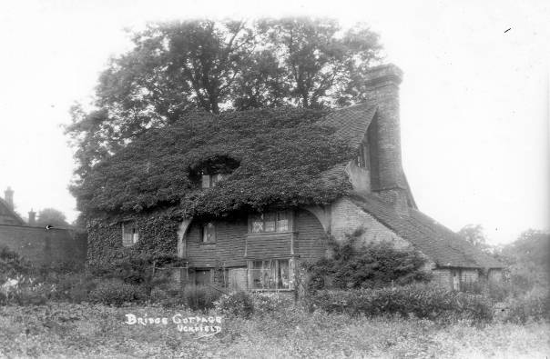

Archaeology in advance of installing under the floor a most welcome hypocaust heating system revealed traces of an earlier structure on a slightly different alignment that had suffered fire damage. Post holes for use of the site before that were also found. No settlement here before the mid-15th century would have been improbable.

More details of the building’s past and present can be seen on the new website: www.bridgecottageuckfield.co.uk

The Lewes Mount

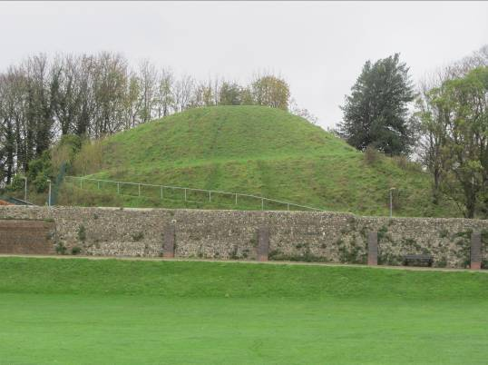
As noted in last autumn’s newsletter Dr Jim Leary from the University of Reading is carrying out a project aimed at unlocking the history of monumental mounds, including the Lewes Mount (off Mountfield Road). As part of this project the team visited Lewes and drilled two boreholes: one from the summit, and a second down-slope a little. In the laboratory a large number of charcoal fragments were extracted, and these fragments were submitted for radiocarbon dating. The results showed that charcoal from a range of sources had been incorporated into the mound during its construction, but the dates were clear: The Mount was constructed at some point after the mid-15th to early 16th century. This means that The Mount was either built right at the end of the life of the Priory, or perhaps more likely, after the Dissolution when the site became part of the gardens of a substantial house, known as Lords Place. As such, it seems most probable, that this mound is indeed a garden feature.
Jim Leary and Elaine Jamieson are due to come to give a LAG talk on Friday 15th February when they will set out their findings in more detail.
St John Sub Castro
Further archaeological investigations may take place at St John Sub Castro into the site of the medieval church. It’s still too early to say if they will happen and whether LAG would be permitted to participate – but it would be useful to know if anyone would like to be involved. Please email me at paulawodcohen@yahoo.co.uk.

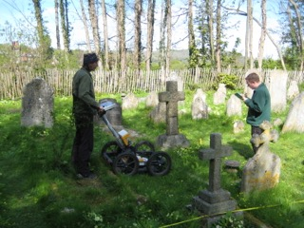

Excavations in Lewes

Land rear of 25a Priory Street. The site is situated close to the northern boundary of Lewes Priory and the potential for the ground-works to reveal archaeology was considered high. Two evaluation trenches excavated at the site by ASE revealed the remains of chalk block wall foundations. A pit was partially revealed by the ground-works which contained pottery dating from the earliest phases of the Priory as well as a single fragment of Roman brick. This was sealed by a mortar surface and a layer of masonry waste consisting of both Quarr stone and Caen Limestone which may have been deposited by the reworking of stone robbed from the Priory post Dissolution. All other features noted on site were cut down through the mortar surface and waste stone deposit including the chalk wall foundations noted in the evaluation carried out at the site. Although there was evidence of extensive post-medieval activity at the site in the form of wall foundations and made ground earlier features and deposits were little disturbed and it is reasonable to assume that any archaeological remains still present at the site will be preserved in-situ.

21 High Street. Ongoing watching brief being maintained during redevelopment of the site. Cobbled surface and masonry structures have been identified.
1 Rotten Row. A single pit, containing the sherds of a large early 12th century cooking vessel, was found to have been truncated by the foundations of the existing house. No other archaeological features were observed.

Home Histories
As well as carrying out watching briefs on properties in Lewes, Archaeology Services Lewes are providing home histories reports. For further information contact Lisa Jayne Fisher at info@aslewes.co.uk.

Talks and events

BHAS Brighton & Hove Archaeological Society
ENHAS Eastbourne Natural History and Archaeological Society
FOAC Friends of Anne of Cleves House
LHG Lewes History Group
LAG Lewes Archaeological Group
SAS Sussex Archaeological Society
SSA Sussex School of Archaeology
USAS University of Sussex Archaeological Society

Early Churches and Country House 1840
Members with an interest in the history of historic buildings may like the
two day events in the successful series currently being run by the Sussex
Archaeological Society.

On Saturday 29th April 2017 the theme of the day is 'The Changing Parish
Church: from Saxon to Victorian c.600-1900' at the King's Church, Lewes.
On Saturday 21st October 2017 'The Long Sunset: the Country House c.1840-1940'
The full programmes are on
https://sussexpast.co.uk/become-a-member/conferences-events. Or email Lorna
Gartside, the Society's Membership and Events Secretary members@sussexpast.co.uk for a pdf copy. There will also be other events about churches, including in Lewes which members can look for from December on the same section of the Sussex Past website.

DECEMBER
Fri 9 Dec BHAS AGM and report on Ovingdean excavations and talk by Jane Russell on Neolithic Rock Art of Britain and Ireland. Unitarian Church, Brighton. 7pm.
Mon 12 Dec LHG – The Woman’s Land Army and AGM. Kings Church, Lewes. 7.30pm. £3/2.

JANUARY 2017
Fri 6 Jan LAG – Dr William Harcourt Smith – The Curious Case of Homo Naledi. 7.30pm Lewes Town Hall. £4/3/2/free.
Mon 9 Jan LHG Paul Quinn – the Lewes Matayrs. Kings Church, Lewes. 7.30pm. £3/2.
Tues 10 Jan Worthing AS Jane Russell – Neolithic Rock Art in Britain and Ireland. 7pm. Worthing Library, Richmond Road.
Fri 13 Jan BHAS John Manley – the Archaeology of the South Downs National Park. Unitarian Church, Brighton. 7.30pm. £3/free.
Fri 13 Jan ENHAS – Greg Chuter – Malling Down, Lewes. 7.30pm at St Saviour’s Church Hall, Eastbourne. £2.50.
Thurs 19 Jan USAS Judie English – Metal work as an indicator of social change in early and mid Saxon period. Lecture Theatre A, Fulton Building, Uni Sussex. 7pm £3/2.
Sat 21 Jan Steve Patton – The Paleolithic – out of Africa and into Britain. Three two hour linked lectures (other dates 4th and 18th February). Rottingdean Whiteway Centre. Cost £10 per session.Contact - veronica.carter@btinternet.com.
Sat 28 Jan BHAS – Cherry Gillingham – Paintings of the Brighton and Hove Seafronts from 19th and 20th Century. Central United Reform Church, Hove. 2.15pm. Free/£3.

FEBRUARY
Fri 10 Feb BHAS Sean Wallis – Monuments, Massacre and Medieval Expansion in Oxford. Unitarian Church, Brighton. 7.30pm. £3/free.
Mon 13 Feb LHG John Blackwell – John Evelyn’s Phoenix Ironworks. Kings Church, Lewes. 7.30pm. £3/2.
Fri 17 Feb LAG Jim Leary and Elaine Jamieson – Lewes Mount, Mountfield Road and the Round Mounds Project. Lewes Town Hall. 7.30pm. £4/3/2/free.
Fri 17 Feb ENHAS – Tom Dommett – recent National Trust archaeological projects. 7.30pm at St Saviour’s Church Hall, Eastbourne. £2.50.
Thurs 23 Feb USAS Edwin Wood – Finds from the River Thames and a History of Mudlarking. Lecture Theatre A, Fulton Building, Uni Sussex. 7pm £3/2.
Sat 25 Feb BHAS Richard Howell – A Talk and the Chalk and Lime Industry of the Arun Valley. Central United Reform Church, Hove. 2.15pm. Free/£3.
Sat 25 Feb WEA - Robert Carrington – Paul Nash. 2-5pm. St Thomas Church Hall, Lewes. For info tel 01273 477447. Cost £15.

MARCH
Fri 10 March BHAS Paola Ponce – The Human Remains at the Brighton Museum a summary of their assessment and potential for study. Unitarian Church, Brighton. 7.30pm. £3/free.
Fri 10 March ENHAS – Matt Pope – the Pre-history of Jersey. 7.30pm at St Saviour’s Church Hall, Eastbourne. £2.50.
Mon 13 March LHG. Frances Stenlake – Rehabilitating Kate Fowler-Tutt. Kings Church, Lewes. 7.30pm. £3/2.
Fri 17 March LAG John Bleach – The Medieval Churches and Chapels in and around Lewes. Lewes Town Hall. 7.30pm. £4/3/2/free. And AGM
Sat 25 March SAS Sussex Archaeological Symposium. All day.
Thurs 30 March USAS Geoffrey Leigh – Aztec and Maya Archaeology: visiting some key sites in Mexico. Lecture Theatre A, Fulton Building, Uni Sussex. 7pm £3/2.

APRIL
Sat 1 April BHAS Judie English –Space and Status – how the medieval house was used. Central United Reform Church, Hove. 2.15. Free/£3.
Mon 10 April LHG No details of talk available. Kings Church, Lewes. 7.30pm. £3/2.
Fri 21 April LAG Rob Wallace – Bridge Farm, near Barcombe. Lewes Town Hall. 7.30pm. £4/3/2/free.
Sat 29 April SAS The Changing Parish Church (details see above).

The Sussex School of Archaeology also runs practical day schools on all aspects of field archaeology including illustration, geo physics, finds preservation and field walking as well as holding other events. To find details of these courses visit - http://www.sussexarchaeology.org

